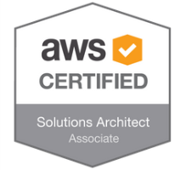

Goutam Nayak
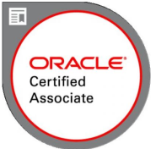
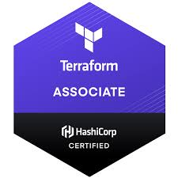
AWS Cloud /Platform Engineer
Phone : +31-659580699
Address : Almere, Netherlands
Email : goutam.nayak1706@gmail.com
AWS Platform Engineer passionate about building secure, cost-effective, and scalable cloud platforms that empower teams. Adept at simplifying complex AWS environments, automating essential processes, and collaborating with stakeholders to ensure rapid, confident, and fully compliant project delivery. Experienced with Python, GitLab, Artifactory, Vault, and Bash, consistently driving initiatives to reduce costs, strengthen security, and promote reliable releases.
L I N K S    My Portfolio    GitHub    LinkedIn  T E C H N I C A L S K I L L S  + Amazon Web Services  + Linux/Windows  + Application Administration  + Python/Bash  + Gitlab  + Terraform/CloudFormation  + Hashi Corp Vault  + Jfrog Artifactory  + Datadog  + Splunk  + Opsgenie  + Rapid 7  + Informatica  + Siebel CRM Administration  + Oracle and DB2 database  + OBIEE Administration  + Mentoring & Coaching  + Git/Bitbucket  + Splunk  + JIRA  + Siebel Development Tools  + HP ALM, ServiceNOW, Cascade  C E R T I F I C A T I O N S  + AWS certified Solution Architect-  Associate  + Terraform Certified Associate  + Oracle RightNow Cloud Service  Presales Specialist  + Oracle RightNow Cloud Service  Sales Specialist  + Oracle Siebel 8.1 Consultant  O R G A N I Z A T I O N S  + Schuberg Philis, Netherlands  + Knab, Netherlands  + Tata Consultancy Services  + Fujitsu Consulting India  + Wipro Technologies India  E D U C A T I O N  Bachelor of Engineering in  Computer Science,  National Institute of Technology, Rourkela  2005-2009  R E F E R E N C E S  - Will be provided on demand | C A R E E R H IG H L IG H T S  + IT Platform Engineer for Amazon Web Services working on multi account structure  + Create and Provide Platform/Services as to teams as AWS landing zone via terraform/AWS-CF to create a platform for them to work on.  + Creating Pipelines for day-to-day activities with AWS Codepieline , bitbucket etc.  + Analyzing and continuously improving the internal cloud stack in respect to security, enhancements and features.  + Working with applications like Splunk, Divvy Cloud, Opsgenie ,GIT in accordance to support the whole IT stack for the organization  + Single Sign On setup between applications (AWS) and Azure Active Directory via SAML.  + Bridging the gap between business and IT to derive technical solutions to business problems related to IT platform.  + Experience in working with an onsite-offshore model by being part of daily huddle calls and other SCRUM calls (Refinement, Retrospective and Planning)  + In depth knowledge of different AWS services like EC2, VPC, RDS, Dynamo DB, S3, IAM, CloudWatch, CloudFormation, CodeBuild, CodePipeline etc.  + Amazon Web Services (AWS) Cloud Administration.  + Work closely with the development teams to guide them during migration of applications.  + Worked on migration of Siebel CRM applications from on premises to AWS cloud infrastructure in a Hybrid Model.  + Installation and configuration of various CRM Applications and Databases like Siebel, OBIEE, Informatica, BIP, Oracle 11g etc.  + Apply release changes, Code Migration and Product  Enhancements in close cooperation with other technical  departments.  + Troubleshooting, Load Balancing, Clustering, Deploying Applications, Performance Tuning of Applications.  + Monitoring and analyzing resources, Standard logs, application logs.  + On Premise to Cloud Migration of CRM Applications to IBM private cloud  + Experience of working in Development and 24x7 Production  Support environments.  + Writing automation shell scripts for daily BAU activities, Release Deployments and Monitoring.  + Linux and AIX support for various applications and regular BAU activities.  + Supporting all planned & unplanned outages.  + Informatica Administration and ETL job monitoring  + Experience of ITIL processes and AGILE concepts.  W O R K E X P E R I E N C E  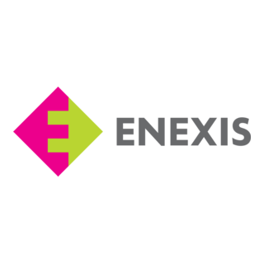  + Mission Critical Engineer  Dec,2021 – Present, Schuberg Philis, Netherlands  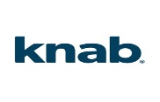  + Cloud Engineer  August,2018- Nov,2021  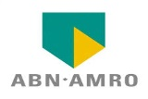  + CRM Application Support for Siebel and AWS consultant  Jan 2015 – March 2018, Tata Consultancy Services, Netherlands  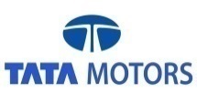  + Siebel CRM Team Lead Tata Motors    Nov 2013 – Jan 2015, Tata Consultancy Services, India  + Application Support Consultant at Thomson Reuters  Nov 2013 – Jan 2015, Fujitsu Consulting India  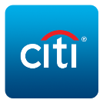  + Siebel Administrator and Developer at CITIBANK MRM  May 2010 – Nov 2012, Wipro Technologies, India

