MACHINE LEARNING LABORATORY
RECORD OF PROGRAMS

Department of Computer Science and Engineering
Gokaraju Rangaraju Institute of Engineering and Technology

Reference: Python Machine Learning — Sebastian Raschka, O'Reilly

Experiment 1

Aim
To write a Python program to import and export data using Pandas library functions.

Program
# Task 1: Import and export data using Pandas library functions
import pandas as pd

# Create a DataFrame
df = pd.DataFrame({
'Name': ['Ram', 'Sita', 'John', 'Asha', 'Ravi'],
'Age': [21, 22, 20, 23, 21],
'Marks': [85, 90, 78, 88, 72]
})
print("Original Data:\n", df)

# ---------- EXPORT ----------
df.to_csv('data/students.csv', index=False)
df.to_excel('data/students.xlsx', index=False)
df.to_json('data/students.json', orient='records')
print("\nData exported to CSV, Excel and JSON.")

# ---------- IMPORT ----------
data = pd.read_csv('data/students.csv')
print("\nImported from CSV:\n", data)

print("\nStatistical summary:\n", data.describe())
print("\nAverage Marks:", data['Marks'].mean())
print("Topper:", data.loc[data['Marks'].idxmax(), 'Name'])

Output
Original Data:
Name Age Marks
0 Ram 21 85
1 Sita 22 90
2 John 20 78
3 Asha 23 88
4 Ravi 21 72

Data exported to CSV, Excel and JSON.

Imported from CSV:
Name Age Marks
0 Ram 21 85
1 Sita 22 90
2 John 20 78
3 Asha 23 88
4 Ravi 21 72

Statistical summary:
Age Marks
count 5.000000 5.00000
mean 21.400000 82.60000
std 1.140175 7.46994
min 20.000000 72.00000
25% 21.000000 78.00000
50% 21.000000 85.00000
75% 22.000000 88.00000
max 23.000000 90.00000

Average Marks: 82.6
Topper: Sita

Experiment 2

Aim
To demonstrate various data preprocessing techniques for a given dataset.

Program
# Task 2: Data preprocessing techniques
import numpy as np
import pandas as pd
from sklearn.impute import SimpleImputer
from sklearn.preprocessing import LabelEncoder, StandardScaler
from sklearn.model_selection import train_test_split

df = pd.DataFrame({
'Age': [25, 30, np.nan, 35, 40, 28],
'Salary': [50000, np.nan, 61000, 58000, 52000, 49000],
'Country': ['India', 'US', 'India', 'UK', 'US', 'UK'],
'Buys': ['No', 'Yes', 'No', 'Yes', 'Yes', 'No']
})
print("Original Data:\n", df)
print("\nMissing values:\n", df.isnull().sum())

# 1. Handle missing values (mean imputation)
imp = SimpleImputer(strategy='mean')
df[['Age', 'Salary']] = imp.fit_transform(df[['Age', 'Salary']])

# 2. Encode categorical columns
df['Country'] = LabelEncoder().fit_transform(df['Country'])
df['Buys'] = LabelEncoder().fit_transform(df['Buys'])

# 3. Feature scaling
df[['Age', 'Salary']] = StandardScaler().fit_transform(df[['Age', 'Salary']])
print("\nAfter Preprocessing:\n", df.round(2))

# 4. Train-test split
X, y = df.drop('Buys', axis=1), df['Buys']
Xtr, Xte, ytr, yte = train_test_split(X, y, test_size=0.33, random_state=1)
print("\nTraining samples:", len(Xtr), " Testing samples:", len(Xte))

Output
Original Data:
Age Salary Country Buys
0 25.0 50000.0 India No
1 30.0 NaN US Yes
2 NaN 61000.0 India No
3 35.0 58000.0 UK Yes
4 40.0 52000.0 US Yes
5 28.0 49000.0 UK No

Missing values:
Age 1
Salary 1
Country 0
Buys 0
dtype: int64

After Preprocessing:
Age Salary Country Buys
0 -1.36 -0.93 0 0
1 -0.33 0.00 2 1
2 0.00 1.63 0 0
3 0.70 0.93 1 1
4 1.73 -0.47 2 1
5 -0.74 -1.17 1 0

Training samples: 4 Testing samples: 2

Experiment 3

Aim
To implement dimensionality reduction using Principal Component Analysis (PCA).

Program
# Task 3: Dimensionality reduction using PCA
import matplotlib.pyplot as plt
from sklearn.datasets import load_iris
from sklearn.preprocessing import StandardScaler
from sklearn.decomposition import PCA

iris = load_iris()
X, y = iris.data, iris.target
print("Original shape:", X.shape)

# Standardize the data
X_std = StandardScaler().fit_transform(X)

# Apply PCA: reduce 4 features -> 2
pca = PCA(n_components=2)
X_pca = pca.fit_transform(X_std)
print("Reduced shape :", X_pca.shape)
print("Explained variance ratio:", pca.explained_variance_ratio_.round(3))
print("Total variance retained:", round(pca.explained_variance_ratio_.sum()*100, 2), "%")

# Plot the 2 principal components
plt.figure(figsize=(7, 5))
for i, name in enumerate(iris.target_names):
plt.scatter(X_pca[y == i, 0], X_pca[y == i, 1], label=name)
plt.xlabel('PC 1'); plt.ylabel('PC 2'); plt.title('PCA on Iris Dataset')
plt.legend(); plt.show()

Output
Original shape: (150, 4)
Reduced shape : (150, 2)
Explained variance ratio: [0.73 0.229]
Total variance retained: 95.81 %
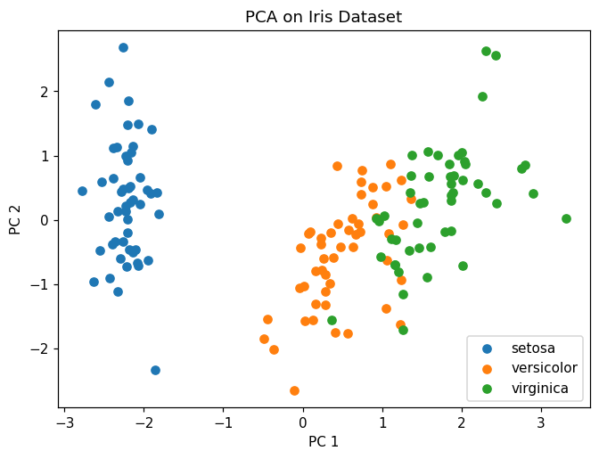

Experiment 4

Aim
To write a Python program to demonstrate various data visualization techniques.

Program
# Task 4: Data Visualization techniques
import matplotlib.pyplot as plt
import seaborn as sns
from sklearn.datasets import load_iris

df = load_iris(as_frame=True).frame
df['species'] = load_iris().target_names[load_iris().target]

# 1. Line plot
df['sepal length (cm)'].plot(kind='line', title='Line Plot')
plt.show()

# 2. Histogram
df['sepal width (cm)'].plot(kind='hist', bins=15, title='Histogram')
plt.show()

# 3. Bar plot (mean petal length per species)
df.groupby('species')['petal length (cm)'].mean().plot(kind='bar', title='Bar Plot')
plt.show()

# 4. Scatter plot
sns.scatterplot(data=df, x='petal length (cm)', y='petal width (cm)', hue='species')
plt.title('Scatter Plot'); plt.show()

# 5. Box plot
sns.boxplot(data=df, x='species', y='sepal length (cm)')
plt.title('Box Plot'); plt.show()

# 6. Correlation heatmap
sns.heatmap(df.iloc[:, :4].corr(), annot=True, cmap='coolwarm')
plt.title('Correlation Heatmap'); plt.show()

Output
(program produced plots only)
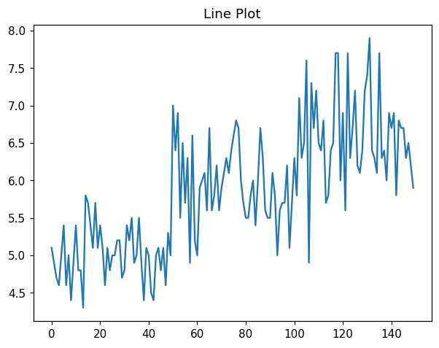
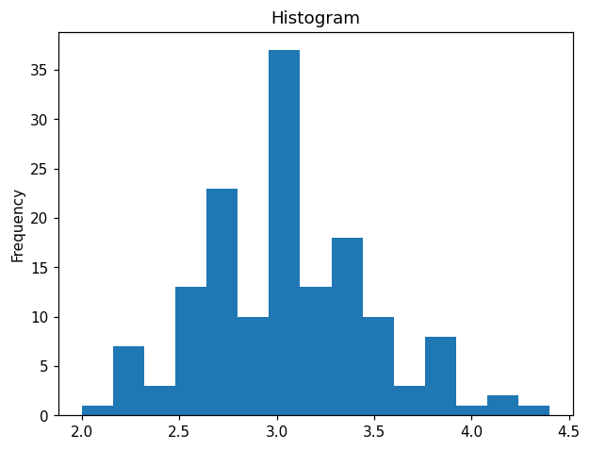
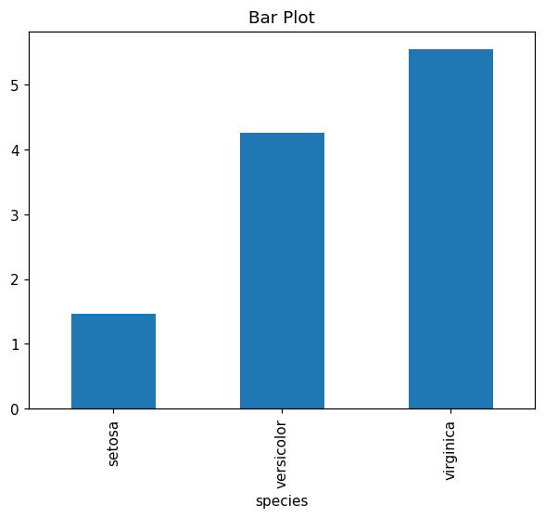
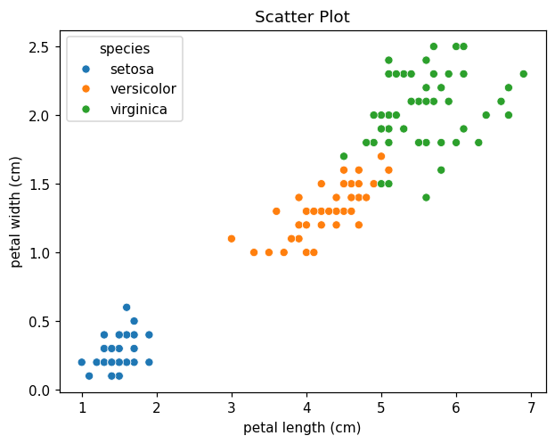
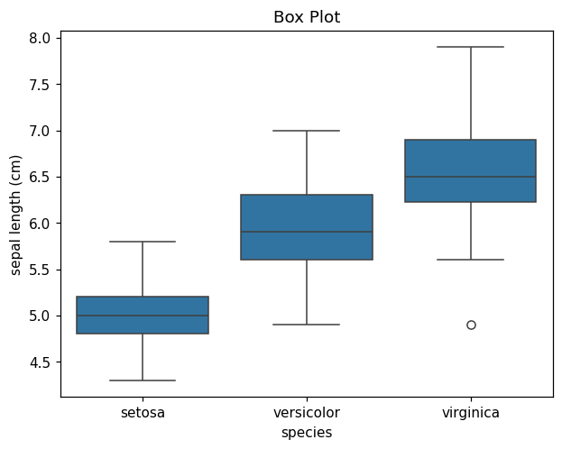
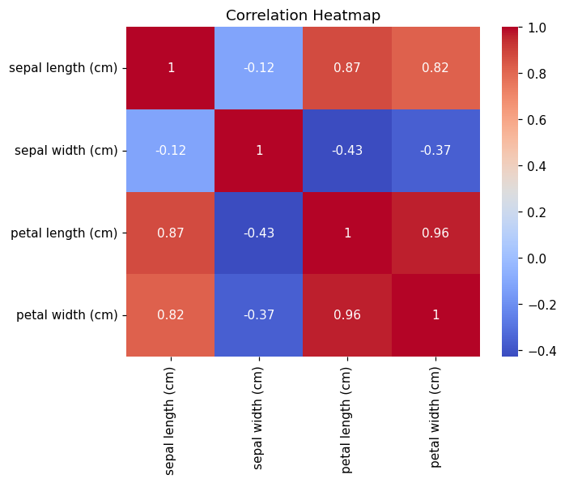

Experiment 5

Aim
To implement Simple and Multiple Linear Regression models.

Program
# Task 5: Simple and Multiple Linear Regression
import matplotlib.pyplot as plt
from sklearn.datasets import load_diabetes
from sklearn.model_selection import train_test_split
from sklearn.linear_model import LinearRegression
from sklearn.metrics import r2_score, mean_squared_error

X, y = load_diabetes(return_X_y=True)

# ---------- Simple Linear Regression (one feature) ----------
x1 = X[:, [2]] # BMI feature
xtr, xte, ytr, yte = train_test_split(x1, y, test_size=0.2, random_state=1)
slr = LinearRegression().fit(xtr, ytr)
pred = slr.predict(xte)
print("Simple Linear Regression")
print(" Slope:", round(slr.coef_[0], 2), " Intercept:", round(slr.intercept_, 2))
print(" R2:", round(r2_score(yte, pred), 3),
" RMSE:", round(mean_squared_error(yte, pred)**0.5, 2))

plt.scatter(xte, yte, label='Actual')
plt.plot(xte, pred, color='red', label='Predicted')
plt.title('Simple Linear Regression'); plt.legend(); plt.show()

# ---------- Multiple Linear Regression (all features) ----------
Xtr, Xte, ytr, yte = train_test_split(X, y, test_size=0.2, random_state=1)
mlr = LinearRegression().fit(Xtr, ytr)
pred = mlr.predict(Xte)
print("\nMultiple Linear Regression")
print(" R2:", round(r2_score(yte, pred), 3),
" RMSE:", round(mean_squared_error(yte, pred)**0.5, 2))

Output
Simple Linear Regression
Slope: 977.74 Intercept: 151.67
R2: 0.251 RMSE: 63.17

Multiple Linear Regression
R2: 0.438 RMSE: 54.7
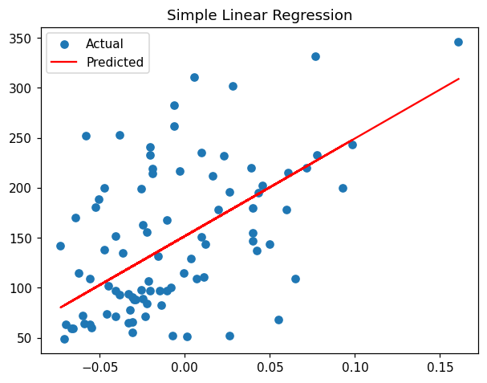

Experiment 6

Aim
To develop a Logistic Regression model for a given dataset.

Program
# Task 6: Logistic Regression
from sklearn.datasets import load_breast_cancer
from sklearn.model_selection import train_test_split
from sklearn.preprocessing import StandardScaler
from sklearn.linear_model import LogisticRegression
from sklearn.metrics import accuracy_score, confusion_matrix, classification_report

data = load_breast_cancer()
X, y = data.data, data.target
Xtr, Xte, ytr, yte = train_test_split(X, y, test_size=0.2, random_state=1)

# Scale features for better convergence
sc = StandardScaler()
Xtr, Xte = sc.fit_transform(Xtr), sc.transform(Xte)

model = LogisticRegression(max_iter=1000).fit(Xtr, ytr)
pred = model.predict(Xte)

print("Accuracy:", round(accuracy_score(yte, pred), 3))
print("\nConfusion Matrix:\n", confusion_matrix(yte, pred))
print("\nClassification Report:\n", classification_report(yte, pred, target_names=data.target_names))

Output
Accuracy: 0.974

Confusion Matrix:
[[40 2]
[ 1 71]]

Classification Report:
precision recall f1-score support

malignant 0.98 0.95 0.96 42
benign 0.97 0.99 0.98 72

accuracy 0.97 114
macro avg 0.97 0.97 0.97 114
weighted avg 0.97 0.97 0.97 114

Experiment 7

Aim
To develop a Decision Tree classification model and classify a new sample.

Program
# Task 7: Decision Tree classification and classify a new sample
import matplotlib.pyplot as plt
from sklearn.datasets import load_iris
from sklearn.model_selection import train_test_split
from sklearn.tree import DecisionTreeClassifier, plot_tree
from sklearn.metrics import accuracy_score, classification_report

iris = load_iris()
X, y = iris.data, iris.target
Xtr, Xte, ytr, yte = train_test_split(X, y, test_size=0.2, random_state=1)

clf = DecisionTreeClassifier(criterion='gini', max_depth=3, random_state=1)
clf.fit(Xtr, ytr)
pred = clf.predict(Xte)

print("Accuracy:", round(accuracy_score(yte, pred), 3))
print("\nClassification Report:\n", classification_report(yte, pred, target_names=iris.target_names))

# Classify a new sample
new = [[5.1, 3.5, 1.4, 0.2]]
print("New sample", new[0], "-> predicted:", iris.target_names[clf.predict(new)[0]])

# Visualize the tree
plt.figure(figsize=(10, 6))
plot_tree(clf, feature_names=iris.feature_names, class_names=iris.target_names, filled=True)
plt.title('Decision Tree'); plt.show()

Output
Accuracy: 0.967

Classification Report:
precision recall f1-score support

setosa 1.00 1.00 1.00 11
versicolor 1.00 0.92 0.96 13
virginica 0.86 1.00 0.92 6

accuracy 0.97 30
macro avg 0.95 0.97 0.96 30
weighted avg 0.97 0.97 0.97 30

New sample [5.1, 3.5, 1.4, 0.2] -> predicted: setosa
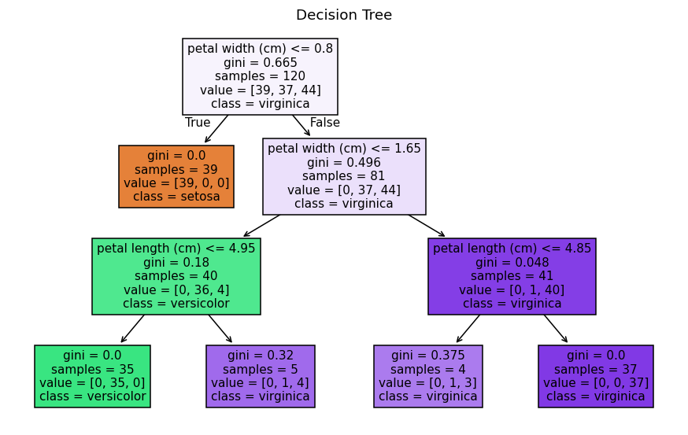

Experiment 8

Aim
To implement Naive Bayes classification in Python for a given dataset.

Program
# Task 8: Naive Bayes Classification
from sklearn.datasets import load_wine
from sklearn.model_selection import train_test_split
from sklearn.naive_bayes import GaussianNB
from sklearn.metrics import accuracy_score, confusion_matrix, classification_report

data = load_wine()
X, y = data.data, data.target
Xtr, Xte, ytr, yte = train_test_split(X, y, test_size=0.2, random_state=1)

model = GaussianNB().fit(Xtr, ytr)
pred = model.predict(Xte)

print("Naive Bayes Accuracy:", round(accuracy_score(yte, pred), 3))
print("\nConfusion Matrix:\n", confusion_matrix(yte, pred))
print("\nClassification Report:\n", classification_report(yte, pred, target_names=data.target_names))

# Predict a new sample
sample = Xte[0].reshape(1, -1)
print("Sample predicted class:", data.target_names[model.predict(sample)[0]])

Output
Naive Bayes Accuracy: 1.0

Confusion Matrix:
[[14 0 0]
[ 0 13 0]
[ 0 0 9]]

Classification Report:
precision recall f1-score support

class_0 1.00 1.00 1.00 14
class_1 1.00 1.00 1.00 13
class_2 1.00 1.00 1.00 9

accuracy 1.00 36
macro avg 1.00 1.00 1.00 36
weighted avg 1.00 1.00 1.00 36

Sample predicted class: class_2

Experiment 9

Aim
To build a KNN classification model in Python for a given dataset.

Program
# Task 9: KNN Classification
from sklearn.datasets import load_iris
from sklearn.model_selection import train_test_split
from sklearn.preprocessing import StandardScaler
from sklearn.neighbors import KNeighborsClassifier
from sklearn.metrics import accuracy_score, confusion_matrix, classification_report

iris = load_iris()
X, y = iris.data, iris.target
Xtr, Xte, ytr, yte = train_test_split(X, y, test_size=0.2, random_state=1)

# Scale features (KNN is distance based)
sc = StandardScaler()
Xtr, Xte = sc.fit_transform(Xtr), sc.transform(Xte)

model = KNeighborsClassifier(n_neighbors=5).fit(Xtr, ytr)
pred = model.predict(Xte)

print("KNN (k=5) Accuracy:", round(accuracy_score(yte, pred), 3))
print("\nConfusion Matrix:\n", confusion_matrix(yte, pred))
print("\nClassification Report:\n", classification_report(yte, pred, target_names=iris.target_names))

Output
KNN (k=5) Accuracy: 0.967

Confusion Matrix:
[[11 0 0]
[ 0 12 1]
[ 0 0 6]]

Classification Report:
precision recall f1-score support

setosa 1.00 1.00 1.00 11
versicolor 1.00 0.92 0.96 13
virginica 0.86 1.00 0.92 6

accuracy 0.97 30
macro avg 0.95 0.97 0.96 30
weighted avg 0.97 0.97 0.97 30

Experiment 10

Aim
To implement a Back Propagation model in Python for a given dataset.

Program
# Task 10: Back Propagation (Neural Network trained using backpropagation)
from sklearn.datasets import load_iris
from sklearn.model_selection import train_test_split
from sklearn.preprocessing import StandardScaler
from sklearn.neural_network import MLPClassifier
from sklearn.metrics import accuracy_score, confusion_matrix

iris = load_iris()
X, y = iris.data, iris.target
Xtr, Xte, ytr, yte = train_test_split(X, y, test_size=0.2, random_state=1)

# Scale inputs
sc = StandardScaler()
Xtr, Xte = sc.fit_transform(Xtr), sc.transform(Xte)

# MLPClassifier uses the back-propagation algorithm to train
model = MLPClassifier(hidden_layer_sizes=(8, 8), activation='relu',
max_iter=1000, random_state=1)
model.fit(Xtr, ytr)
pred = model.predict(Xte)

print("Back Propagation Neural Network")
print("Accuracy:", round(accuracy_score(yte, pred), 3))
print("Confusion Matrix:\n", confusion_matrix(yte, pred))

Output
Back Propagation Neural Network
Accuracy: 0.967
Confusion Matrix:
[[11 0 0]
[ 0 12 1]
[ 0 0 6]]

Experiment 11

Aim
To implement Random Forest classification and a Boosting ensemble method.

Program
# Task 11: a) Random Forest b) Boosting (AdaBoost)
from sklearn.datasets import load_iris
from sklearn.model_selection import train_test_split
from sklearn.ensemble import RandomForestClassifier, AdaBoostClassifier
from sklearn.metrics import accuracy_score, confusion_matrix

iris = load_iris()
X, y = iris.data, iris.target
Xtr, Xte, ytr, yte = train_test_split(X, y, test_size=0.2, random_state=1)

# a) Random Forest
rf = RandomForestClassifier(n_estimators=100, random_state=1).fit(Xtr, ytr)
rp = rf.predict(Xte)
print("a) Random Forest")
print(" Accuracy:", round(accuracy_score(yte, rp), 3))
print(" Feature importances:", rf.feature_importances_.round(3))

# b) Boosting (AdaBoost)
ab = AdaBoostClassifier(n_estimators=50, random_state=1).fit(Xtr, ytr)
ap = ab.predict(Xte)
print("\nb) AdaBoost (Boosting)")
print(" Accuracy:", round(accuracy_score(yte, ap), 3))
print(" Confusion Matrix:\n", confusion_matrix(yte, ap))

Output
a) Random Forest
Accuracy: 0.967
Feature importances: [0.123 0.027 0.439 0.411]

b) AdaBoost (Boosting)
Accuracy: 0.967
Confusion Matrix:
[[11 0 0]
[ 0 12 1]
[ 0 0 6]]

Experiment 12

Aim
To write a Python program to implement the K-Means clustering algorithm.

Program
# Task 12 a) K-Means clustering (with library and from scratch)
import numpy as np
import matplotlib.pyplot as plt
from sklearn.datasets import load_iris
from sklearn.cluster import KMeans

X = load_iris().data

# ---------- WITH library ----------
km = KMeans(n_clusters=3, random_state=1, n_init=10).fit(X)
print("Library K-Means cluster sizes:", np.bincount(km.labels_))

# ---------- WITHOUT library (from scratch) ----------
np.random.seed(1)
k = 3
centroids = X[np.random.choice(len(X), k, replace=False)]
for _ in range(10):
# assign each point to nearest centroid
labels = np.array([np.argmin([np.linalg.norm(x - c) for c in centroids]) for x in X])
# update centroids
centroids = np.array([X[labels == i].mean(axis=0) for i in range(k)])
print("Scratch K-Means cluster sizes:", np.bincount(labels))

# Plot the scratch result (first two features)
plt.scatter(X[:, 0], X[:, 1], c=labels, cmap='viridis')
plt.scatter(centroids[:, 0], centroids[:, 1], c='red', marker='X', s=200)
plt.title('K-Means Clustering'); plt.show()

Output
Library K-Means cluster sizes: [62 50 38]
Scratch K-Means cluster sizes: [50 60 40]
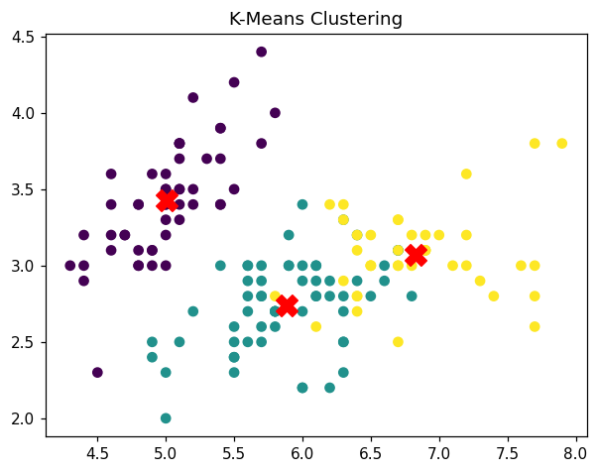

Experiment 13

Aim
To write a Python program to implement the BIRCH clustering algorithm.

Program
# Task 12 b) BIRCH clustering algorithm
import numpy as np
import matplotlib.pyplot as plt
from sklearn.datasets import load_iris
from sklearn.cluster import Birch

X = load_iris().data

# BIRCH clustering
model = Birch(threshold=0.5, n_clusters=3)
labels = model.fit_predict(X)

print("Cluster labels:\n", labels)
print("Cluster sizes:", np.bincount(labels))

# Plot (first two features)
plt.scatter(X[:, 0], X[:, 1], c=labels, cmap='viridis')
plt.xlabel('Sepal Length'); plt.ylabel('Sepal Width')
plt.title('BIRCH Clustering'); plt.show()

Output
Cluster labels:
[2 2 2 2 2 2 2 2 2 2 2 2 2 2 2 2 2 2 2 2 2 2 2 2 2 2 2 2 2 2 2 2 2 2 2 2 2
2 2 2 2 2 2 2 2 2 2 2 2 2 0 0 0 1 0 0 0 1 0 1 1 0 1 0 1 0 0 1 0 1 0 1 0 0
0 0 0 0 0 1 1 1 1 0 0 0 0 0 1 1 1 0 1 1 1 1 1 0 1 1 0 0 0 0 0 0 1 0 0 0 0
0 0 0 0 0 0 0 0 0 0 0 0 0 0 0 0 0 0 0 0 0 0 0 0 0 0 0 0 0 0 0 0 0 0 0 0 0
0 0]
Cluster sizes: [76 24 50]
