High school student interested in senior internship and summer job opportunities

Data Science • Programming • Web Development • Graphic Design • Video Production

**EDUCATION**

**Bergen County Academies, Hackensack, NJ** [www.bcts.bergen.org](http://www.bcts.bergen.org) Sep 2015 – Present

*Academy for Engineering Design and Technology, High School Class of 2019*

Founded in 1991, BCA is free public magnet high-school in Bergen County, with ~1060 students, organized into seven academies, offering programs in science, engineering, medical science, technology/computer science, business/finance, culinary arts/hospitality administration, and visual/performing arts.

* Recognized as the **#11 Best High School** in the Nation by Niche.com and **#1 Public HS** in NJ by USA Today
* Named a 2015 **National Blue Ribbon** school
* Highly selective admissions process (16% acceptance rate) with enrollment from 70 municipalities in Bergen County

Coursework

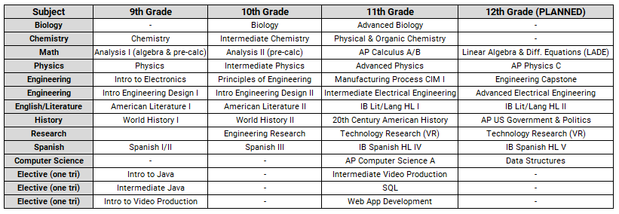

Club and Activities

* **SPARK** – One of 15 students selected during my sophomore year to serve a three-year term in this peer leadership organization, which mentors 9th and 10th graders. We conduct many school activities to promote school spirit.
* **South Asian Club** – Serving as co-president for a club that promotes awareness of South Asian culture. We have over 75 members and conduct annual Diwali and Holi celebrations.
* **Diversity Alliance** – Serving a student leader in an organization that tries to promote cultural awareness. Our flagship event is the International Day of Acceptance (IDA), which
* **Global Ambassador Student** – Selected by the school’s administration to promote our interactions with international schools and organizations. Involved with guiding foreign exchange students throughout the school. Currently developing an exchange program between BCA and the Hughes Schools in Cochabamba, Bolivia (http://hughesschools.com/).
* **Community Outreach** – working to organize a visit from the students of the Hughes School in Bolivia.
* **Art Department Organizer** - in charge of creating website and accessory designs for hackBCA events (hackbca.com).
* **Boys Cross Country** –earned a varsity letter as a 10th grader, my first year on the team; PB of 19:34 in 5K course
* **E-Camp** **Head Counselor**– serving as guide since 9th grade in BCA’s summer engineering enrichment camp for new students
* **Community Service** – on track to complete 400-500 hours of community service by graduation; BCA minimum is 40 hours

**SKILLS**

**Programming**: R (advanced); JAVA (intermediate); Python, PHP & SQL, Android Studio (beginner)

**3D Modeling**: Autodesk AutoCAD, Autodesk Fusion 360, Autodesk Inventor, Autodesk Revit, 3D printing (advanced)

**Machine Experience**: Epilog Engraver, Tormach Personal CNC, Flow Mach2 Waterjet, Picza Laser Scanner (advanced)

**Video Software**: Adobe Premiere Pro CC (advanced)

**Certifications**: Certified in Adobe Premiere Pro CC, Adobe Photoshop CC, Adobe Illustrator CC (advanced); Adobe After Effects ; first student at BCA to earn certification in three Adobe products in one trimester**EXPERIENCE**

**The Gifted Child Society, Allendale, NJ** [www.gifted.org](http://www.gifted.org) Feb 2018 – Present

*Junior Instructor in Java programming and 3D Modeling*

TGCS is a 501(c)3 nonprofit organization dedicated to providing academic enrichment to elementary and middle school students; served over 70,000 children since 1957. US DOE has named TGCS a national demonstration model.

* Hired as an instructor for their weekend enrichment program, to teach middle school students about programming , robotics, and 3D modelling.

**Bergen Makerspace, Hackensack, NJ** [bergenmakerspace.bergen.org](http://bergenmakerspace.bergen.org/) Feb 2018 – Present

*Student Intern*

Bergen Makerspace is community center that offers a weekly evening program for Bergen County residents, to explore new technologies at BCA, in a hands-on environment, guided by educators and student volunteers from BCA.

* Serving as guide in the use of various equipment, including the Laser Cutter, 3D Printer, and Arduino microcontroller
* Currently producing project videos that are showcased during open hours

**Refresh Bolivia, Cambridge, MA** [refreshbolivia.com](https://www.refreshbolivia.com/) Jan 2017 – Present

*Videographer, Volunteer*

RB is an international 501(c)3 nonprofit organization that serves underprivileged communities in Cochabamba, Bolivia, through charitable project work in sanitation, health education, and community outreach. Volunteer organization run by students from Harvard University, Pomona College, Pomona College, and Cornell University, along with partners in Bolivia.

* Traveled to Bolivia for three weeks during the summer of 2017 to film and produce documentary videos for the organization
* Published videos/photos on their web site; assisted in preparing content for securing grants from the Ford Motor Co.
* Assisted in community outreach programs with the Hughes School in Bolivia
* First high school student ever allowed to work with RB

**PERSONAL**

* **Martial Arts**: Earned 2nd Degree Black Belt in Taekwondo from Xcel Tae Kwon Do, Hasbrouck Heights, NJ ([xceltkd.com](http://xceltkd.com/home_page.htm)), founded by Master Steven Lee, a former 5-time US National Team Member and NJ Junior Olympic Team Coach.
* **Music**: Student of South Indian Classical Music (Carnatic) since age 7; singing, bamboo flute, and mridangam (percussion); participated in middle school band (tenor saxophone, flute)
* **Languages**: Proficient in Tamil and Spanish
* **Speed-cubing**: PB times: 4s in 2x2, 16s in 3x3; 84s in 4x4
* **Social Media**: Created a YouTube channel that has hundreds of subscribers and over 60K hits; content includes cinematic “slice of life” videos as well as various personal projects
* **Other**: Avid amateur card magician with an interest in sleight-of-hand artistry