Day 3 – Sub Queries, Set Operations and CTEs

1. Write a query to display the average monthly ticket cost for each flight in ABC Airlines. The query should display the Flight_Id, From_location, To_location, Month Name as “Month_Name” and average price as “Average_Price”. Display the records sorted in ascending order based on flight id and then by Month Name.
SELECT afd.flight_id, af.from_location, af.to_location,
DATENAME(month, afd.flight_departure_date) AS Month_Name,
AVG(afd.price) AS Average_Price
FROM air_flight_details AS afd
JOIN air_flight AS af
ON afd.flight_id = af.flight_id
WHERE airline_name = 'ABC'
GROUP BY afd.flight_id, af.from_location, af.to_location,
DATENAME(month, afd.flight_departure_date)
ORDER BY flight_id, Month_Name;
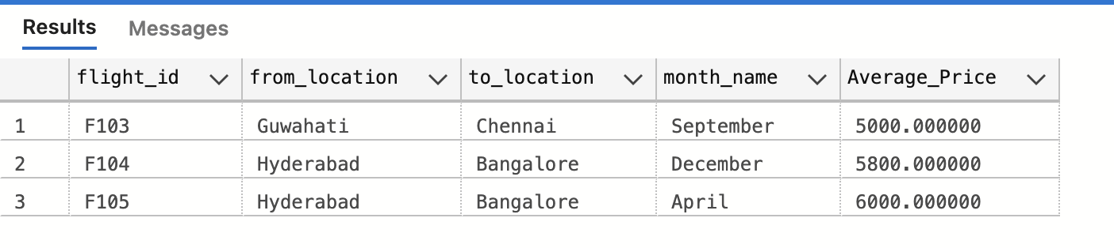
2. Write a query to display the customer(s) who has/have booked least number of tickets in ABC Airlines. The Query should display profile_id, customer’s first_name, Address and Number of Tickets booked as “No_of_Tickets”. Display the records sorted in ascending order based on customer's first name.
SELECT app.profile_id, app.first_name, app.address,
COUNT(ati.ticket_id) AS No_of_Tickets
FROM air_ticket_info AS ati
JOIN air_passenger_profile AS app
ON app.profile_id = ati.profile_id
JOIN air_flight_details AS afd
ON afd.flight_id = ati.flight_id
JOIN air_flight AS af
ON af.flight_id = afd.flight_id
GROUP BY app.profile_id, app.first_name, app.address
HAVING COUNT(ati.ticket_id) = (
SELECT MIN(ticket_count)
FROM (
SELECT COUNT(ati.ticket_id) AS ticket_count
FROM air_ticket_info AS ati
JOIN air_passenger_profile AS app
ON app.profile_id = ati.profile_id
JOIN air_flight_details AS afd
ON afd.flight_id = ati.flight_id
JOIN air_flight AS af
ON af.flight_id = afd.flight_id
GROUP BY app.profile_id
) AS min_ticket_count
)
ORDER BY app.first_name;
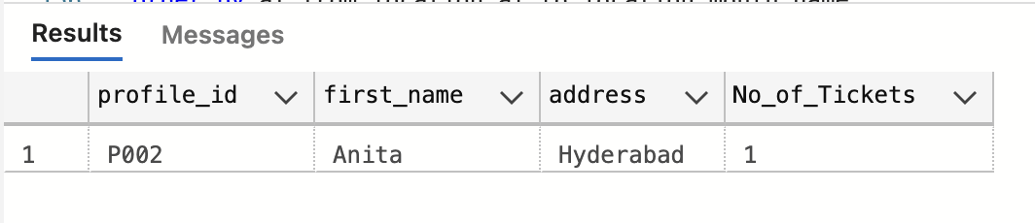
3. Write a query to display the number of flight services between locations in a month.
The Query should display From_Location, To_Location, Month as “Month_Name” and number of flight services as “No_of_Services”. The records should be displayed in ascending order based on From_Location, To_Location and Month Name.
SELECT af.from_location, af.to_location,
DATENAME(month, afd.flight_departure_date) AS Month_Name,
COUNT(af.flight_id) AS No_of_Services
FROM air_flight_details AS afd
JOIN air_flight AS af
ON afd.flight_id = af.flight_id
GROUP BY af.from_location, af.to_location,
DATENAME(month, afd.flight_departure_date)
ORDER BY af.from_location, af.to_location, Month_Name;
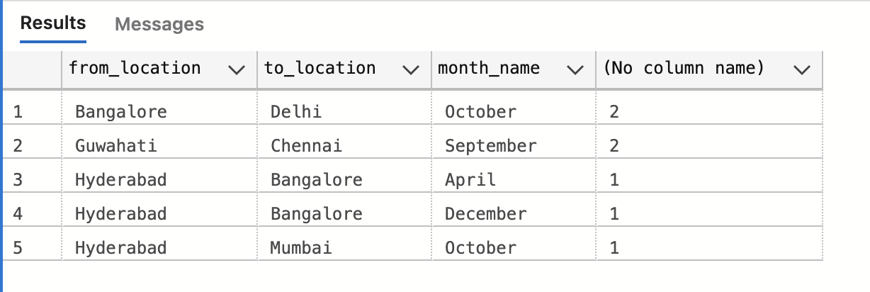
4. Write a query to display the customer(s) who has/have booked maximum number of tickets in ABC Airlines. The Query should display profile_id, customer’s first_name, Address and Number of Tickets booked as “No_of_Tickets”. Display the records sorted in ascending order based on customer's first name.
SELECT app.profile_id, app.first_name, app.address,
COUNT(ati.ticket_id) AS No_of_Tickets
FROM air_ticket_info AS ati
JOIN air_passenger_profile AS app
ON app.profile_id = ati.profile_id
JOIN air_flight_details AS afd
ON afd.flight_id = ati.flight_id
JOIN air_flight AS af
ON af.flight_id = afd.flight_id
GROUP BY app.profile_id, app.first_name, app.address
HAVING COUNT(ati.ticket_id) = (
SELECT MAX(ticket_count)
FROM (
SELECT COUNT(ati.ticket_id) AS ticket_count
FROM air_ticket_info AS ati
JOIN air_passenger_profile AS app
ON app.profile_id = ati.profile_id
JOIN air_flight_details AS afd
ON afd.flight_id = ati.flight_id
JOIN air_flight AS af
ON af.flight_id = afd.flight_id
GROUP BY app.profile_id
) AS max_ticket_count
)
ORDER BY app.first_name;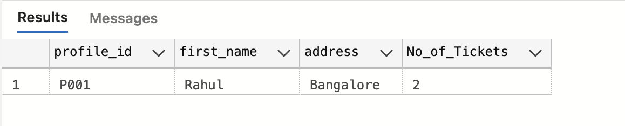
5. Write a query to display the number of tickets booked from Chennai to Hyderabad.
The Query should display passenger profile_id, first_name, last_name, Flight_Id,
Departure_Date and number of Tickets booked as “No_of_Tickets”. Display the records sorted in ascending order based on profile id, flight id and departure date.
SELECT app.profile_id, app.first_name, app.last_name,
af.flight_id, afd.flight_departure_date,
COUNT(ati.ticket_id) AS No_of_Tickets
FROM air_ticket_info AS ati
JOIN air_flight_details AS afd
ON ati.flight_id = afd.flight_id
AND ati.flight_departure_date = afd.flight_departure_date
JOIN air_flight AS af
ON ati.flight_id = af.flight_id
JOIN air_passenger_profile AS app
ON app.profile_id = ati.profile_id
WHERE af.from_location = 'Chennai'
AND af.to_location = 'Hyderabad'
GROUP BY app.profile_id, app.first_name, app.last_name,
af.flight_id, afd.flight_departure_date
ORDER BY profile_id, flight_id, flight_departure_date;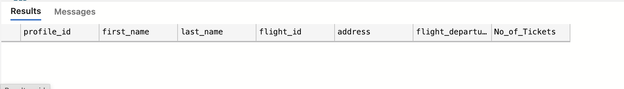
6. Write a query to display flight id, from location, to location and ticket price of flights whose departure is in the month of April.

SELECT afd.flight_id, af.from_location, af.to_location, afd.price
FROM air_flight_details AS afd
JOIN air_flight AS af
ON afd.flight_id = af.flight_id
WHERE MONTH(afd.flight_departure_date) = 4;
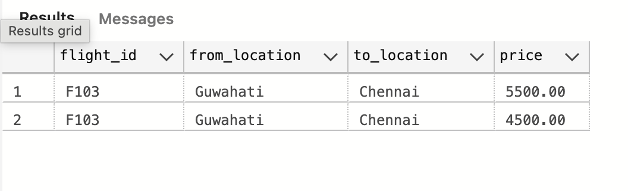
7. Write a query to display the average cost of the tickets in each flight on all scheduled dates. The query should display flight_id, from_location, to_location and Average price as “Price”. Display the records sorted in ascending order based on flight id, from_location and to_location.
SELECT afd.flight_id, af.from_location, af.to_location,
AVG(afd.price) AS Price
FROM air_flight_details AS afd
JOIN air_flight AS af
ON afd.flight_id = af.flight_id
GROUP BY afd.flight_id, af.from_location, af.to_location
ORDER BY afd.flight_id, af.from_location, af.to_location;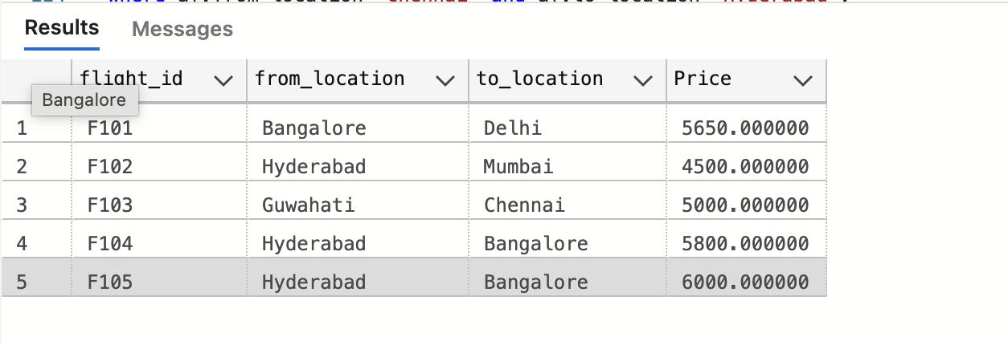
8. Write a query to display the customers who have booked tickets from Chennai to Hyderabad. The query should display profile_id, customer_name (combine first_name & last_name with comma), address of the customer. Display unique customers only and sort by profile id.
SELECT app.profile_id,
CONCAT(app.first_name, ',', app.last_name) AS customer_name,
app.address
FROM air_ticket_info AS ati
JOIN air_flight_details AS afd
ON ati.flight_id = afd.flight_id
AND ati.flight_departure_date = afd.flight_departure_date
JOIN air_flight AS af
ON ati.flight_id = af.flight_id
JOIN air_passenger_profile AS app
ON app.profile_id = ati.profile_id
WHERE af.from_location = 'Chennai'
AND af.to_location = 'Hyderabad'
GROUP BY app.profile_id, app.first_name, app.last_name, app.address
ORDER BY app.profile_id;
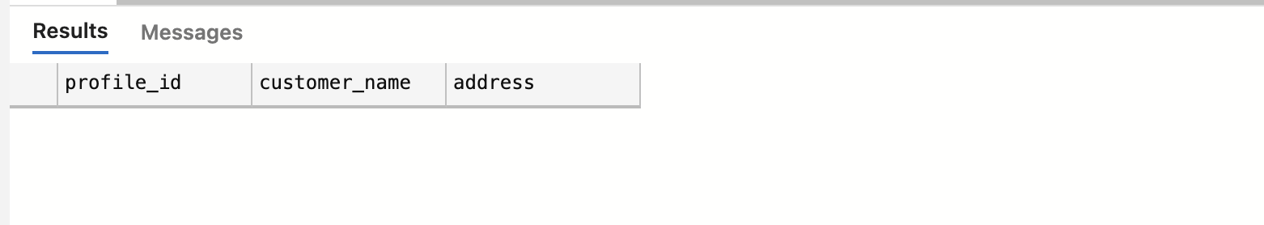
9. Write a query to display profile id of the passenger(s) who has/have booked maximum number of tickets. In case of multiple records, display the records sorted in ascending order based on profile id.
SELECT app.profile_id, COUNT(ati.ticket_id) AS No_of_Tickets
FROM air_ticket_info AS ati
JOIN air_passenger_profile AS app
ON ati.profile_id = app.profile_id
GROUP BY app.profile_id
HAVING COUNT(ati.ticket_id) = (
SELECT MAX(ticket_count)
FROM (
SELECT COUNT(ticket_id) AS ticket_count
FROM air_ticket_info
GROUP BY profile_id
) AS max_ticket
)
ORDER BY app.profile_id;
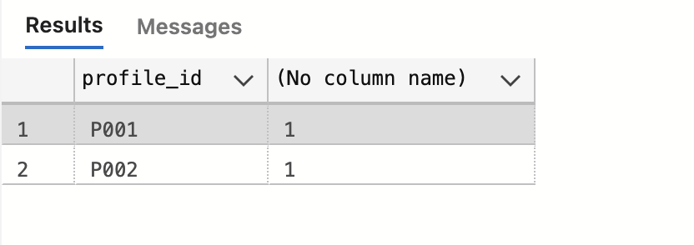
10. Write a query to display the total number of tickets booked in each flight in ABC Airlines. The Query should display flight_id, from_location, to_location and number of tickets as “No_of_Tickets”. Display only flights with at least one ticket booked and sort by flight id.
SELECT af.flight_id, af.from_location, af.to_location,
COUNT(ticket_id) AS No_of_Tickets
FROM air_ticket_info AS ati
JOIN air_flight_details AS afd
ON ati.flight_id = afd.flight_id
AND ati.flight_departure_date = afd.flight_departure_date
JOIN air_flight AS af
ON afd.flight_id = af.flight_id
WHERE airline_name = 'ABC'
GROUP BY af.flight_id, af.from_location, af.to_location
HAVING COUNT(ticket_id) >= 1
ORDER BY af.flight_id;
