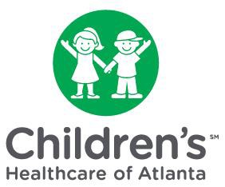Physician Groups Included In Children’s

Financial Assistance Program



|  |
| --- |
| Children’s Healthcare of Atlanta at Egleston - Emergency Medicine |
| Children’s Healthcare of Atlanta at Scottish - Emergency Medicine |