Experimental results of Randomized Algorithm

The graphs plotted have two curves: the best performance and the average performance.

N is the number of tests the approximation ratio was averaged over, for each T.

Key observations:
1. If the functions (arms) are defined for a length smaller than T, the average ratio seems to be fluctuating. Saturation seems to occur after the T crosses tau_max.
2. Obviously, larger the N, better the best performance. Larger the K, the larger the value of N that will be needed to achieve better Best_performance.

1.
Funtions: tau_max = 8, K=3
3 5 8 10 12 14 11 8
5 5 7 10 15 14 9 7
8 7 3 1 12 15 20 24

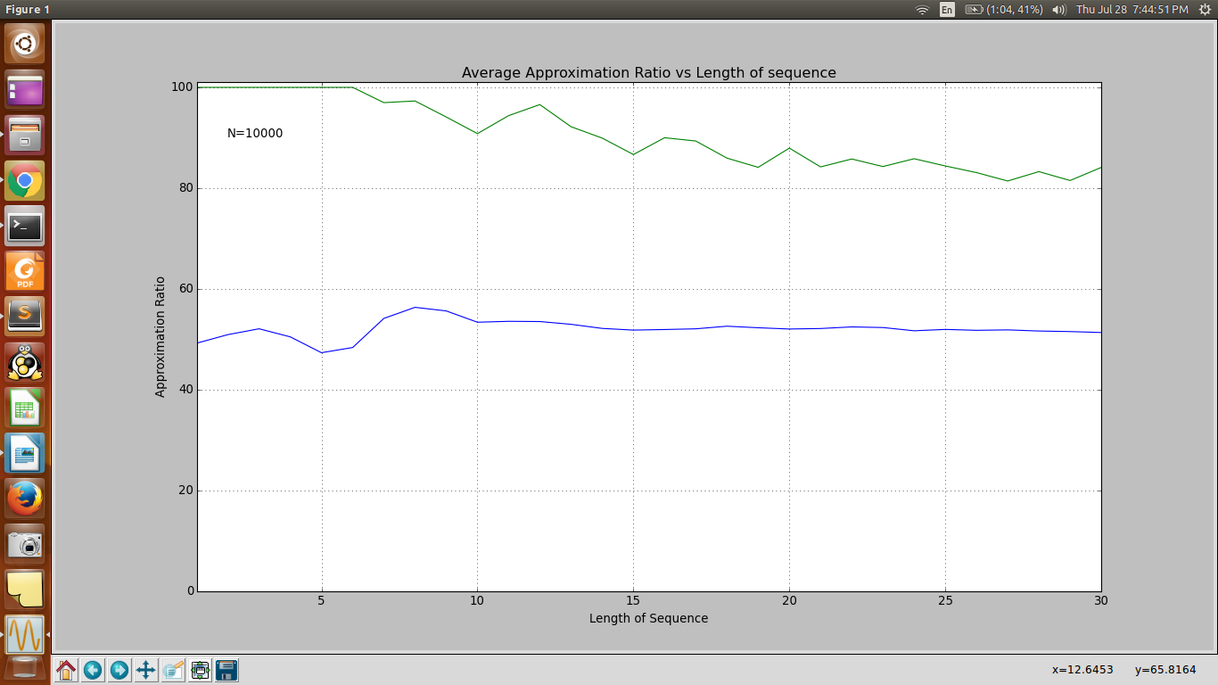

2. tau_max = 12, K=4
12 15 20 21 21 26 35 40 41 35 31 25
15 15 14 13 10 20 24 51 53 55 55 60
16 19 24 24 29 32 38 40 45 46 59 67
12 12 11 11 10 10 30 34 76 81 82 82

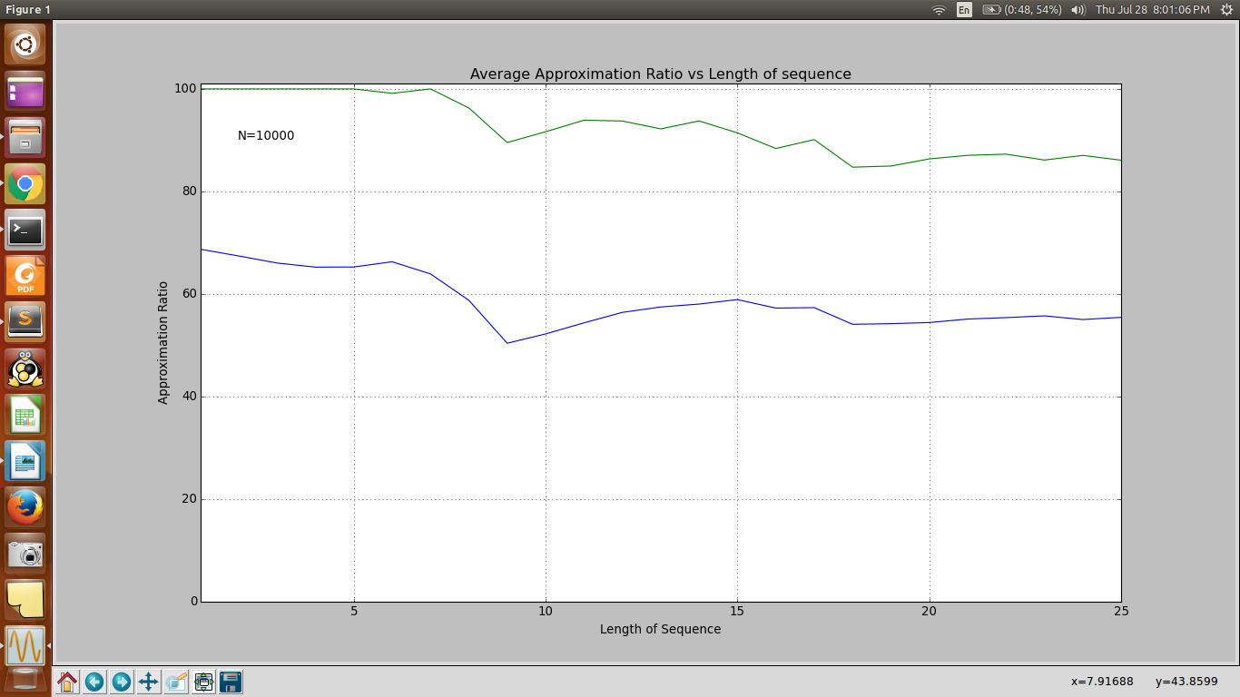

3. tau_max = 40, K=3
3 15 24 28 50 78 83 99 126 143 152 152 164 169 180 190 214 226 253 260 276 285 296 311 328 348 370 377 387 398 428 444 462 491 514 521 542 571 587 591
37 58 73 99 118 144 150 173 191 206 221 237 265 271 300 313 323 343 366 383 412 429 450 454 480 499 495 487 484 477 469 467 460 454 448 442 433 424 415 415
27 23 13 8 0 0 7 15 32 41 63 93 122 149 157 162 189 213 213 237 249 269 279 283 307 329 331 336 343 373 384 394 415 444 454 478 482 483 483 505

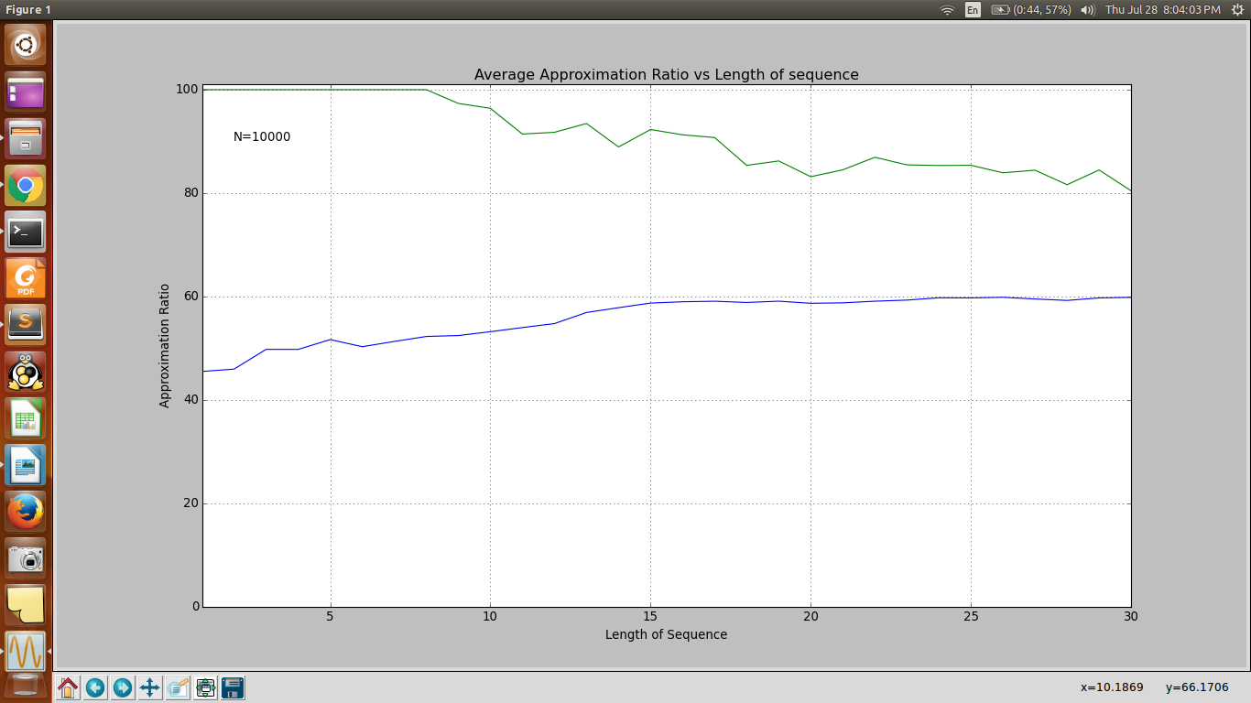

4.
1 2 7 8 16 32 62 126 256 512 1000
2 4 5 9 19 37 65 124 255 517 1002
3 3 6 10 17 31 61 132 260 510 1005
4 5 6 11 15 35 68 136 254 516 1010

The above four are very similar looking functions, all of which are growing exponentially. On average, the algorithm fares very poorly. Saturation is unclear.

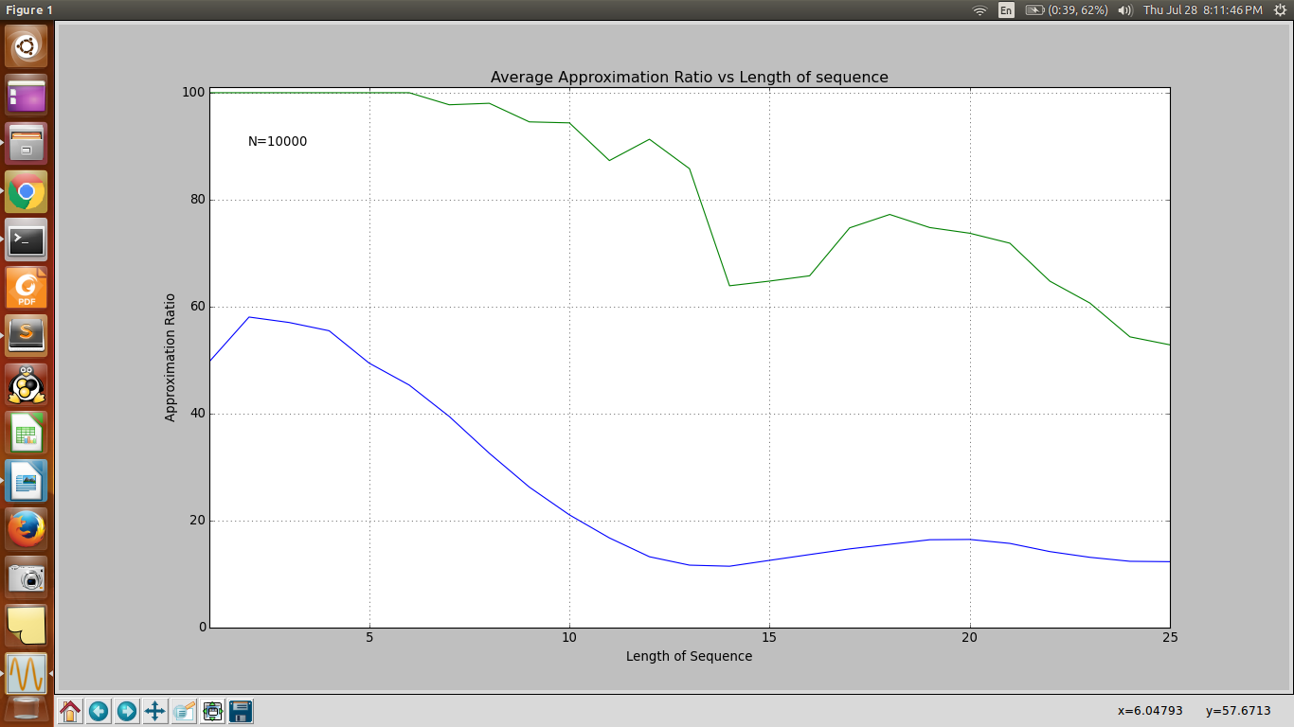

5. tau_max=9, K=2
5 8 10 15 15 16 18 20 22
6 9 11 13 13 12 11 10 8

Clear definite saturation!

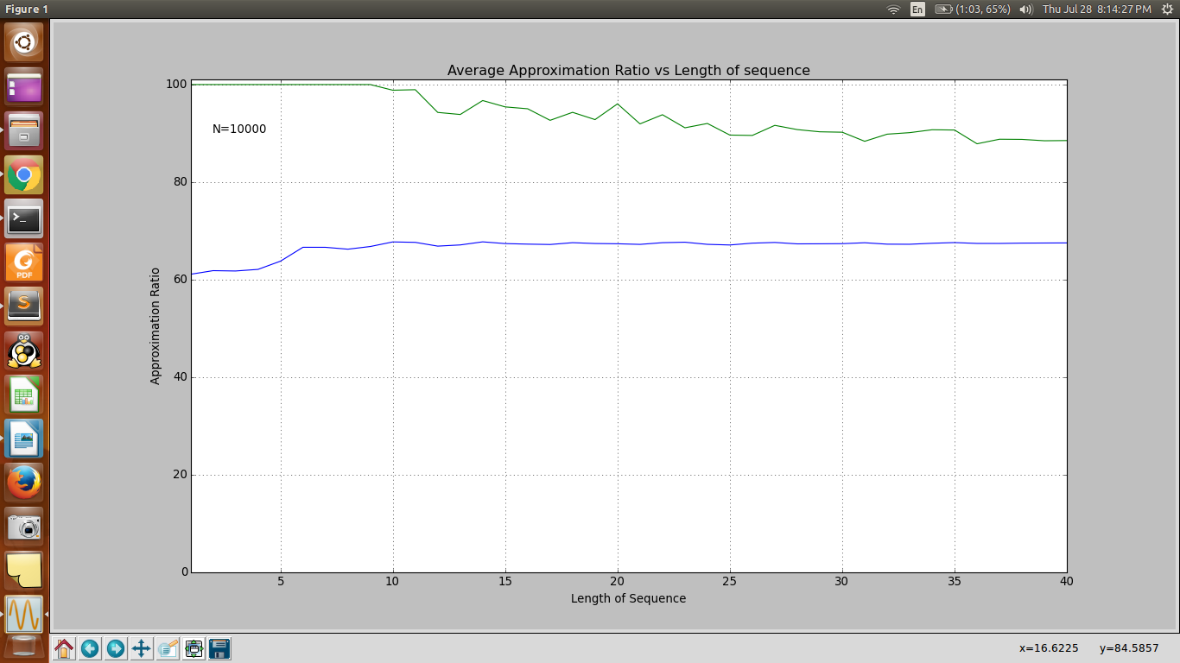

6. Single Arm, tau_max=40

3 15 24 28 50 78 83 99 126 143 152 152 164 169 180 190 214 226 253 260 276 285 296 311 328 348 370 377 387 398 428 444 462 491 514 521 542 571 587 591

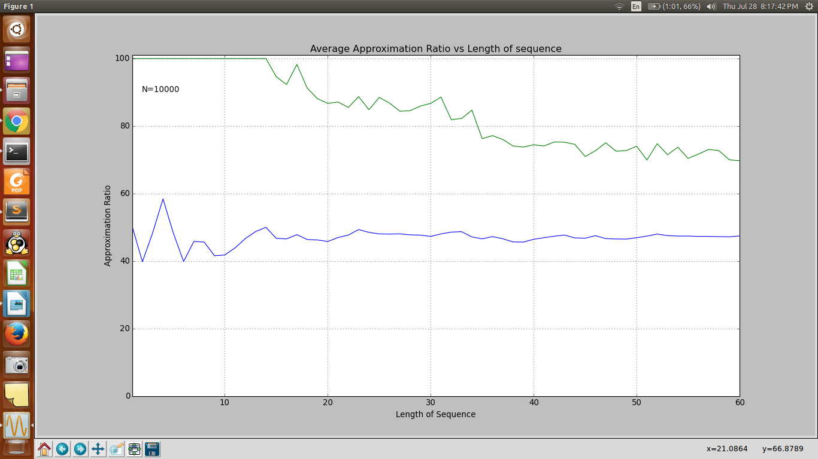

7. K=5, tau_max=12
12 15 20 21 21 26 35 40 41 35 31 25
15 15 14 13 10 20 24 51 53 55 55 60
16 19 24 24 29 32 38 40 45 46 59 67
12 12 11 11 10 10 30 34 76 81 82 82
23 24 24 25 25 26 30 30 34 28 23 12

