LAB SUBMISSION WEEK-01
ESE 3005---EMBEDDED SYSTEMS ARCHITECTURE II
LAMBTON COLLEGE IN TORONTO
INSTRUCTOR: TAKIS ZOURNTOS
STUDENT NAME & ID:
GOUTHAM REDDY ALUGUBELLY---C0747981
VISHAL HASRAJANI---C0761544
PARTH PATEL---C0764929
RATNAJAHNAVI REBBAPRAGADA---C0762196

INTRODUCTION:
To get the yocto working by following the yocto mega manual and to build “core-image-sato” operating systems. Also to display it that it runs on an emulated machine using qemuarm.
We have to check the requirements for installing Yocto, the system should be having an updated software along with 50GB of space.

DESCRIPTION:
YOCTO PROJECT QUICK BUILD
In this process we are going to build a typical image using the Yocto-project. We will configure a build for a specific hardware and also to build a reference embedded operating systems called Poky.
To initialize the build we need to follow the below steps.
Initializing the build environment
$cd ~/poky
In this poky directory, we have to run oe-init-build-env environment script for building yocto project environment on host machine.
$source oe-init-build-env
Now a local conf file will be created in conf subdirectory folder with some default values. Then we can edit it by selecting any machine.
Now to build an OS image for this process, we need to run,
$bitbake core-image-sato
Now we need to simulate our image using qemu and then exit from qemu.
OUTPUTS:
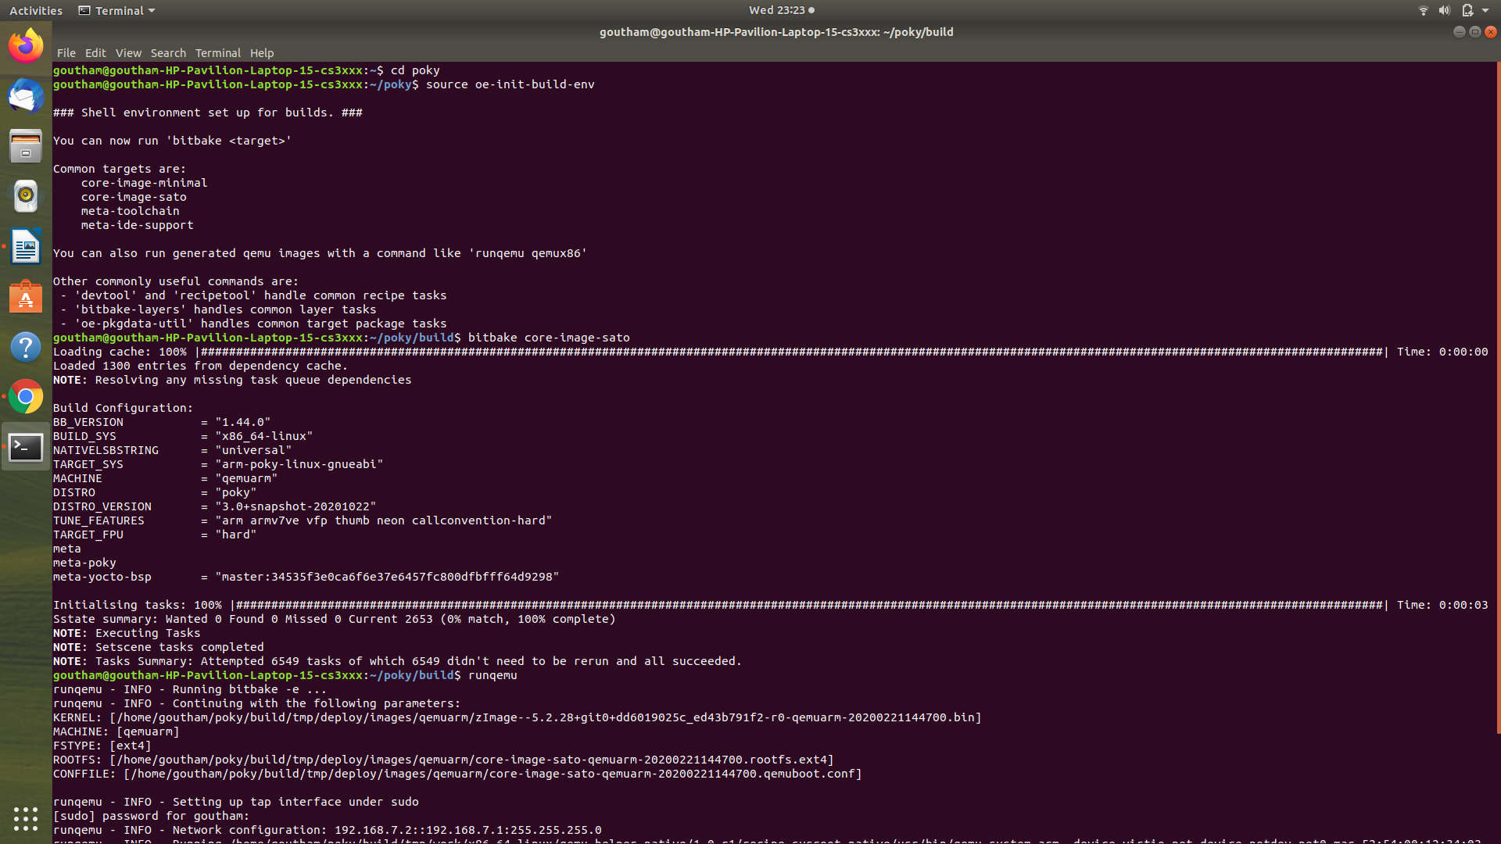
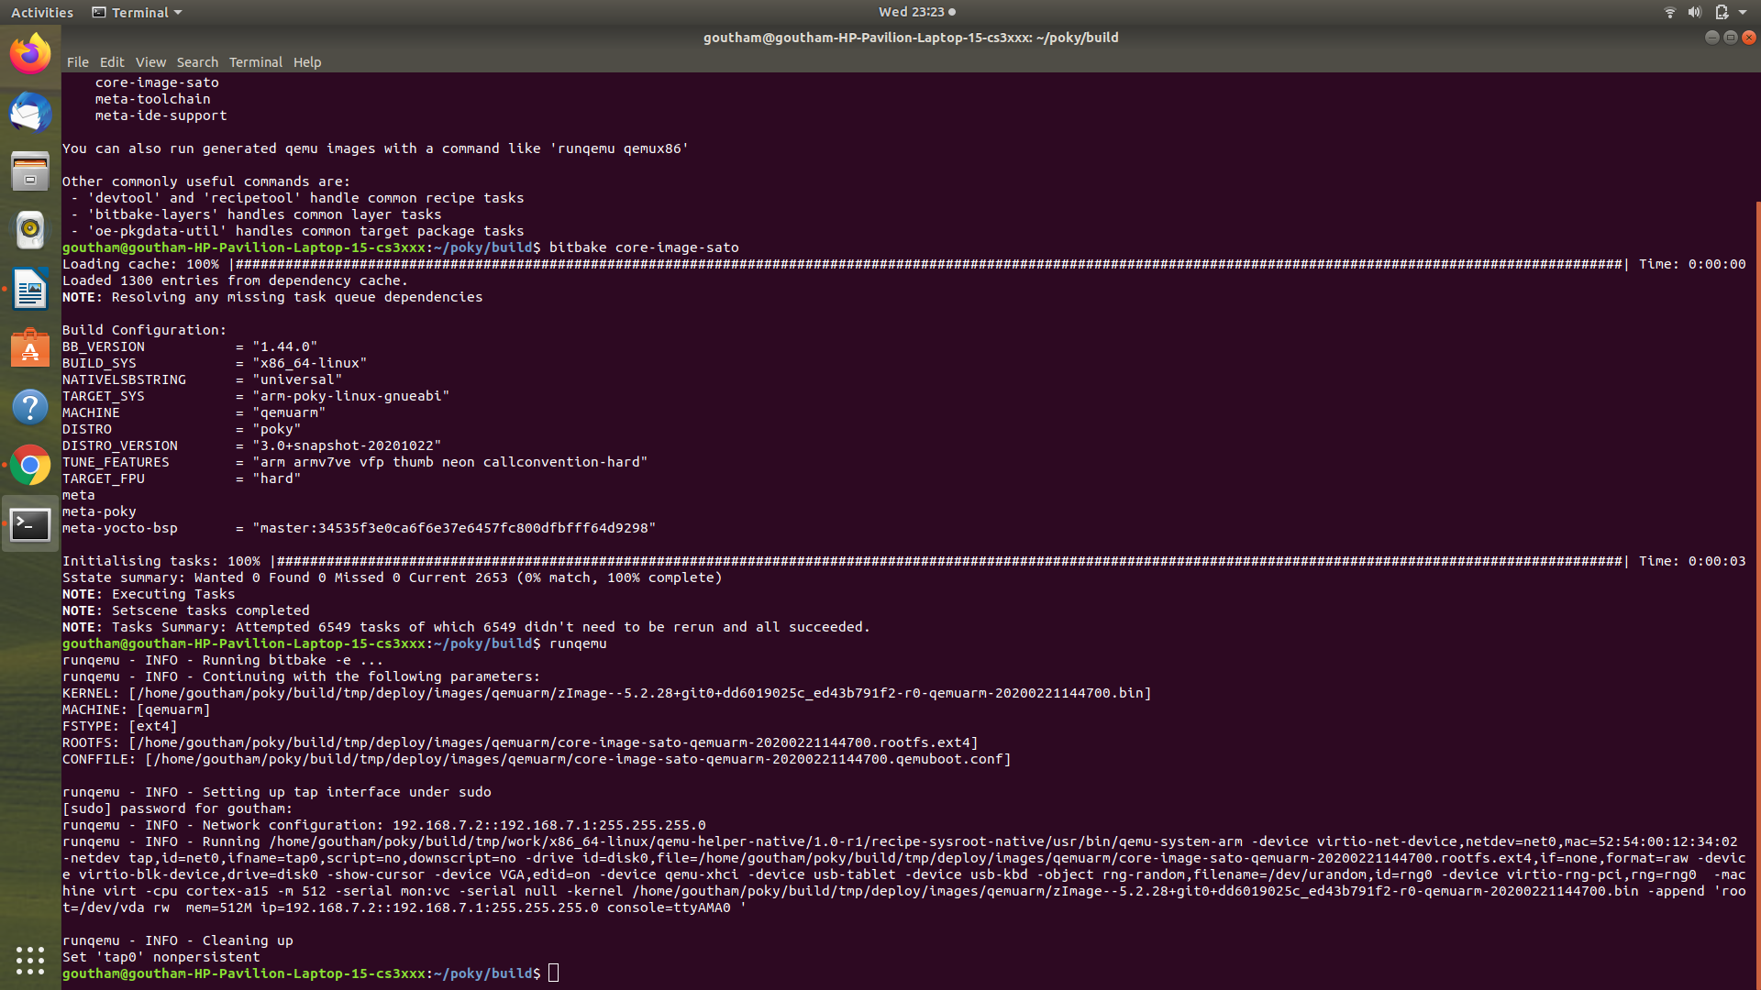
QEMU OUTPUTS:
Applications in QEMU
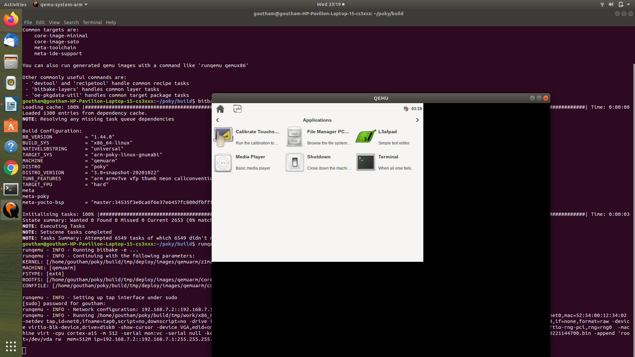

Terminal in QEMU:
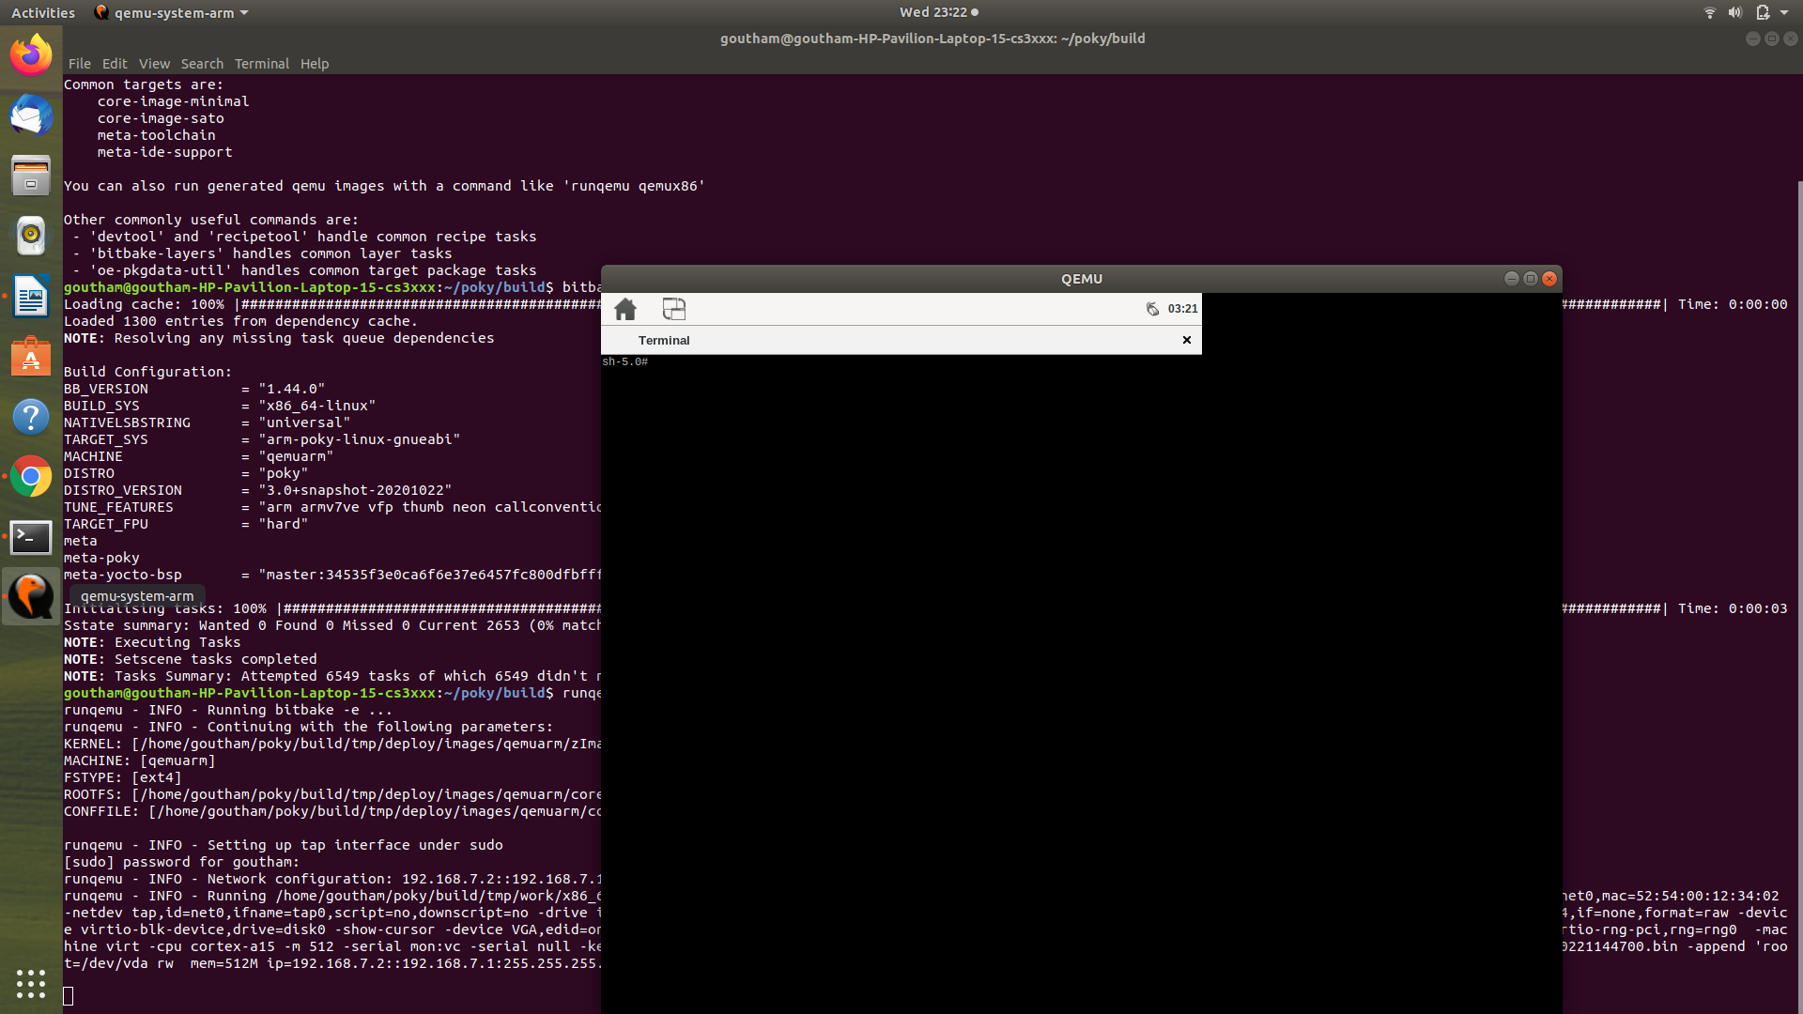
Games In QEMU:
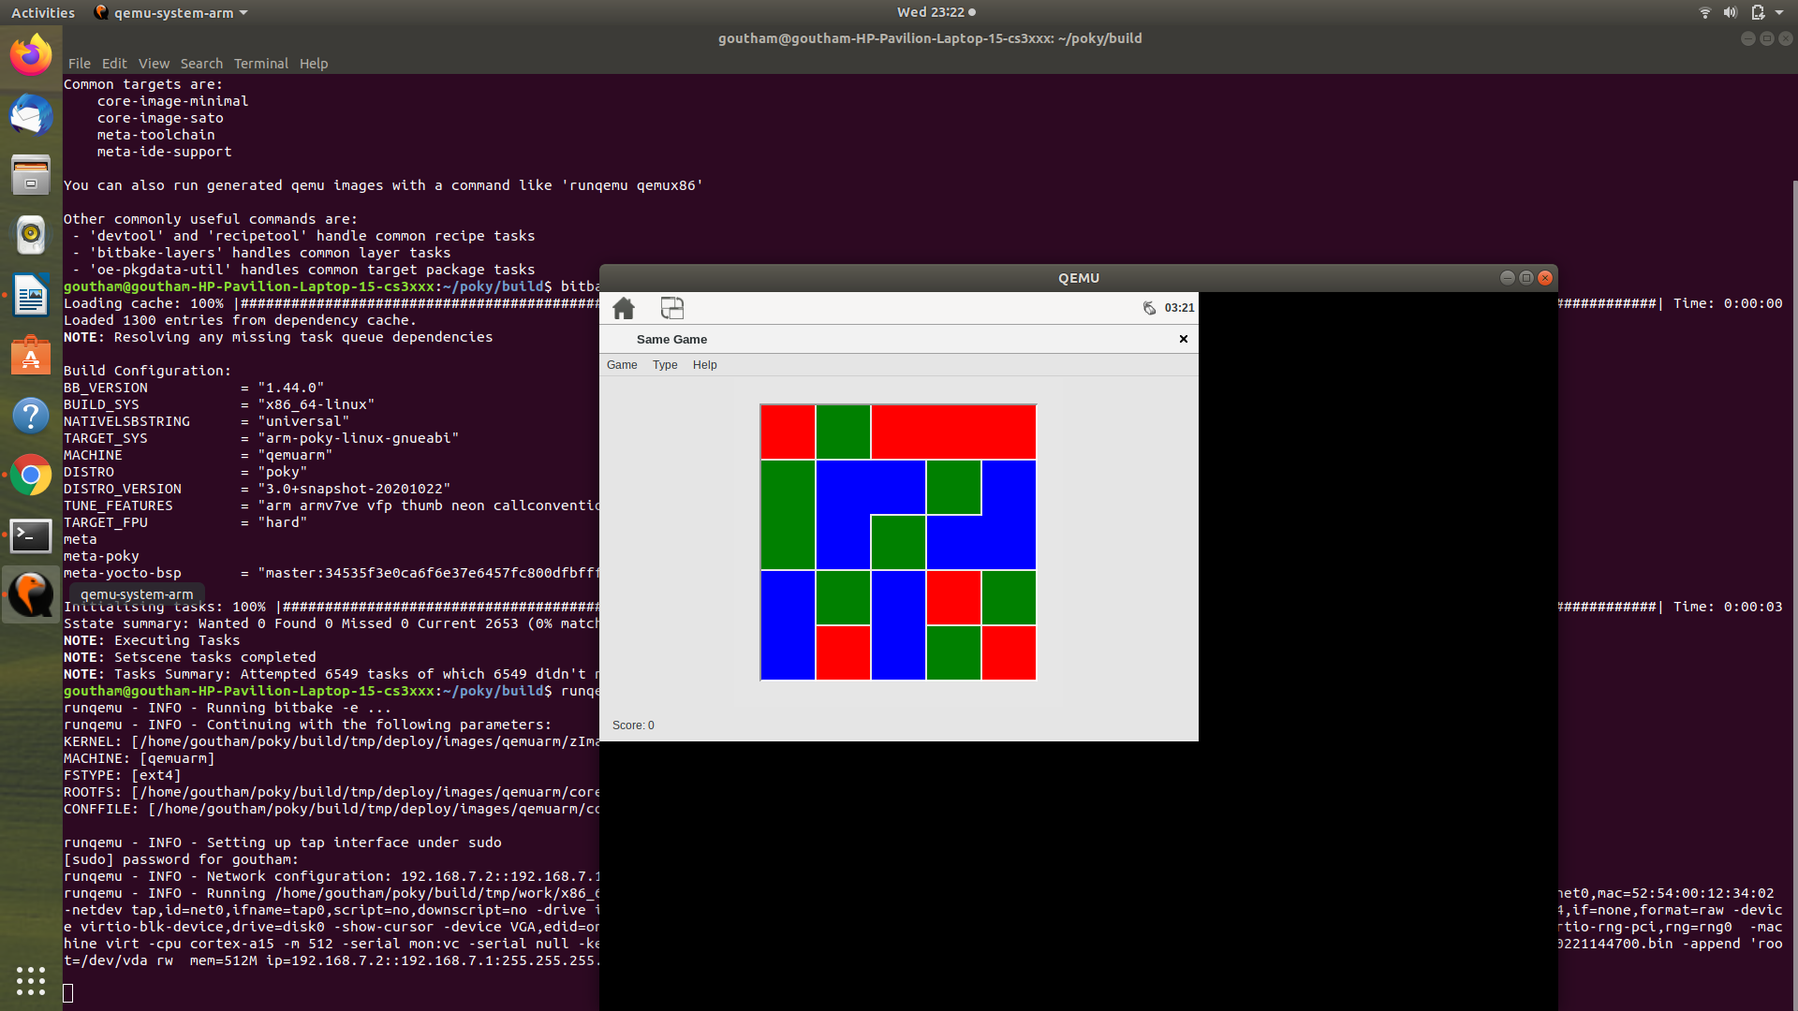

CONCLUSION:

Building the Yocto project has been done. We have build our “core-image-sato” operating systems and after that it ran on an emulated machine using qemuarm. By doing the Yocto project we have build an reference embedded operating system called Poky. In QEMU we have different applications build, it is a qucik EMUlator along with Yocto-project.

