Cloud Application Development

**Disaster Recovery with IBM Cloud Virtual Servers**

**Phase 4**

* Continue building the disaster recovery plan by configuring replication and testing recovery procedures.
* Implement replication of data and virtual machine images from on-premises to IBM Cloud Virtual Servers.
* Conduct recovery tests to ensure that the disaster recovery plan works as intended. Simulate a disaster scenario and practice recovery procedures.

Continue:

Here we can do the testing, recovery and backup step using VPC and VM are done

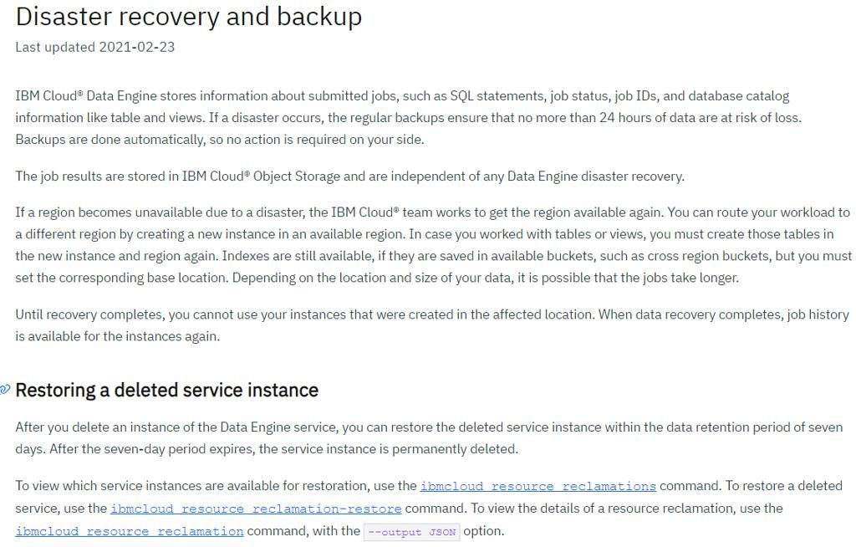

This is the whole process to do the backup and recovery of the data using IBM cloud virtual servers

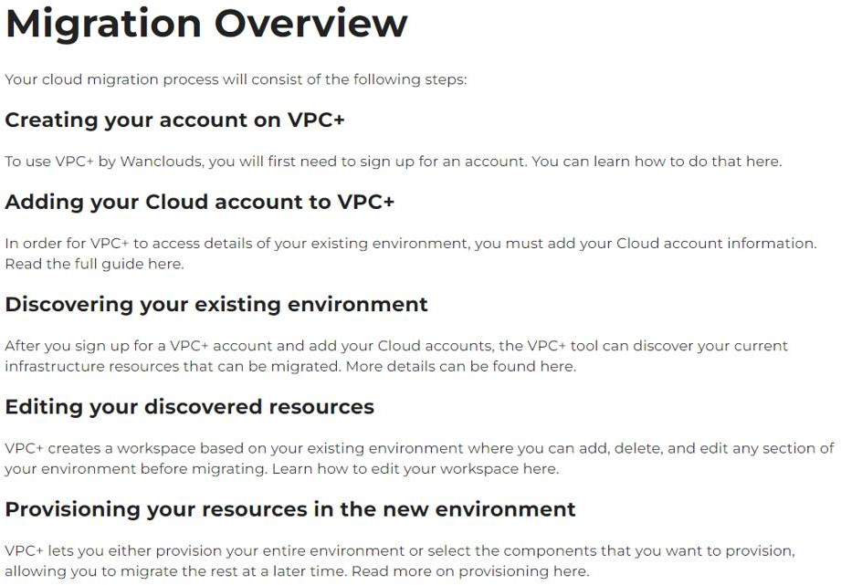

These are the main steps to do the recovery and backup process

The below steps to create an account on VPC

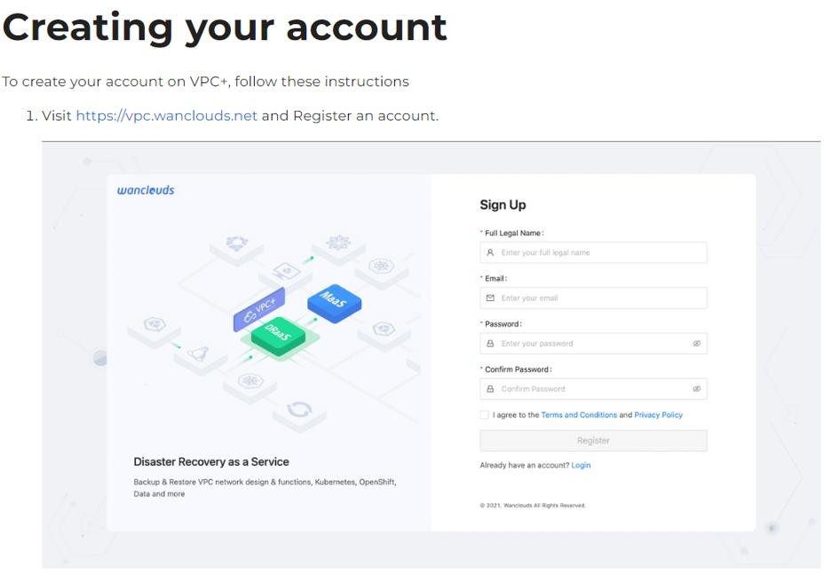

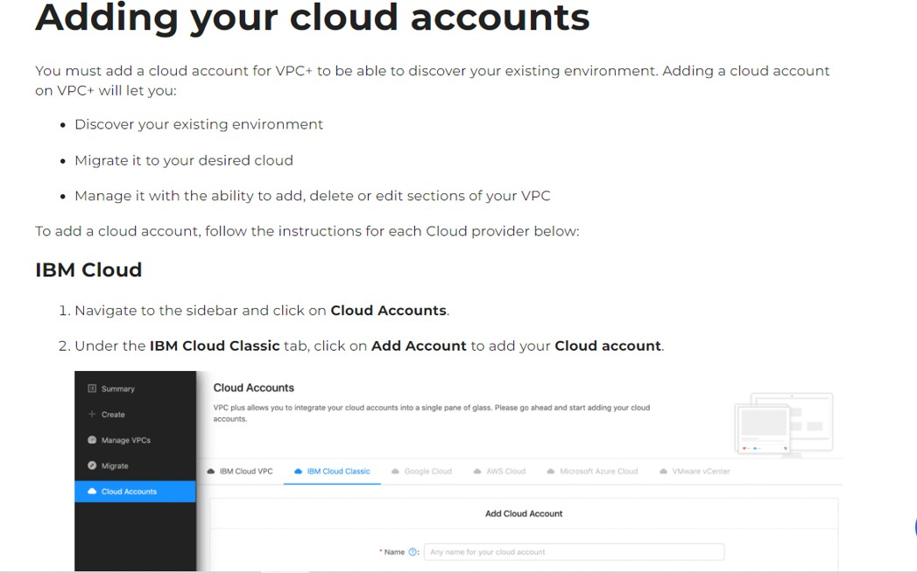

Here click on add cloud account then we get the below page

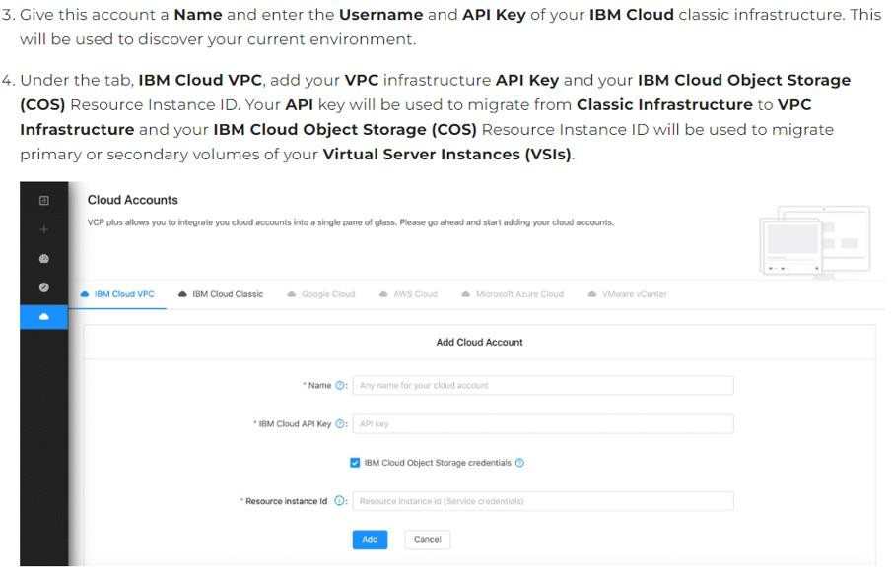

Here we give the API key and name then click on add the account will be added

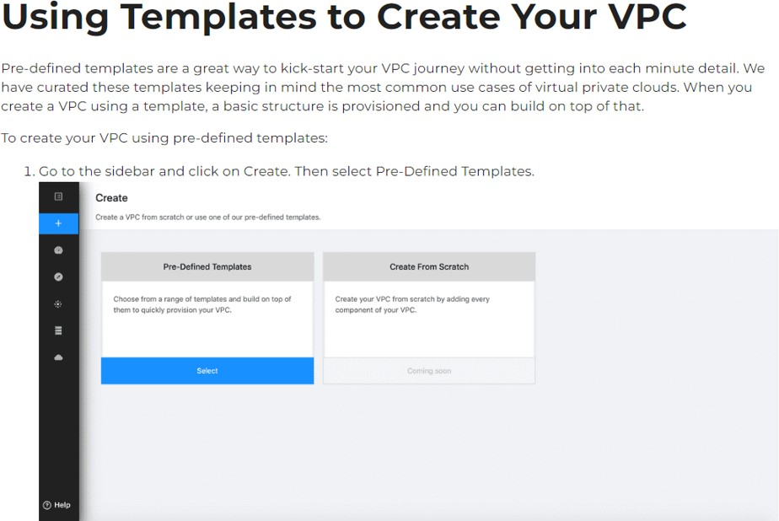

These are the templates used to create VPC

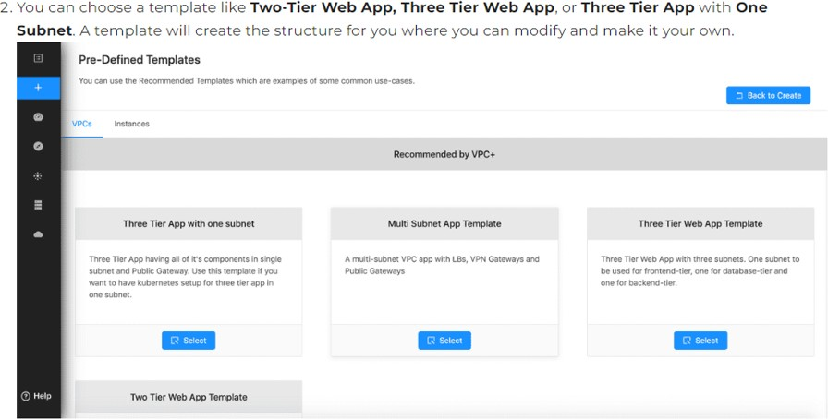

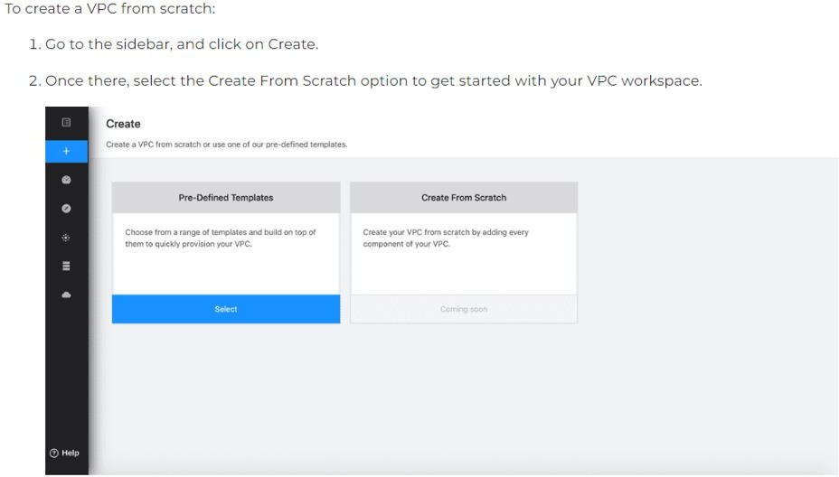

This is for to create a VPC from scratch.

Now see the virtual servers use in recovery and backup process

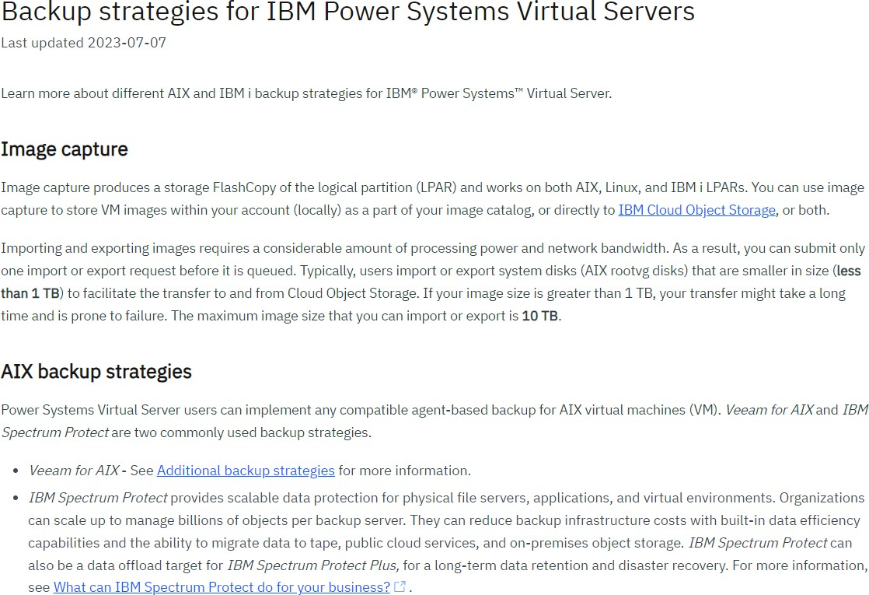

All these are the steps for backup strategies using virtual servers

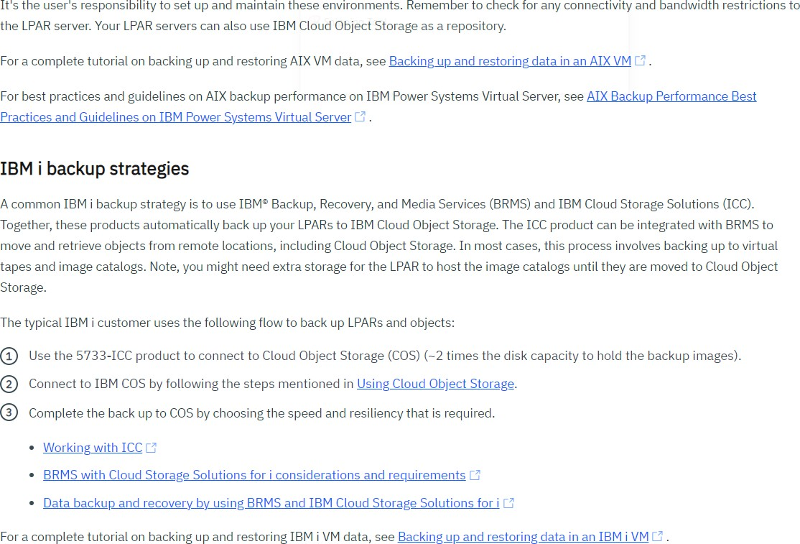

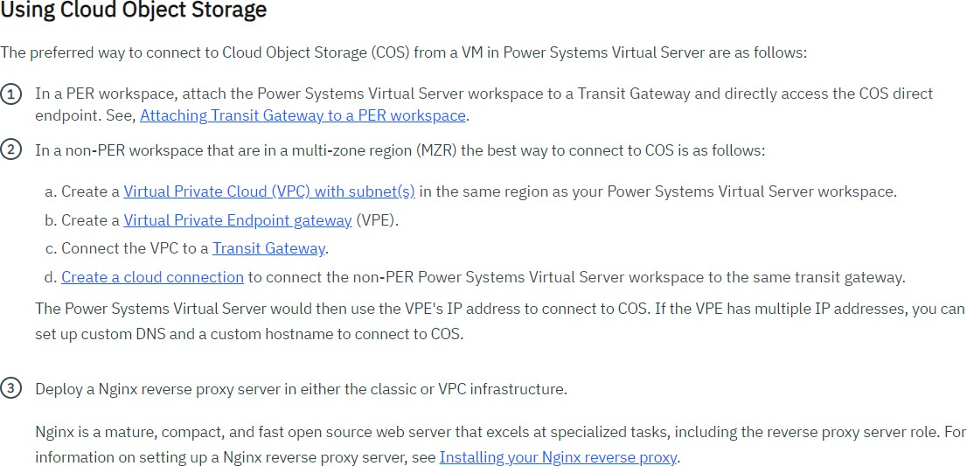

Here we use the cloud object storage

This is cloud AIX

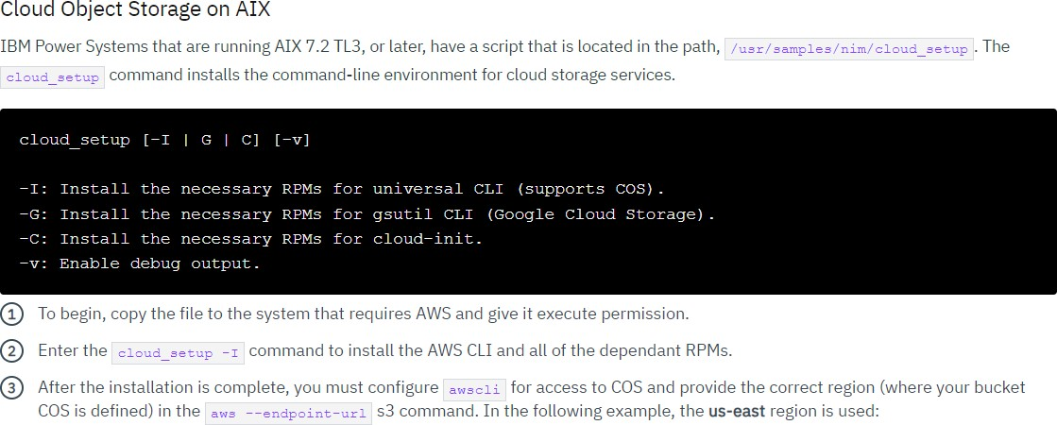

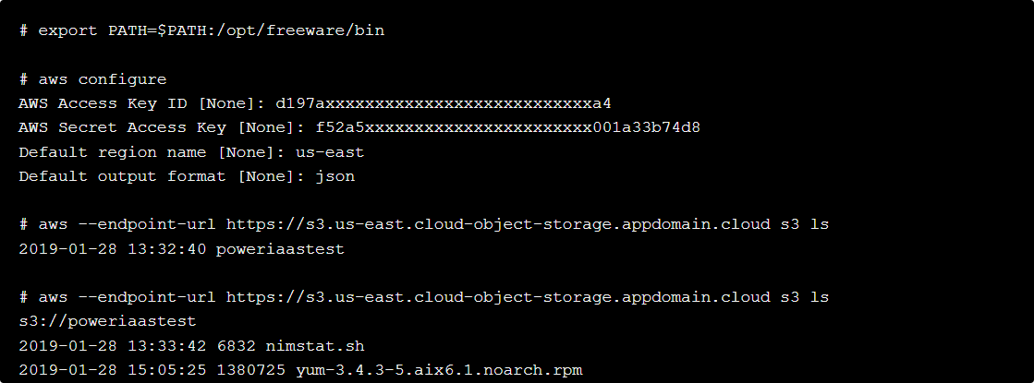

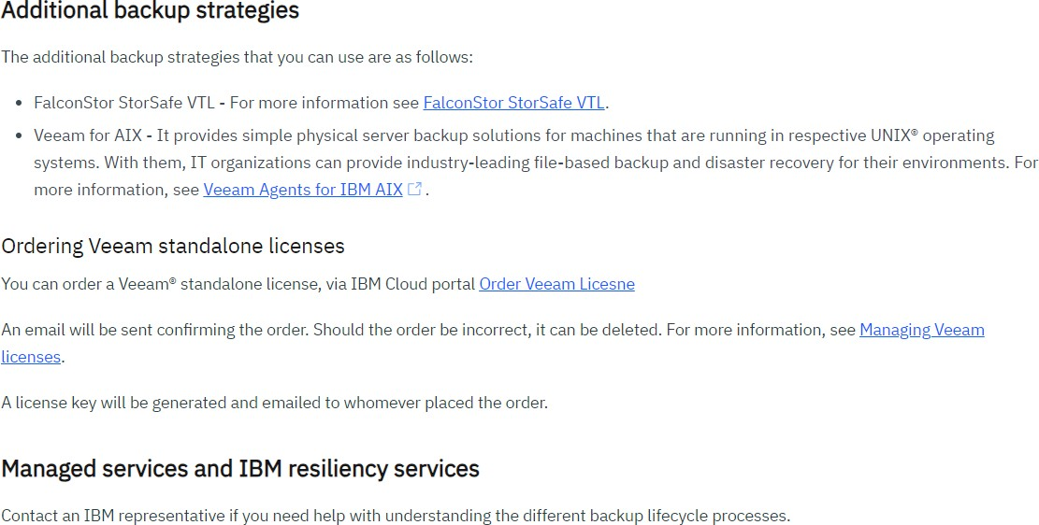

Backup using VPCs

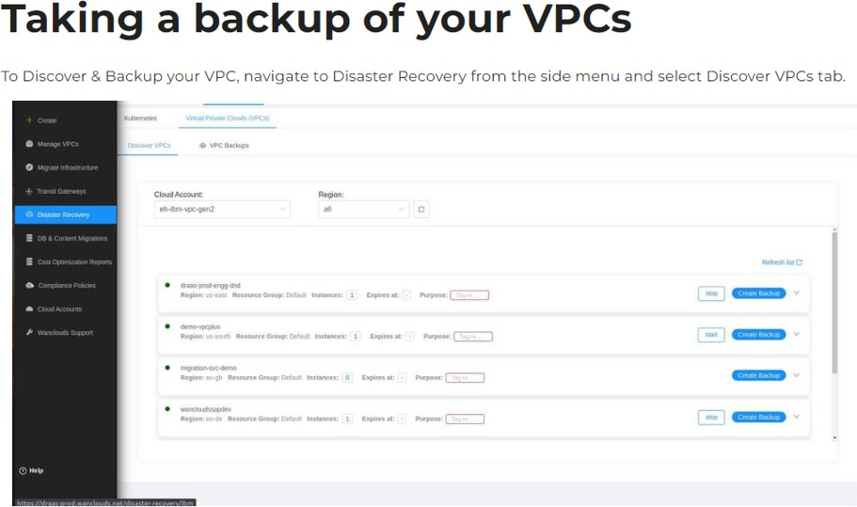

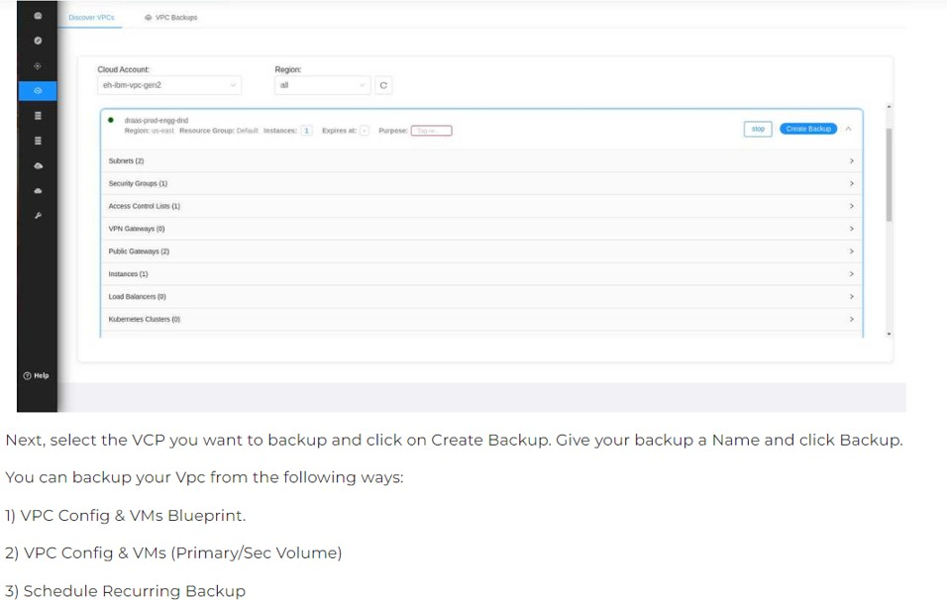

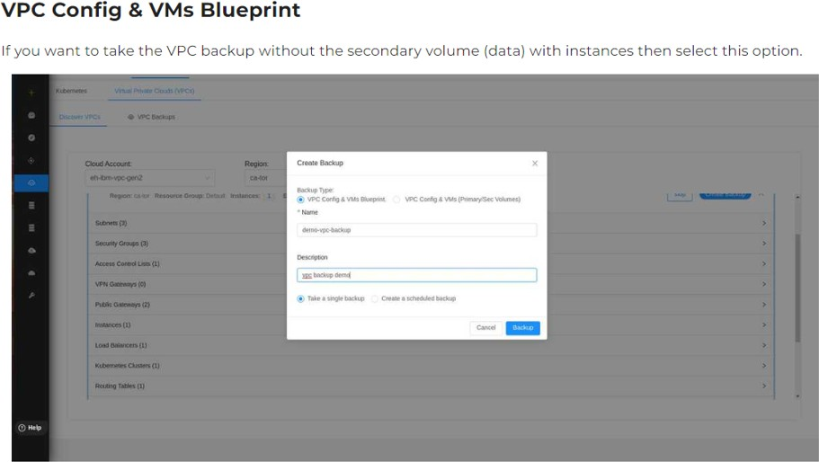

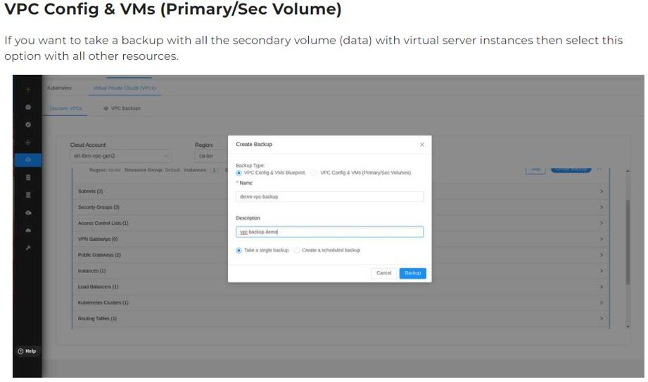

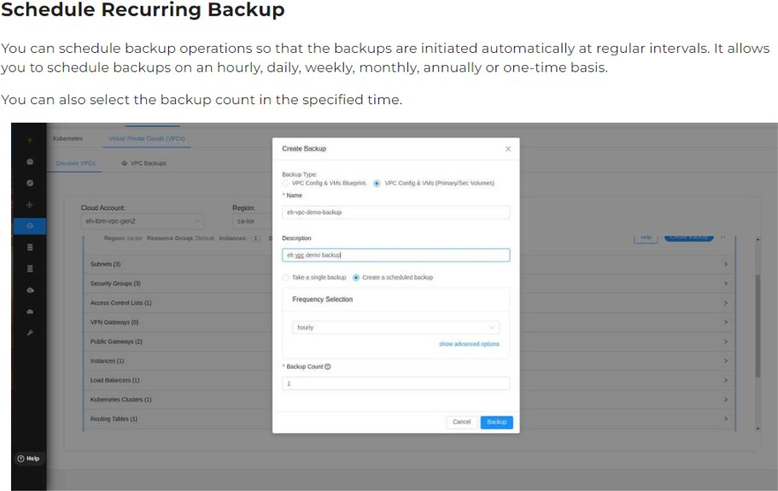

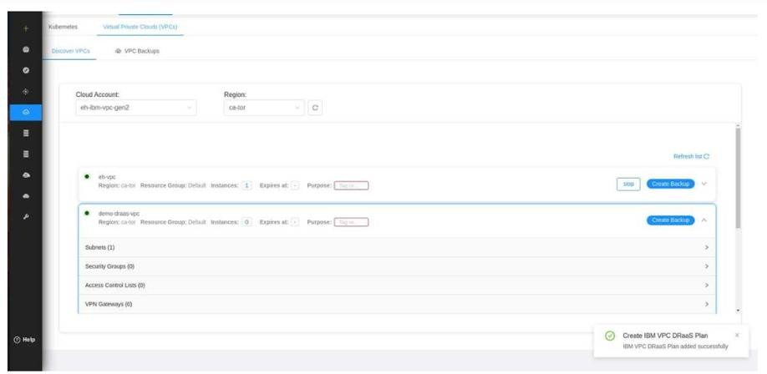

Restoring Process using VPCs

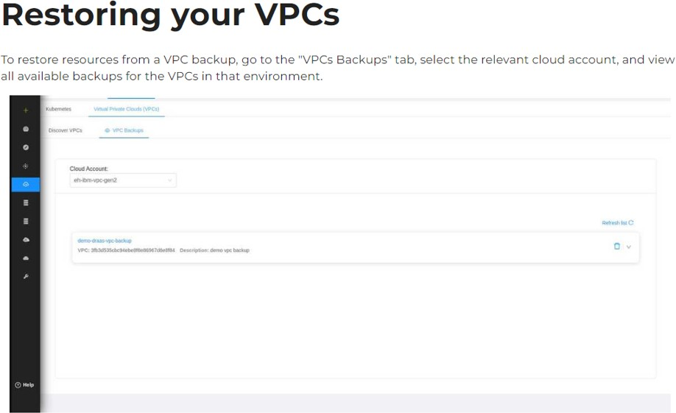

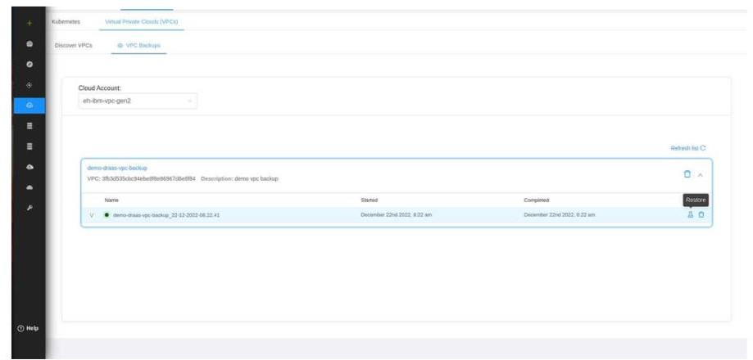

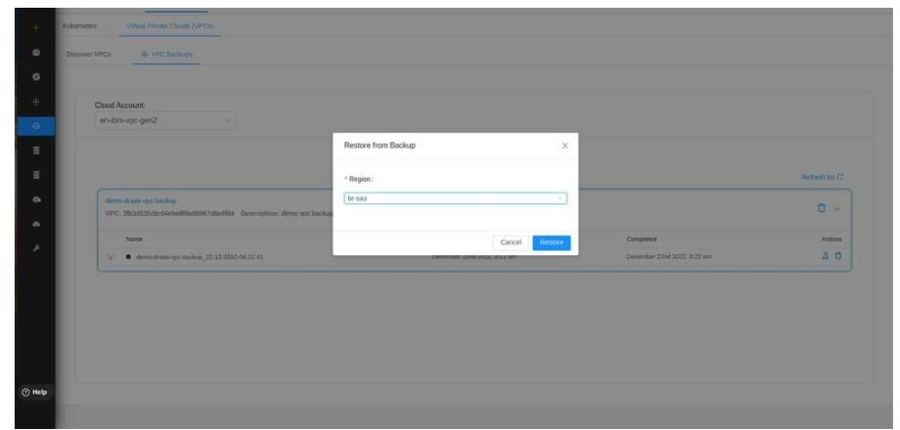

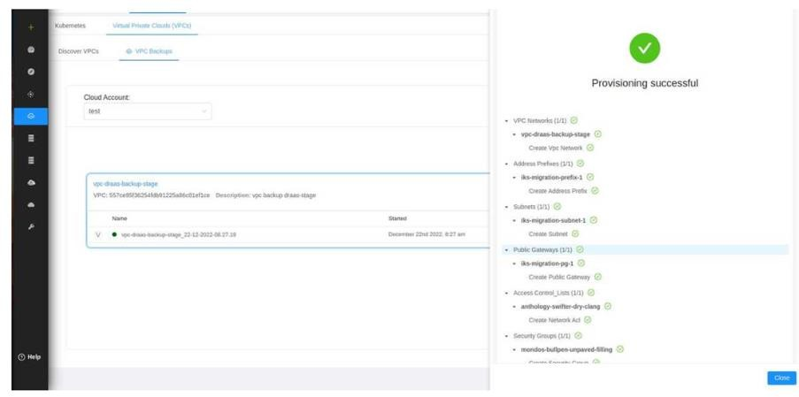

All these steps are about the testing, backup and recovery using the virtual servers and VPC with cloud .