**Color Palette for DeepCorn**

The first thing that it me was the colour. Different colours of the corn varieties are available across the global.

But, according to our use case is the corn colour should be in the yellowish colour. And by identifying the colour code is also important in this section.

The colour code for the corn is a **medium light shade of Yellow**. The hexadecimal colour code is #fbec5d and it contains of the RGB colour whereas red is 251, and green is 236 and last one blue is 93 values.

Now, by executing the different varieties of corn images here are some few examples which is shown below. There is a one android application available in the playstore i.e **Color Palette**.

The UI of the colour palette application is like shown below

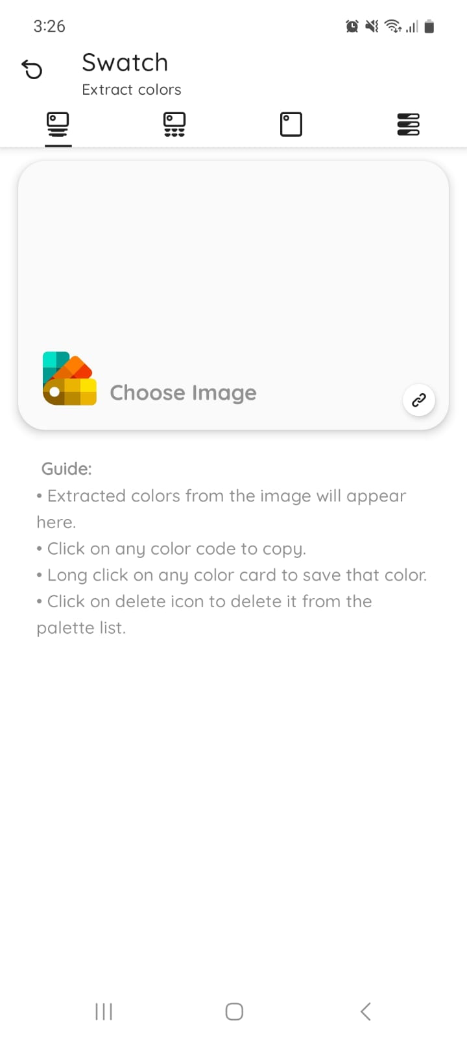

By using that application, we have gone through it and identify the colour palette.

1. A complete best quality of the corn which is taken in the image and get the colour code.

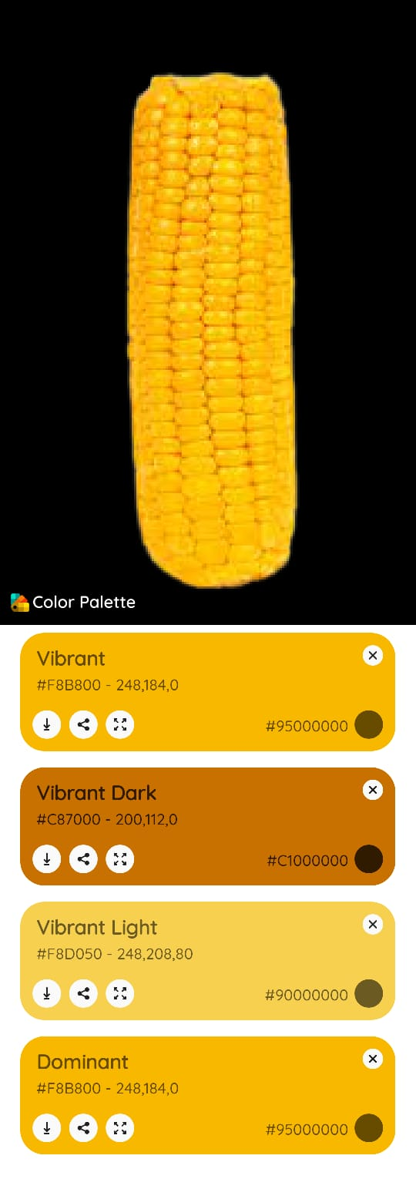

1. A group of corns are good but, slightly 10% of the kernels are in the whitish colour.

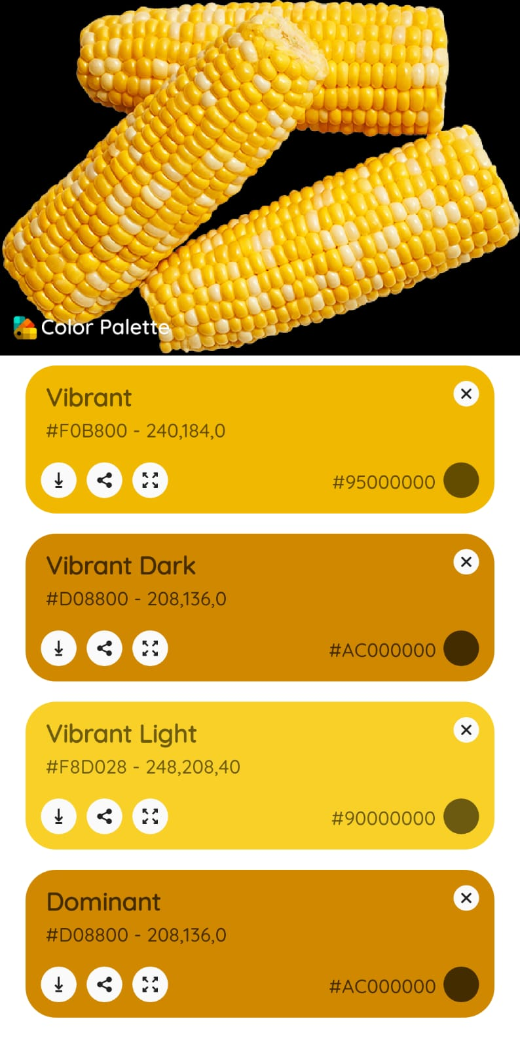

1. A corn is in good condition but some of the kernels are got damaged for outer part.

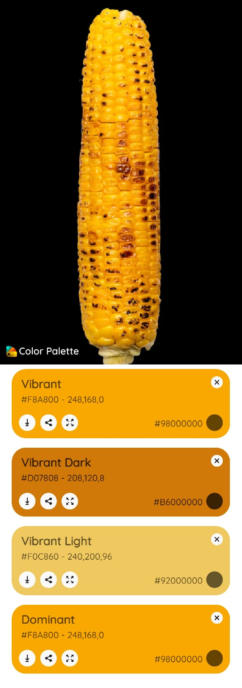

1. A group of different sizes of the corn image and executed a colour palette at a time and the result is shown below.

