Contents

Board to board connectors 2

AVX INTERCONNECT 009159010061916 2

AVR INTERCONNECT 009159006551906 3

AVX Corporation 13 9159006101916 3

**Brick R Knowledge: Click here** 4

**Similar model brick connector from Alibaba: Click here _Alibaba** 4

Quick connect Blade type pcb smd terminal block 4

TE Connectivity, Hermaphroditic Board to Board, Surface Mount, Rated At 6A, 125 V ac/dc 4

Pluggable Terminal Blocks ZEC 1.5/ 6-5.0-LPV 6

Magnetic connectors 6

HYTEPRO-HTP-CON-M417 6

HYTEPRO –Positive 4 pogo pin magnetic charger connector M411P 7

STEM kits providing companies 8

# Board to board connectors

AVX INTERCONNECT 009159010061916

Card Edge Connector, Dual Side, 1.6 mm, 10 Contacts, Surface Mount, Right Angle, Solder

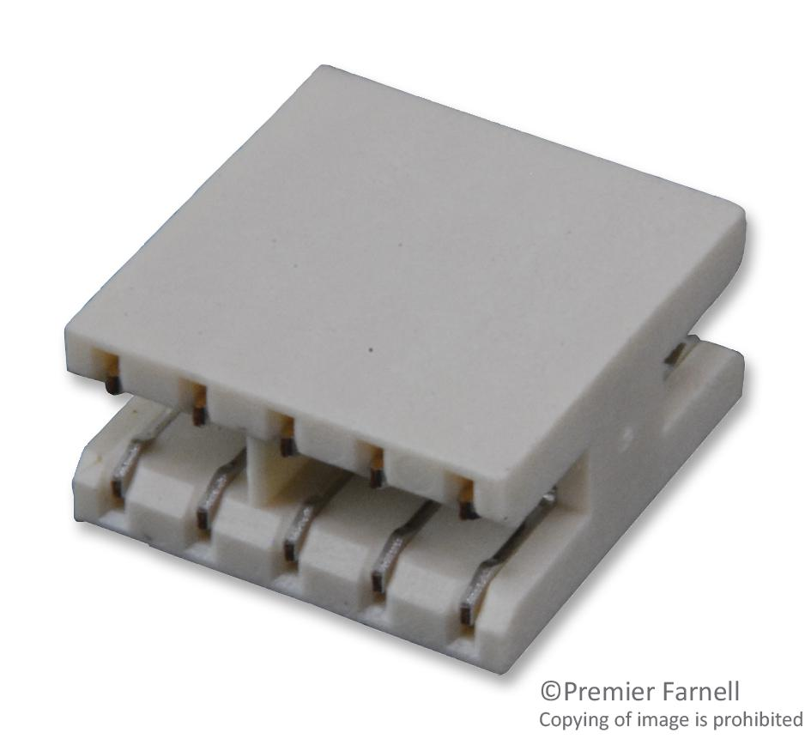

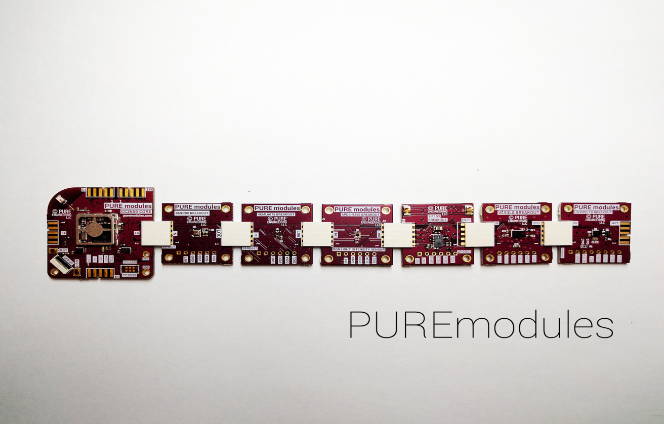

* Features
  + Coplanar
  + Easy to connect using gold fingers
  + Polarized
* Number of positions:4,6,8,10
* Availability & cost
  + element14 :2747 in stock –Rs 72.8[Click here](https://in.element14.com/avx-interconnect/009159010061916/card-edge-conn-dual-side-10pos/dp/2668413)
  + Mouser:2 in stock-Rs62.05 [Click here](https://www.mouser.in/ProductDetail/AVX/009159010061916?qs=%2Fha2pyFadujLRCBjhj%2FMFr3djm7uBops4tNUsywMCgkteCOR9K2UmO9%2FOM2El6nm&utm_source=octopart&utm_medium=aggregator&utm_campaign=581-009159010061916&utm_content=AVX)

### AVR INTERCONNECT 009159006551906

Card Edge Connector, Single Side, 1.6 mm, 6 Contacts, Surface Mount, Straight, Solder

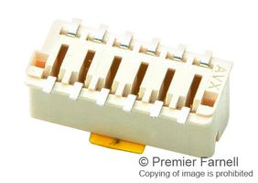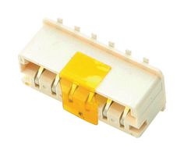

* Features
  + Right angle connection
  + Board is connected using gold fingers.
  + SMT type
* Number of positions:2,3,4,5,6
* Availability & cost
  + element14 :223 in stock –Rs 94.21[Click here](https://in.element14.com/avx-interconnect/009159006551906/card-edge-conn-single-side-6pos/dp/2668411)
  + Mouser:2683 in stock-Rs61.32[Click here](https://www.mouser.in/ProductDetail/AVX/009159006501906?qs=4xWrLIlwatDG%2FIqPw5dxXw%3D%3D)

### AVX Corporation 13 9159006101916

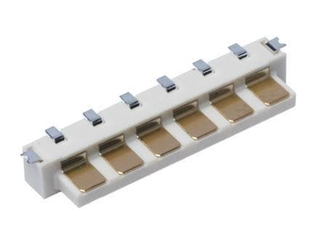

* Feature
  + End to end connection, Coplanar
  + SMT type
  + Requires female socket for connection
* Number of positions:2,3,4,5,6
* Availability & cost
  + Mouser:3845 in stock-Rs124.83[Click here](https://www.mouser.in/ProductDetail/AVX/139159006101916?qs=Dc2RuoSqrEW%252BfVsIzni8kQ%3D%3D)

AVX Corporation 209159006101916

Horizontal Socket: BTB 20-9159

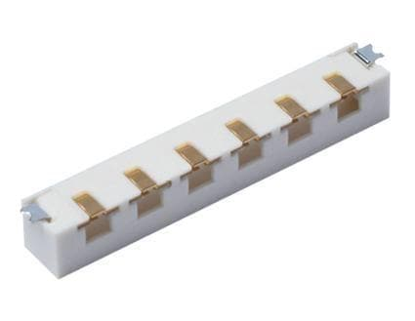

* Features
  + SMT type
  + Requires male connector
* Number of positions:2,3,4,5,6
* Availability & cost
  + Mouser:2444 in stock-Rs115.34[Click here](https://www.mouser.in/ProductDetail/AVX/209159006101916?qs=%2Fha2pyFadujXKcGNb8hX5DE51ChAMthOgvYgAxYfJlF%252BSD5SzB4vIK3unLq5WEtO)

**Brick R Knowledge:** [**Click here**](https://www.brickrknowledge.de/fr/bricks/active-basic/)

Youtube video:<https://youtu.be/XAMB9qxogMY>

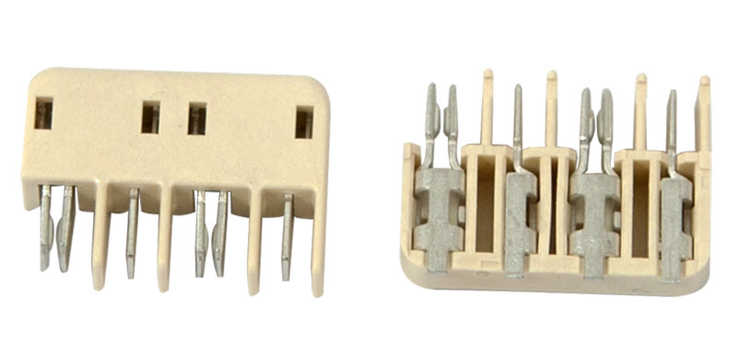

**Hermaphroditic Blade And Receptacle connector**

**Board-to-Board**

**Similar model brick connector from Alibaba:** [**Click here _Alibaba**](https://www.alibaba.com/product-detail/Quick-connect-Blade-type-pcb-smd_1850369566.html)

Quick connect Blade type pcb smd terminal block

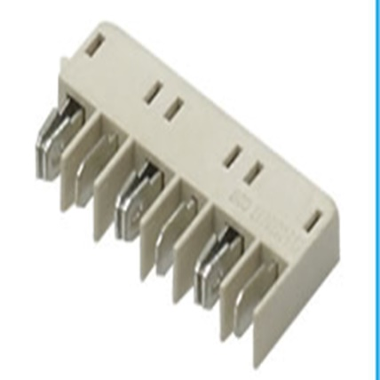

TE Connectivity, Hermaphroditic Board to Board, Surface Mount, Rated At 6A, 125 V ac/dc

[Click here_TE](https://www.te.com/usa-en/products/connectors/lighting-connectors/intersection/hermaphroditic-connectors.html?source=header-match&tab=pgp-story)

[Click here_RS delivers](https://in.rsdelivers.com/product/te-connectivity/1-1954289-2/te-connectivity-hermaphroditic-board-to-board/6860855?gclid=EAIaIQobChMItsi8iMuf7QIV0nwrCh0bXwGEEAQYASABEgIp6vD_BwE&gclsrc=aw.ds)

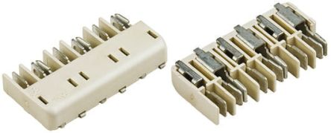

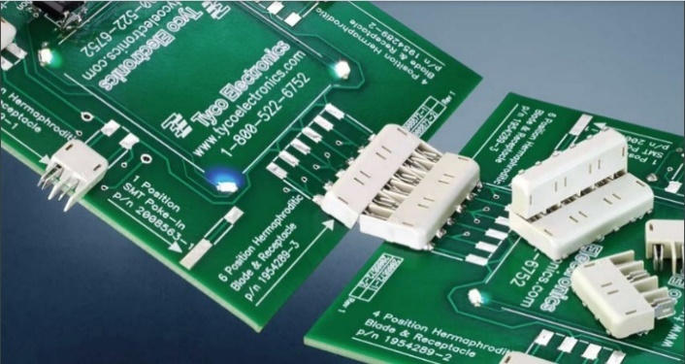

* Features
  + Use the same connector for power, data or signal connections with 2, 4 or 6 positions
  + Single connector that mates to itself
  + Vertical or horizontal connections can be made(connector can be articulated from 90° to 180°)
  + Simplify design by allowing the same footprint on both ends of the board
  + Speed assembly time with surface mount and reflow compatible low profile design in tape and reel packaging.
* Number of positions:2,4,6
* Availability & cost for 6 pin connector:
  + Model no:1954289-3,1325 in stock Cost:Rs145.18 per piece,RS delivers: [Click here](https://in.rsdelivers.com/product/te-connectivity/1-1954289-2/te-connectivity-hermaphroditic-board-to-board/6860855?gclid=EAIaIQobChMItsi8iMuf7QIV0nwrCh0bXwGEEAQYASABEgIp6vD_BwE&gclsrc=aw.ds)
  + Model no:1954289-3,8600 in stock,Cost:Rs148.92 per piece,Mouser:[Click here](https://www.mouser.in/ProductDetail/TE-Connectivity/1954289-3?qs=%2Fha2pyFaduiYDP43xn3I9E5Ka2lfFRtI10gnyom%2FOYk=)
  + Model no:2213614-3, 11905 in stock ,Cost:Rs254.04 per piece,Mouser :[Click here](https://www.mouser.in/ProductDetail/TE-Connectivity-PB/2213617-3?qs=%2Fha2pyFaduiduGWC%252BCGrj6efUffcHAvvbgbAUuwCsEdVTdPYjdgJgw%3D%3D&utm_source=octopart&utm_medium=aggregator&utm_campaign=571-2213617-3&utm_content=TE%20Connectivity&tetid=8wnlCKxIgi)

Pluggable Terminal Blocks ZEC 1.5/ 6-5.0-LPV

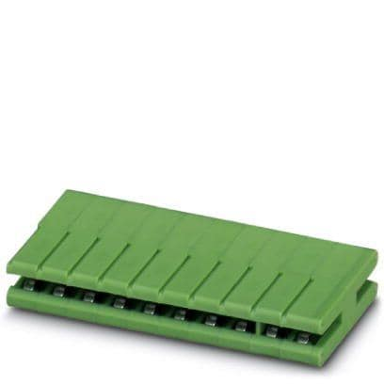

* Features
  + Coplanar edge connector
  + Easy to connect using gold fingers.
  + Polarized
* Number of positions:6
* Availability & cost
  + Mouser:26 in stock-Rs1005.94 [Click here](https://www.mouser.in/ProductDetail/Phoenix-Contact/1898305?qs=71zq8cT40IQ55Ox2N2UCWg==)

# Magnetic connectors

## HYTEPRO-HTP-CON-M417

Right angle 4 pogo pin PCB mount magnetic connector anti-reverse design

[Click here from alibaba](https://www.alibaba.com/product-detail/Right-angle-4-pogo-pin-pcb_62321909258.html?spm=a2700.7724857.0.0.166d79bb2cPHbX)

Cost:

* 500-999 Pairs **US$2.85=Rs210**
* >=1000 Pairs **US$2.70=Rs199.75**

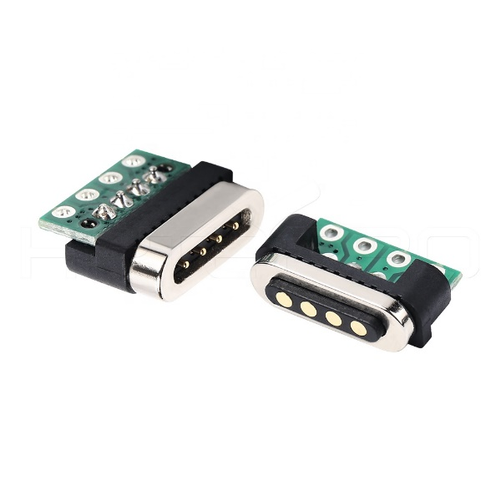 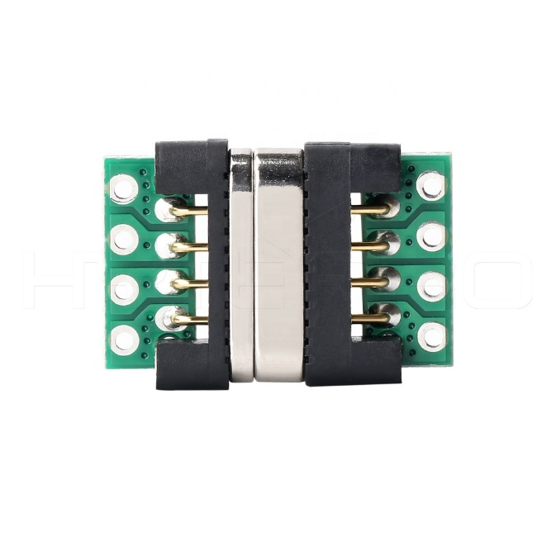

## HYTEPRO –Positive 4 pogo pin magnetic charger connector M411P

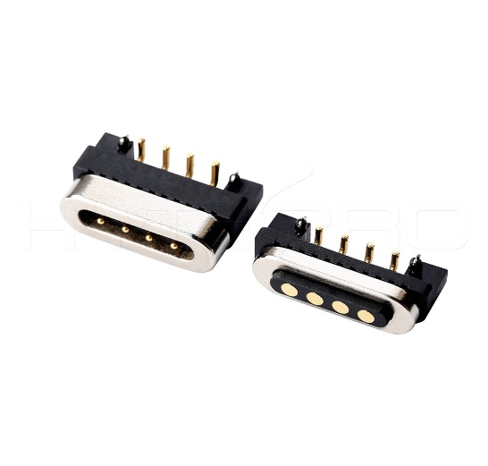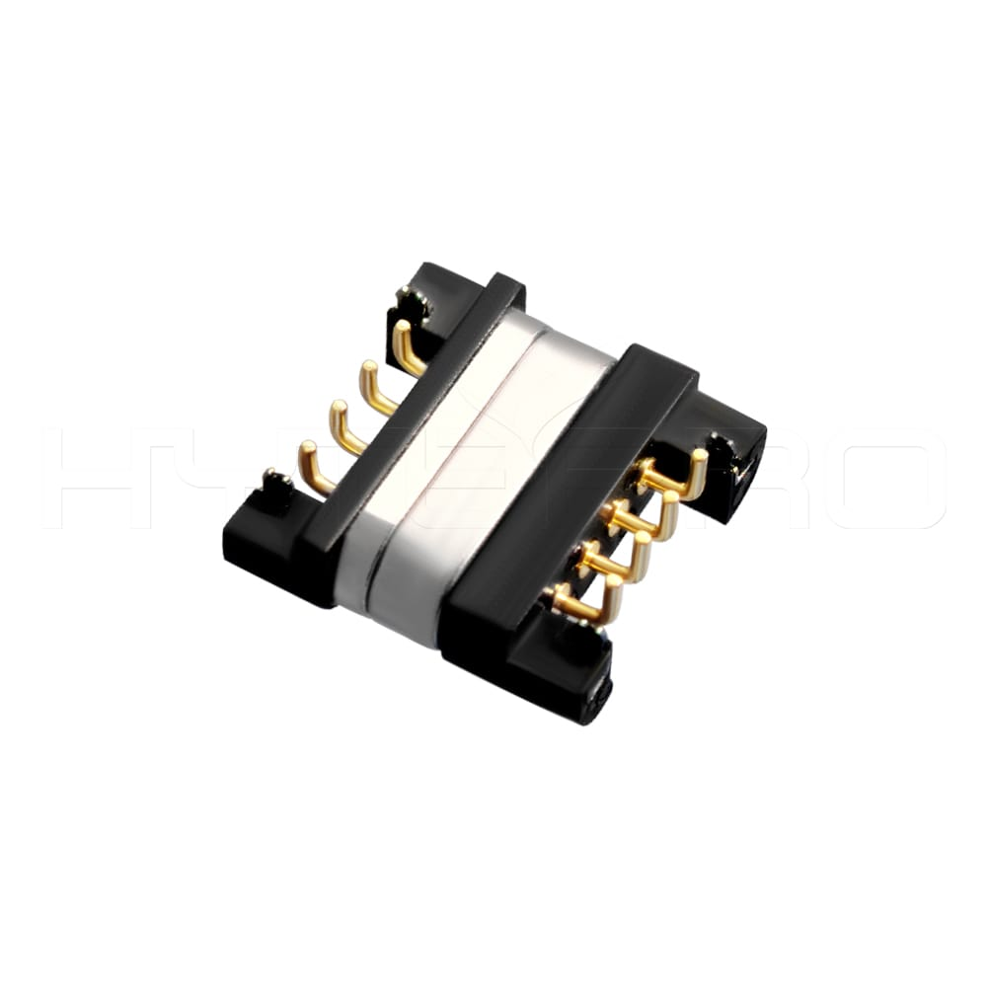

* Features
  + Used for data transmission and charging
  + Can be connected with PCB board.
* Availability and cost
  + Instock from Alibaba[Click here](https://www.alibaba.com/product-detail/Positive-5v-power-connector-right-angle_1600135824305.html?spm=a2700.icbuShop.152.6.1feb66a19z5adR)
  + 500-999 pairs -Rs186.51
  + >=1000pairs-Rs176.9

# 1-12-2020:Finalised connector is magnetic type.- Positive 4 pogo pin magnetic charger connector M411P

# STEM kits providing companies

1. Little bits
2. Creation create
3. Snapcircuits
4. Brick R Knowledge
5. Mind storms

# Communication Protocols

UART-How it works