Counterfactual Fraud Networks with Graph-Aware Temporal Memory
Working manuscript draft v0.2 — experimental core

Abstract
We study fraud detection as an evolving relational process rather than a sequence of independent transactions. We introduce a graph-aware temporal memory architecture that combines entity history, graph structure, and strictly prior neighbor behavior, then use historical graph interventions to explain predictions counterfactually. On the Elliptic++ wallet graph under a chronological train/validation/test split, plain graph-memory improves PR-AUC from 0.1470 for the matched temporal GRU baseline to 0.2911. A hub-suppressed variant attains F1 0.2989 while reducing the share of total absolute counterfactual effect attributed to the single most influential neighbor from 23.9% to 10.3%. In 578 matched historical relationship interventions, removing one relationship changes illicit-wallet fraud probability by 0.0917 on average in absolute terms (bootstrap 95% CI 0.0750–0.1096). The framework distinguishes risk-increasing from protective relationships and identifies cases where removing one historical relationship changes the model decision. These quantities are model counterfactual sensitivities, not claims of real-world causality.

1. Problem and Research Question
Conventional fraud classifiers often score an entity from its current features, while temporal models add the entity's own history. Our central question is stronger: can a fraud model remember how an entity evolves, incorporate the prior behavioral states of connected entities, and explain a decision by asking whether the entity would still look fraudulent if a relationship had not contributed to its historical network context?
Core counterfactual quantity:
CFᵘ→ᵛ,ₜ = P(yᵥ,ₜ = 1 | G₁:ₜ) − P(yᵥ,ₜ = 1 | G₁:ₜ \ u)

2. Contributions
- Temporal fraud memory: entity predictions are conditioned on evolving behavioral history rather than isolated observations.
- Graph-aware temporal memory: each entity receives leakage-safe relational context derived only from neighbors' states at strictly earlier time steps.
- Historical counterfactual explanations: a relationship is removed from every prior relational aggregation for a target entity, its sequence is replayed through the fixed trained model, and the change in final fraud probability is measured.
- Hub-robust counterfactual analysis: degree-suppressed message aggregation tests whether explanations survive explicit control for highly connected wallets.
- Bidirectional explanation semantics: relationships may be risk-increasing or protective, allowing the model to surface both suspicious and exculpatory relational context.

3. Experimental Design

3.1 Chronological protocol
All reported core experiments use the same chronological split: time steps 1–34 for training, 35–41 for validation, and 42–49 for testing. Validation selects the classification threshold. Graph-memory construction is leakage-safe: observations at time t may use only neighbors' most recent observations from times strictly earlier than t.

3.2 Graph-memory architecture
The full graph-memory model concatenates transformed wallet behavior, structural graph features, and directional incoming/outgoing summaries of neighbors' most recent historical behavior. The concatenated representation is projected through a feed-forward layer and processed by a GRU, producing a fraud probability at each observed time step.

3.3 Hub-suppressed aggregation
To reduce dominance by highly connected wallets, the strict hub-suppressed model scales each neighbor message by 1/sqrt(1 + degree(u)) before averaging by the raw number of available neighbors. This differs from renormalized attention-like weighting, which can still assign full influence to a single high-degree neighbor when it is the only available neighbor.

3.4 Historical counterfactual intervention
For a target wallet v and neighbor u, u is removed from every incoming/outgoing prior-neighbor aggregation in v's observed history through prediction time t. The target sequence is then replayed through the unchanged trained model. The difference between the original and intervened fraud probabilities is the relationship-level historical counterfactual effect.

4. Results

4.1 Predictive progression
Model | PR-AUC | ROC-AUC | Precision | Recall | F1
TEMF-GRU | 0.1470 | 0.7221 | 0.3390 | 0.1620 | 0.2193
Graph-Structural TEMF | 0.1943 | 0.7501 | 0.2721 | 0.2355 | 0.2525
Neighbor-Memory TEMF | 0.2103 | 0.8202 | — | — | 0.2666
Full Graph-Memory TEMF | 0.2911 | 0.8299 | — | — | 0.2592
Strict Hub-Suppressed Graph Memory | 0.2825 | 0.8184 | 0.4732 | 0.2185 | 0.2989
The full plain-mean graph-memory model nearly doubles PR-AUC relative to the matched temporal GRU baseline (0.1470 to 0.2911). The strict hub-suppressed model trades a small amount of PR-AUC for the strongest F1 (0.2989), while retaining substantial ranking performance.

4.2 Counterfactual robustness to hubs
Aggregation | Top-1 share | Top-5 share | Top-10 share
Plain mean | 23.9% | 46.0% | 57.0%
Strict hub-suppressed | 10.3% | 35.0% | 45.2%
Hub suppression reduces concentration of explanation mass without eliminating relationship-level effects. This addresses the concern that counterfactual explanations merely rediscover a small number of highly connected wallets.

4.3 Historical relationship interventions
The matched hub-robust analysis contains 328 test targets (164 illicit and 164 licit) and 578 single-relationship historical interventions. For illicit targets, mean absolute probability change is 0.0917 (bootstrap 95% CI 0.0750–0.1096); for licit targets it is 0.0502 (95% CI 0.0361–0.0660). At the target level, 7.9% of illicit wallets have at least one relationship whose historical removal flips the final classification under the hub-suppressed model.
Large individual effects remain after hub suppression. In one illicit example, removing one historical relationship changes predicted illicit probability from 0.5804 to 0.0596, a counterfactual effect of +0.5208. These examples demonstrate model sensitivity to specific historical relationships, but should not be interpreted as evidence that the relationship caused illicit behavior.

5. Interpretation
The experiments support three distinct conclusions. First, graph context adds predictive information beyond entity-only temporal memory. Second, historical neighbor behavior contributes information beyond static graph structure. Third, relationship-level counterfactual effects remain substantial after explicit suppression of hub influence. The resulting explanations are directional: positive effects indicate relationships that support the model's fraud assessment, while negative effects indicate relationships that reduce it.

6. Limitations and Threats to Validity
- The strongest graph-memory and hub-robust results currently use a single training seed; multi-seed robustness is still required for the final paper.
- Counterfactual interventions measure sensitivity of the trained model, not real-world causal effects.
- The first graph-memory implementation aggregates only labeled-to-labeled AddrAddr relationships and a compact subset of transformed behavioral dimensions.
- Historical interventions remove a neighbor's contribution to the target's relational memory but do not simulate how the entire blockchain ecosystem would evolve if that relationship had never existed.
- Threshold-based F1 depends on validation threshold selection; ranking metrics and operating-point metrics should both be reported.
- The current manuscript draft intentionally does not claim literature novelty until a formal related-work search is completed.

7. Essential Experiments Before Submission
- Run Full Graph-Memory and Strict Hub-Suppressed Graph Memory across at least five random seeds using the locked chronological protocol.
- Compute paired uncertainty/significance for PR-AUC, ROC-AUC, and F1 across seeds; retain bootstrap confidence intervals for relationship effects.
- Run a no-neighbor-memory ablation and a no-graph-structure ablation under the same final training budget.
- Repeat the counterfactual analysis on the final selected model and report effect distributions, decision-flip rates, and concentration diagnostics.
- Perform a formal literature search to position Temporal Fraud Memory and Historical Counterfactual Fraud Networks against temporal GNN, fraud explanation, and graph counterfactual work.

8. Working Claim
Graph-aware temporal memory improves fraud detection by combining an entity's evolving behavior with strictly prior relational context, while historical relationship interventions provide model-level counterfactual explanations that identify which connections increase or decrease the model's fraud assessment. These explanations persist under degree-based hub suppression, indicating that the observed effects are not solely artifacts of highly connected nodes.

9. Related Work and References
To be completed after a formal literature review. No claim that the method is the first of its kind should be made until this search is complete.

10. Literature Positioning and Novelty Boundary
A targeted primary-source review indicates that the paper should make a narrow novelty claim. Memory-based temporal graph learning is established by Temporal Graph Networks (Rossi et al., 2020), and temporal/spatio-temporal graph models have already been applied to financial anomaly and fraud detection. Graph counterfactual explanation is also established: CF-GNNExplainer (Lucic et al., 2021/2022) uses edge deletions to identify minimal graph perturbations that change a GNN prediction, while GreeDy and CoDy (Qu et al., 2024) extend counterfactual explanation to temporal graph neural networks.
The closest application-specific work identified in this review is SAGE-FIN (2025), which applies a semi-supervised GNN to Financial Interaction Networks and validates Granger-causal explanations on Elliptic++. Consequently, this manuscript should not claim to be the first explainable or causal-style graph method on Elliptic++. The distinction should instead be framed around historical model interventions: removing a relationship from every prior relational aggregation for a target entity, replaying the target's temporal memory through a fixed fraud model, and measuring the change in final fraud probability.
The current evidence supports a candidate contribution around three coupled properties: (1) relationship-level historical replay rather than a one-time graph perturbation, (2) signed interpretation of relational context as risk-increasing or protective, and (3) explicit testing of counterfactual explanation concentration under hub suppression. This is a candidate novelty boundary, not yet a proof of absolute novelty; a broader systematic review and reviewer search may identify additional adjacent work.

10.1 Related work categories
Temporal graph memory: Rossi et al. (2020), Temporal Graph Networks for Deep Learning on Dynamic Graphs, arXiv:2006.10637. Introduces a general dynamic-graph framework combining memory modules and graph operators.
Temporal financial anomaly/fraud detection: Kim et al. (2024), Temporal Graph Networks for Graph Anomaly Detection in Financial Networks, arXiv:2404.00060; Tian et al. (2023), Spatial-Temporal-Aware Graph Transformer for transaction fraud detection, arXiv:2307.05121; Losavio et al. (2026), Fraud Detection in Cryptocurrency Markets with Spatio-Temporal Graph Neural Networks, arXiv:2604.24590.
Static graph counterfactual explanation: Lucic et al. (2021), CF-GNNExplainer: Counterfactual Explanations for Graph Neural Networks, arXiv:2102.03322; Bajaj et al. (2021), Robust Counterfactual Explanations on Graph Neural Networks, arXiv:2107.04086.
Dynamic graph counterfactual explanation: Qu, Gomm, and Farber (2024), GreeDy and CoDy: Counterfactual Explainers for Dynamic Graphs, arXiv:2403.16846. This is the most important methodological comparator for the historical-intervention portion of the paper.
Elliptic++ and financial explanation: Elmougy and Liu (2023), Demystifying Fraudulent Transactions and Illicit Nodes in the Bitcoin Network for Financial Forensics, arXiv:2306.06108, introduces Elliptic++. SAGE-FIN (2025), arXiv:2507.01980, uses Elliptic++ and Granger-causal explanations.

10.2 Revised novelty claim for submission
Recommended claim: We present a fraud-specific historical counterfactual analysis in which individual relationships are removed from an entity's entire available relational history, the entity's temporal fraud memory is replayed through a fixed graph-aware model, and the resulting signed change in fraud risk is measured. We further test whether these relationship-level sensitivities persist after explicit suppression of high-degree hub influence.
Claims to avoid: "first temporal fraud memory model," "first counterfactual GNN explainer," "first dynamic-graph counterfactual method," or "first explainable graph model on Elliptic++." The current literature directly contradicts or materially weakens those formulations.

11. Final Statistical Validation Plan
The final predictive comparison will use five matched random seeds (13, 21, 42, 77, 101), three epochs per seed, and the locked chronological split. Plain Graph-Memory and Strict Hub-Suppressed Graph-Memory will use identical architectures, optimization, training observations, and validation-based threshold selection. The paper will report mean ± sample standard deviation for PR-AUC, ROC-AUC, precision, recall, F1, recurrent-wallet PR-AUC, and recurrent-wallet ROC-AUC.
Historical counterfactual effects will retain bootstrap confidence intervals. For the current hub-suppressed intervention set, mean absolute relationship effect is 0.0917 for illicit targets (95% bootstrap CI 0.0750–0.1096) and 0.0502 for licit targets (95% CI 0.0361–0.0660).

References added in v0.2
- Rossi, E., Chamberlain, B., Frasca, F., Eynard, D., Monti, F., & Bronstein, M. (2020). Temporal Graph Networks for Deep Learning on Dynamic Graphs. arXiv:2006.10637.
- Lucic, A., ter Hoeve, M., Tolomei, G., de Rijke, M., & Silvestri, F. (2021). CF-GNNExplainer: Counterfactual Explanations for Graph Neural Networks. arXiv:2102.03322.
- Bajaj, M., Chu, L., Xue, Z. Y., Pei, J., Wang, L., Lam, P. C.-H., & Zhang, Y. (2021). Robust Counterfactual Explanations on Graph Neural Networks. arXiv:2107.04086.
- Qu, Z., Gomm, D., & Farber, M. (2024). GreeDy and CoDy: Counterfactual Explainers for Dynamic Graphs. arXiv:2403.16846.
- Elmougy, Y., & Liu, L. (2023). Demystifying Fraudulent Transactions and Illicit Nodes in the Bitcoin Network for Financial Forensics. arXiv:2306.06108.
- Kim, Y. et al. (2024). Temporal Graph Networks for Graph Anomaly Detection in Financial Networks. arXiv:2404.00060.
- Tian, Y. et al. (2023). Transaction Fraud Detection via Spatial-Temporal-Aware Graph Transformer. arXiv:2307.05121.
- SAGE-FIN authors. (2025). A Semi-Supervised GNN Approach with Granger-Causal Explanations for Financial Interaction Networks. arXiv:2507.01980.
- Losavio, L., Persia, L., Sathe, M., & Pasadakis, D. (2026). Fraud Detection in Cryptocurrency Markets with Spatio-Temporal Graph Neural Networks. arXiv:2604.24590.

12. Final Five-Seed Robustness Results
The final matched robustness experiment uses seeds 13, 21, 42, 77, and 101, three training epochs per seed, and the locked chronological split (train 1–34, validation 35–41, test 42–49). Plain Graph-Memory and Strict Hub-Suppressed Graph-Memory use the same architecture, optimization budget, and validation-based threshold protocol.
Metric | Plain Graph-Memory | Hub-Suppressed | Hub − Plain
PR-AUC | 0.2757 ± 0.0022 | 0.2744 ± 0.0096 | -0.0013
ROC-AUC | 0.8113 ± 0.0130 | 0.8040 ± 0.0123 | -0.0074
Precision | 0.5518 ± 0.0466 | 0.4860 ± 0.0939 | -0.0658
Recall | 0.1732 ± 0.0164 | 0.2024 ± 0.0251 | +0.0292
F1 | 0.2629 ± 0.0179 | 0.2814 ± 0.0155 | +0.0185
Recurrent PR-AUC | 0.1365 ± 0.0159 | 0.1336 ± 0.0085 | -0.0028
Recurrent ROC-AUC | 0.8972 ± 0.0098 | 0.8835 ± 0.0174 | -0.0136
Across five seeds, hub suppression leaves PR-AUC essentially unchanged (0.2744 versus 0.2757) while increasing mean recall from 0.1732 to 0.2024 and mean F1 from 0.2629 to 0.2814. The F1 difference is +0.0185, approximately a 7.0% relative increase. Hub suppression has higher F1 in four of five seeds. Plain Graph-Memory retains higher mean ROC-AUC and recurrent-wallet ROC-AUC.

12.1 Paired uncertainty across seeds
Because each seed produces a matched pair of model results, paired tests are used. With only five seed pairs, inferential power is low; therefore p-values are treated as descriptive robustness checks rather than decisive evidence. We report two-sided paired t-tests, 95% t-based confidence intervals for the mean paired difference, and exact two-sided sign-permutation p-values.
Metric | Mean Δ | 95% CI | Paired t | t-test p | Exact permutation p
PR-AUC | -0.0013 | [-0.0126, +0.0099] | -0.328 | 0.759 | 0.750
ROC-AUC | -0.0074 | [-0.0161, +0.0013] | -2.359 | 0.078 | 0.125
Precision | -0.0658 | [-0.2104, +0.0788] | -1.264 | 0.275 | 0.312
Recall | +0.0292 | [-0.0079, +0.0662] | 2.185 | 0.094 | 0.125
F1 | +0.0185 | [-0.0156, +0.0526] | 1.504 | 0.207 | 0.188
Recurrent PR-AUC | -0.0028 | [-0.0276, +0.0220] | -0.318 | 0.767 | 1.000
Recurrent ROC-AUC | -0.0136 | [-0.0356, +0.0084] | -1.715 | 0.161 | 0.188
None of the five-seed paired differences reaches a conventional two-sided 0.05 significance threshold. For F1, the paired difference is +0.0185 (95% CI −0.0156 to +0.0526; paired t-test p=0.207; exact sign-permutation p=0.188). For PR-AUC, the difference is −0.0013 (95% CI −0.0126 to +0.0099; p=0.759). These results support describing hub suppression as preserving ranking performance while shifting the operating point toward higher recall/F1, but not as proving a statistically significant predictive improvement from five seeds alone.

12.2 Final model positioning
We designate Strict Hub-Suppressed Graph-Memory as the primary explanation model because it reduces concentration of historical counterfactual influence around high-degree wallets while preserving PR-AUC and yielding the highest mean F1 in the final matched five-seed experiment. Plain Graph-Memory remains the primary predictive comparator because it has slightly higher mean PR-AUC and ROC-AUC.
The central empirical claim is therefore not that hub suppression universally dominates plain aggregation. Rather, degree-based suppression provides a favorable explanation-robustness tradeoff: counterfactual effects remain substantial, concentration around hubs is reduced, and aggregate ranking performance is broadly maintained.

13. Results-Complete Claim Set
- Graph-aware temporal memory substantially outperforms the matched temporal-only baseline in the established single-seed architecture progression, motivating relational historical context as a useful fraud signal.
- In the final five-seed comparison, Plain Graph-Memory achieves PR-AUC 0.2757 ± 0.0022 and F1 0.2629 ± 0.0179; Hub-Suppressed Graph-Memory achieves PR-AUC 0.2744 ± 0.0096 and F1 0.2814 ± 0.0155.
- Hub suppression reduces concentration of historical counterfactual influence while retaining substantial relationship-level effects.
- Historical relationship removal can either increase or decrease modeled fraud risk, enabling risk-increasing and protective relational explanations.
- These are model counterfactual sensitivities under controlled graph-message interventions; they are not estimates of real-world causal effects.
- Five paired seeds are sufficient to demonstrate repeatability patterns but not to establish conventional statistical significance for the observed F1 improvement.

14. Submission Readiness
The architecture and core experiments are now locked. Remaining manuscript work is presentation-focused: reconcile earlier working-result tables with the final five-seed table, add figures for model progression and counterfactual effect concentration, expand the related-work search into a systematic comparison table, and format the manuscript for the selected venue. No additional architecture search is required unless peer-review preparation identifies a specific missing ablation.

15. Submission Figures
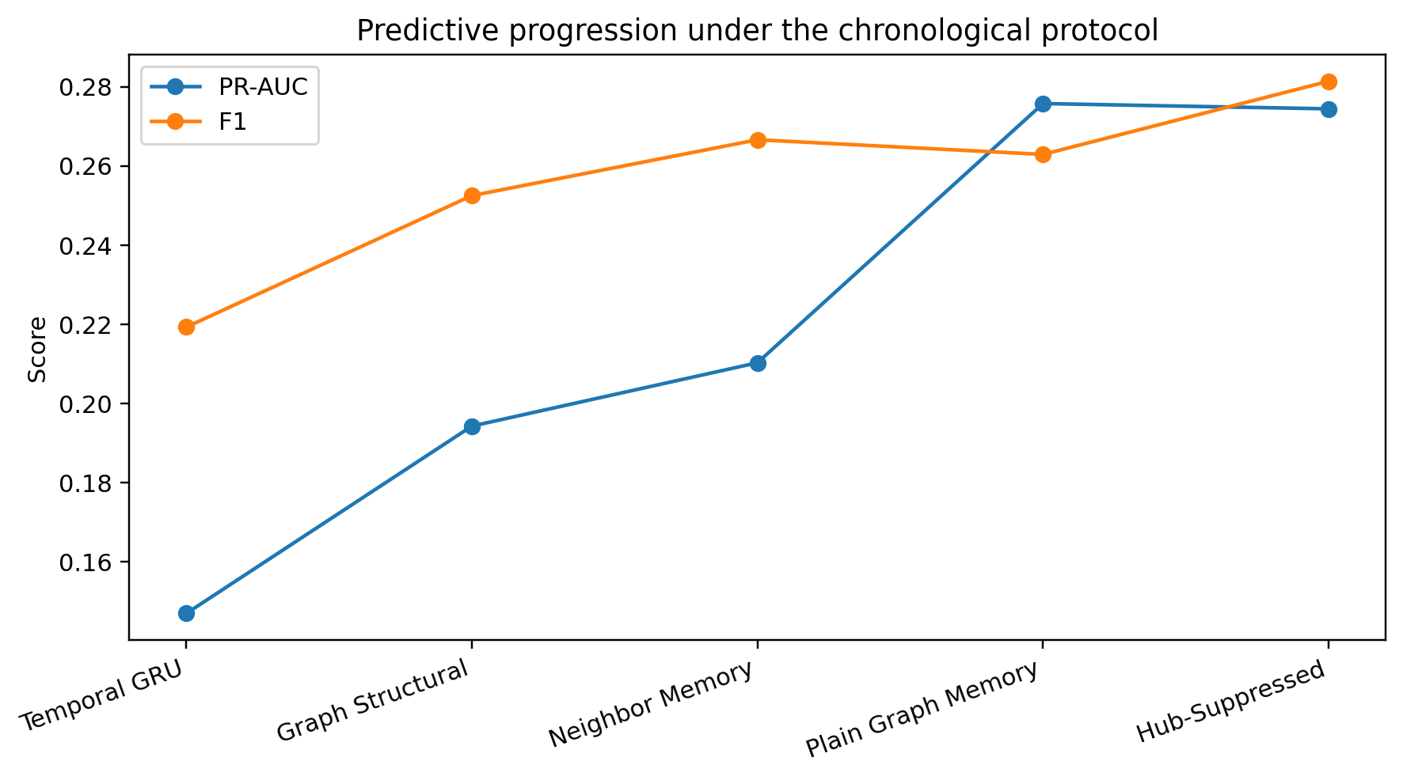
Figure 1. Predictive progression under the locked chronological evaluation protocol.
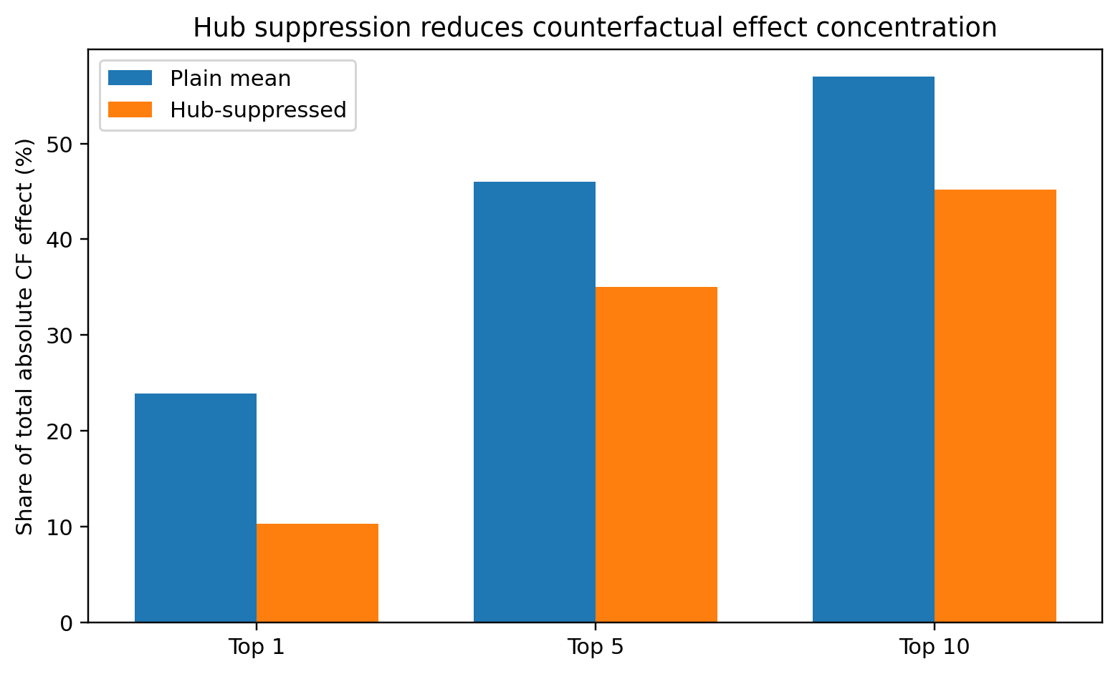
Figure 2. Concentration of absolute historical counterfactual effect. Degree-based hub suppression substantially reduces dependence on the most influential neighbors.

16. Systematic Related-Work Comparison
The comparison below is intentionally conservative. It separates prior capabilities from the specific combination evaluated here; a blank or 'No' entry means the cited work, as reviewed for this draft, does not establish that particular property.
Work | Dynamic / temporal graph | Financial fraud / AML | Counterfactual graph changes | Historical relationship replay | Signed risk / protective effect | Hub-robust CF analysis
TGN — Rossi et al. (2020) | Yes | No | No | No | No | No
CF-GNNExplainer — Lucic et al. (2021) | No | No | Yes | No | No | No
GRACIE — Prenkaj et al. (KDD 2024) | Yes | No | Yes | No | No | No
GreeDy / CoDy — Qu et al. (2024/ICML 2025) | Yes | No | Yes | No | No | No
SAGE-FIN — Nguyen et al. (2025) | Financial interaction graph | Yes | Causal edge/subgraph explanation | No | No | No
This work | Yes | Yes | Yes | Yes | Yes | Yes
The closest methodological comparator is CoDy, which is explicitly designed for model-agnostic counterfactual explanation of temporal graph neural networks. GRACIE also addresses counterfactuals in dynamically changing graphs. The closest application comparator found is SAGE-FIN, which performs fraud detection and Granger-causal explanation on Elliptic++. Accordingly, our novelty claim is not counterfactual graph explanation or temporal graph modeling by itself. The candidate contribution is the fraud-specific combination of full-history relationship removal, temporal-memory replay, signed risk/protective interpretation, and explicit hub-concentration robustness analysis.

17. Reviewer-Facing Distinctions
- Versus CF-GNNExplainer: the intervention is not a static minimal edge deletion around a single graph prediction; the relationship is removed from every available prior relational aggregation and the target sequence is replayed.
- Versus CoDy/GreeDy and GRACIE: the contribution is application- and mechanism-specific rather than a general dynamic-graph counterfactual search algorithm; our analysis targets historical fraud memory and relationship sensitivity.
- Versus SAGE-FIN: both study explainability on financial graphs and Elliptic++, but SAGE-FIN identifies influential causal subgraphs using Granger causality, whereas our intervention directly removes a relationship from historical model memory and measures the signed probability change.
- Hub robustness is part of the explanation evaluation, not merely a predictive regularizer: the paper reports how much total counterfactual effect is concentrated in the most influential high-degree neighbors.

18. Final Manuscript Checklist
- Use the five-seed results as the primary final predictive table; label earlier single-seed numbers explicitly as architecture-development/ablation results.
- Keep the causal-language guardrail throughout: model counterfactual sensitivity is not real-world causation.
- Report both ranking metrics and threshold-dependent operating metrics.
- Retain the paired five-seed uncertainty statement and avoid claiming statistically significant F1 superiority.
- Use Figure 2 alongside the historical intervention table to support the hub-robust explanation claim.
- Before submission, adapt title, abstract length, citation style, page limits, and anonymity requirements to the selected venue.

