Historical Counterfactual Fraud Networks:
Graph-Aware Temporal Memory with Hub-Robust Relationship Explanations
Goutam Dyapa
IEEE Member
goutamdyapa@gmail.com
Abstract—Fraud in transaction networks is inherently temporal and relational: an entity's risk may depend not only on its own evolving behavior but also on the historical behavior of connected entities. We present a graph-aware temporal fraud-memory model and a historical counterfactual analysis for relationship-level explanation. The model combines wallet behavior, temporal memory, structural graph features, and strictly prior incoming/outgoing neighbor behavior under a chronological evaluation protocol. On Elliptic++, plain graph memory reaches 0.2757±0.0022 PR-AUC across five seeds, while a degree-based hub-suppressed variant reaches 0.2744±0.0096 PR-AUC and improves mean F1 from 0.2629±0.0179 to 0.2814±0.0155. For explanation, we remove one relationship from every prior relational aggregation of a target wallet, replay its temporal memory through the fixed trained model, and measure the signed change in fraud probability. Hub suppression reduces the single most influential neighbor's share of total absolute counterfactual effect from 23.9% to 10.3% while preserving substantial relationship effects. The resulting explanations distinguish risk-increasing from protective relational context. These interventions measure model sensitivity rather than real-world causality.
Index Terms—fraud detection, temporal graphs, graph neural networks, counterfactual explanations, blockchain analytics, Elliptic++, explainable AI
I. INTRODUCTION
Financial fraud detection is commonly formulated as classification over transactions or entities, but blockchain activity is neither independent nor static. Wallets evolve over time and participate in relational structures whose historical context can alter the meaning of current behavior. A useful fraud model should therefore answer two questions: how does relational history improve detection, and which historical relationships materially support or reduce a particular risk assessment?
We study these questions using Elliptic++, a large Bitcoin transaction/address dataset designed for financial forensics. Our approach augments entity-level temporal memory with structural graph context and strictly prior behavioral summaries from incoming and outgoing neighbors. We then explain a prediction through a historical intervention: remove one relationship from every available prior neighbor-memory aggregation for the target wallet, replay the target sequence through the unchanged trained model, and measure the change in final fraud probability.
The main contribution is not a claim that temporal graph memory or graph counterfactual explanation is new in isolation. Temporal Graph Networks establish memory-based dynamic graph learning [1], static graph counterfactual explainers include CF-GNNExplainer [2], and recent work extends counterfactual explanation to dynamic graphs [3], [4]. Our contribution is a fraud-specific historical replay analysis that produces signed relationship effects and explicitly tests whether explanations remain meaningful after suppressing high-degree hubs.
Our results show a useful predictive/explanatory tradeoff. Across five fixed seeds, degree-based hub suppression preserves PR-AUC while shifting the selected operating point toward higher recall and F1. More importantly, it reduces concentration of counterfactual influence around a few highly connected wallets without eliminating large relationship-level effects.
Our contributions are threefold: (1) a leakage-safe temporal fraud-memory representation that combines wallet history, structural context, and strictly prior directional neighbor behavior; (2) a historical relationship intervention that removes one relationship from all eligible prior relational-memory states and replays the fixed target sequence to obtain a signed probability effect; and (3) a hub-robustness evaluation showing how degree suppression changes both predictive operating characteristics and concentration of counterfactual influence.
II. RELATED WORK
A. Temporal graph learning
Temporal Graph Networks (TGN) provide a general framework for learning on dynamic graphs using memory modules, message functions, and graph-based embeddings [1]. Financial anomaly and fraud research has subsequently used temporal and spatio-temporal graph models to capture evolving transaction structure [5], [6]. Our model uses a deliberately compact temporal-memory architecture because the central question is not architectural novelty, but whether historical relational context can support robust relationship-level interventions.
B. Graph counterfactual explanations
CF-GNNExplainer formulates counterfactual explanation through graph perturbations that change a GNN prediction [2]. Robust graph counterfactual methods further study stability and plausibility [7]. Dynamic-graph explanation is especially relevant: GRACIE addresses counterfactual reasoning in evolving graphs [3], while GreeDy/CoDy develops counterfactual explainers for temporal graph neural networks [4]. We therefore position historical replay as an application-specific intervention mechanism rather than a general counterfactual-search algorithm.
C. Financial graph explainability
Elliptic++ extends earlier cryptocurrency forensic datasets with transaction and address graphs for illicit-node detection [8]. Recent SAGE-FIN work applies graph learning and Granger-causal explanation to financial interaction networks including Elliptic++ [9]. Our analysis differs by intervening directly on the trained model's historical relational memory and measuring signed probability changes for individual relationships.
D. Positioning relative to prior counterfactual methods
Static counterfactual explainers such as CF-GNNExplainer search for small graph perturbations that change a prediction, whereas CoDy searches temporal subgraphs for model-agnostic explanations of temporal GNNs. GRACIE instead learns a generative model for counterfactuals under evolving graph distributions. Our intervention is narrower: for a fixed target wallet and one observed relationship, we delete that relationship from all eligible prior relational-memory states of the target and replay the target sequence. We do not claim minimality of the removed subgraph or a general-purpose counterfactual search procedure. This distinction is important because the experiment is designed to measure historical relationship sensitivity in fraud models rather than to solve the general temporal-graph explanation problem.
III. METHOD
A. Chronological fraud memory
Each labeled wallet v is represented by an ordered sequence of observations. A GRU processes transformed behavioral features and produces a fraud probability at each observed time. We use a strict chronological split: time steps 1–34 for training, 35–41 for validation, and 42–49 for testing. Threshold-dependent metrics use a threshold selected only on validation data.
B. Leakage-safe relational memory
For each observation of wallet v at time t, incoming and outgoing relational-memory channels aggregate each neighbor's most recent behavioral state strictly before t. Observations at t are added to memory only after all predictions/features for t have been constructed. Thus same-time or future neighbor information cannot leak into the target representation.
The full representation concatenates wallet behavior, structural graph features, and directional historical-neighbor summaries. The representation is projected to 48 dimensions, processed by a 32-unit GRU, normalized, and mapped to a binary logit. Training uses weighted binary cross-entropy, AdamW, gradient clipping, and three epochs in the final five-seed robustness experiment.
C. Hub-suppressed relational aggregation
Plain mean aggregation can overemphasize highly connected wallets in explanation analyses. We therefore evaluate a strict hub-suppressed message rule. Each historical neighbor state is scaled by the inverse square root of its labeled graph degree before aggregation:
$$m_{u→v,t} = \frac{h_{u,t−}}{\sqrt{1 + d_{u}}}$$
Messages are then averaged by the raw number of available neighbors. Unlike renormalized weighting, this rule continues to attenuate a high-degree wallet even when it is the only available neighbor.
D. Historical relationship counterfactual
For target wallet v, neighbor u, and prediction time t, we remove u from every incoming/outgoing prior-neighbor aggregation in v's observed history through t. We then replay v's sequence through the fixed trained model. The signed historical counterfactual effect is:
$${CF}_{u→v,t}^{hist} = p_{v,t} − p_{v,t}^{(−u)}$$
$$p_{v,t} = P(y_{v,t} = 1 | G_{1:t}), p_{v,t}^{(−u)} = P(y_{v,t} = 1 | G_{1:t}^{(−u)})$$
Here, G(−u) denotes the same graph history with neighbor u removed. Positive values indicate that the relationship supports the model's fraud assessment; negative values indicate protective or exculpatory model context. This quantity is an interventional model sensitivity, not a causal effect on real-world illicit behavior.
IV. EXPERIMENTAL SETUP
The experiments use Elliptic++ labeled wallet observations and AddrAddr relationships. The final predictive robustness comparison uses seeds 13, 21, 42, 77, and 101 with an identical three-epoch budget for plain and hub-suppressed graph memory. We report PR-AUC and ROC-AUC as ranking metrics and precision, recall, and F1 at the validation-selected threshold. Recurrent-wallet metrics evaluate test observations with prior entity history.
Historical counterfactual evaluation uses 328 class-balanced test targets: 164 illicit and 164 licit wallets with prior-neighbor memory and 1–15 active historical neighbors. The analysis contains 578 single-relationship historical interventions. Counterfactual concentration is measured as the fraction of total absolute effect attributable to the most influential one, five, and ten neighbors.
A. Dataset and task

Elliptic++ contains 822,942 Bitcoin wallet addresses, 1,268,260 temporal wallet interactions, 2,868,964 address-to-address edges, 1,314,241 address-transaction-address edges, 49 time steps, and 56 actor features. The published actor labels include 14,266 illicit, 251,088 licit, and 557,588 unknown wallets [8]. Our supervised wallet experiment uses labeled wallet observations and the AddrAddr relationship graph; unknown labels are not treated as negative examples. Consequently, reported metrics characterize discrimination among labeled observations and should not be interpreted as performance over the full unlabeled Bitcoin population.
B. Chronological evaluation and leakage controls
The split is fixed before model fitting: time steps 1-34 are training, 35-41 validation, and 42-49 test. Feature standardization statistics are computed from training observations. At each time t, relational memory is constructed only from each neighbor's most recent observation at a time strictly less than t. Current-time observations are committed to memory only after all rows at t have been processed. The validation interval alone selects the F1 operating threshold; test labels do not influence threshold selection.
C. Reproducibility settings
The final five-seed robustness experiment uses random seeds {13, 21, 42, 77, 101}. Both selected models use a 48-dimensional projection, ReLU and layer normalization, a 32-unit GRU, a layer-normalized binary output head, AdamW with learning rate 10^-3 and weight decay 10^-4, batch size 1024, gradient clipping at norm 5, class-weighted binary cross-entropy, and three training epochs. Thus the plain and hub-suppressed variants differ in relational aggregation rather than training budget or classifier capacity.
D. Counterfactual cohort
Historical counterfactual analysis is intentionally restricted to test targets with prior relational memory and between 1 and 15 active historical neighbors. All 164 eligible illicit targets are retained and balanced with 164 randomly selected eligible licit targets using a fixed sampling seed. Removing each active historical neighbor in turn yields 578 relationship interventions. The model parameters remain frozen during replay.
Setting | Value
Split | Train 1-34; val. 35-41; test 42-49
Seeds | 13, 21, 42, 77, 101
Projection / GRU | 48 / 32
Optimizer | AdamW, lr=1e-3, wd=1e-4
Batch / epochs | 1024 / 3
Loss | Class-weighted BCE
Threshold | Validation F1 optimum
CF targets | 164 illicit + 164 licit
CF interventions | 578
E. Temporal-neighbor event baseline
To test whether the selected Graph-Memory models outperform a simpler non-recurrent use of the same leakage-safe neighbor history, we add a temporal-neighbor event baseline. It concatenates the current 50-dimensional wallet representation with 22 strictly-prior directional neighbor-event summary features and classifies each observation with a 72-48-32-1 MLP using ReLU and layer normalization. It excludes static graph-structural features and excludes the target wallet's recurrent hidden state. The baseline uses the same chronological split, five seeds, three-epoch budget, class weighting, optimizer family, and validation-threshold protocol. This is a controlled internal baseline, not a reproduction of TGN or another published temporal-GNN implementation.
V. RESULTS
A. Predictive robustness
Model | PR-AUC | ROC-AUC | F1
Plain Graph Memory | 0.2757 (.0022) | 0.8113 (.0130) | 0.2629 (.0179)
Hub-Suppressed | 0.2744 (.0096) | 0.8040 (.0123) | 0.2814 (.0155)
Mean (SD) across five fixed seeds.
Hub suppression changes mean PR-AUC by only −0.0013 while increasing mean recall from 0.1732 to 0.2024 and mean F1 by +0.0185 (about 7.0% relative). Hub suppression has higher F1 in four of five seeds. The paired F1 difference has a 95% confidence interval of −0.0156 to +0.0526 (paired t-test p=0.207; exact sign-permutation p=0.188). With only five pairs, these results demonstrate a repeatable operating-point shift but do not establish statistically significant predictive superiority.
B. Temporal-neighbor event baseline
The temporal-neighbor event baseline reaches PR-AUC 0.2089±0.0099, ROC-AUC 0.7942±0.0136, and F1 0.2450±0.0137. Across the same seeds, Plain Graph Memory improves PR-AUC by +0.0668 (95% paired CI +0.0552 to +0.0784; paired t-test p<0.001) and ROC-AUC by +0.0171 (95% CI +0.0053 to +0.0289; p=0.016). Hub-Suppressed Graph Memory improves PR-AUC by +0.0655 (95% CI +0.0529 to +0.0780; p<0.001) and F1 by +0.0363 (95% CI +0.0060 to +0.0666; p=0.029). These comparisons support the value of combining relational history with target-wallet temporal memory and/or graph structure, while remaining an internal controlled comparison rather than evidence of superiority to published temporal GNNs.
C. Architecture progression
In the development ablation at seed 42, temporal-only GRU PR-AUC is 0.1470, graph-structural temporal memory reaches 0.1943, neighbor-memory temporal modeling reaches 0.2103, and full plain graph memory reaches 0.2911. This progression motivates the use of historical relational context, while the five-seed experiment above provides the final robustness estimate for the two selected graph-memory variants.
D. Historical counterfactual effects
Under the hub-suppressed model, mean absolute relationship effect is 0.0917 for illicit targets (bootstrap 95% CI 0.0750–0.1096) and 0.0502 for licit targets (95% CI 0.0361–0.0660). At the target level, 7.9% of illicit wallets have at least one relationship whose historical removal flips the final classification. Individual effects can be large: one illicit example changes from 0.5804 to 0.0596 after one relationship is removed throughout its available history, corresponding to CF=+0.5208.
E. Hub robustness
Aggregation | Top-1 | Top-5 | Top-10
Plain mean | 23.9% | 46.0% | 57.0%
Hub-suppressed | 10.3% | 35.0% | 45.2%
The single largest neighbor's share of total absolute counterfactual effect falls from 23.9% to 10.3%, and top-ten concentration falls from 57.0% to 45.2%. Relationship effects therefore remain substantial even when high-degree neighbors are explicitly attenuated.

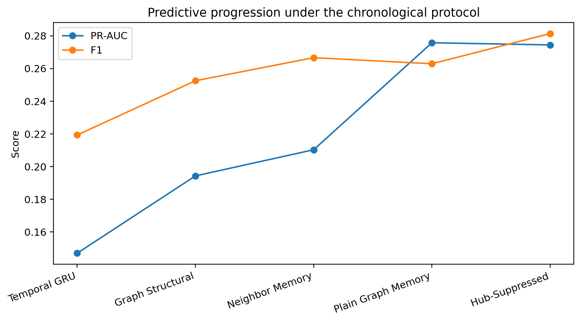
Fig. 1. Predictive progression from temporal-only memory to graph-aware
and hub-suppressed models.
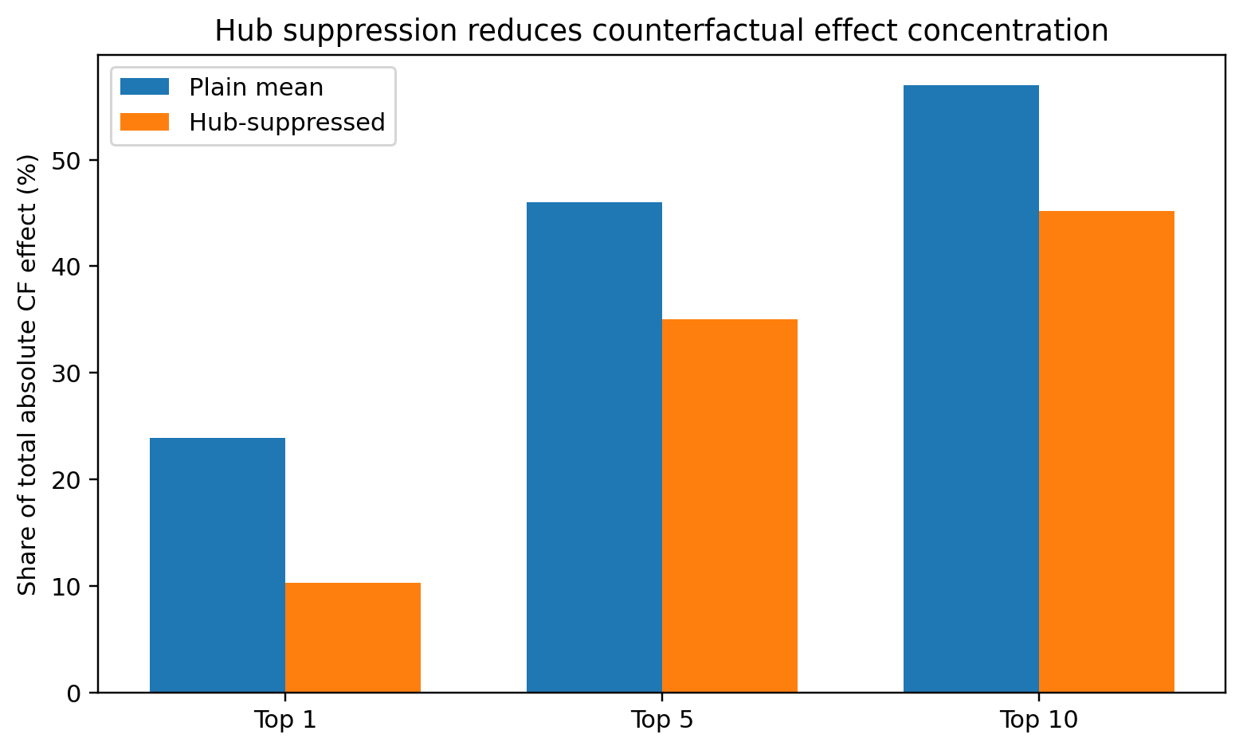
Fig. 2. Hub suppression reduces concentration of absolute historical counterfactual effect.
F. Five-seed paired analysis
The paired five-seed comparison does not support a claim of statistically significant predictive superiority. For F1, hub suppression changes the mean by +0.0185 with a 95% t-based confidence interval of [-0.0156, +0.0526], paired t-test p=0.207, and exact sign-permutation p=0.188. For PR-AUC, the mean difference is -0.0013 with 95% CI [-0.0126, +0.0099] and paired t-test p=0.759. We therefore describe the result as preservation of ranking performance with an operating-point shift toward recall/F1, not as universal predictive dominance.
G. Explanation concentration and direction
Hub suppression changes not only aggregate prediction metrics but the distribution of explanation mass. The top-1 share of total absolute counterfactual effect falls by 13.6 percentage points and the top-10 share by 11.8 points. Meanwhile, signed deltas remain both positive and negative, so the explanation is not constrained to identifying suspicious relationships: a relationship may either support or reduce the model's illicit-risk estimate. This signed interpretation is retained throughout the paper as model evidence rather than causal attribution.
External results are not numerically compared in the main predictive table because published financial temporal-graph studies use different datasets, graph constructions, labels, and evaluation protocols. For example, Kim et al. evaluate TGN on DGraph [5], while the original Elliptic++ study evaluates multiple graph representations and feature configurations [8]. The architecture progression therefore functions as an internal ablation, not a claim of state-of-the-art predictive performance.
VI. DISCUSSION
The results support three conclusions. First, historical relational context contains fraud-relevant signal beyond entity-only temporal memory. Second, individual relationships can provide either suspicious or protective context to the trained model. Third, these effects are not explained solely by a few graph hubs: degree suppression materially reduces concentration while broadly preserving ranking performance.
The explanation semantics are particularly useful for investigation. A positive counterfactual effect identifies a relationship whose historical contribution raises modeled fraud risk; a negative effect identifies a relationship whose presence lowers it. This is richer than simply ranking suspicious neighbors because it exposes both incriminating and exculpatory model evidence.
The tradeoff between plain and hub-suppressed aggregation should not be overstated. Plain graph memory retains slightly higher mean PR-AUC and ROC-AUC, whereas hub suppression has higher mean F1 and substantially better effect concentration. We therefore treat the hub-suppressed model as the primary explanation model and plain graph memory as the predictive comparator.
VII. LIMITATIONS
Our strongest predictive comparison uses five seeds but one primary dataset. We add a same-protocol temporal-neighbor event baseline, but do not provide a reproduction of a published temporal-GNN system; predictive results should therefore be interpreted as controlled evidence for the proposed relational-memory design rather than a state-of-the-art benchmark claim. The historical intervention is also not benchmarked against general temporal counterfactual search methods such as CoDy using their sparsity/fidelity suite; our evaluation instead measures signed probability sensitivity, decision flips, bootstrap uncertainty, and concentration under hub suppression. Counterfactual interventions replay only the target wallet's learned history and do not simulate how the full transaction ecosystem would have evolved if an edge had never existed. The implementation aggregates labeled-to-labeled AddrAddr relationships and a compact subset of behavioral dimensions. Threshold-based metrics depend on validation threshold selection, and unknown wallets are excluded from supervised evaluation. Finally, historical counterfactual sensitivity is a property of the trained model and is not evidence that a relationship caused criminal behavior.
VIII. CONCLUSION
We presented graph-aware temporal fraud memory with historical relationship interventions for explainable cryptocurrency fraud detection. The method integrates strictly prior relational behavior with temporal wallet memory and evaluates explanations by removing individual relationships throughout the target's history and replaying the fixed model. Across five seeds, hub suppression leaves mean PR-AUC nearly unchanged, shifts the validation-selected operating point toward higher recall/F1, and substantially reduces concentration of counterfactual influence. The resulting signed effects identify both risk-increasing and protective relational context, providing an investigator-oriented view of how historical relationships shape model predictions.
IX. Positioning summary
The literature audit indicates that temporal memory, graph counterfactuals, and financial graph explanations each have substantial prior art. The paper's defensible contribution is therefore the combined fraud-specific mechanism and evaluation shown below.
Work | Relevant capability | Historical replay
TGN [1] | Temporal memory | No
CF-GNNExplainer [2] | Static graph CF | No
GRACIE [3] | Dynamic graph CF | No
CoDy [4] | Temporal GNN CF | No
SAGE-FIN [9] | Financial causal explanation | No
This work | Temporal fraud CF | Yes
*SAGE-FIN evaluates Elliptic++ financial interaction graphs and Granger-causal explanations; its published limitations explicitly motivate incorporating the temporal dimension. Our comparison does not imply that the listed systems are directly comparable on predictive scores because they use different tasks, graph constructions, and protocols.
REFERENCES
[1] E. Rossi, B. Chamberlain, F. Frasca, D. Eynard, F. Monti, and M. Bronstein, "Temporal Graph Networks for Deep Learning on Dynamic Graphs," arXiv:2006.10637, 2020.
[2] A. Lucic, M. A. ter Hoeve, G. Tolomei, M. de Rijke, and F. Silvestri, "CF-GNNExplainer: Counterfactual Explanations for Graph Neural Networks," in Proc. 25th Int. Conf. Artificial Intelligence and Statistics (AISTATS), PMLR, vol. 151, pp. 4499-4511, 2022.
[3] B. Prenkaj, M. Villaizan-Vallelado, T. Leemann, and G. Kasneci, "Unifying Evolution, Explanation, and Discernment: A Generative Approach for Dynamic Graph Counterfactuals," in Proc. 30th ACM SIGKDD Conf. Knowledge Discovery and Data Mining, pp. 2420-2431, 2024, doi: 10.1145/3637528.3671831.
[4] Z. Qu, D. Gomm, and M. Färber, "CoDy: Counterfactual Explainers for Dynamic Graphs," in Proc. 42nd Int. Conf. Machine Learning (ICML), PMLR, vol. 267, pp. 50762-50785, 2025.
[5] Y. Kim, Y. Lee, M. Choe, S. Oh, and Y. Lee, "Temporal Graph Networks for Graph Anomaly Detection in Financial Networks," arXiv:2404.00060, 2024.
[6] Y. Tian and G. Liu, "Transaction Fraud Detection via Spatial-Temporal-Aware Graph Transformer," arXiv:2307.05121, 2023.
[7] M. Bajaj, L. Chu, Z. Y. Xue, J. Pei, L. Wang, P. C.-H. Lam, and Y. Zhang, "Robust Counterfactual Explanations on Graph Neural Networks," in Advances in Neural Information Processing Systems, vol. 34, pp. 5644-5655, 2021.
[8] Y. Elmougy and L. Liu, "Demystifying Fraudulent Transactions and Illicit Nodes in the Bitcoin Network for Financial Forensics," in Proc. 29th ACM SIGKDD Conf. Knowledge Discovery and Data Mining, pp. 3979-3990, 2023, doi: 10.1145/3580305.3599803.
[9] L. Nguyen, M. Boersma, and E. Acar, "Detecting Fraud in Financial Networks: A Semi-Supervised GNN Approach with Granger-Causal Explanations," in Explainable Artificial Intelligence, CCIS, vol. 2579, pp. 330-353, Springer, 2026, doi: 10.1007/978-3-032-08330-2_16.

