Task 1 — Design a mini data model

A Hospital OPD — patients, doctors, appointments, prescriptions

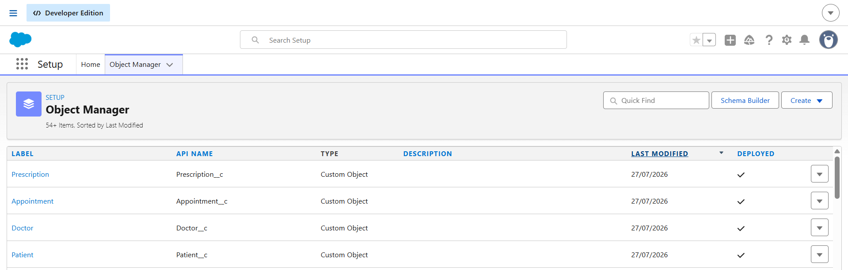

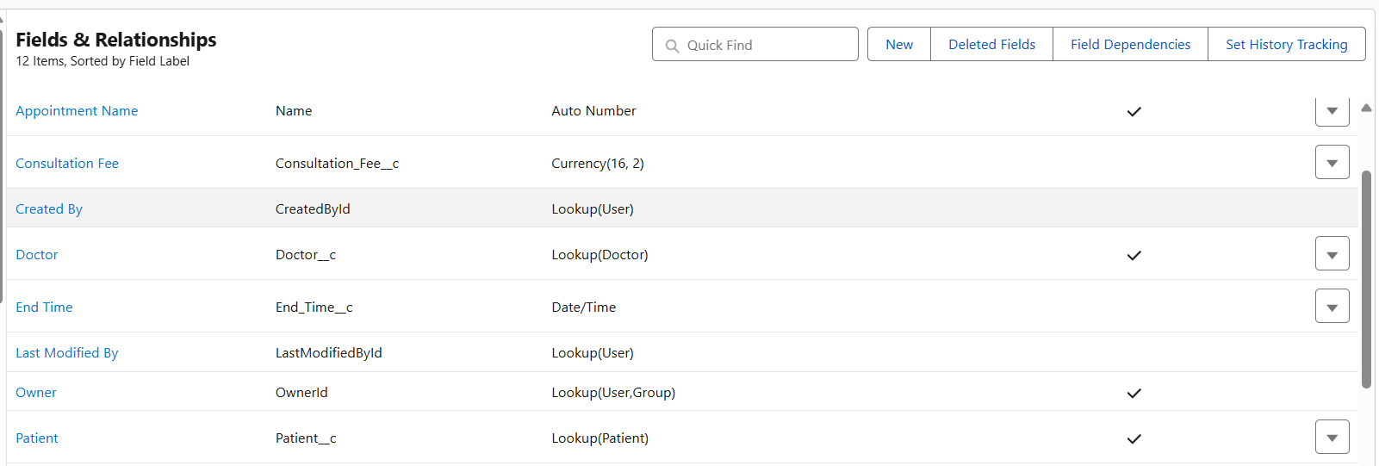

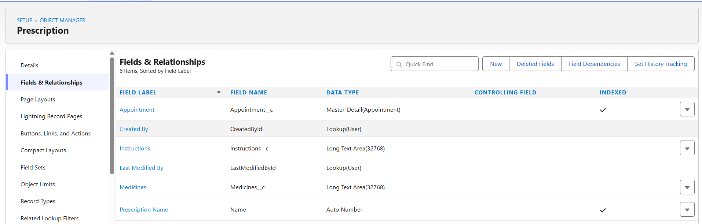

Task 2 — Write it yourself - APEX CODE

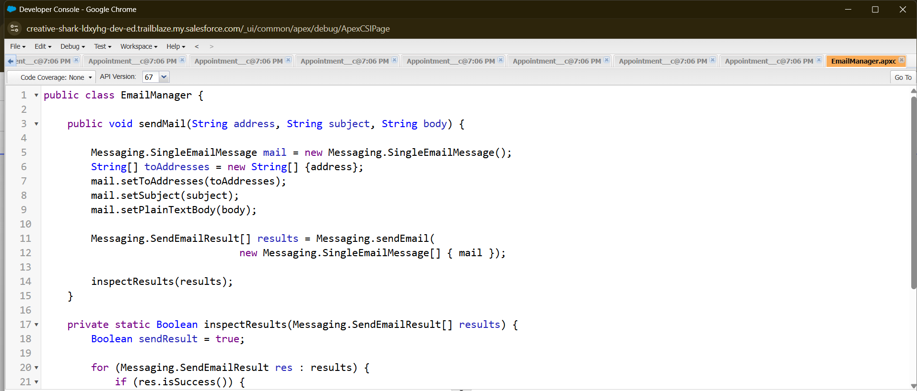

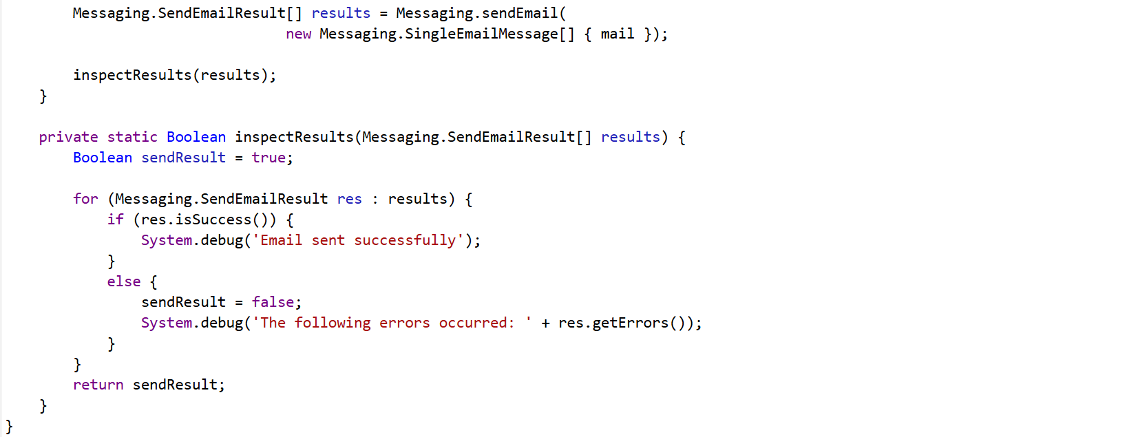

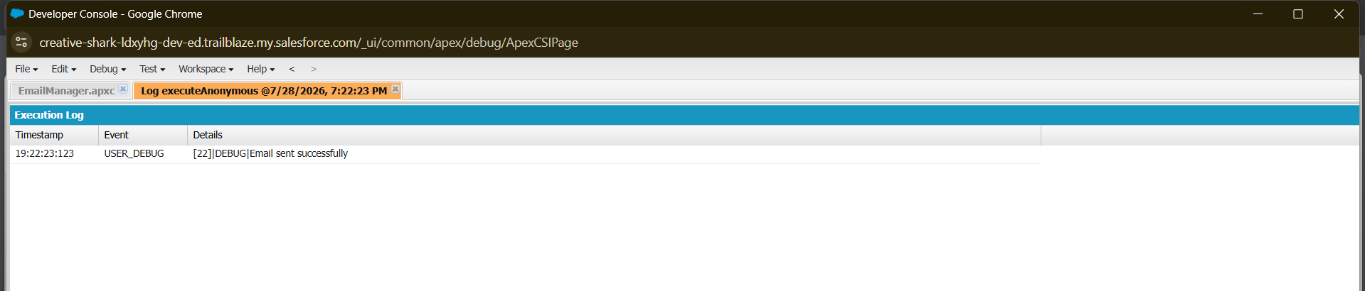

Task 3 — SOQL practice

WHERE clause query

SELECT Id, Name, Appointment_Date__c, Status__c FROM Appointment__c WHERE Status__c = 'Scheduled'

OUTPUT :
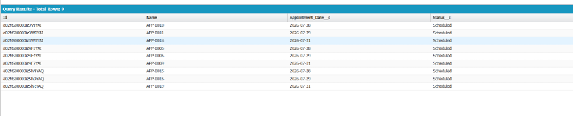

ORDER BY + LIMIT

SELECT Id, Name, Appointment_Date__c FROM Appointment__c ORDER BY Appointment_Date__c LIMIT 3
OUTPUT :

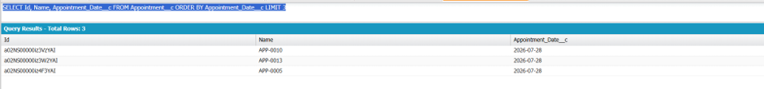

Relationship query (parent-to-child or child-to-parent)

SELECT Id, Name, Patient__r.Name, Doctor__r.Name, Appointment_Date__c FROM Appointment__c
OUTPUT :
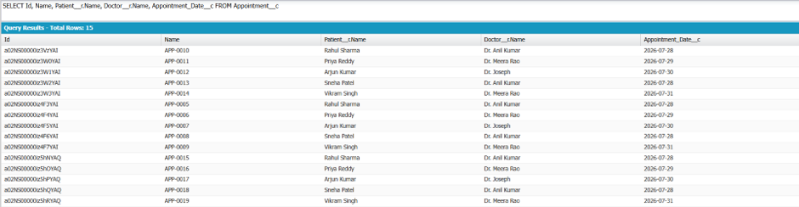
Aggregate query with COUNT() or GROUP BY
SELECT Status__c, COUNT(Id) FROM Appointment__c GROUP BY Status__c
OUTPUT :
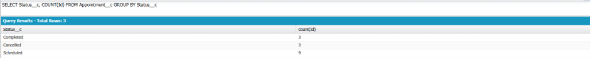
Comparison operator (>=) on a date or number field
SELECT Id, Name, Appointment_Date__c FROM Appointment__c WHERE Appointment_Date__c >= TODAY LIMIT 3
OUTPUT :
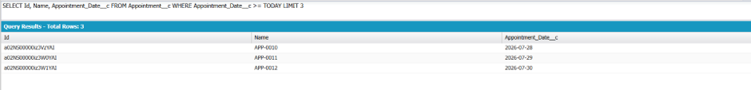
Task 4 — Write a real trigger

On your Task 1 object, write a trigger that: 8. Before Insert: Prevents a duplicate record (e.g., stop two appointments for the same vehicle on the same date) 9. After Update: Updates a field on a related record 10. Structure: Logic must live in a separate handler class, called from the trigger — not written directly in the trigger body

trigger AppointmentTrigger on Appointment__c (before insert, after update) {
if(Trigger.isBefore && Trigger.isInsert){
AppointmentTriggerHandler.preventDuplicateAppointments(Trigger.new);
}
if(Trigger.isAfter && Trigger.isUpdate){
AppointmentTriggerHandler.updatePatientRecord(Trigger.new, Trigger.oldMap);
}
}

public class AppointmentTriggerHandler {

public static void preventDuplicateAppointments(List<Appointment__c> Appointments){
Set<Id> patients = new Set<Id>();
for(Appointment__c a : Appointments){
if(a.Patient__c != null) patients.add(a.Patient__c);
}

List<Appointment__c> existingApp = [SELECT Id, Patient__c, Start_Time__c FROM Appointment__c WHERE Patient__c IN :patients];

for(Appointment__c a : Appointments){
for(Appointment__c e : existingApp){
if(a.Patient__c == e.Patient__c && a.Start_Time__c == e.Start_Time__c){
a.addError('Patient already has an appointment at this time.');
}
}
}
}

public static void updatePatientRecord(List<Appointment__c> Appointments, Map<Id, Appointment__c> oldMap){
Set<Id> patients = new Set<Id>();
for(Appointment__c a : Appointments){
Appointment__c old = oldMap.get(a.Id);
if(old.Status__c != 'Completed' && a.Status__c == 'Completed') patients.add(a.Patient__c);
}

List<Patient__c> existingPat = [SELECT Id, Last_Visit_Date__c FROM Patient__c WHERE Id IN :patients];

for(Patient__c p : existingPat){
p.Last_Visit_Date__c = Date.today();
}

if(!existingPat.isEmpty()) update existingPat;

}
}
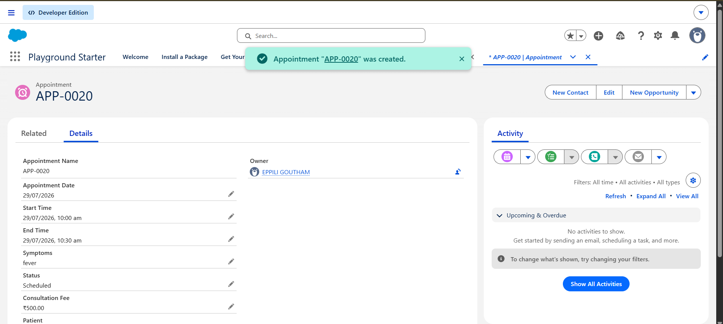

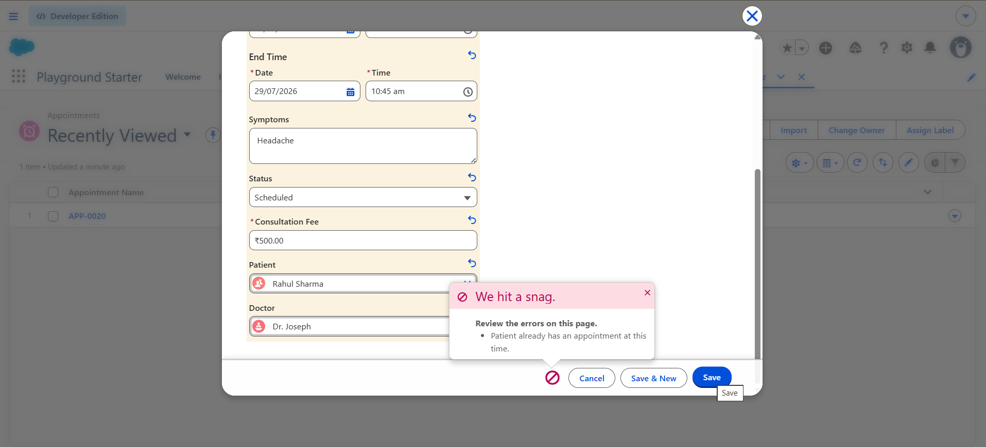

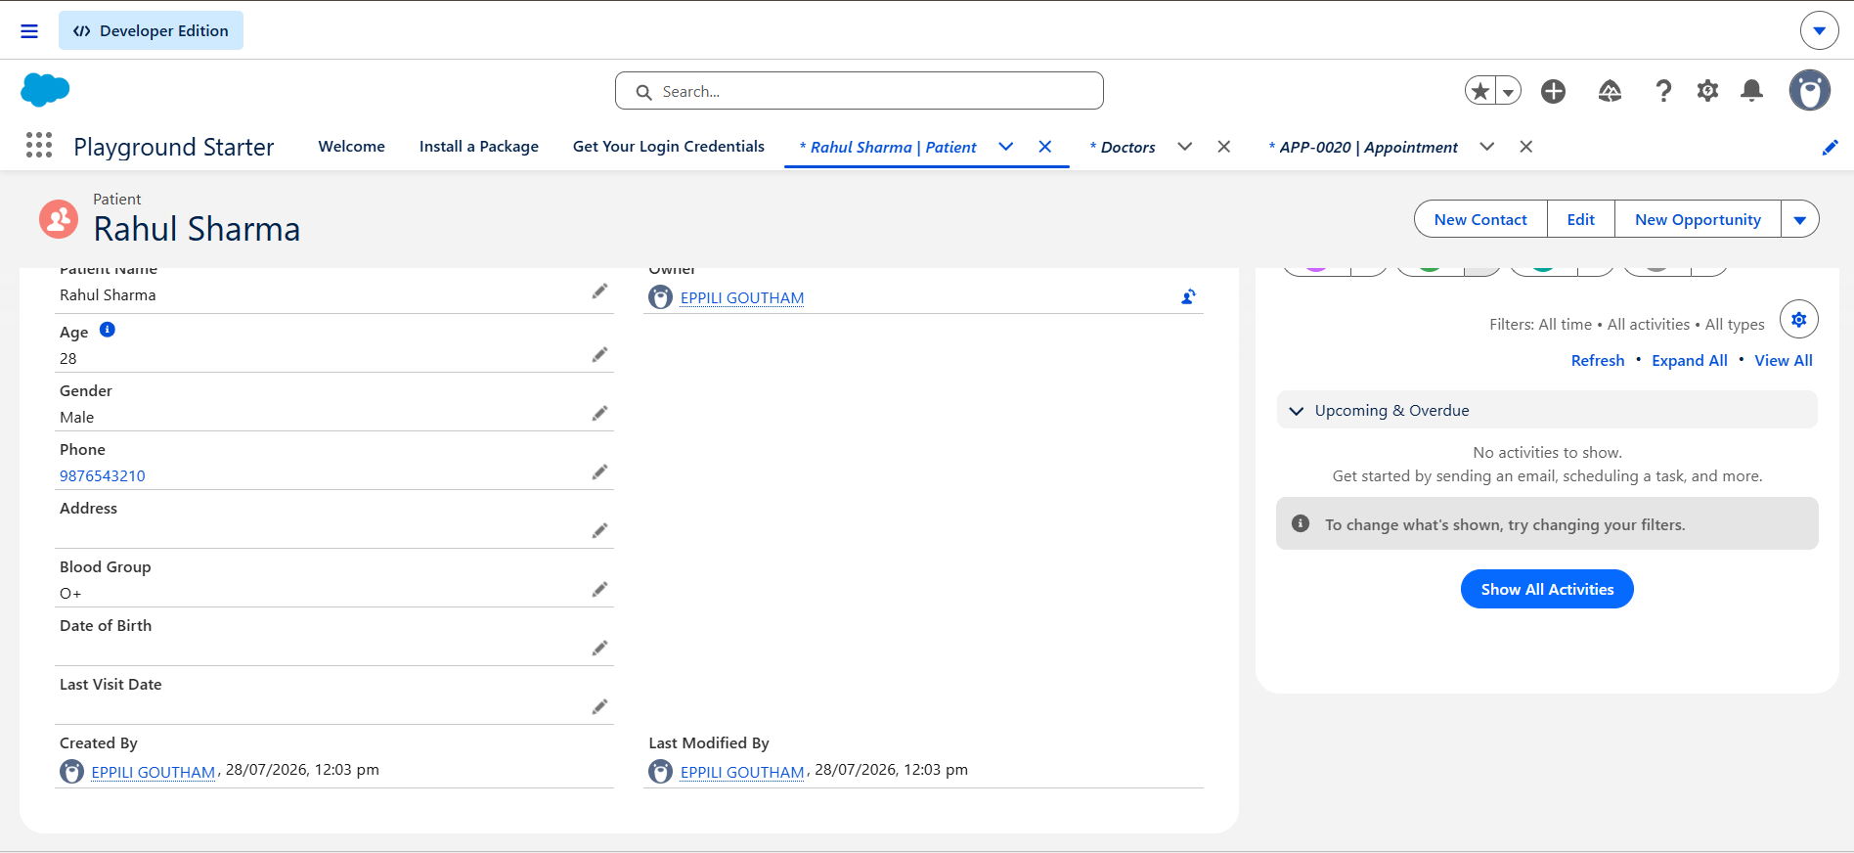

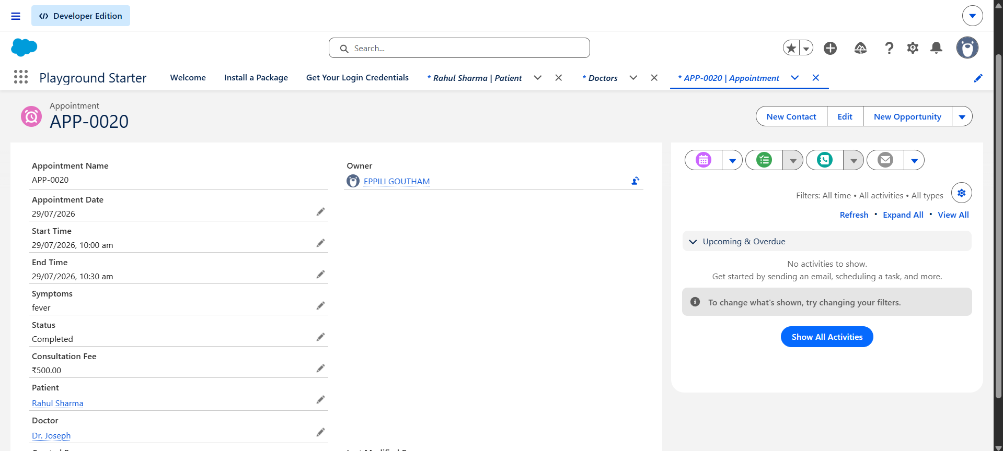

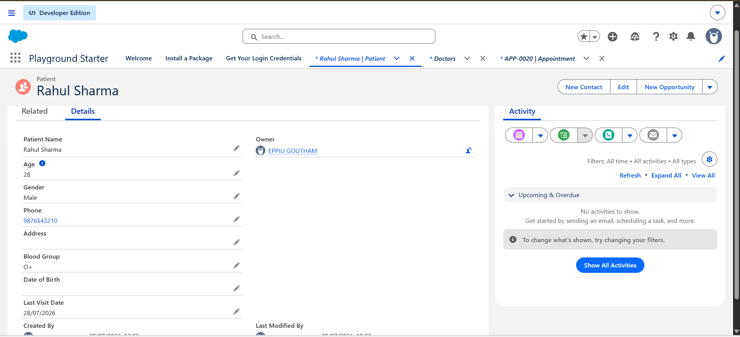

Task 5 — Build one simple component Create an LWC displaying records from your custom object using @wire.
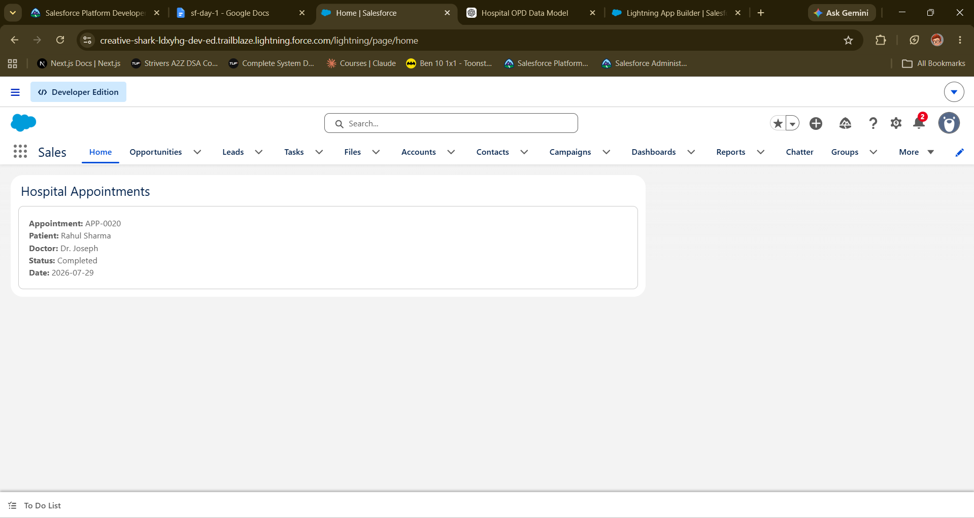
Zipfile : zip-file

