1. Duplicate alert message is displayed when both Party ID and Group Name is entered while creating a Sales Quote.

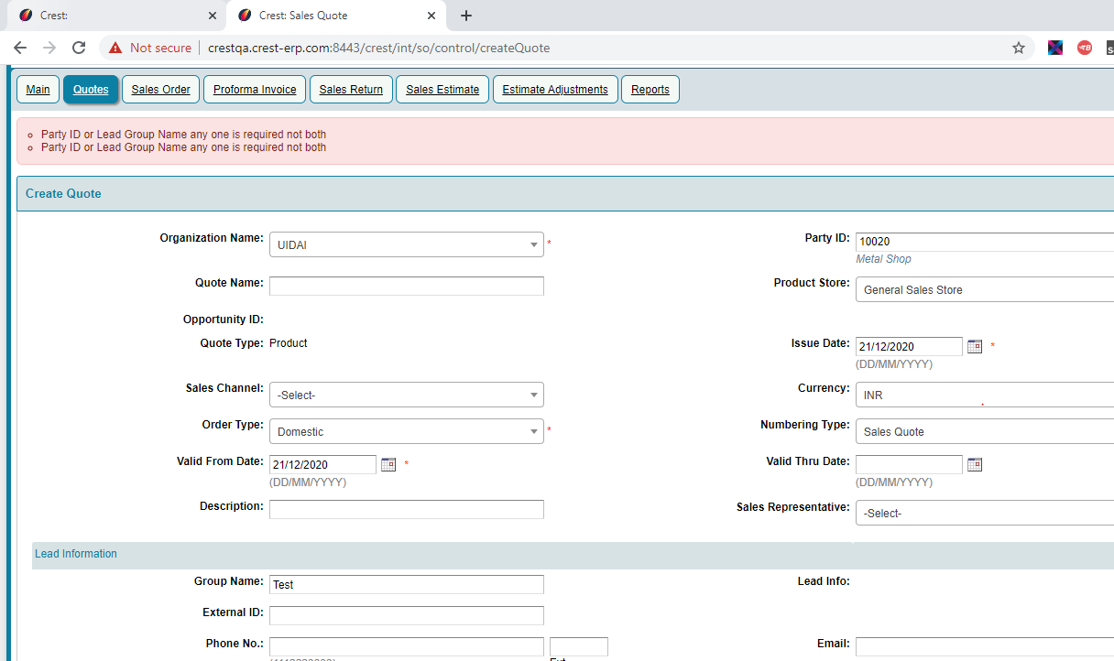

2. Once the Sales Quote is created, if Quantity is entered only with special characters, on click of "Add Item" getting an exception.

