curl -s http://public-dns.info/nameserver/br.csv

curl is used to download or upload data using one of the supported protocols http, https, ftp, scp, sftp.
Curl can be installed using sudo apt install curl.

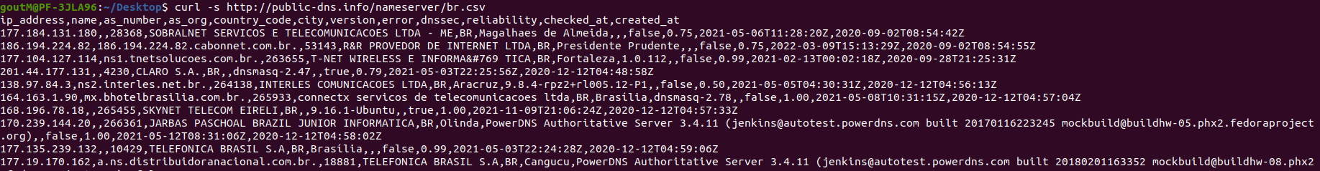

Cut command

The cut command is a command for cutting out the sections from each line of files and writing the result to standard output.
cut uses tab as a default field delimiter but can also work with other delimiter by using -d option.
If -d option is used then it considered space as a field separator or delimiter
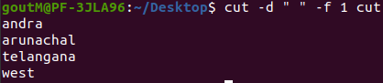

shuf command

shuf command is used for random permutations of input lines to output. It displays output in shuffeled manner.

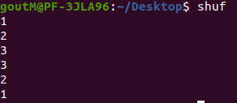
Tail command

It will print last N lines of input data. By default it will print last 10 lines of the file.

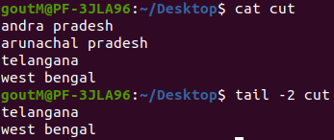

Grep command

The grep filter searches a file for a particular pattern of characters, and displays all lines that contain that pattern. The pattern that is searched in the file is referred to as the regular expression.

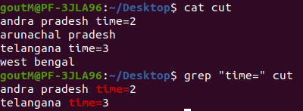

Awk command with substr

(a) Scans a file line by line
(b) Splits each input line into fields
(c) Compares input line/fields to pattern
(d) Performs action on matched lines

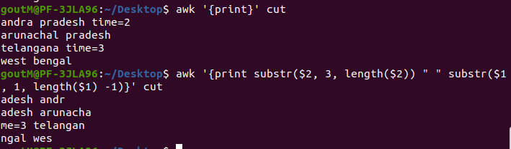

sort command

SORT command is used to sort a file, arranging the records in a particular order. By default, the sort command sorts file assuming the contents are ASCII.
We can perform a reverse-order sort using the -r flag.
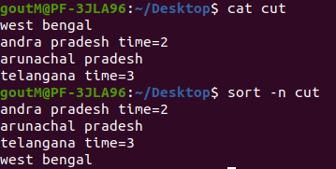

Awk coomand

awk command searches files for text containing a pattern. When a line or text matches, awk performs a specific action on that line/text.

Syntax:
awk options 'selection _criteria {action }' input-file > output-file

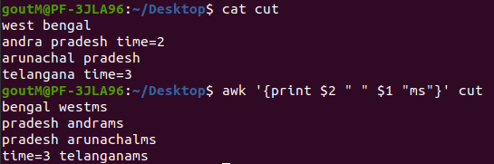
head command

head command print the top N number of data of the given input. By default, it prints the first 10 lines of the specified files.
-n num: Prints the first ‘num’ lines instead of first 10 lines. num is mandatory to be specified in command otherwise it displays an error.
Syntax:
head [OPTION]... [FILE]...

