Database Design Document of Enterprise Procurement System

1. Project Overview
This document defines the proposed database design for the Enterprise Procurement System. It includes the core database tables, primary keys, foreign keys, relationships, and role-based authentication considerations.

2. System architecture

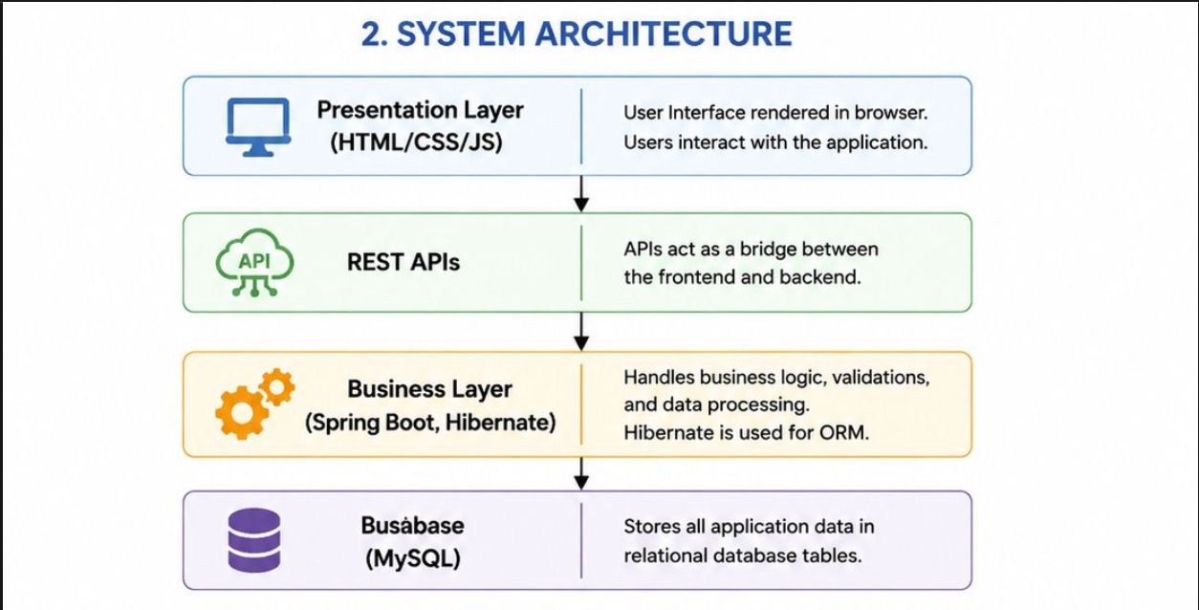

Role-Based Login & JWT Authentication
Roles: Admin, Manager, Procurement Officer, Finance Officer, Employee.
Users authenticate using email and password. After successful login, the backend generates a JWT token. The token is used to authorize subsequent API requests. The JWT itself is not stored in the core business tables.

3. Database Tables

Roles
Column | Key | Description
role_id (PK) | Primary Key | Application field
role_name |  | Application field
description |  | Application field

Users
Column | Key | Description
user_id (PK) | Primary Key | Application field
full_name |  | Application field
email (Unique) |  | Application field
password_hash |  | Application field
phone |  | Application field
department |  | Application field
role_id (FK) | Foreign Key | Application field
status |  | Application field
created_at |  | Application field

Vendors
Column | Key | Description
vendor_id (PK) | Primary Key | Application field
vendor_name |  | Application field
contact_person |  | Application field
email |  | Application field
phone |  | Application field
address |  | Application field
gst_number |  | Application field
status |  | Application field
created_at |  | Application field

Products
Column | Key | Description
product_id (PK) | Primary Key | Application field
product_name |  | Application field
description |  | Application field
category |  | Application field
unit_price |  | Application field
stock_quantity |  | Application field
vendor_id (FK) | Foreign Key | Application field
created_at |  | Application field

Purchase_Request
Column | Key | Description
purchase_id (PK) | Primary Key | Application field
user_id (FK) | Foreign Key | Application field
request_date |  | Application field
total_amount |  | Application field
status |  | Application field
remarks |  | Application field

Purchase_Order
Column | Key | Description
po_id (PK) | Primary Key | Application field
purchase_id (FK) | Foreign Key | Application field
vendor_id (FK) | Foreign Key | Application field
order_date |  | Application field
expected_delivery |  | Application field
status |  | Application field

Goods_Receipt
Column | Key | Description
receipt_id (PK) | Primary Key | Application field
po_id (FK) | Foreign Key | Application field
received_by (FK->Users) | Foreign Key | Application field
received_date |  | Application field
quantity_received |  | Application field
remarks |  | Application field

Invoice
Column | Key | Description
invoice_id (PK) | Primary Key | Application field
po_id (FK) | Foreign Key | Application field
vendor_id (FK) | Foreign Key | Application field
invoice_number |  | Application field
invoice_date |  | Application field
amount |  | Application field
payment_status |  | Application field

4. Table Relationships
- One Role -> Many Users
- One Vendor -> Many Products
- One User -> Many Purchase Requests
- One Purchase Request -> One or Many Purchase Orders
- One Purchase Order -> One Goods Receipt
- One Purchase Order -> One Invoice
- One Vendor -> Many Purchase Orders

5. Business Flow 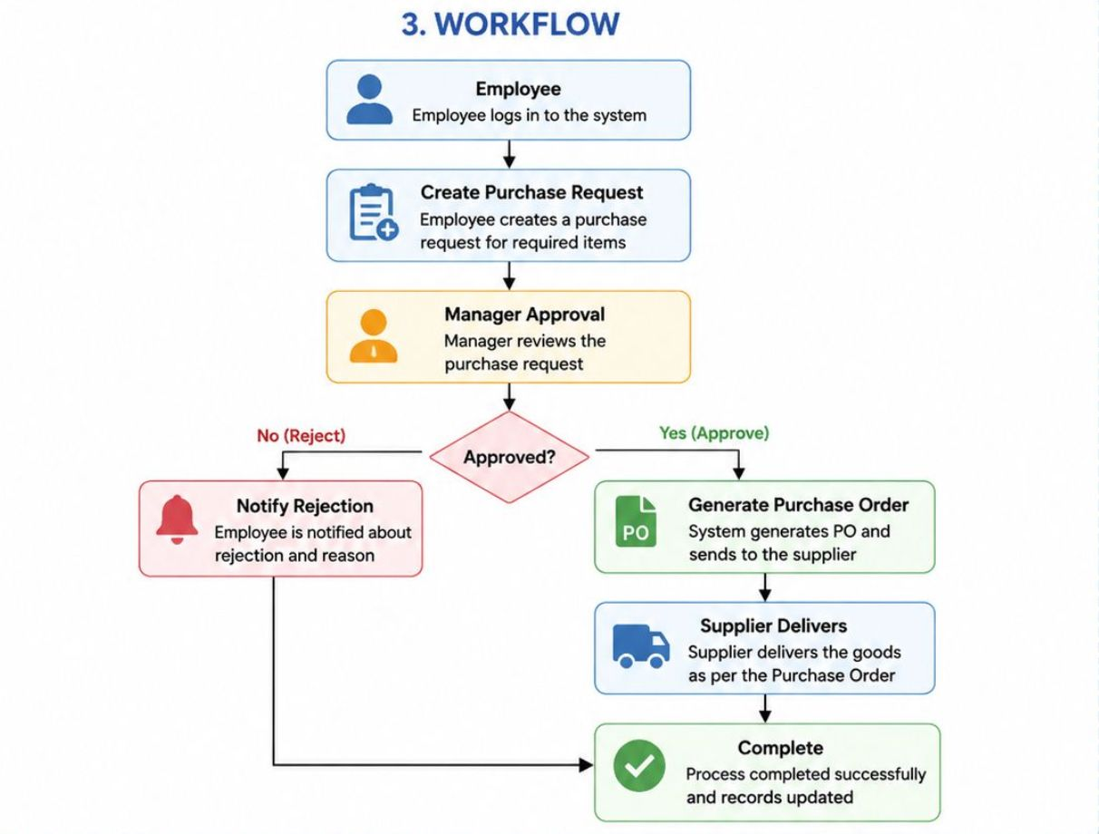

1 | Purchase Request | Employee/Procurement Officer raises a purchase request for required products.
2 | Approval | Manager reviews and approves or rejects the request.
3 | Purchase Order | On approval, Purchase Order is created and sent to the vendor.
4 | Goods Receipt | Vendor delivers goods. Store In-charge verifies and records receipt.
5 | Invoice | Vendor raises invoice against the dellvered goods.
6 | Payment | Finance verifies invoice and processes payment.
7 | Reports | System generates various procurement reports and analytics.

6. Business Rules
- Email must be unique.
- Passwords are stored as hashes.
- Only Managers/Admins can approve purchase requests.
- Products belong to a vendor.
- Purchase Orders are created only after request approval.
- Goods Receipt and Invoice must reference a valid Purchase Order.

