DEVELOPMENT OF SMART PROCUREMENT & PURCHASE ORDER MANAGEMENT SYSTEM GROUP
Software Design Document
Development of Smart Procurement & Purchase Order Management System Group
Final Project / Internship Documentation
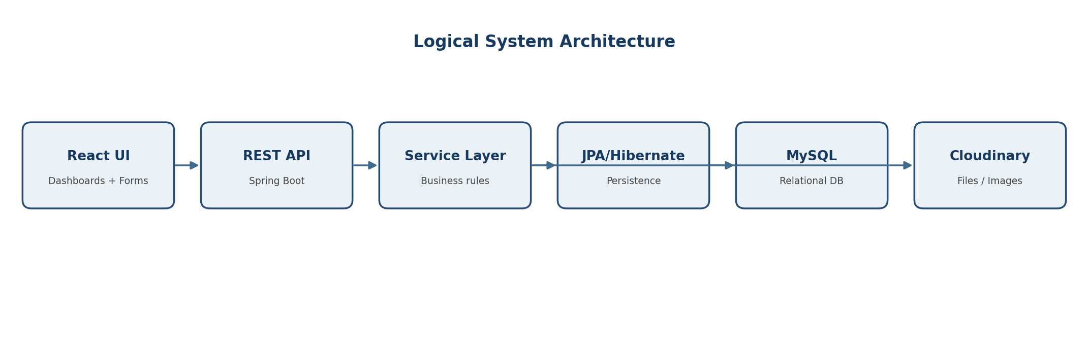
Prepared for project review and technical reference

Document Control
Document | Software Design Document
System | Smart Procurement and Purchase Order Management System
Primary Stack | React, Spring Boot / Java, MySQL, JPA/Hibernate
Security | Spring Security + JWT
Storage / Reporting | Cloudinary, OpenPDF, Apache POI
This design document consolidates the architecture, workflows, module responsibilities, data relationships, security controls, status transitions, and integration points reflected in the project documentation and implementation discussions.

Table of Contents
- 1. Purpose and Scope
- 2. System Overview
- 3. Architecture Design
- 4. Actors and Role Responsibilities
- 5. Functional Module Design
- 6. End-to-End Workflow
- 7. Approval and Notification Design
- 8. Purchase Order and Supplier Design
- 9. Inventory and Goods Receipt Design
- 10. Data Model Design
- 11. API and Service Design
- 12. Security Design
- 13. Validation, Errors and Concurrency
- 14. Reporting and Document Management
- 15. Non-Functional Requirements
- 16. Testing Strategy
- 17. Deployment and Operational Design
- 18. Project Links and Working Documents
- 19. Future Enhancements

1. Purpose and Scope
The system is designed to digitize the procurement lifecycle and bring purchase requests, multi-stage approvals, supplier coordination, purchase orders, delivery, inventory updates, procurement-led returns/replacements, notifications, and reporting into one controlled platform.
The design emphasizes traceability, role-based access, status-driven workflow control, centralized records, and a modular REST-based backend.

In Scope
- Purchase requisition creation and tracking
- Manager, Finance and Procurement approval workflow
- Supplier and product/category management
- Purchase Order generation, PDF export and lifecycle tracking
- Supplier portal actions and supplier document upload
- Goods receipt, inspection, inventory update and procurement-led return/replacement handling
- Role-based notifications, audit/history records and reporting

2. System Overview

Business Flow
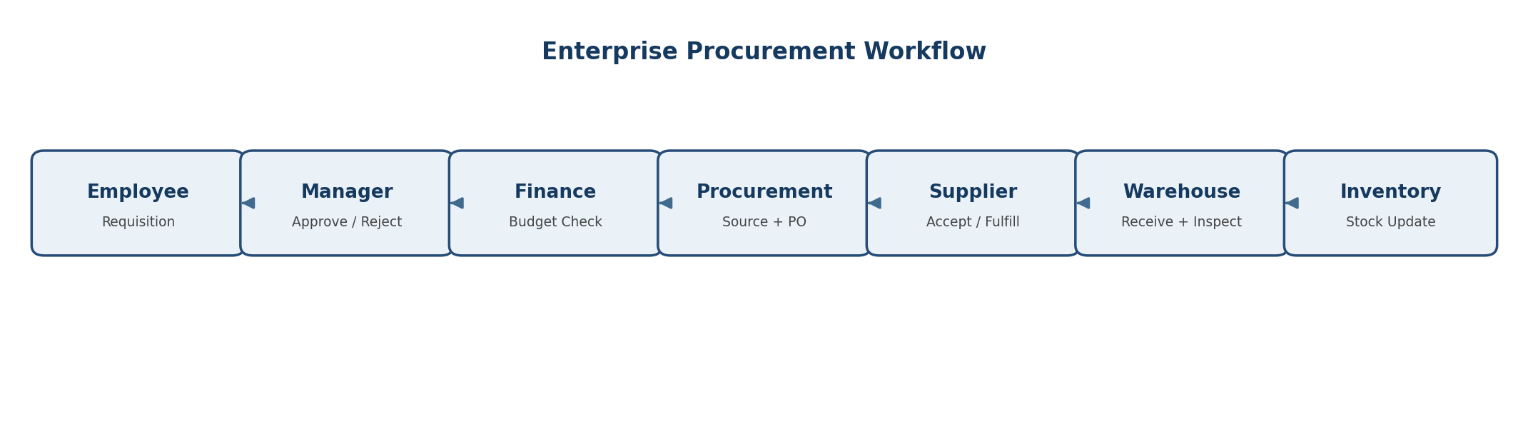
The primary flow starts with an employee request and proceeds through manager and finance checks, procurement execution, supplier response, delivery/receipt/inspection, and inventory update.

Design Principles
- Single source of truth for procurement records
- Strict role boundaries between business functions
- Explicit state transitions to prevent invalid workflow moves
- Auditability through status history and audit logs
- Reusable service/repository patterns and DTO-based API responses
- Separation of operational records from historical tracking records

3. Architecture Design


Architecture Layers
Layer | Technology | Responsibility
Presentation | React | Dashboards, forms, tables, modals, timelines and role-specific actions
API / Controller | Spring Web | REST endpoints, request binding, role guards, response wrappers
Business / Service | Spring Boot services | Workflow rules, validation, PO/requisition processing, notifications
Persistence | JPA / Hibernate | Entity mapping, repositories, queries and transactions
Database | MySQL | Structured relational procurement data
File / Media | Cloudinary | Supplier documents, images and uploaded files
Reporting / Documents | OpenPDF + Apache POI | PDF generation and Excel exports
Security | Spring Security + JWT | Authentication, authorization and role-based access

Architecture Characteristics
- REST-first modular backend
- DTOs at API boundaries rather than exposing persistence entities directly
- Transactional service methods for multi-table state changes
- Centralized status-transition validation
- Cloud object storage for uploaded documents/files rather than binary payloads in core business tables

4. Actors and Role Responsibilities
Role | Primary Responsibilities | Typical System Actions
Employee | Raise and track requisitions | Create request, select category/products, view history
Manager | First approval gate | Approve/reject requisitions, receive notifications
Finance | Budget validation gate | Approve/reject requisitions, receive notifications
Procurement | Sourcing and PO execution | Select supplier, generate/send PO, track PO, handle procurement actions
Supplier | Supplier-side fulfillment | View PO, accept/reject, update PO progress, upload documents/invoices
Admin | Governance and oversight | View records, receive notifications, access administrative information

5. Functional Module Design

5.1 Authentication and Authorization
JWT authentication, role-based endpoint authorization and current-user context.

5.2 Requisition Management
Create, validate, submit, view, track and maintain status history for employee purchase requests.

5.3 Approval Management
Manager and Finance decisions with state-transition controls, remarks, notifications and audit records.

5.4 Supplier Management
Supplier profile, category mapping, active/inactive state and supplier documents.

5.5 Product and Category Management
Product master, category assignment, standard price and active-state management.

5.6 Purchase Order Management
Create PO from approved requisition, select category-aligned supplier, generate PDF, send/track order and manage status.

5.7 Return and Replacement Management
Procurement can raise a return or replacement request after delivery when items are damaged, incorrect, defective, or short. The request is linked to the purchase order and affected items and records the reason, remarks, current status, and supplier response.
- Supplier is notified and the request is tracked through its lifecycle.
- Replacement can progress through REPLACEMENT_PENDING → REPLACEMENT_RECEIVED → COMPLETED.
- Return/replacement actions are retained in history for traceability.
- Procurement initiates the return/replacement request.

5.8 Inventory Management
Track quantity on hand, inspection/quarantine quantities, receiving location and last PO reference.

5.9 Delivery Receipt / Inspection
Record receipt, inspection result, partial receipt and return/replacement paths.

5.10 Notifications
Role-based notifications at key workflow transitions.

5.11 Reports and Analytics
KPIs, spending, supplier performance, approval analytics and downloadable reports.

5.12 Audit and History
Immutable-style status history records and audit events for business traceability.

6. End-to-End Workflow
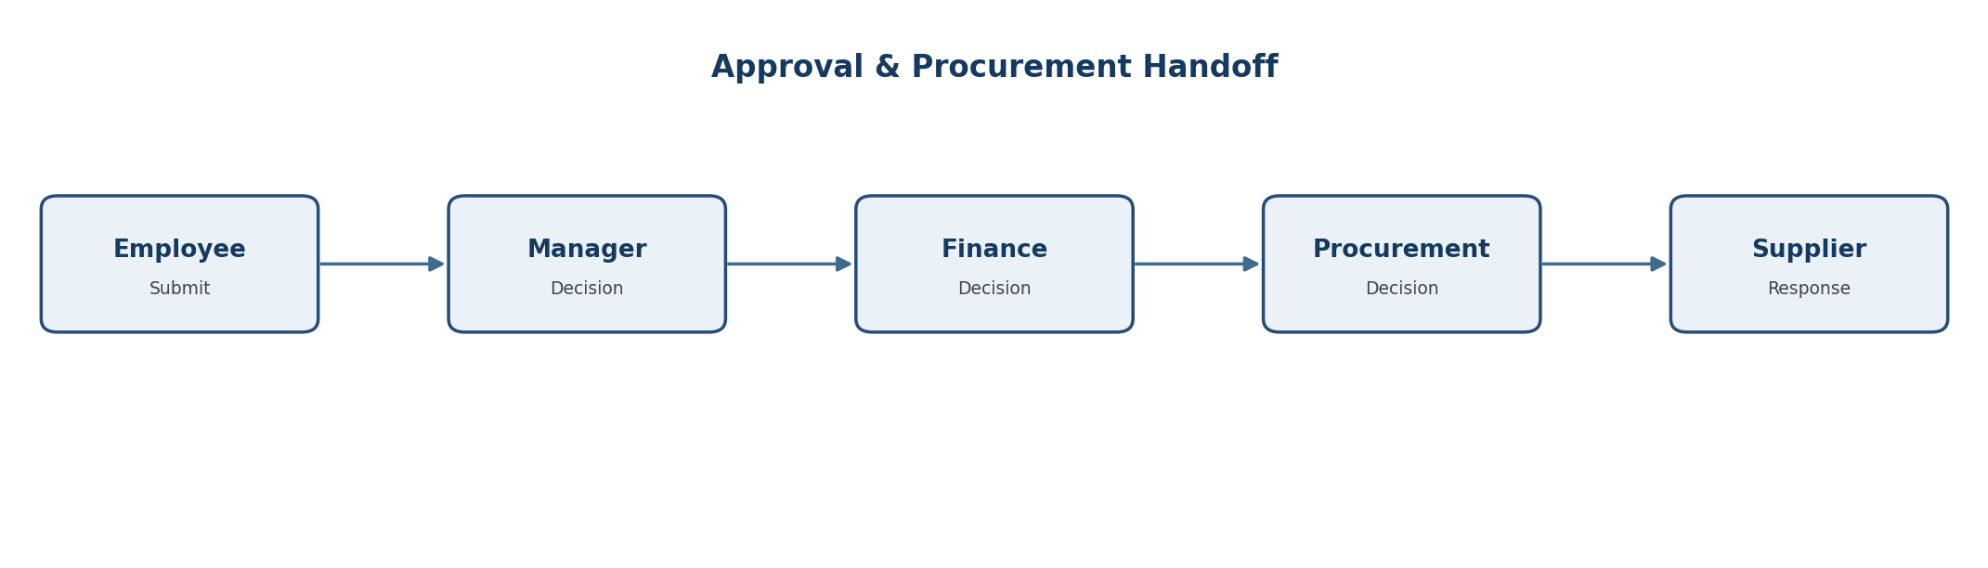
- Employee creates a requisition and selects a single product category for the request.
- Manager reviews the request and either approves or rejects it.
- Finance validates the request/budget and either approves or rejects it.
- Approved requisitions become available to Procurement for supplier selection and PO generation.
- Procurement creates the PO, generates a PDF and dispatches it to the supplier.
- Supplier views the PO and responds. In the current project flow, supplier acceptance transitions the requisition/PO workflow to PO_RECEIVED.
- The order then progresses through supplier delivery, receipt/inspection, inventory updates, and completion. Procurement can raise return or replacement requests when delivered goods have quality, quantity, or fulfillment issues.
- History records are written whenever important status changes occur.

7. Approval and Notification Design

Notification Rules
Event | Recipients | Purpose
Requisition created | Manager, Admin | Start approval workflow
Manager approved | Finance, Admin, Employee | Move request to budget validation
Manager rejected | Admin, Employee | Inform stakeholders of rejection
Finance approved | Procurement, Admin, Employee | Release for procurement execution
Finance rejected | Admin, Employee | Inform requester and governance role
Procurement decision | Admin, Employee | Confirm procurement outcome
PO sent to supplier | Supplier | Present PO for supplier action
Supplier accepted/rejected | Procurement, Admin | Close supplier response loop
PO status changes | Relevant stakeholders | Maintain visibility throughout lifecycle

Notification Design Pattern
Business services invoke a centralized NotificationService after a successful transactional state change. Notifications are based on role/user context and the affected requisition or purchase order.

8. Purchase Order and Supplier Design

PO Lifecycle
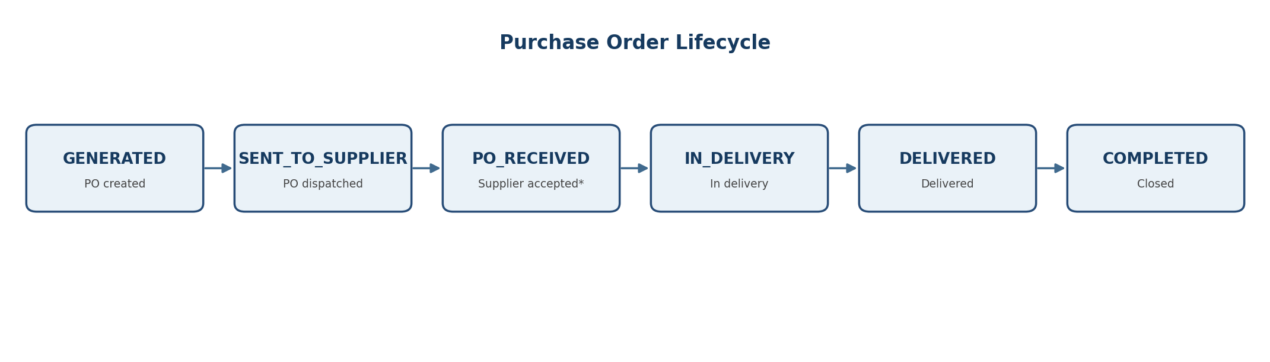
*In the current project workflow, PO_RECEIVED is used as the supplier-accepted stage. The UI can present this as “Supplier Accepted” while retaining the existing enum value.

Purchase Order Generation Rules
- Only approved requisitions may generate a PO.
- Duplicate PO generation for the same requisition is blocked.
- Supplier must exist and be active.
- Supplier category must match the requisition product category.
- Purchase quantity is calculated as requisition quantity minus available inventory; if current inventory is already sufficient, purchase is rejected for that line.
- PO line total = purchase quantity × unit price.
- PO creation writes the initial purchase order history record.

Supplier Portal Functions
- View assigned purchase orders
- Accept or reject a PO
- Progress the order through configured status transitions
- Upload supplier documents
- View/download relevant order and document files

9. Inventory and Goods Receipt Design

Inventory Entity Responsibilities
Field / Relation | Purpose | Design Note
product_id | Unique product inventory record | One inventory record per product
quantity_on_hand | Available stock | Primary stock quantity
quantity_under_inspection | Goods awaiting inspection | Should be non-null / default 0
quantity_quarantined | Held due to issue | Should be non-null / default 0
receiving_location | Physical location | Human-readable storage location
last_po_id | Last related PO | Traceability back to procurement
updated_at | Last modification timestamp | Maintained by lifecycle hooks

Receipt and Exception Handling
- Goods receipt should verify delivered quantities against PO items.
- Inspection may result in full receipt, partial receipt, or quality issue.
- Partial receipt can follow a replacement path when shortages are reported.
- Quality issues can initiate return and replacement handling.
- Successful receipt updates quantity_on_hand and references the related PO. Procurement can raise return or replacement requests for damaged, incorrect, defective, or short deliveries.
- Procurement can raise return/replacement requests for damaged, incorrect, defective, or short deliveries.

10. Data Model Design
The system uses a normalized relational design centered on requisitions, purchase orders, suppliers, products, approvals, inventory, documents, and history tables.

Core Relationships
Entity | Key Relationships | Purpose
PurchaseRequisition | Many-to-one Employee; one-to-many RequisitionItem; one-to-many RequisitionStatusHistory | Request and approval context
RequisitionItem | Many-to-one PurchaseRequisition; many-to-one Product | Requested quantity and price
Product | Many-to-one ProductCategory | Product master data
Supplier | Many-to-one ProductCategory; one-to-many SupplierDocument; one-to-many PurchaseOrder | Supplier master and fulfillment partner
PurchaseOrder | Many-to-one PurchaseRequisition; many-to-one Supplier; one-to-many PoItem; one-to-many PurchaseOrderHistory | Commercial order record
PoItem | Many-to-one PurchaseOrder; many-to-one Product | PO line details
Inventory | One-to-one Product; optional last PurchaseOrder; one-to-many InventoryTransaction | Stock and movement context
SupplierDocument | Many-to-one Supplier | Supplier-uploaded files
PurchaseOrderHistory | Many-to-one PurchaseOrder; many-to-one User | PO lifecycle audit trail
RequisitionStatusHistory | Many-to-one PurchaseRequisition; many-to-one User | Requisition lifecycle audit trail

Status History Design
- History tables store old status, new status, actor, remarks and change timestamp.
- History is appended during status changes instead of overwriting previous events.

11. API and Service Design

Representative REST Endpoints
Method | Endpoint Pattern | Purpose
POST | /requisitions | Create requisition
GET | /requisitions/{id}/history | Get requisition status history
GET | /approvals/procurement?status={status} | Get procurement requests by status
POST | /purchase-orders | Generate purchase order from approved requisition
PUT | /purchase-orders/{id}/status | Transition PO to a valid next status
GET | /purchase-orders/{id}/pdf | Generate/download PO PDF
GET | /purchase-orders/supplier/status?status={status} | Supplier POs filtered by status
GET | /purchase-orders/{id}/history | Track PO lifecycle history
POST | /supplier-documents/documents | Upload supplier document as multipart form-data
PUT | /supplier-documents/documents/{documentId} | Replace supplier document
GET | /suppliers/{supplierId}/documents | List supplier documents

Service Layer Responsibilities
- Repositories handle persistence and derived queries.
- Services perform validation, state changes, mapping and orchestration.
- Controllers expose small, role-aware endpoints and return DTOs/ApiResponse wrappers.
- DTOs prevent direct entity exposure and allow UI-oriented representations.

12. Security Design
- JWT-based authentication identifies the current user.
- Spring Security + @PreAuthorize enforce role-based permissions on sensitive endpoints.
- Roles map to business capabilities such as approval, procurement, supplier actions and administration.
- Current-user lookup is used where ownership or supplier identity must be derived server-side.
- Validation and structured exceptions prevent malformed or unauthorized workflow operations.
- File uploads should be restricted by accepted content types and handled outside the relational database.

Security Boundaries
Area | Control
Authentication | JWT token validation
Authorization | Role-based method security
Business ownership | Server-side current user / supplier lookup
Data integrity | Transactional state changes
Auditability | History + AuditService
File access | Controlled document endpoints / stored URLs

13. Validation, Errors and Concurrency

Validation Rules
- Required fields are validated with Jakarta Bean Validation.
- Requisition requests validate quantities and amount constraints.
- Supplier category must match the PO requisition category.
- Inactive suppliers cannot be selected.
- Duplicate PO generation is rejected.
- Invalid state transitions are rejected by a dedicated PO state machine.
- Inventory values used in business decisions should not be nullable when represented as primitive numeric fields.

Structured Error Handling
The API uses ResponseStatusException and centralized response/error handling to return meaningful HTTP responses such as 400 for invalid requests/transitions, 403 for authorization failures, and 404 for missing resources.

Concurrency and Transaction Design
- PO status changes are executed within @Transactional service methods.
- The state machine validates currentStatus → newStatus before persistence.
- History creation occurs in the same business transaction so the event record remains consistent with the status change.
- Where simultaneous approvals or duplicate actions are possible, optimistic locking/versioning is a suitable extension to strengthen concurrent-update protection.

14. Reporting and Document Management

Reports and Dashboards
- Procurement summary KPIs
- Spending analysis and trends
- Supplier performance indicators
- Approval cycle/bottleneck reporting
- PO status visibility
- Inventory insights and stock indicators
- Downloadable Excel and PDF reports

PDF / Excel Generation
OpenPDF is used for PDF generation such as Purchase Orders and invoices, while Apache POI supports Excel exports for management reporting.

Supplier Documents
- Documents are uploaded as multipart/form-data.
- The service identifies the current supplier from the authenticated user.
- The file is stored in Cloudinary and the secure URL is persisted in SupplierDocument.
- Supported document types include GST Certificate, PAN Card, Business Registration, Bank Proof and Other.
- The current scope is document storage/view/replace; verification status is not required in the simplified workflow.

15. Non-Functional Requirements
Category | Requirement | Design Response
Security | Protect role-sensitive operations | JWT + Spring Security + method authorization
Reliability | Keep status and history consistent | Transactions + history writes in same transaction
Maintainability | Keep modules independent | Controller → Service → Repository pattern
Traceability | Understand who changed what and when | History entities + AuditService
Usability | Provide role-oriented dashboards | React dashboards, filters, actions and timeline tracking
Scalability | Support additional workflow modules | REST APIs, normalized schema, modular services
Performance | Avoid unnecessary data processing | Derived JPA queries, category filtering, targeted status queries
Data Integrity | Prevent invalid states and invalid references | Validation, FK relationships, state machine rules

16. Testing Strategy
- Controller/API tests for success and validation failures
- Service tests for workflow/state-machine rules
- Repository tests for status/category/supplier filters
- Integration tests for transactional status + history updates
- Security tests for role restrictions
- File upload tests for supported content types and replacement
- PO PDF generation tests
- Regression tests for notification-triggering transitions

Critical Test Scenarios
Scenario | Expected Result
Generate PO from non-approved requisition | 400 and no PO created
Generate duplicate PO | 400 and existing PO preserved
Supplier category mismatch | 400 and no PO created
Invalid PO status transition | 400 with valid next-status list
Supplier uploads document | File stored and SupplierDocument created
Replace supplier document | Existing record updated with new file metadata
PO status update | PO status and history change together
Unauthorized role | 403

17. Deployment and Operational Design

Runtime Components
- React frontend served as the web client
- Spring Boot application as REST backend
- MySQL database
- Cloudinary account for document/media storage
- Mail/notification infrastructure where configured

Environment Configuration
- Database connection and credentials
- JWT/security secrets
- Cloudinary credentials
- Mail server configuration
- Application profile / port
- CORS configuration for frontend integration

Operational Considerations
- Back up MySQL data and retain audit/history tables.
- Monitor failed uploads, notification errors and PDF generation exceptions.
- Keep environment secrets outside source control.
- Use migration/versioning discipline when schema fields or enums change.

18. Project Links and Working Documents
Resource | Reference
GitHub – Development Branch | github.com/PraveenBirla/Procurement-System/tree/development
Google Drive – Project Documents | Project folder in Google Drive
Database Design – dbDiagram | dbdiagram.io/d/PS_System-6a4cb7964ac62e474c47b810
Defect Tracker Sheet | Google Sheets – Defect Tracker
Unit Testing Sheet | Google Sheets – Unit Testing
Agile Documentation | Google Sheets – Agile Documentation
The project presentation also identifies AI Chatbot / AI-based Supplier Recommendation as a project capability/theme; implementation coverage can be documented separately according to the final code state.

19. Future Enhancements
- Advanced supplier scoring and benchmarking
- AI demand forecasting
- Automated invoice processing and payment integration
- Mobile application for approvals and monitoring
- Improved supplier portal capabilities
- Enhanced analytics and configurable procurement KPIs
- Stronger concurrent update controls with optimistic locking/versioning
- Workflow configuration rather than hard-coded state transitions

Design Summary
The system is designed as a role-driven, status-controlled procurement platform. Its core architecture separates presentation, business logic and persistence; its workflows emphasize controlled approvals and PO state transitions; and its history, audit, notification and reporting features provide end-to-end visibility.

