Machine Learning Assignment – 01

Goutham Parakala

700745866

1. Numpy:

a. Using NumPy create random vector of size 15 having only Integers in the range 1-20.

1. Reshape the array to 3 by 5

2. Print array shape.

3. Replace the max in each row by 0

import numpy as np

# create random vector of size 15 with integers in range 1-20 vec = np.random.randint(1, 21, size=15)

# reshape to 3 by 5

arr = vec.reshape(3, 5)

# print array shape

print("Array shape:", arr.shape)

# replace max in each row by 0 arr[np.arange(len(arr)), arr.argmax(axis=1)] = 0

print(arr)

**Array shape: (3, 5)**

|  |  |  |  |  |
| --- | --- | --- | --- | --- |
| **[[15** | **2** | **0** | **16** | **8]** |
| **[ 1** | **13** | **0** | **7** | **7]** |
| **[ 2** | **9** | **10** | **0** | **11]]** |
|  |  |  |  |  |
|  |  |  |  |  |

Create a 2-dimensional array of size 4 x 3 (composed of 4-byte integer elements), also print the shape, type and data type of the array.

1. Write a program to compute the eigenvalues and right eigenvectors of a given square array given below: [[ 3 -2] [ 1 0]]
2. Compute the sum of the diagonal element of a given array. [[0 1 2] [3 4 5]]
3. Write a NumPy program to create a new shape to an array without changing its data. Reshape 3x2: [[1 2] [3 4] [5 6]] Reshape 2x3: [[1 2 3] [4 5 6]]

import numpy as np

# create square array

arr = np.array([[3, -2], [1, 0]])

# compute eigenvalues and right eigenvectors eig_vals, eig_vecs = np.linalg.eig(arr)

print("Eigenvalues:", eig_vals) print("Right eigenvectors:\n", eig_vecs)

Eigen values: [2. 1.]

Right eigenvectors :

[[0.89442719 0.70710678]

[0.4472136 0.70710678]]

import numpy as np

# create array

arr = np.array([[0, 1, 2], [3, 4, 5]])

# compute sum of diagonal elements diag_sum = np.trace(arr)

print("Sum of diagonal elements:", diag_sum)

Sum of diagonal elements: 4

import numpy as np

# create original array

arr = np.array([[1, 2], [3, 4], [5, 6]])

# reshape to 3 by 2

arr_3by2 = arr.reshape(3, 2)

# reshape to 2 by 3

arr_2by3 = arr.reshape(2, 3)

print("Original array:\n", arr) print("Reshaped to 3 by 2:\n", arr_3by2) print("Reshaped to 2 by 3:\n", arr_2by3)

Original array: [[1 2]

[3 4]

[5 6]]

Reshaped to 3 by 2:

[[1 2]

[3 4]

[5 6]]

Reshaped to 2 by 3:

[[1 2 3]

[4 5 6]]

# Import the matplotlib.pyplot module, which allows us to create plots import matplotlib.pyplot as plt

# Define the data we want to plot

languages = 'Java', 'Python', 'PHP', 'JavaScript', 'C#', 'C++'

popularity = [22.2, 17.6, 8.8, 8, 7.7, 6.7]

colors = ["#1f77b4", "#ff7f0e", "#2ca02c", "#d62728", "#9467bd", "#8c564b"]

# Define how much we want to "explode" each slice of the pie chart explode = (0.1, 0, 0, 0, 0, 0)

# Use the pie function to create the pie chart

plt.pie(popularity, # The data to plot (popularity percentages)

explode=explode, # How much to "explode" each slice labels=languages, # Labels for each slice (the language names) colors=colors, # Colors for each slice

autopct='%1.1f%%', # Format for the percentage labels shadow=True, # Whether to include a shadow effect startangle=140 # The angle at which the chart starts

)

# Set the aspect ratio of the chart to be equal, so it appears circular plt.axis('equal')

# Display the chart plt.show()

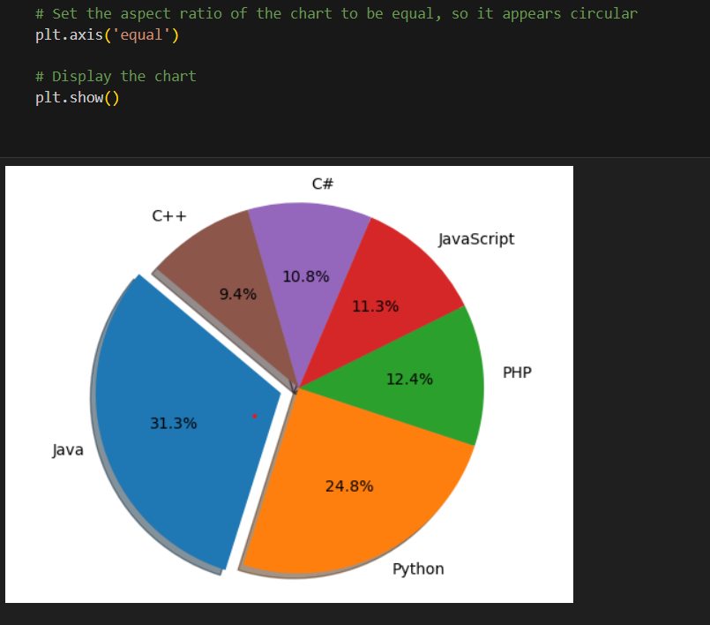

**Github Link :** [**https://github.com/gouthamro45/ML_Assignment01**](https://github.com/gouthamro45/ML_Assignment01)

**Video Link :** [**https://github.com/gouthamro45/ML_Assignment01/blob/main/ML_700745866_Assignment1.mp4**](https://github.com/gouthamro45/ML_Assignment01/blob/main/ML_700745866_Assignment1.mp4)