**WEEK6:**

1. **ReactJS-HOL:**

**Src:**

Set up a react environment

Use create-react-app

**1.1 App.css:**

.App {

  text-align: center;

}

.App-logo {

  height: 40vmin;

  pointer-events: none;

}

@media (prefers-reduced-motion: no-preference) {

  .App-logo {

    animation: App-logo-spin infinite 20s linear;

  }

}

.App-header {

  background-color: #282c34;

  min-height: 100vh;

  display: flex;

  flex-direction: column;

  align-items: center;

  justify-content: center;

  font-size: calc(10px + 2vmin);

  color: white;

}

.App-link {

  color: #61dafb;

}

@keyframes App-logo-spin {

  from {

    transform: rotate(0deg);

  }

  to {

    transform: rotate(360deg);

  }

}

**App.js:**

import React from 'react';

function App() {

  return (

    <div>

      <h1>Welcome to the first session of React</h1>

    </div>

  );

}

export default App;

**App.test.js:**

import { render, screen } from '@testing-library/react';

import App from './App';

test('renders learn react link', () => {

  render(<App />);

  const linkElement = screen.getByText(/learn react/i);

  expect(linkElement).toBeInTheDocument();

});

**Index.css:**

body {

  margin: 0;

  font-family: -apple-system, BlinkMacSystemFont, 'Segoe UI', 'Roboto', 'Oxygen',

    'Ubuntu', 'Cantarell', 'Fira Sans', 'Droid Sans', 'Helvetica Neue',

    sans-serif;

  -webkit-font-smoothing: antialiased;

  -moz-osx-font-smoothing: grayscale;

}

code {

  font-family: source-code-pro, Menlo, Monaco, Consolas, 'Courier New',

    monospace;

}

**Index.js:**

import React from 'react';

import ReactDOM from 'react-dom/client';

import './index.css';

import App from './App';

import reportWebVitals from './reportWebVitals';

const root = ReactDOM.createRoot(document.getElementById('root'));

root.render(

  <React.StrictMode>

    <App />

  </React.StrictMode>

);

// If you want to start measuring performance in your app, pass a function

// to log results (for example: reportWebVitals(console.log))

// or send to an analytics endpoint. Learn more: https://bit.ly/CRA-vitals

reportWebVitals();

**Output:**

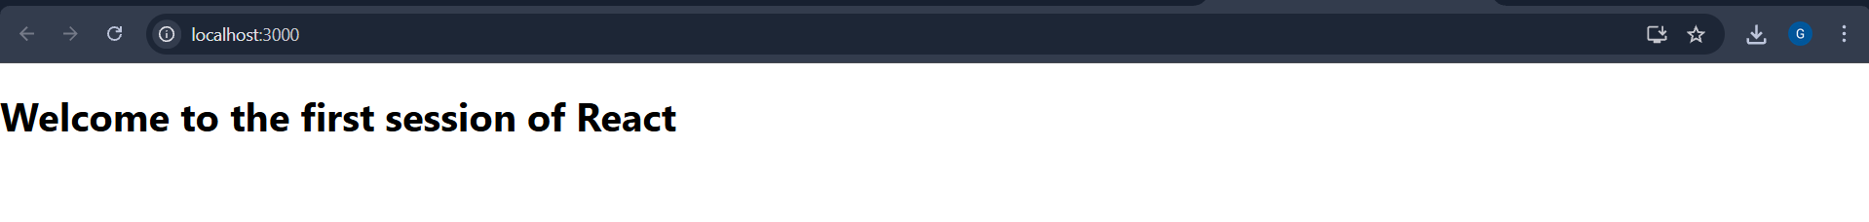

1. **ReactJS-HOL:**

**Studentapp:**

**About.js:**

import React, { Component } from 'react';

class About extends Component {

  render() {

    return (

      <div>

        <h3>Welcome to the About Page of Student Management Portal</h3>

      </div>

    );

  }

}

export default About;

**Contact.js:**

import React, { Component } from 'react';

class Contact extends Component {

  render() {

    return (

      <div>

        <h3>Welcome to the Contact Page of Student Management Portal</h3>

      </div>

    );

  }

}

export default Contact;

**Home.js:**

import React, { Component } from 'react';

class Contact extends Component {

  render() {

    return (

      <div>

        <h3>Welcome to the Contact Page of Student Management Portal</h3>

      </div>

    );

  }

}

export default Contact;

**App.js:**

import React from 'react';

import './App.css';

import Home from './Components/Home';

import About from './Components/About';

import Contact from './Components/Contact';

function App() {

  return (

    <div className="container">

      <Home />

      <About />

      <Contact />

    </div>

  );

}

export default App;

**Output:**

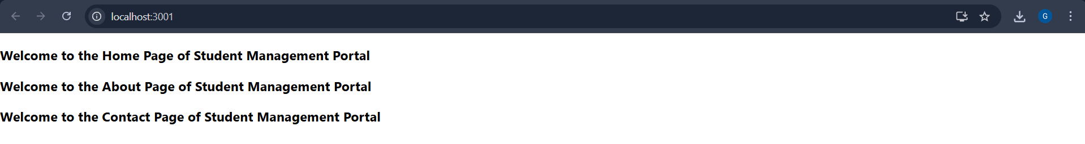

1. **ReactJS-HOL:**

**Scorecalculatorapp:**

**CalculateScore.js:**

import '../Stylesheets/mystyle.css';

const percentToDecimal = (decimal) => {

  return (decimal.toFixed(2) + '%');

};

const calcScore = (total, goal) => {

  return percentToDecimal(total / goal);

};

export const CalculateScore = ({ Name, School, total, goal }) => (

  <div className="formatstyle">

    <h1><font color="Brown">Student Details:</font></h1>

    <div className="Name">

      <b><span>Name:</span></b>

      <span> {Name}</span>

    </div>

    <div className="School">

      <b><span>School:</span></b>

      <span> {School}</span>

    </div>

    <div className="Total">

      <b><span>Total:</span></b>

      <span> {total}</span> Marks

    </div>

    <div className="Score">

      <b>Score:</b>

      <span> {calcScore(total, goal)}</span>

    </div>

  </div>

);

**mystyle.css:**

.Name {

  font-weight: 300;

  color: blue;

}

.School {

  color: crimson;

}

.Total {

  color: darkmagenta;

}

.Score {

  color: forestgreen;

}

.formatstyle {

  text-align: center;

  font-size: large;

}

**App.js:**

import { CalculateScore } from './Components/CalculateScore';

function App() {

  return (

    <div>

      <CalculateScore

        Name="Gowtham"

        School="Vel Tech University"

        total={284}

        goal={300}

      />

    </div>

  );

}

export default App;

**index.css:**

body {

  margin: 0;

  padding: 0;

  font-family: Arial, sans-serif;

}

**Output:**

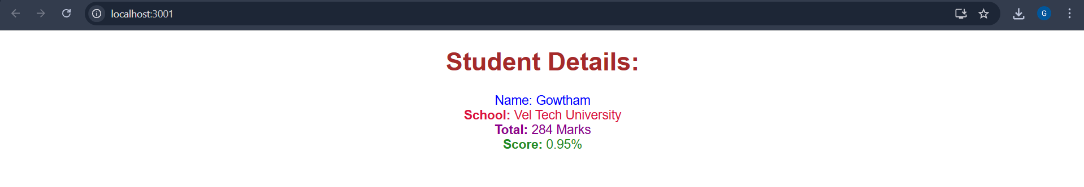

1. **ReactJS-HOL:**

**blogapp:**

**index.html:**

<!DOCTYPE html>

<html lang="en">

<head>

  <meta charset="UTF-8" />

  <meta name="viewport" content="width=device-width, initial-scale=1.0"/>

  <title>Post Viewer</title>

  <style>

    body {

      font-family: Arial, sans-serif;

      background: #f5f5f5;

      margin: 0;

      padding: 20px;

    }

    .container {

      max-width: 800px;

      margin: auto;

    }

    .post {

      background: #fff;

      margin-bottom: 15px;

      padding: 15px;

      border-radius: 8px;

      box-shadow: 0 2px 6px rgba(0,0,0,0.1);

    }

    .post h2 {

      font-size: 1.25rem;

      margin-bottom: 10px;

      color: #333;

    }

    .post p {

      font-size: 1rem;

      color: #555;

      line-height: 1.6;

    }

  </style>

</head>

<body>

  <div class="container">

    <h1>Posts</h1>

<div class="post">

  <h2>Title goes here</h2>

  <p>Body goes here</p>

</div>

    <!-- Posts Start Here -->

    <div class="post">

      <h2>sunt aut facere repellat provident occaecati excepturi optio reprehenderit</h2>

      <p>quia et suscipit suscipit recusandae consequuntur expedita et cum reprehenderit molestiae ut ut quas totam nostrum rerum est autem sunt rem eveniet architecto</p>

    </div>

    <div class="post">

      <h2>qui est esse</h2>

      <p>est rerum tempore vitae sequi sint nihil reprehenderit dolor beatae ea dolores neque fugiat blanditiis voluptate porro vel nihil molestiae ut reiciendis qui aperiam non debitis possimus qui neque nisi nulla</p>

    </div>

    <!-- Add more posts here by repeating the same div structure -->

    <!-- For brevity, you can paste more posts below using this format -->

    <!-- <div class="post"><h2>Title</h2><p>Body</p></div> -->

  </div>

</body>

</html>

**App.js:**

// src/App.js

import React from "react";

import "./App.css";

import Posts from "./Posts";

function App() {

  return (

    <div className="App">

      <Posts />

    </div>

  );

}

export default App;

**Post.js:**

// src/Post.js

import React from "react";

function Post({ title, body }) {

  return (

    <div className="post">

      <h2>{title}</h2>

      <p>{body}</p>

    </div>

  );

}

export default Post;

**Posts.js:**

// src/Posts.js

import React from "react";

import Post from "./Post";

class Posts extends React.Component {

  constructor(props) {

    super(props);

    this.state = {

      posts: [],

      hasError: false,

      errorInfo: null,

    };

  }

  // Step 6: Fetch Posts

  loadPosts() {

    fetch("https://jsonplaceholder.typicode.com/posts")

      .then((response) => response.json())

      .then((data) => {

        this.setState({ posts: data });

      })

      .catch((error) => {

        this.setState({ hasError: true, errorInfo: error });

      });

  }

  // Step 7: Lifecycle hook to call loadPosts()

  componentDidMount() {

    this.loadPosts();

  }

  // Step 9: Handle unexpected rendering errors

  componentDidCatch(error, info) {

    alert(`An error occurred: ${error.toString()}`);

    this.setState({ hasError: true, errorInfo: info });

  }

  // Step 8: Render posts

  render() {

    if (this.state.hasError) {

      return <h2>Something went wrong.</h2>;

    }

    return (

      <div>

        <h1>Posts</h1>

        {this.state.posts.length > 0 ? (

          this.state.posts.map((post) => (

            <Post key={post.id} title={post.title} body={post.body} />

          ))

        ) : (

          <p>Loading...</p>

        )}

      </div>

    );

  }

}

export default Posts;

**Output:**

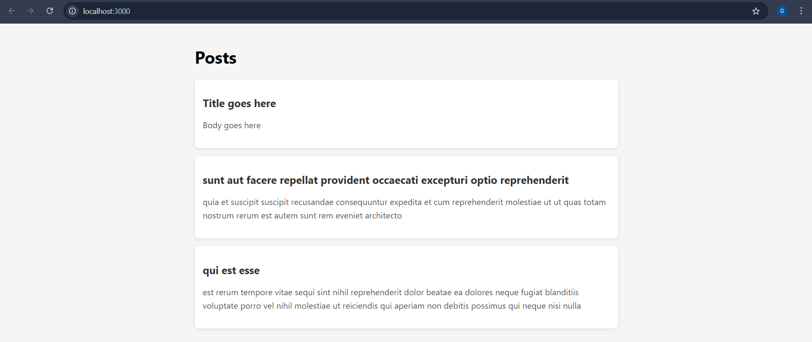

1. **ReactJS-HOL:**

**COHORT:**

**App.js:**

import React from 'react';

import CohortDetails from './CohortDetails';

const cohortList = [

  {

    name: 'INTADMDF10 -.NET FSD',

    startDate: '22-Feb-2022',

    status: 'Scheduled',

    coach: 'Aathma',

    trainer: 'Jojo Jose',

  },

  {

    name: 'ADM21JF014 - Java FSD',

    startDate: '10-Sep-2021',

    status: 'Ongoing',

    coach: 'Apoorv',

    trainer: 'Elisa Smith',

  },

  {

    name: 'CDBJF21025 - Java FSD',

    startDate: '24-Dec-2021',

    status: 'Ongoing',

    coach: 'Aathma',

    trainer: 'John Doe',

  }

];

function App() {

  return (

    <div>

      <h2>Cohorts Details</h2>

      {cohortList.map((cohort, index) => (

        <CohortDetails key={index} cohort={cohort} />

      ))}

    </div>

  );

}

export default App;

**Cohort.js:**

class Cohort {

    constructor(cohortCode,

        startDate,

        technology,

        trainerName,

        coachName,

        currentStatus) {

        this.cohortCode = cohortCode;

        this.coachName = coachName;

        this.trainerName = trainerName;

        this.technology = technology;

        this.startDate = startDate;

        this.currentStatus = currentStatus;

    }

}

const CohortsData =[

    new Cohort('INTADMDF10','22-Feb-2022', '.NET FSD', 'Jojo Jose','Aathma', 'Scheduled'),

    new Cohort('ADM21JF014','10-Sep-2021', 'Java FSD', 'Elisa Smith','Apoorv', 'Ongoing'),

    new Cohort('CDBJF21025','24-Dec-2021', 'Java FSD', 'John Doe','Aathma', 'Ongoing'),

    new Cohort('INTADMJF12','22-Feb-2022', 'Java FSD', 'To Be Assigned','Ibrahim', 'Scheduled'),

    new Cohort('CDE22JF011','24-Dec-2021', 'Java FSD', 'Emma Swan','Apoorv', 'Ongoing'),

    new Cohort('INTADMDF09','22-Feb-2022', 'Dataware Housing', 'Babjee Rao','Aathma', 'Scheduled'),

    new Cohort('ADM22DF001','10-Sep-2021', '.NET FSD', 'Marie Curie','Ibrahim', 'Ongoing'),

];

export {Cohort, CohortsData};

**CohortDetails.js:**

import React from 'react';

import styles from './CohortDetails.module.css';

const CohortDetails = ({ cohort }) => {

  return (

    <div className={styles.box}>

      <h3 style={{ color: cohort.status === 'Ongoing' ? 'green' : 'blue' }}>

        {cohort.name}

      </h3>

      <dl>

        <dt>Started On</dt>

        <dd>{cohort.startDate}</dd>

        <dt>Current Status</dt>

        <dd>{cohort.status}</dd>

        <dt>Coach</dt>

        <dd>{cohort.coach}</dd>

        <dt>Trainer</dt>

        <dd>{cohort.trainer}</dd>

      </dl>

    </div>

  );

};

export default CohortDetails;

**Output:**

