**Week7:**

**9. ReactJS-HOL:**

**Cricketapp:**

**App.js:**

import React from 'react';

import ListofPlayers from './ListofPlayers';

import Scorebelow70 from './Scorebelow70';

import { OddPlayers } from './OddPlayers';

import { EvenPlayers } from './EvenPlayers';

import ListofIndianPlayers from './ListofIndianPlayers';

import { players } from './data';

const T20Players = ['First Player', 'Second Player', 'Third Player'];

const RanjiTrophyPlayers = ['Fourth Player', 'Fifth Player', 'Sixth Player'];

export const IndianPlayers = [...T20Players, ...RanjiTrophyPlayers];

const flag = true;

function App() {

  if (flag === true) {

    return (

      <div>

        <h1>List of Players</h1>

        <ListofPlayers players={players} />

        <hr />

        <h1>List of Players having Scores Less than 70</h1>

        <Scorebelow70 players={players} />

      </div>

    );

  } else {

    return (

      <div>

        <div>

          <h1>Indian Team</h1>

          <h1>Odd Players</h1>

          {OddPlayers(IndianPlayers)}

          <hr />

          <h1>Even Players</h1>

          {EvenPlayers(IndianPlayers)}

        </div>

        <hr />

        <div>

          <h1>List of Indian Players Merged:</h1>

          <ListofIndianPlayers IndianPlayers={IndianPlayers} />

        </div>

      </div>

    );

  }

}

export default App;

**Data.js:**

export const players = [

  { name: "Jack", score: 50 },

  { name: "Michael", score: 70 },

  { name: "John", score: 40 },

  { name: "Ann", score: 61 },

  { name: "Elisabeth", score: 61 },

  { name: "Sachin", score: 95 },

  { name: "Dhoni", score: 100 },

  { name: "Virat", score: 84 },

  { name: "Jadeja", score: 64 },

  { name: "Raina", score: 75 },

  { name: "Rohit", score: 80 },

];

**EvenPlayers.js:**

export function EvenPlayers([ , second, , fourth, , sixth]) {

  return (

    <div>

      <li>Second : {second}</li>

      <li>Fourth : {fourth}</li>

      <li>Sixth : {sixth}</li>

    </div>

  );

}

**ListofIndianPlayers.js:**

function ListofIndianPlayers({ IndianPlayers }) {

  return (

    <div>

      {IndianPlayers.map((player, index) => (

        <li key={index}>Mr. {player}</li>

      ))}

    </div>

  );

}

export default ListofIndianPlayers;

**ListofPlaayers.js:**

function ListofPlayers({ players }) {

  return (

    <div>

      {players.map((item, index) => (

        <li key={index}>Mr. {item.name} <span>{item.score}</span></li>

      ))}

    </div>

  );

}

export default ListofPlayers;

**OddPlayers.js:**

export function OddPlayers([first, , third, , fifth]) {

  return (

    <div>

      <li>First : {first}</li>

      <li>Third : {third}</li>

      <li>Fifth : {fifth}</li>

    </div>

  );

}

**Scorebelow70.js:**

function Scorebelow70({ players }) {

  const players70 = players.filter(item => item.score <= 70);

  return (

    <div>

      {players70.map((item, index) => (

        <li key={index}>Mr. {item.name} <span>{item.score}</span></li>

      ))}

    </div>

  );

}

export default Scorebelow70;

**Output:**

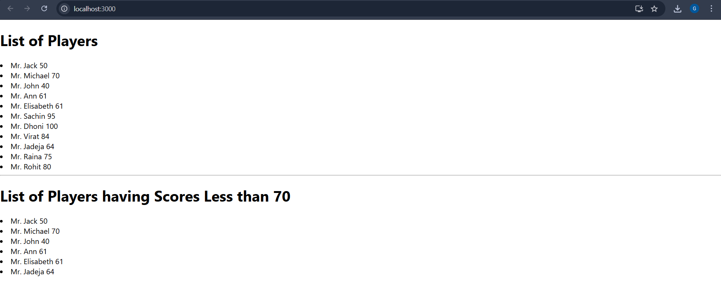

**10. ReactJS-HOL:**

**Officespacerentalapp:**

**App.js:**

import React from 'react';

// Office data list

const officeList = [

  {

    name: "IndiQube Alpha",

    rent: 50000,

    address: "BTM Layout, Bangalore",

    image: process.env.PUBLIC_URL + "/91s.jpeg"

  },

  {

    name: "WeWork Prestige",

    rent: 75000,

    address: "Koramangala, Bangalore",

    image: process.env.PUBLIC_URL + "/co.jpeg"

  },

  {

    name: "CoWrks",

    rent: 65000,

    address: "Manyata Tech Park, Bangalore",

    image: process.env.PUBLIC_URL + "/indi.jpeg"

  },

  {

    name: "91Springboard",

    rent: 40000,

    address: "HSR Layout, Bangalore",

    image: process.env.PUBLIC_URL + "/we.jpeg"

  }

];

function App() {

  return (

    <div style={{ padding: '20px', fontFamily: 'Arial' }}>

      <h1 style={{ color: '#2c3e50', textAlign: 'center' }}>🏢 Office Space Rental Portal</h1>

      {officeList.map((office, index) => {

        const rentStyle = {

          color: office.rent < 60000 ? 'red' : 'green',

          fontWeight: 'bold'

        };

        return (

          <div

            key={index}

            style={{

              border: '1px solid #ccc',

              padding: '15px',

              marginBottom: '20px',

              borderRadius: '10px',

              display: 'flex',

              alignItems: 'center',

              gap: '20px'

            }}

          >

            <img

              src={office.image}

              alt={office.name}

              style={{

                width: '300px',

                height: '200px',

                objectFit: 'cover',

                borderRadius: '8px'

              }}

            />

            <div>

              <h2>{office.name}</h2>

              <p><strong>Address:</strong> {office.address}</p>

              <p><strong>Rent:</strong> <span style={rentStyle}>₹{office.rent}</span></p>

            </div>

          </div>

        );

      })}

    </div>

  );

}

export default App;

**Index.js:**

import React from 'react';

import ReactDOM from 'react-dom/client';

import App from './App';

const root = ReactDOM.createRoot(document.getElementById('root'));

root.render(<App />);

**Output:**

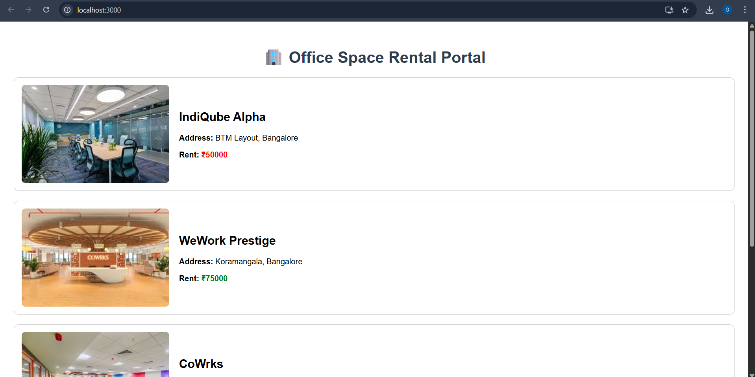

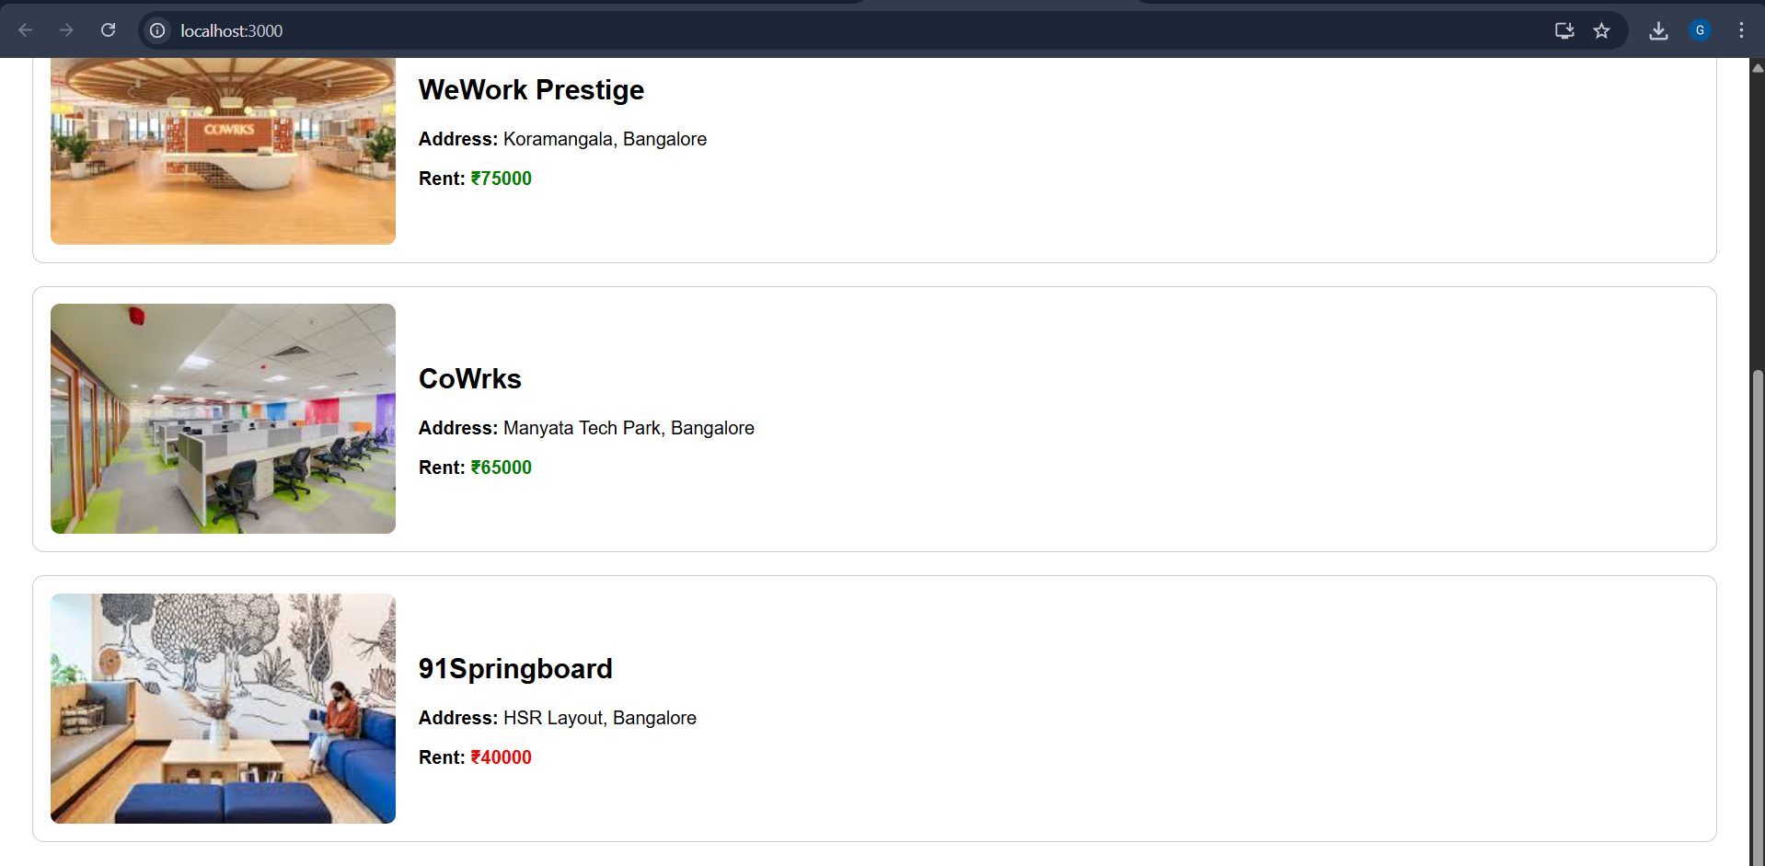

**11. ReactJS-HOL:**

**Eventexamplesapp:**

**App.js:**

import React from 'react';

import Counter from './Counter';

import CurrencyConverter from './CurrencyConverter';

function App() {

  return (

    <div style={{ padding: '20px' }}>

      <h1>🎯 Event Examples App</h1>

      <Counter />

      <CurrencyConverter />

    </div>

  );

}

export default App;

**Counter.js:**

import React, { Component } from 'react';

class Counter extends Component {

  constructor(props) {

    super(props);

    this.state = {

      count: 0,

    };

    // Binding for 'this'

    this.handleIncrement = this.handleIncrement.bind(this);

    this.sayHello = this.sayHello.bind(this);

    this.sayWelcome = this.sayWelcome.bind(this);

  }

  handleIncrement() {

    this.setState({ count: this.state.count + 1 });

    this.sayHello();

  }

  handleDecrement = () => {

    this.setState({ count: this.state.count - 1 });

  }

  sayHello() {

    console.log('Hello! You clicked increment.');

  }

  sayWelcome(message) {

    alert(`Welcome message: ${message}`);

  }

  handleSyntheticEvent = (event) => {

    alert("I was clicked!");

    console.log("Synthetic Event:", event);

  }

  render() {

    return (

      <div>

        <h2>Counter: {this.state.count}</h2>

        <button onClick={this.handleIncrement}>Increment</button>

        <button onClick={this.handleDecrement}>Decrement</button>

        <br /><br />

        <button onClick={() => this.sayWelcome("Welcome to the React Event App!")}>Say Welcome</button>

        <br /><br />

        <button onClick={this.handleSyntheticEvent}>OnPress</button>

      </div>

    );

  }

}

export default Counter;

**CurrencyConverter.js:**

import React, { useState } from 'react';

function CurrencyConverter() {

  const [rupees, setRupees] = useState('');

  const [euros, setEuros] = useState('');

  const handleSubmit = () => {

    const euroRate = 0.011; // 1 INR = 0.011 EUR

    const converted = (parseFloat(rupees) * euroRate).toFixed(2);

    setEuros(converted);

  };

  return (

    <div style={{ marginTop: '30px' }}>

      <h2>Currency Converter</h2>

      <input

        type="number"

        placeholder="Enter INR"

        value={rupees}

        onChange={(e) => setRupees(e.target.value)}

      />

      <button onClick={handleSubmit}>Convert</button>

      {euros && <p>Euro: €{euros}</p>}

    </div>

  );

}

export default CurrencyConverter;

**Output:**

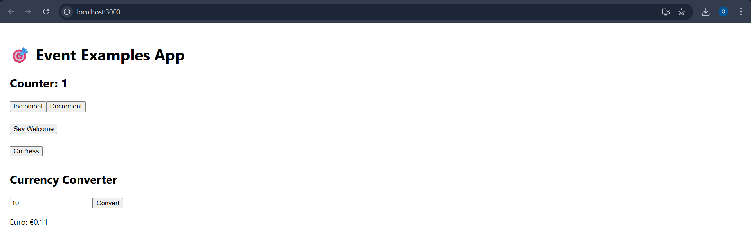

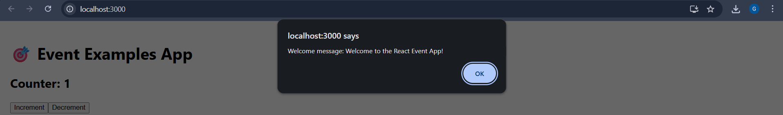

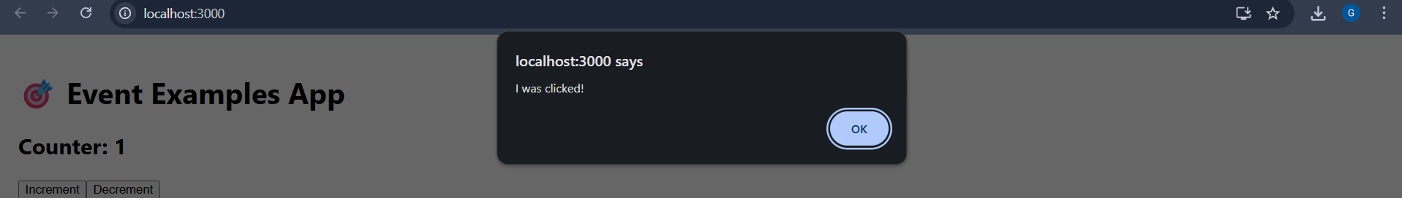

**12. ReactJS-HOL:**

**Ticketbookingapp:**

**App.js:**

import React, { useState } from 'react';

// Greeting components

function GuestGreeting() {

  return <h1>Please sign up.</h1>;

}

function UserGreeting() {

  return <h1>Welcome back</h1>;

}

// Button components

function LoginButton(props) {

  return <button onClick={props.onClick}>Login</button>;

}

function LogoutButton(props) {

  return <button onClick={props.onClick}>Logout</button>;

}

// Main App Component

function App() {

  const [isLoggedIn, setIsLoggedIn] = useState(false);

  // Toggle functions

  const handleLoginClick = () => setIsLoggedIn(true);

  const handleLogoutClick = () => setIsLoggedIn(false);

  // Conditional element

  let button;

  let greeting;

  if (isLoggedIn) {

    greeting = <UserGreeting />;

    button = <LogoutButton onClick={handleLogoutClick} />;

  } else {

    greeting = <GuestGreeting />;

    button = <LoginButton onClick={handleLoginClick} />;

  }

  return (

    <div style={{ textAlign: 'center', marginTop: '50px' }}>

      {greeting}

      {button}

    </div>

  );

}

export default App;

**FlightDetails.js:**

import React from 'react';

function FlightDetails() {

  return (

    <div>

      <h2>✈️ Flight Details</h2>

      <ul>

        <li>Flight: AI-202 | From: Bangalore | To: Delhi | Price: ₹5500</li>

        <li>Flight: 6E-101 | From: Chennai | To: Mumbai | Price: ₹4800</li>

        <li>Flight: SG-333 | From: Hyderabad | To: Kolkata | Price: ₹6200</li>

      </ul>

    </div>

  );

}

export default FlightDetails;

**GuestPage.js:**

import React from 'react';

import FlightDetails from './FlightDetails';

function GuestPage() {

  return (

    <div>

      <h1>Guest View</h1>

      <p>Please login to book tickets.</p>

      <FlightDetails />

    </div>

  );

}

export default GuestPage;

**Output:**

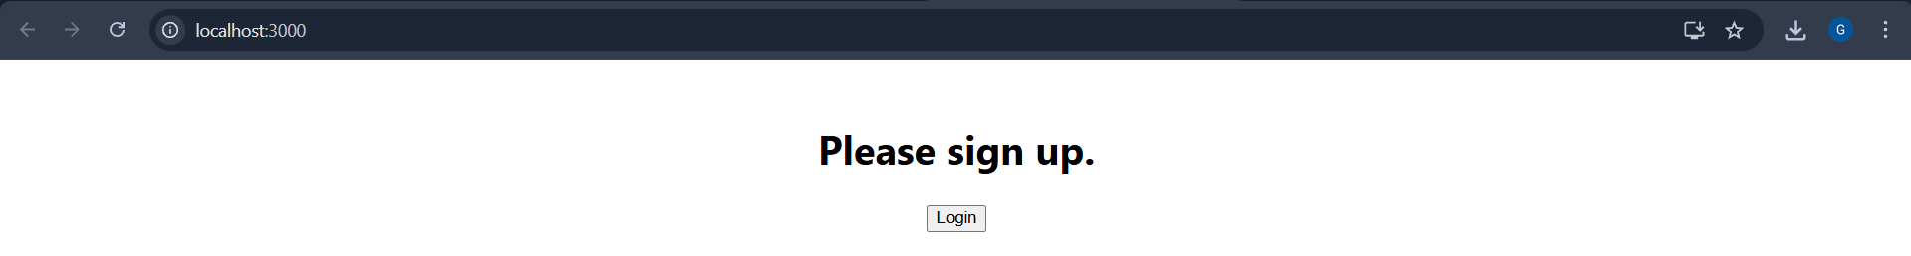

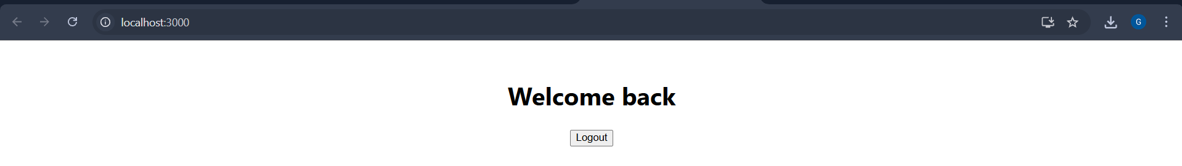

**13. ReactJS-HOL:**

**Bloggerapp:**

**App.js:**

import React, { useState } from 'react';

import BookDetails from './BookDetails';

import BlogDetails from './BlogDetails';

import CourseDetails from './CourseDetails';

import CourseList from './CourseList';

function App() {

  const [selected, setSelected] = useState("book");

  const [showCourses, setShowCourses] = useState(true);

  const renderSelectedComponent = () => {

    if (selected === "book") return <BookDetails />;

    return selected === "blog" ? <BlogDetails /> : null;

  };

  let courseComponent;

  if (showCourses) {

    courseComponent = <CourseDetails />;

  }

  const renderComponentBySwitch = () => {

    switch (selected) {

      case "book":

        return <BookDetails />;

      case "blog":

        return <BlogDetails />;

      case "course":

        return <CourseDetails />;

      default:

        return <h3>No component selected</h3>;

    }

  };

  const courseData = [

    { id: 1, name: "React Basics", instructor: "John" },

    { id: 2, name: "Advanced JS", instructor: "Jane" },

    { id: 3, name: "CSS Mastery", instructor: "Alice" }

  ];

  return (

    <div style={{ textAlign: 'center' }}>

      <h1>Welcome to Blogger App</h1>

      <h2>Rendering List with map() and keys</h2>

      <CourseList courses={courseData} />

      <div>

        <button onClick={() => setSelected("book")}>Book</button>

        <button onClick={() => setSelected("blog")}>Blog</button>

        <button onClick={() => setSelected("course")}>Course</button>

      </div>

      <hr />

      <h2>Method 1 & 2 (if-else & ternary)</h2>

      {renderSelectedComponent()}

      <h2>Method 3 (Element variable)</h2>

      {courseComponent}

      <h2>Method 4 (Switch-case)</h2>

      {renderComponentBySwitch()}

      <br />

      <button onClick={() => setShowCourses(!showCourses)}>

        Toggle Course Visibility

      </button>

    </div>

  );

}

export default App;

**BlogDetails.js:**

import React from 'react';

function BlogDetails() {

  return (

    <div>

      <h3>Blog: Understanding JSX</h3>

      <p>Written by: Sophie Alpert</p>

    </div>

  );

}

export default BlogDetails;

**BookDetails.js:**

import React from 'react';

function BookDetails() {

  return (

    <div>

      <h3>Book: React for Beginners</h3>

      <p>Author: Dan Abramov</p>

    </div>

  );

}

export default BookDetails;

**CourseDetails.js:**

import React from 'react';

function CourseDetails() {

  return (

    <div>

      <h3>Course: JavaScript Essentials</h3>

      <p>Instructor: Kyle Simpson</p>

    </div>

  );

}

export default CourseDetails;

**CourseList.js:**

import React from 'react';

function CourseList({ courses }) {

  return (

    <ul>

      {courses.map(course => (

        <li key={course.id}>

          {course.name} - Instructor: {course.instructor}

        </li>

      ))}

    </ul>

  );

}

export default CourseList;

**Output:**

