**Task1:**

**Familiar with Git commands like git init, git status, git add, git commit, git push, and git pull**

**Verify welcome.txt is created:**

**Output:**

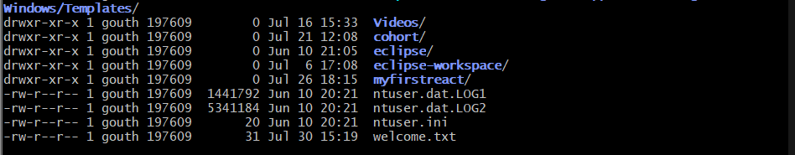

**GitDemo:**

**Output:**

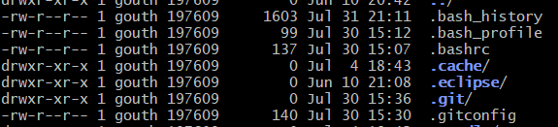

**To verify content:**

**Output:**

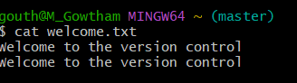

**Git pull origin master:**

**Output:**

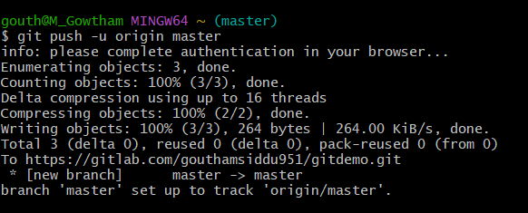

**Git push origin master:**

**Output:**

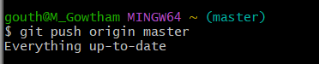

**Task2:**

**Implement git ignore command to ignore unwanted files and folders**

**Output:**

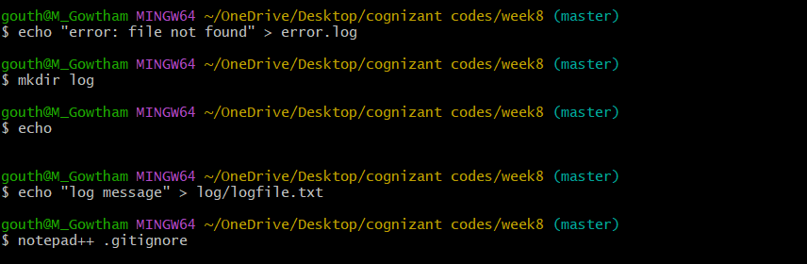

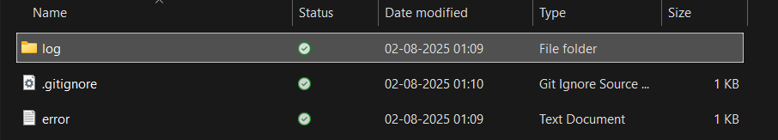

**Task3:**

**Construct a branch, do some changes in the branch, and merge it with master (or trunk)**

**Create a new Branch:**

**Output:**



**List all branches and Switch Branch:**

**Output:**

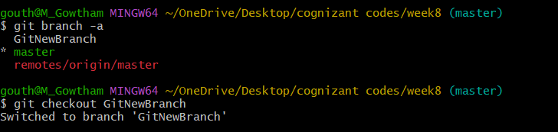

**Show CLI Differences Between master and GitNewBranch:**

**Output:**

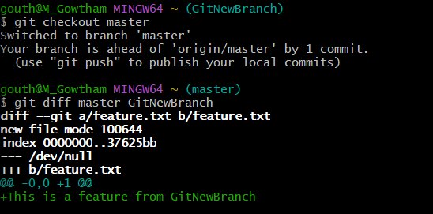

**View Merge History (Visual Tree):**

**Output:**

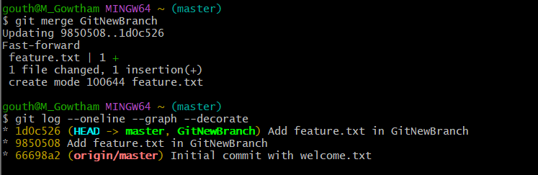

**Delete the Branch After Merging:**

**Output:**

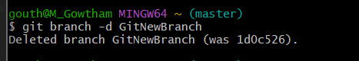

**Output Git Lab:**

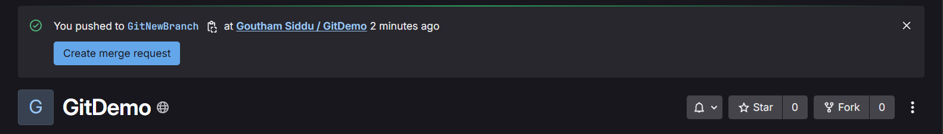

**Task4:**

**Implement conflict resolution when multiple users are updating the trunk (or master) in such a way that it results into a conflict with the branch’s modification.**

**Create a new file:**

**Output:**

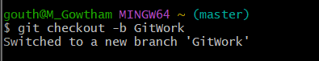

**Add file and commit changes:**

**Output:**

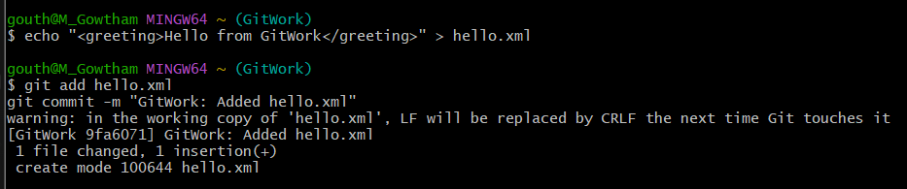

**Add a file hello.xml:**

**Output:**

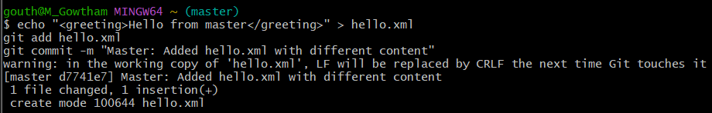

**Observe the Git markup in conflicted file:**

**Output:**

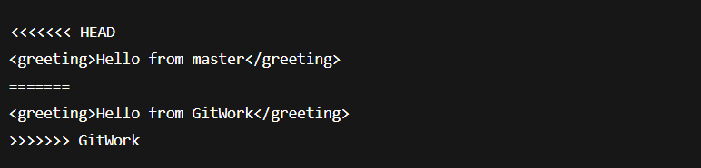

**Delete the merged branch:**

**Output:**

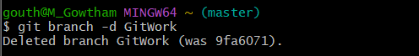

**Final log view:**

**Output:**

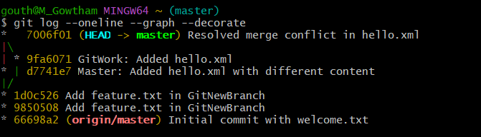

**Task5:**

**Execute steps involving clean up and push back to remote Git**

**Git checkout master:**

**Output:**

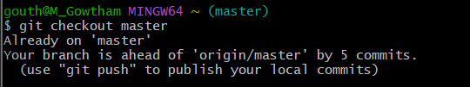

**List all variable branches:**

**Output:**

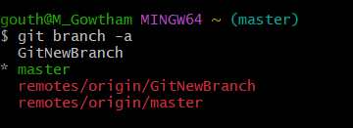

**Pull latest changes from remote to master**

**Output:**

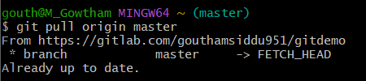

**Push any pending changes:**

**Output:**

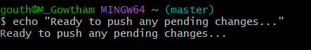

**Verify changes are reflected remotely**

**Output:**

