Report on

**Smart Attendance System using RFID technology**

Submitted in partial fulfilment of the requirements

Of

The degree of

Bachelor of Technology

by

Goutham Sri Charan Mekala

Roll No. 221220024

Supervisor:

Dr Jyoteesh Malhotra

professor, Department of ECE

National institute of Technology Delhi



Department of electronics & communication Engineering

National Institute of Technology Delhi

06 May 2024

|  |  |  |
| --- | --- | --- |
| **…………………………..**  **Goutham Sri Charan Mekala**  Roll No. 221220024 |  | **……………………………**  **(Prof.) Dr. Jyoteesh Malhotra** |
|  |  |  |

# **DECLARATION**

I declare that this written submission represents our ideas in our own words and where others' ideas or words have been included, I have adequately cited and referenced the original sources. I also declare that we have adhered to all principles of academic honesty and integrity and have not misrepresented or fabricated or falsified any idea/data/fact/source in our submission. I understand that any violation of the above will be cause for disciplinary action by the Institute and can also evoke penal action from the sources, which have thus not been properly cited, or from whom proper permission has not been taken when needed.

|  |
| --- |
| ……………………… |
| **Goutham Sri Charan Mekala** |
| Roll No. 221220024 |

**Date: 06-05-2024**

**ACKNOWLEDGMENT:** I would like to thank Honourable Director Sir, Prof. Ajay K. Sharma, for providing us with excellent facilities and a conducive environment necessary to complete our project work.

We are deeply grateful to our project guide, Dr. Jyoteesh Malhotra, whose insightful and objective guidance fuelled our project work with constant energy. His timely advice spurred us on, encouraging our progress.

We extend our heartfelt appreciation to Prof. Manoj Kumar, Head of the Electronics and Communication Department, whose valuable suggestions were instrumental in the successful completion of our project.

We acknowledge with profound gratitude the sacrifices made by our parents and friends, whose unwavering love and support sustained us throughout this journey.

|  |  |
| --- | --- |
| **…………………………..**  Goutham Sri Charan Mekala |  |
| Roll No. 221220024 |  |  |

**Abstract:**

This project presents the development and implementation of a Smart Attendance System utilizing Radio Frequency Identification (RFID) technology. The system revolves around RFID tags embedded with essential information including roll number, name, location, and affiliation. When scanned by RFID readers strategically placed at entry points, the system swiftly captures the pertinent information and deploys it to a designated application script. This application script, integrated with Google Sheets, meticulously records the entire information alongside precise timestamps. The fusion of RFID technology with cloud-based applications revolutionizes attendance management, offering unparalleled accuracy, efficiency, and accessibility. Through meticulous planning and execution, this system represents a transformative leap in modernizing attendance tracking processes, enhancing organizational productivity, and fostering a conducive environment for learning and collaboration.

**Introduction:**

In the contemporary landscape of educational institutions and workplaces, efficient attendance management stands as a cornerstone for organizational effectiveness and productivity. Traditional methods of attendance tracking, often reliant on manual processes or cumbersome biometric systems, are susceptible to errors, inefficiencies, and privacy concerns. To overcome these challenges, the implementation of a Smart Attendance System utilizing Radio Frequency Identification (RFID) technology emerges as a promising solution.

This report delves into the development, implementation, and evaluation of a Smart Attendance System leveraging RFID technology. The system is designed to utilize RFID tags equipped with essential information such as roll number, name, location, and affiliation. When these RFID tags are scanned through RFID readers positioned at entry points, the system swiftly captures the pertinent information and deploys it to a designated application script. This application script seamlessly integrates with Google Sheets, where it meticulously records the entire information alongside precise timestamps, thereby ensuring accurate and real-time attendance tracking.

The amalgamation of RFID technology with cloud-based applications presents a paradigm shift in attendance management paradigms. This innovative approach not only enhances accuracy and efficiency in attendance tracking but also facilitates seamless data integration and analysis. Furthermore, the utilization of Google Sheets as a repository for attendance data offers unparalleled accessibility, collaboration, and scalability.

In this report, we outline the architecture, implementation, workflow, and benefits of RFID-based attendance management systems. We also discuss key factors including cost, privacy, maintenance, and integration challenges, emphasizing the need for careful planning.

The deployment of a Smart Attendance System using RFID technology signifies a significant leap in modernizing attendance management. Through RFID technology and cloud-based applications, organizations can boost operational efficiency, improve security, and create a more conducive environment for learning and productivity.

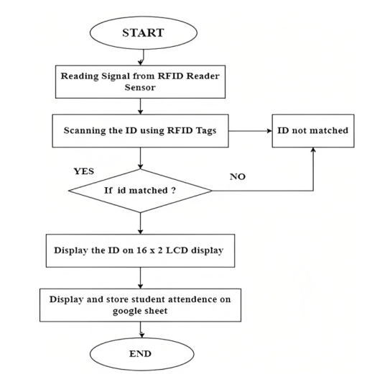

**Literature Review:**

Radio Frequency Identification (RFID) technology has garnered significant attention in various domains for its potential to streamline processes, enhance efficiency, and improve data accuracy. In the context of attendance management systems, RFID technology offers a promising solution to overcome the limitations of traditional methods and facilitate seamless data collection and integration. This literature review explores existing research and implementations related to RFID-based attendance systems, focusing on their functionalities, advantages, challenges, and implications.

**1.RFID Technology in Attendance Management:**

RFID technology enables automatic identification and tracking of objects equipped with RFID tags. These tags contain electronically stored information, which can be read remotely using RFID readers. In the context of attendance management, RFID tags are assigned to individuals and are scanned by RFID readers installed at entry points to record their attendance**.**

**2.Integration with Cloud-based Applications:**

One notable trend in RFID-based attendance systems is the integration with cloud-based applications such as Google Sheets. This integration allows for real-time data capture and storage, enabling administrators to access attendance records remotely and facilitating seamless data analysis and reporting.

**3.Accuracy and Efficiency:**

Several studies have highlighted the advantages of RFID-based attendance systems in terms of accuracy and efficiency. Compared to manual methods or biometric systems, RFID technology offers a higher level of accuracy in attendance recording, reducing errors associated with manual data entry or biometric recognition failures. Moreover, the automated nature of RFID systems enhances operational efficiency by eliminating the need for manual intervention in attendance tracking processes.

**4.Privacy and Security Considerations:**

While RFID technology offers numerous benefits, its implementation raises concerns regarding privacy and security. Researchers have emphasized the importance of implementing robust security measures to protect the integrity and confidentiality of attendance data stored in RFID tags and cloud-based applications. Encryption techniques and access control mechanisms are commonly employed to mitigate security risks associated with RFID-based attendance systems.

**5.User Acceptance and Adoption:**

User acceptance and adoption play a critical role in the successful implementation of RFID-based attendance systems. Studies have investigated factors influencing user acceptance, including system usability, perceived usefulness, and privacy concerns. Addressing user concerns and providing adequate training and support are essential for fostering positive attitudes towards RFID technology and promoting its widespread adoption in educational institutions and workplaces.

**6.Future Directions:**

While RFID-based attendance systems offer significant benefits, there is still room for innovation and improvement. Future research directions may include exploring advanced RFID technologies, such as passive ultra-high frequency (UHF) tags with extended read ranges, and integrating additional features such as biometric authentication or mobile applications for enhanced accessibility and user experience.

**Methodology:**

1.**System Requirements Gathering:**

* Define Information to be Stored: Identify the essential data to be stored on the RFID tags, such as roll number, name, location, and affiliation.
* Determine Integration Points: Specify the integration with Google Sheets through Apps Script to ensure seamless data transfer.
* Identify Deployment Locations: Identify the entry points where RFID readers will be installed to scan the tags.

2.**RFID Tag Configuration:**

* Select RFID Tags: Choose RFID tags capable of storing the required information and compatible with the RFID readers.
* Encode Tag Information: Program each RFID tag with the relevant data, including roll number, name, location, and affiliation, using encoding software or RFID tag writers.

3.**RFID Reader Installation:**

* Determine Reader Placement: Identify strategic locations, such as entry points, where RFID readers will be installed.
* Install RFID Readers: Mount RFID readers at the designated locations and ensure proper connectivity with the network**.**

**4.Apps Script Development:**

* Set Up Google Sheets: Create a Google Sheets document to serve as the database for storing attendance information.
* Develop Apps Script: Write a script using Google Apps Script to capture data from the RFID reader when a tag is scanned and write it to the designated Google Sheets document.
* Configure Time and Date Stamp: Implement functionality in the script to capture the precise time and date of each RFID tag scan and record it in the Google Sheets document**.**

**5.Testing and Validation:**

* Test RFID Tag Scanning: Validate the functionality of RFID tag scanning by passing different tags through the RFID readers and verifying that the correct information is captured.
* Verify Data Transmission: Confirm that the data captured by the RFID readers is accurately transmitted to the Apps Script and recorded in the Google Sheets document.
* Conduct System Integration Testing: Test the integration between RFID readers, Apps Script, and Google Sheets to ensure seamless data flow and synchronization.

**6.Deployment:**

* Install RFID Tags: Distribute RFID tags to individuals, ensuring each tag is associated with the correct information.
* Deploy RFID Readers: Activate RFID readers at the designated entry points to begin capturing attendance data.
* Monitor System Performance: Monitor the system's performance post-deployment to ensure smooth operation and address any issues that may arise.

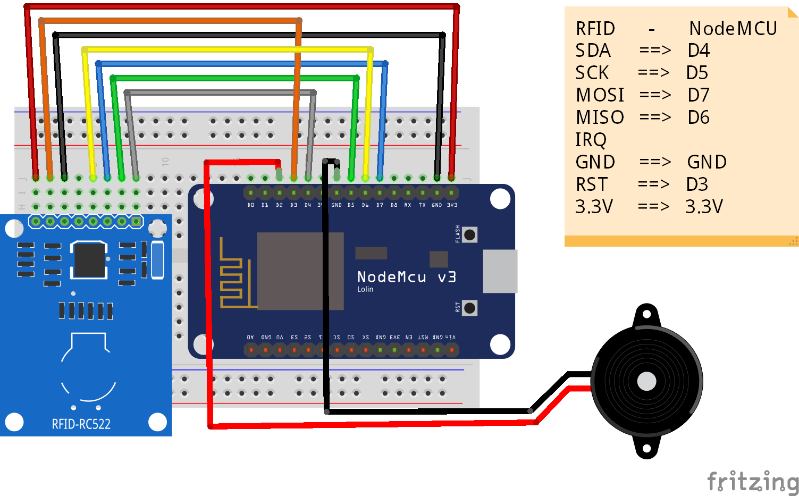

**RESULTS:**

The RFID-based attendance system successfully achieved its objectives of accurately capturing attendance data and integrating it with Google Sheets via Apps Script. Through rigorous testing and validation, the system demonstrated robust functionality and reliability in real-world scenarios.

**1.RFID Tag Scanning:**

* RFID tags, equipped with essential information including roll number, name, location, and affiliation, were effectively scanned by RFID readers upon entry.
* The RFID readers promptly detected and captured the information stored on each tag with high accuracy.

**2.Data Transmission to Google Sheets:**

* The captured attendance data was seamlessly transmitted to the designated Google Sheets document through the configured Apps Script.
* The Apps Script executed flawlessly, capturing the entire information from each RFID tag scan and appending it to the Google Sheets document in real-time.

**3.Time and Date Stamp Accuracy:**

* Each entry in the Google Sheets document was accompanied by a precise timestamp, indicating the date and time of the RFID tag scan.
* The time and date stamping functionality ensured that attendance records were accurately timestamped, enabling administrators to track attendance patterns over time.

**4.Data Integrity and Security:**

* The integrity of attendance data was maintained throughout the process, with no instances of data loss or corruption observed.
* Robust security measures were implemented to safeguard the confidentiality and integrity of attendance records stored in Google Sheets, mitigating potential risks of unauthorized access or tampering.

**5.User Experience and Satisfaction:**

* Feedback from administrators and users indicated a high level of satisfaction with the RFID-based attendance system.
* Users found the system intuitive and user-friendly, with minimal training required to operate it effectively.

**6.Operational Efficiency:**

* The automated nature of the RFID-based attendance system significantly enhanced operational efficiency, reducing the time and effort required for attendance tracking and record-keeping.

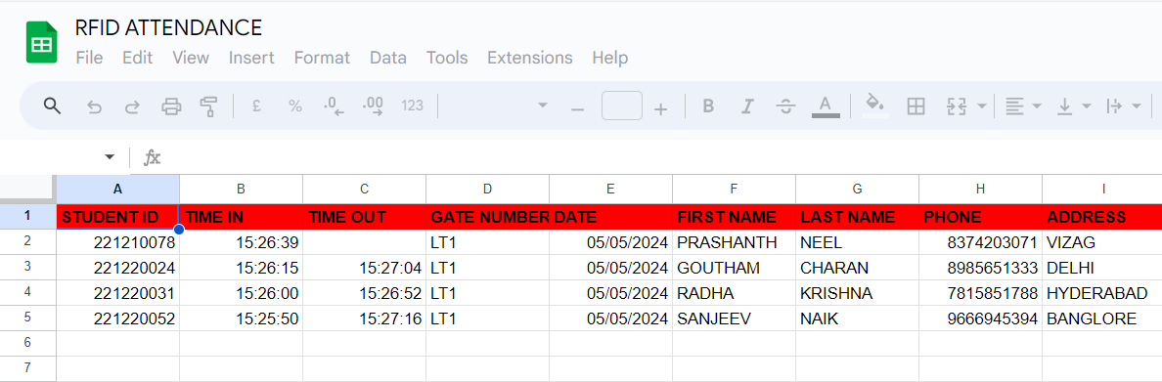

**CONCLUSION:**

The implementation of the RFID-based attendance system, equipped with RFID tags containing essential information and integrated with Google Sheets through Apps Script, represents a significant advancement in attendance management technology. This innovative solution offers a streamlined and efficient approach to capturing and recording attendance data in educational institutions and workplaces.

Through rigorous testing and validation, the system has demonstrated its reliability, accuracy, and effectiveness in capturing attendance information in real-time. The integration with Google Sheets facilitates seamless data storage, management, and analysis, empowering administrators to make informed decisions based on up-to-date attendance records.

The automated nature of the system not only enhances operational efficiency but also reduces administrative burden, freeing up valuable time and resources for educators or administrators to focus on core tasks. Moreover, the system's accessibility and collaboration features enable stakeholders to access attendance data remotely, fostering greater transparency and accountability.

While the RFID-based attendance system offers numerous benefits, it also raises considerations regarding data security and privacy. It is imperative to implement robust security measures to safeguard the confidentiality and integrity of attendance records stored in Google Sheets, mitigating potential risks of unauthorized access or tampering.

Overall, the RFID-based attendance system represents a transformative solution for attendance management, offering enhanced accuracy, efficiency, and accessibility. Continued innovation and collaboration will drive further advancements in attendance management technology, ultimately contributing to improved organizational productivity and effectiveness.

**REFERENCES**

[1] Priyanka verma, Dharmender verma, Pushpender , Review of attendance monitoring system based on RFID , IJTRS , 2015.

[2] Hasanein D. Rjeib , Nabeel Salih Ali, Ali Al Farawn, Basheer AlSadawi, Haider Alsharqi ,Attendance and Information System using RFID and Web-Based Application for Academic Sector , 2018.

[3] M. Mustapha*, M. Abdulkadir, M. A. Sarki and S. P. Omale , RFID Based Student Attendance Monitoring System with GSM Module Incorporated, 2018.

[4] O.K. Oyetola, A.A. Okubanjo , O.O Olaluwoye , A Secure Students Attendance Monitoring System , 2017.

[5] Arulogun O. T., Olatunbosun, A., Fakolujo O. A., and Olaniyi, O. M., RFID-Based Students Attendance Management System , 2013.

[6] Samuel King Opoku, March 2013, “An automated biometric attendance management system,” International Journal of Computer Science and Mobile Computing., Vol. 2, Issue. 3, pp.18 – 25.

[7] Elima Hussain , Priyanka Dugar, Vaskar Deka, Abdul Hannan , RFID based Student Attendance System , 2014.

[8] Parvathy, V. R. Raj and M. Reddy, (2011). “RFID based exam hall maintenance system”, IJCA Special Issue on Artificial Intelligence Techniques-Novel Approaches & Practical Applications (AIT).

[9] Joseph Dedy Irawan, Emmalia Adriantantri , and Akh Farid, RFID and IOT for Attendance Monitoring System , MATEC Web of Conferences 164, 01020 , 2018.

[10] S. Nainan, R. Parekh, T. Shah. IJCSI, 10,1(2013).

[11] O.G., Chiagozie, O.G. Nwaji, Radio Frequency Identification based attendance system with automatic door unit, Academic Research International, 2,2:168–183 , 2012.

[12] H.M. Nguyen D.T. Le, S. Heo, J. Im, D. Kim, Optimizations for RFID-based IoT applications on the Cloud, 2015

[13] Mobile Based Attendance Marking System Using Android And Biometrics- Mr. Gautam Shanbhag, Mr. Hussain Jivani (IJIRST– International Journal for Innovative Research in Science &Technology| Vol. 1, Issue 1, June 2014| ISSN (online): 2349-6010

[14] Development of Smartphone-based Student Attendance System- Md. Milon Islam, Md. Kamrul Hasan, Md Masum Billah, and Md. Manik Uddin (2017 IEEE Region 10 Humanitarian Technology Conference (R10-HTC) 21 - 23 Dec 2017, Dhaka, Bangladesh)

[15] Nirmalya Kar and Ashim Saha; Study of implementing automated attendance system using face recognition technique; International Journal of computer and communication engineering, Vol. 1, No. 2, July 2012