IoT-Based Rain Detection and Alert System Using ESP32
Goutham Vikas Parimi  Roll No. 2520090096  Dept. of CSIT  KLEF, Hyderabad | Satwika Gandhe  Roll No. 2520090111  Dept. of CSIT  KLEF, Hyderabad
Vandanapu Sri Vaishnavi  Roll No. 2520090117  Dept. of CSIT  KLEF, Hyderabad | Kuppi Reddy Krithik Reddy  Roll No. 2520090120  Dept. of CSIT  KLEF, Hyderabad
Abstract—This paper presents an IoT-based rain detection and alert system built around the ESP32 microcontroller. A rain sensor module detects water droplets and provides analog and digital output signals, which the ESP32 reads and processes to decide whether rain is present. When rain is detected, the controller activates an LED and a buzzer as immediate local alerts. Using its built-in Wi-Fi, the ESP32 also hosts a local webpage that shows the current rain status, the sensor reading, and the alert states. The system is developed with the Arduino IDE and combines sensing, processing, and wireless monitoring in one low-cost prototype suitable for smart homes, agriculture, greenhouse monitoring, and protection of outdoor equipment. The design is intended as an educational demonstrator rather than a calibrated meteorological instrument.
Keywords—ESP32, rain sensor, Internet of Things, embedded systems, Wi-Fi web server, real-time alert
I. INTRODUCTION
Rain can affect agriculture, outdoor equipment, clotheslines, open windows, and many other everyday activities. Traditional detection relies on manual observation, which does not provide an immediate alert when rainfall begins, especially when people are indoors or away from the monitored area. An automated detector can identify the presence of rain and notify users without continuous human supervision.
This work develops a compact rain detection and alert prototype using an ESP32 controller. A rain sensor detects droplets and produces signals that the controller interprets. On detecting rain, the ESP32 switches on an LED and a buzzer, while its Wi-Fi capability supports a local webpage for remote status viewing. The goal is to demonstrate an affordable embedded system that combines real-time sensing, immediate alerts, and simple network monitoring.
A. Problem Statement
Rain may begin when no one is watching the area, causing inconvenience or damage to exposed objects. Manual checking does not give continuous monitoring and may delay a response. The proposed system senses rain automatically and communicates a clear rain/no-rain state through local indicators and a webpage hosted by the ESP32.
B. Objectives
- Interface a rain sensor with the ESP32 and read its analog and digital outputs.
- Determine whether rain is present and operate an LED and a buzzer as local indicators.
- Display live sensor information over Wi-Fi through a lightweight webpage.
- Keep the circuit low-cost and easy to wire, and provide a base for future extensions.
C. Scope
The project is a working educational prototype, not a certified meteorological instrument. The sensor detects moisture on its plate, and its output depends on the plate condition, module adjustment, and surroundings. The work therefore targets practical rain-presence detection rather than precise rainfall measurement.
II. LITERATURE SURVEY
Rain detection systems range from simple conductive plates to networked devices that publish sensor status. A rain sensor plate detects water when droplets create conductive paths between its tracks. The interface module provides an analog output that varies with the sensed condition and a digital output that changes according to a threshold set with the module’s potentiometer. Such modules are affordable and useful for detecting wetness, but they are not intended to measure rainfall with professional precision [5].
Existing rain monitoring methods include manual observation, conventional rain sensors, and automated systems that use electronic controllers. Manual observation demands continuous attention and may not give timely alerts. Basic rain alarm circuits activate an indicator when water is detected but usually offer limited customization and no wireless monitoring or access to sensor readings. Programmable microcontrollers allow alert conditions and outputs to be changed in software, and a Wi-Fi-enabled controller such as the ESP32 can also expose readings to a browser [1], [4].
The Internet of Things connects physical devices to network services so that sensor information can be viewed beyond the immediate hardware. For a small prototype, a local webpage is a simple way to present current readings without a dedicated mobile application or cloud platform. Local alerts remain useful even when nobody is viewing the page, because the LED and buzzer respond directly to the controller. The proposed design combines sensor acquisition, threshold-based classification, local alerts, and webpage monitoring in one compact system.
III. PROPOSED SYSTEM
The system uses a rain sensor module as the input device and an ESP32 development board as the controller. The sensor’s analog output is connected to GPIO 34 and its digital output to GPIO 27. An LED on GPIO 2, through a 220 Ω current-limiting resistor, gives visual feedback, and a buzzer on GPIO 25 gives an audible alert.
A. Block Diagram
Fig. 1 shows the information flow. The rain sensor passes analog and digital signals to the ESP32, which decides whether rain is detected. The controller then updates the LED and buzzer and publishes the rain status and sensor readings to a webpage over Wi-Fi.
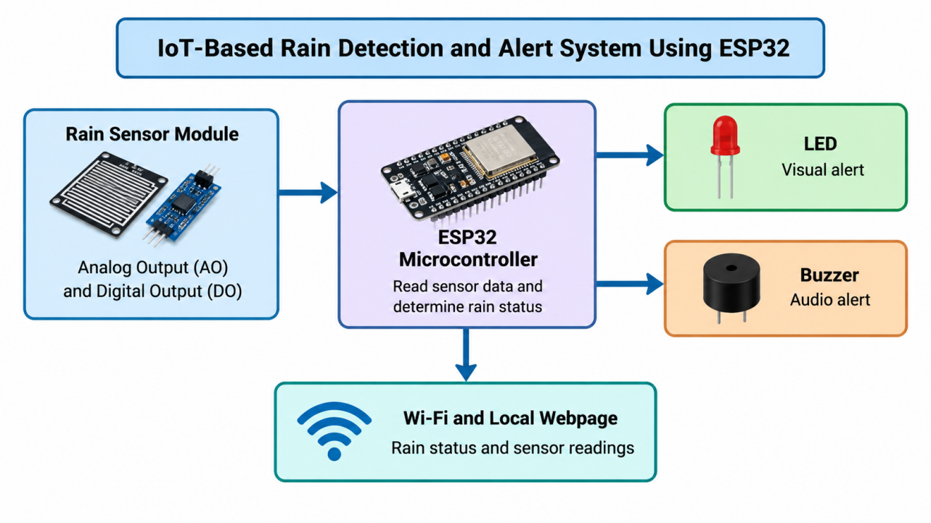
Fig. 1. Block diagram of the proposed system.
B. Hardware Components
The ESP32 development board is the main controller and wireless interface. A rain sensor plate with an LM393-based module supplies the analog and digital signals. An LED provides a visual indication and a buzzer an audible warning, while a 220 Ω resistor limits the LED current. A breadboard and jumper wires allow solderless assembly, and a USB cable supplies power and enables program upload.
C. Software Components
The Arduino IDE with the ESP32 board support package is used to write, compile, and upload the firmware. The program uses GPIO operations to read the sensor and drive the outputs, the ESP32 Wi-Fi functionality for connectivity, and its web server functionality to host the local monitoring page. The Serial Monitor, set to 115200 baud, is used to inspect sensor values and debugging messages [2], [3].
D. Circuit Connections
The rain sensor module is powered from 3.3 V and shares ground with the ESP32. The connections are listed in Table I and shown in Fig. 2. A 5 V supply must not be applied directly to ESP32 GPIO pins, all grounds must be common, and the buzzer’s current requirement should be within the GPIO capability or a driver circuit should be used.
TABLE I. ESP32 PIN MAPPING
Component | ESP32 Connection
Rain sensor VCC | 3.3 V
Rain sensor GND | GND
Rain sensor AO | GPIO 34
Rain sensor DO | GPIO 27
LED (via 220 Ω) | GPIO 2
LED (–) | GND
Buzzer (+) | GPIO 25
Buzzer (–) | GND

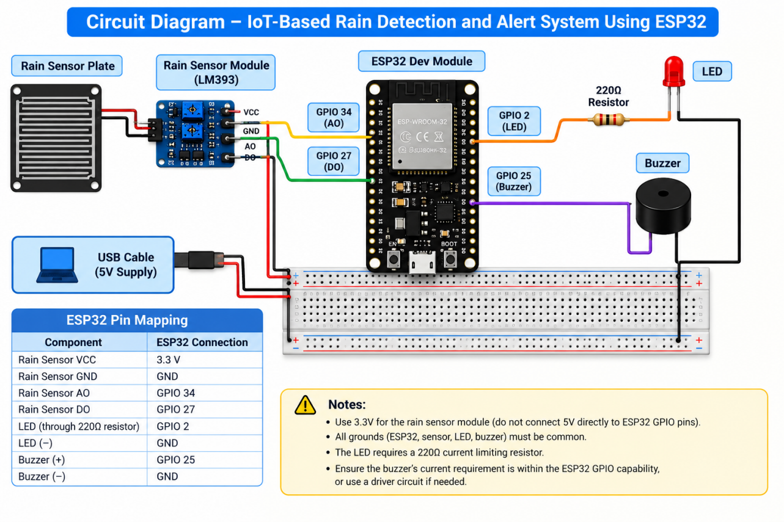
Fig. 2. Circuit diagram of the rain detection prototype.
E. Methodology
Implementation proceeds through hardware assembly, programming, sensor calibration, and functional testing. After the circuit is assembled and its power, ground, and signal connections are checked, the ESP32 Dev Module and the correct serial port are selected in the Arduino IDE. The firmware initializes the sensor and output pins, starts serial communication at 115200 baud, connects to Wi-Fi, and repeatedly reads the sensor. The digital threshold output supports rain/no-rain classification, and the analog reading is shown on the serial output and the webpage.
As shown in Fig. 3, the controller turns the LED and buzzer on when rain is detected, turns them off otherwise, and updates the webpage with the rain state, sensor value, and output states before repeating the loop. The module’s potentiometer is adjusted so that the digital transition matches the desired detection condition. Network credentials should be configured locally and kept private.
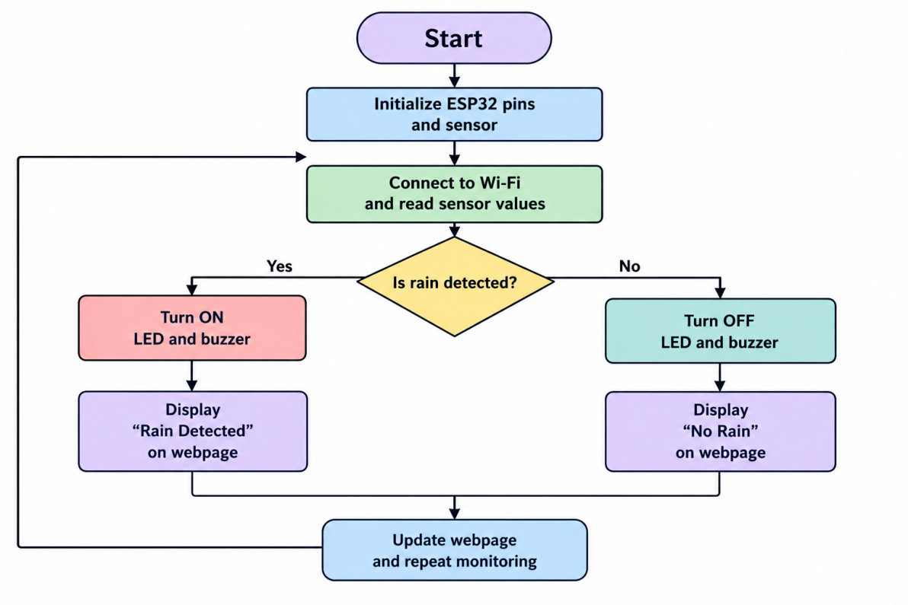
Fig. 3. Flowchart of the system operation.
IV. RESULTS AND DISCUSSION
When water droplets reach the sensing plate, conductive paths form across it and the sensor output changes. The ESP32 reads the analog level and the digital threshold signal and, when the programmed rain condition is met, activates the LED and buzzer. The hosted webpage displays the rain status, the sensor value, and the LED and buzzer states. A sample monitoring state in the project presentation shows a sensor value of 1450 with both the LED and buzzer on; this is an illustrative reading, not a documented measurement series.
A. Testing Approach
Testing begins with a dry plate to establish a baseline and confirm that the outputs are inactive. Small amounts of water are then applied while the analog reading and digital output are observed, and the potentiometer is adjusted until the digital signal changes at a useful point. The LED and buzzer are checked at each change of classification. Network testing confirms that the ESP32 connects to Wi-Fi and that the webpage on a device in the same network matches the physical circuit. Repeated tests are recommended, because droplets spread unevenly and the plate may retain moisture. Actual values should be recorded during physical testing rather than assumed.
B. Advantages
The system is inexpensive, simple to wire, and combines immediate local alerts with Wi-Fi monitoring. The visible chain of sensor input, controller decision, LED, buzzer, and webpage makes it well suited to student demonstrations and small-scale monitoring in smart homes, agriculture, greenhouses, smart clotheslines, and outdoor equipment protection.
C. Limitations
Accuracy depends on the condition of the sensor plate, the threshold calibration, and the reliability of the connections. The conductive plate can corrode, and readings may vary with moisture distribution or contamination. The sensor detects the presence of water rather than measuring rainfall intensity as a professional rain gauge does. The webpage is hosted locally, so access depends on the network configuration. Further testing is needed to assess reliability over extended periods and under varied environmental conditions.
V. CONCLUSION
This paper described a low-cost IoT-based rain detection and alert system using the ESP32. The rain sensor provides analog and digital signals, the ESP32 interprets the sensor state, and the LED and buzzer give immediate local feedback, while Wi-Fi connectivity allows a lightweight webpage to show the current status. The prototype serves as a practical platform for learning GPIO interfacing, analog-to-digital conversion, threshold calibration, output control, serial debugging, and IoT web serving. Reliable operation depends on correct wiring, 3.3 V compatibility, calibration, and care of the sensing plate.
VI. FUTURE SCOPE
The system can be extended with a servo-controlled window, roof, or clothesline mechanism that acts automatically when rain is detected, with suitable safety controls. Other possible additions include an OLED display, a DHT11/DHT22 temperature and humidity sensor, cloud storage, mobile notifications, and data logging to analyze conditions over time. Battery or solar power would allow operation without continuous USB power, and improved sensor protection, calibration, and weather-resistant packaging would increase suitability for outdoor use.
REFERENCES
[1] Espressif Systems, “ESP32 Series Datasheet,” Espressif technical documentation.
[2] Arduino, “Arduino IDE Documentation,” Arduino Documentation.
[3] Espressif Systems, “Arduino ESP32 Documentation,” Arduino ESP32 documentation.
[4] Espressif Systems, “ESP-IDF Programming Guide: Wi-Fi API,” ESP32 Wi-Fi documentation.
[5] Manufacturer documentation or datasheet for the LM393-based rain sensor module used in the project.

