HACKATHON PROJECT DOCUMENTATION
“SMART PAGE REPLACEMENT ALGORITHM”
Project Report submitted for the partial fulfillment of grade for the course
OPERATING SYSTEMS AND SYSTEMS PROGRAMMING (25SC2104E)
Academic Year 2026-2027
Branch: CSIT | Section: 10 | Team Number: 20
Submitted by
GOUTHAM VIKAS PARIMI (2520090096)
Under the guidance of
Raghupathi
Professor, CS(IT)

K L (Deemed to be) University
Hyderabad - 500090, Telangana, India.

K L (Deemed to be) University
DEPARTMENT OF COMPUTER SCIENCE AND INFORMATION TECHNOLOGY
Declaration
The Project Report entitled “Smart Page Replacement Algorithm” is a record of Bonafide work of GOUTHAM VIKAS PARIMI – 2520090096, submitted in partial fulfillment for the course Operating Systems and Systems Programming (25SC2104E) of B. Tech in Computer Science and Information Technology to the K L University. The results embodied in this report have not been copied from any other departments/University/Institute.
GOUTHAM VIKAS PARIMI 2520090096

K L (Deemed to be) University
DEPARTMENT OF COMPUTER SCIENCE AND INFORMATION TECHNOLOGY
CERTIFICATE
This is to certify that the project report entitled “Smart Page Replacement Algorithm” is a bonafide work done and submitted by GOUTHAM VIKAS PARIMI – 2520090096 in partial fulfillment of the requirements of the course Operating Systems and Systems Programming (25SC2104E), Department of Computer Science and Information Technology, K L (Deemed to be University), during the academic year 2026-2027.
Signature of the Guide
Signature of the Course Coordinator
Signature of the HOD

ACKNOWLEDGEMENT
The success of this project would not have been possible without the timely help and guidance rendered by many people. I wish to express my sincere thanks to all those who have assisted me in one way or the other for the completion of my project.
My greatest appreciation goes to my guide, Raghupathi, Professor, CS(IT), whose tremendous support, encouragement and guidance for this project cannot be expressed in words.
I express my gratitude to the Head of the Department and the Department of Computer Science and Information Technology for providing me with adequate facilities, ways and means by which I was able to complete this project.
I thank all the members of the teaching and non-teaching staff who have assisted me directly or indirectly in the successful completion of this project. Finally, I sincerely thank my parents, friends and classmates for their kind help and cooperation during my work.
GOUTHAM VIKAS PARIMI 2520090096

ABSTRACT
The Smart Page Replacement Algorithm is designed to improve memory management in operating systems by reducing page faults and utilizing available memory more efficiently. When the physical memory becomes full and a new page is requested, the operating system must select an existing page for replacement. Traditional algorithms such as First-In, First-Out (FIFO) and Least Recently Used (LRU) have certain limitations in handling different memory access patterns. The proposed Smart Page Replacement Algorithm aims to overcome these limitations by considering factors such as page access frequency, recency of use, and page usage history to identify the least useful page for replacement. The system simulates memory access requests and compares the performance of FIFO, LRU, and the proposed smart algorithm using metrics such as page faults, page hits, hit ratio, and execution time. A visualization interface can be developed to display memory frames and replacement decisions, making the working process easy to understand. The experimental results will help evaluate the effectiveness of the proposed approach under different workloads. This project aims to provide an efficient and user-friendly solution for understanding and improving page replacement strategies in operating systems. The proposed algorithm's performance will be validated through experimental comparison rather than assuming it always outperforms existing methods.

CHAPTER 1
INTRODUCTION
Memory management is one of the most important functions of an operating system. When a program runs, its required pages are loaded into Random Access Memory (RAM) for faster access. Since RAM has limited capacity, the operating system must remove an existing page when a new page is requested and all available memory frames are occupied. This process is known as page replacement. Traditional page replacement algorithms, such as First-In, First-Out (FIFO) and Least Recently Used (LRU), use different strategies to select a page for removal. However, their performance depends on the memory access pattern of a program. The Smart Page Replacement Algorithm aims to improve page replacement decisions by considering factors such as page access frequency and recency of use. This project implements a web-based simulator that visualizes memory operations and compares FIFO, LRU, and a customizable Smart algorithm using performance metrics such as page faults, page hits, and hit ratio.

CHAPTER 2
OBJECTIVES
The Objectives of the Smart Page Replacement Algorithm project are to develop an interactive web-based application that demonstrates and evaluates different page replacement techniques used in operating systems. The project aims to implement and compare First-In, First-Out (FIFO), Least Recently Used (LRU), and the proposed Smart Page Replacement Algorithm to understand their behavior under different memory access patterns. Another objective is to design a Smart algorithm that considers page access frequency and recency to select suitable pages for replacement. The system also aims to visualize RAM frame allocation, page hits, page faults, and replacement decisions, making memory management concepts easier to understand. Furthermore, the project focuses on calculating and comparing performance metrics such as page-fault count, page-hit count, hit ratio, fault ratio, and execution time. Finally, it aims to provide a user-friendly interface with configurable inputs, graphical performance analysis, and CSV export functionality to support experimentation and help identify how different page replacement strategies perform under various workloads.

CHAPTER 3
PROBLEM STATEMENT
Traditional page replacement algorithms may remove useful pages from memory, resulting in additional page faults and increased memory access overhead. FIFO selects pages based on their arrival order, while LRU considers only the time since the last access. Neither strategy directly combines both access frequency and recency in its basic form. Therefore, there is a need to develop and evaluate an improved page replacement strategy that considers multiple page usage characteristics. The project addresses this problem by implementing a configurable Smart Page Replacement Algorithm and comparing its performance against FIFO and LRU under identical workloads.

CHAPTER 4
EXISTING SOLUTION
Existing page replacement methods use predefined rules to select a page for removal when memory becomes full.
FIFO (First-In, First-Out): Replaces the page that entered memory first. It is simple to implement but does not consider whether the page is frequently accessed.
LRU (Least Recently Used): Replaces the page that has not been accessed for the longest time. It considers recent usage but does not directly account for cumulative access frequency.
These algorithms provide useful baseline strategies, but their effectiveness varies according to the page reference sequence. The proposed project uses them as benchmarks to evaluate a multi-factor replacement strategy.

CHAPTER 5
PROPOSED SOLUTION
The proposed system is a browser-based Smart Page Replacement Simulator developed using HTML, CSS, and JavaScript. It allows users to enter a page reference sequence and select the number of available RAM frames. The simulator executes FIFO, LRU, and Smart replacement policies on the same input and displays their results. The Smart algorithm assigns a score to each resident page based on its access frequency and recency. When memory is full, the page with the lowest score is selected for replacement. Users can adjust the frequency and recency weights to experiment with different strategies. The application also provides animated RAM visualization, performance comparison charts, a results table, and CSV export functionality. The objective is to evaluate whether the Smart strategy reduces page faults for different workloads rather than assuming that it always outperforms traditional algorithms.

CHAPTER 6
TECHNOLOGIES USED
The Smart Page Replacement Algorithm project is developed using HTML, CSS, and JavaScript. HTML5 is used to create the structure of the web application, including input fields, buttons, RAM frame displays, and result tables. CSS3 is used to design an attractive, responsive, and user-friendly interface with suitable colors, layouts, and visual effects. JavaScript is used to implement the FIFO, LRU, and Smart Page Replacement algorithms, process page requests, manage simulated memory frames, and calculate page hits, page faults, hit ratios, and fault ratios. The Chart.js library is used to represent algorithm performance through graphical charts, making it easier to compare results. A modern web browser, such as Google Chrome or Microsoft Edge, is used to run the application. Visual Studio Code can be used as the code editor for development and testing, while Git and GitHub can be used for version control and source code management. The CSV export feature allows users to download performance comparison results for further analysis and documentation.

CHAPTER 7
SYSTEM DESIGN
The System Design of the Smart Page Replacement Algorithm consists of several interconnected modules that work together to simulate memory management and compare different page replacement techniques. The system begins with the user interface, where users enter the page reference sequence, specify the number of RAM frames, and configure the frequency weights for the Smart algorithm. The input processing module validates the entered data and passes the page requests to the page replacement engine. This engine implements three algorithms: First-In, First-Out (FIFO), Least Recently Used (LRU), and the proposed Smart Page Replacement Algorithm. FIFO replaces the page that entered memory first, while LRU replaces the page that has not been used for the longest time. The Smart algorithm evaluates the frequency and recency of page accesses to select a suitable page for replacement. The simulation module processes each page request and updates the memory frames, recording page hits, page faults, and replacement decisions. The performance analysis module calculates the total page hits, page faults, hit ratio, fault ratio, and execution time for each algorithm. Finally, the visualization module displays the RAM frame changes, performance comparison charts, and results table on the web interface. Users can also export the results as a CSV file for further analysis. This modular system design makes the application interactive, easy to understand, and suitable for demonstrating and evaluating page replacement strategies in operating systems.

CHAPTER 8
FLOWCHART
The flowchart below shows the complete working of the simulator, from entering the page sequence and RAM frames, through the page-hit and page-fault checks for each request, to the final calculation of performance metrics and display of the charts and results.
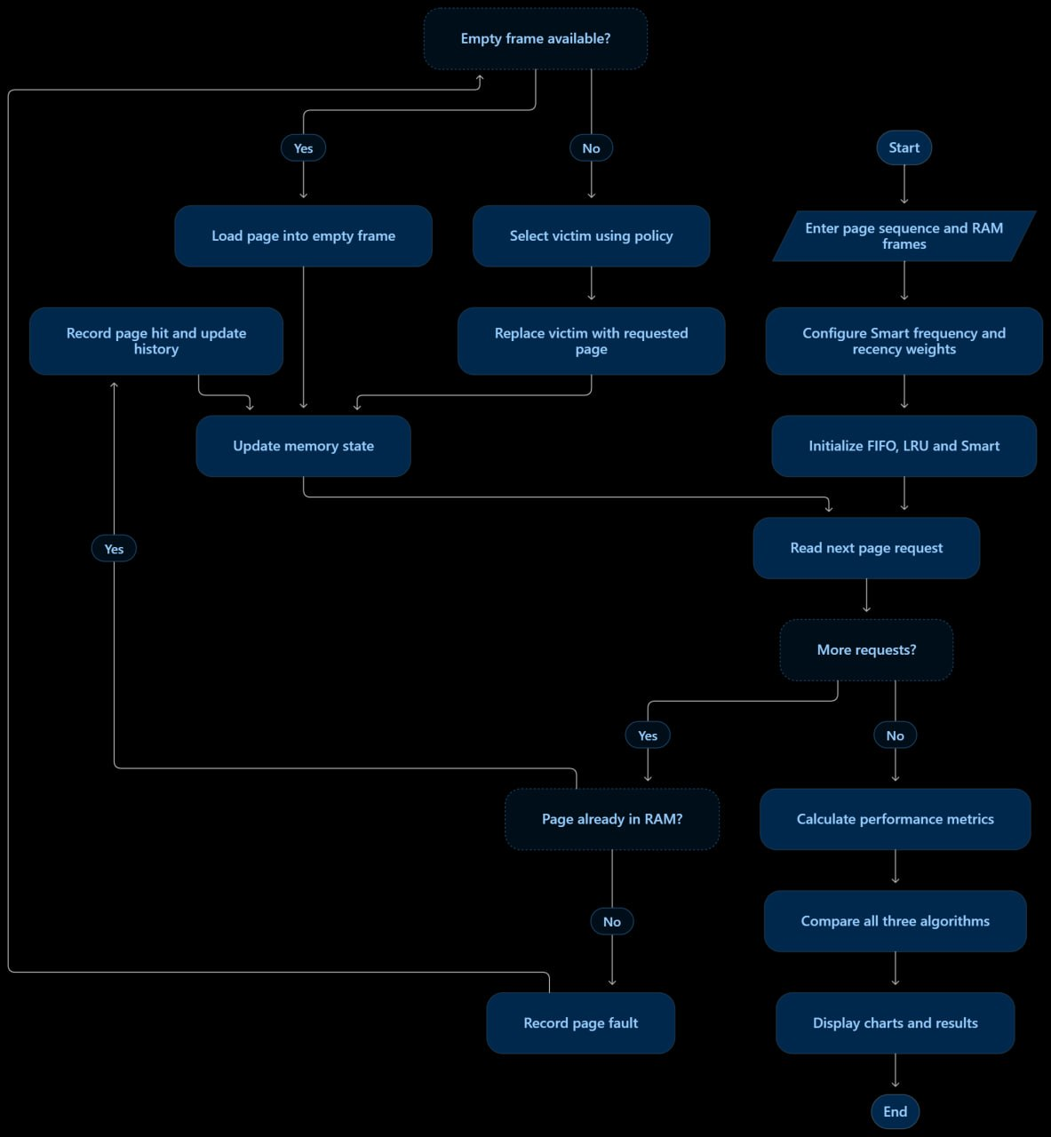
Figure 1: Flowchart of the Smart Page Replacement Simulator

CHAPTER 9
IMPLEMENTATION APPROACH
The Implementation Approach of the Smart Page Replacement Algorithm begins with developing a web-based application using HTML, CSS, and JavaScript. HTML is used to create the user interface, including input fields for the page reference sequence, RAM frame count, animation speed, and Smart algorithm configuration. CSS is applied to design a responsive layout with memory frame displays, buttons, charts, and result tables. JavaScript is used to implement the three page replacement algorithms: First-In, First-Out (FIFO), Least Recently Used (LRU), and the proposed Smart Page Replacement Algorithm. Initially, the user enters a sequence of page requests and specifies the number of available memory frames. The application then processes each request and checks whether the requested page is already present in memory. If the page is available, a page hit is recorded; otherwise, a page fault occurs, and the application either loads the page into an empty frame or replaces an existing page according to the selected algorithm. The Smart algorithm considers both page access frequency and recency to calculate replacement scores and select a page for eviction. During simulation, the application records memory changes, page hits, page faults, and execution time. The Chart.js library is used to display graphical comparisons of algorithm performance, while a results table presents the calculated metrics, including hit ratio and fault ratio. Finally, users can observe the simulation step by step and export the comparison results in CSV format. The implementation is tested using different page reference sequences and memory frame configurations to evaluate the behavior of each algorithm and verify the correctness of the results.

CHAPTER 10
WEB APPLICATION SCREENSHOT
The screenshot below shows the home page of the Smart Page Replacement Simulator, including the configuration panel where a memory workload is set up.
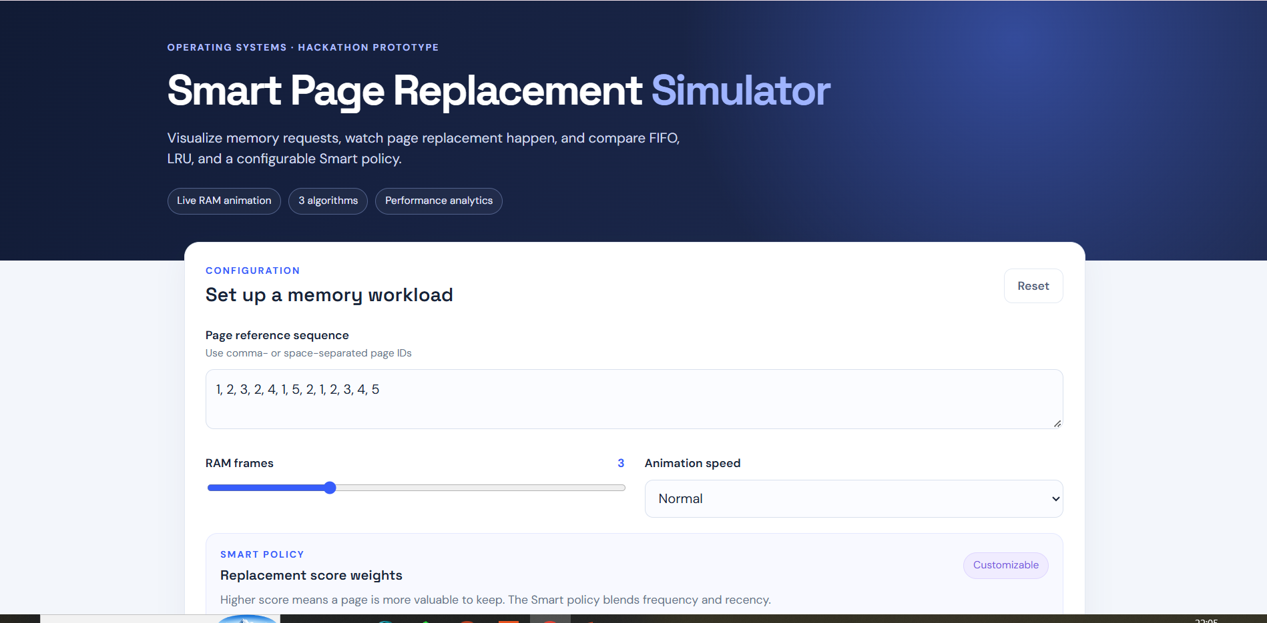
Figure 2: Home page of the Smart Page Replacement Simulator

CHAPTER 11
INPUT SCREENSHOTS
The input panel accepts the page reference sequence (comma- or space-separated page IDs), the number of RAM frames, the animation speed, and the frequency and recency weights of the Smart policy. In this run, the sequence 1, 2, 3, 2, 4, 1, 5, 2, 1, 2, 3, 4, 5 is used with 3 RAM frames, a frequency weight of 60% and a recency weight of 40%. The weights are normalized automatically, and the user can start the simulation using the Run comparison, Step through, or Play animation buttons.
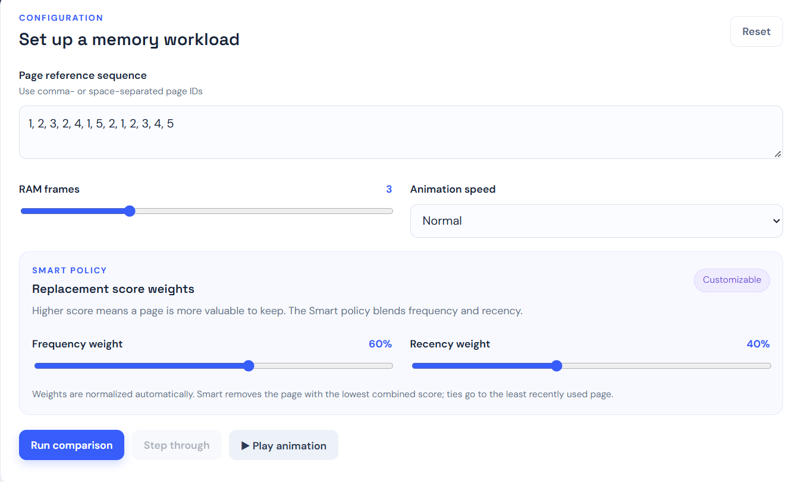
Figure 3: Input configuration of the simulator

CHAPTER 12
OUTPUT SCREENSHOTS
The output section shows summary cards for the total number of requests, the best page-fault result, and the Smart hit ratio and page faults. The RAM frame visualization then replays the selected policy one request at a time, showing the contents of each frame, a request timeline that marks page hits, page faults and replaced pages, and a message describing each replacement decision.
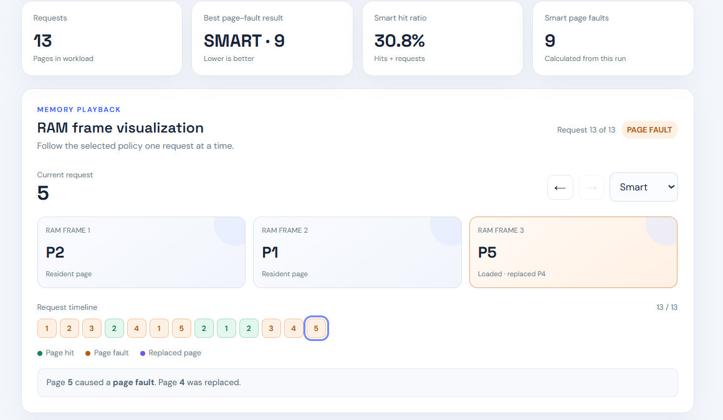
Figure 4: RAM frame visualization and summary output

CHAPTER 13
COMPARISON
All three policies are run on the same page reference sequence and frame count, and the results are shown as charts and a table. The runtime is measured locally and can vary with browser or device load, and the simulator models replacement decisions without modifying the operating system's actual memory manager. The results can be exported as a CSV file using the Export CSV button.
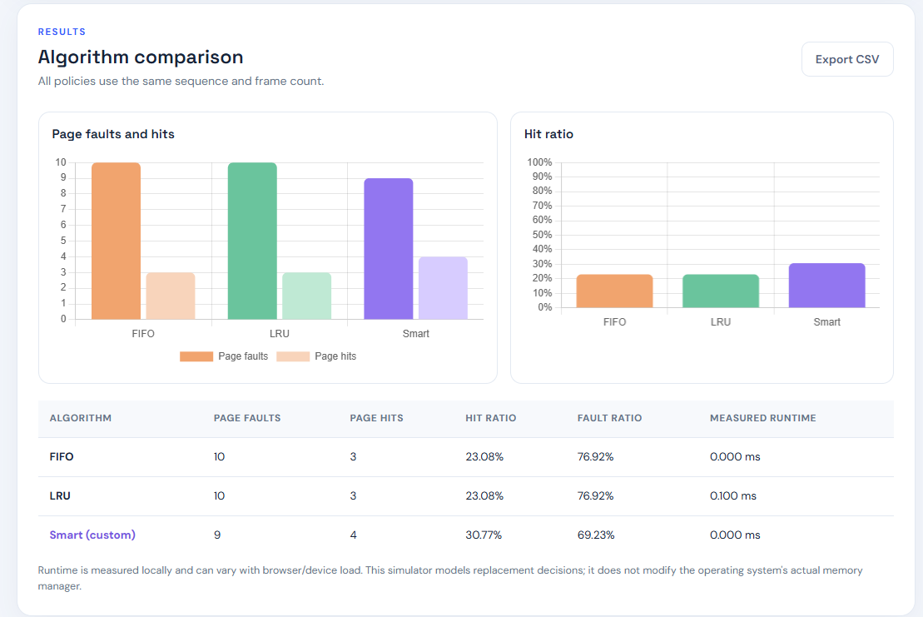
Figure 5: Algorithm comparison charts and results table
For the workload used in this run, FIFO and LRU each recorded 10 page faults and 3 page hits (hit ratio 23.08%), while the Smart policy recorded 9 page faults and 4 page hits (hit ratio 30.77%). This is the result for this particular workload only; further testing across diverse workloads is needed before drawing general conclusions.
Table 1: Performance comparison of FIFO, LRU and Smart
Algorithm | Page Faults | Page Hits | Hit Ratio | Fault Ratio | Runtime
FIFO | 10 | 3 | 23.08% | 76.92% | 0.000 ms
LRU | 10 | 3 | 23.08% | 76.92% | 0.100 ms
Smart (custom) | 9 | 4 | 30.77% | 69.23% | 0.000 ms

CHAPTER 14
IMPACT
The Smart Page Replacement Algorithm project provides an interactive learning environment for understanding operating system memory management. It helps students visualize page faults, page hits, and memory replacement decisions rather than relying only on theoretical explanations. By comparing multiple algorithms on the same workload, the system demonstrates how different replacement policies affect memory performance. The project also introduces practical concepts such as algorithm design, performance measurement, data visualization, and web application development. Its configurable scoring mechanism allows users to experiment with replacement policies and investigate the relationship between access patterns and memory efficiency. Although the prototype does not modify a real operating system, it can serve as an educational foundation for future memory management research.

CHAPTER 15
CONCLUSION
The Smart Page Replacement Algorithm project presents a web-based simulator for understanding and comparing memory replacement strategies. It implements FIFO and LRU as baseline algorithms and introduces a customizable Smart policy that combines page access frequency and recency. The application provides animated RAM frame visualization, step-by-step execution, performance comparison charts, a results table, and CSV export. The system enables users to evaluate the behavior of the three algorithms under different memory workloads. Its effectiveness is assessed using page faults, page hits, hit ratio, fault ratio, and runtime. The project demonstrates how a multi-factor replacement strategy can be designed and experimentally evaluated. Further testing across diverse workloads is necessary to determine when the Smart algorithm offers a practical advantage over traditional approaches.

CHAPTER 16
FUTURE SCOPE
The Future Scope of the Smart Page Replacement Algorithm project includes several improvements to enhance memory management simulation and algorithm performance. The system can be extended by incorporating additional page replacement algorithms, such as Optimal Page Replacement, Least Frequently Used (LFU), and Clock Page Replacement, to provide a more comprehensive comparison. The Smart algorithm can be improved by using adaptive frequency weights that automatically adjust according to memory access patterns. Machine learning techniques could also be explored to predict future page requests and make more effective replacement decisions. Furthermore, the application can be enhanced with advanced visualizations, real-time performance monitoring, larger datasets, and automated testing across different workloads. Additional features, such as downloadable PDF reports, detailed execution logs, and customizable simulation settings, could make the system more useful for students and researchers. In the future, the project could also be integrated into an operating system simulator to demonstrate memory management concepts in a more realistic environment. These enhancements would help improve the application's educational value and support further research into efficient page replacement strategies.

