Github repository: https://github.com/gouthamvk1980/cordapp-template-java

This document has 2 parts
- What I used for development
- How to test/evaluate

- What I used for development

Operating system: Windows7
IDE: IntelliJ IDEA (not needed for testing the L2 assignment)

Pre-requisites
JDK version: jdk1.8.0_172 Executable file for Java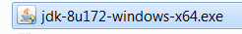

Java home setting: Environment variables has JAVA_HOME set (in my computer it is C:\Program Files\Java\jdk1.8.0_172)

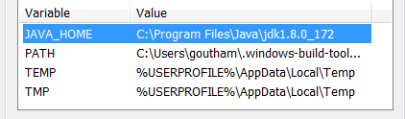

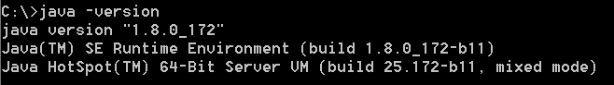

Build and deployment tasks: done using gradle commands clean, build and deployNodes from IntelliJ IDEA IDE

- How to evaluate L2 assignment

Evaluation has below steps
- Setup environment
- Clean the project
- Build the project
- Deploy the project
- Start the nodes (notary, Part A, Party B)
- Test functionalities
- Test cases summary table

Setup environment

- Pre-requisite: Install JDK version: jdk1.8.0_172 and configure JAVA_HOME & Path
- Github repository: https://github.com/gouthamvk1980/cordapp-template-java
- Go to the above git-hub and either download as zip or clone to a directory. Let us say the directory is Wipro_L2_Corda_Assignment
- If the zip is downloaded, extract cordapp-template-java-release-V4.zip file inside Wipro_L2_Corda_Assignment. Folder structure will be ..\Wipro_L2_Corda_Assignment\cordapp-template-java-release-V4.
- Let us consider cordapp-template-java-release-V4 as app_root folder

Clean the project

- Open a command prompt inside app_root (cordapp-template-java-release-V4)
- Clean the project by typing this command in command prompt: gradlew clean.
  - This will delete the “build” folder if it exists inside app_root (see above) folder

Build the project
- Open a command prompt inside app_root (cordapp-template-java-release-V4)
- Build the project by typing this command in command prompt: gradlew.bat build
  - This will create a folder called “build”inside app_root

Deploy the project
- Open a command prompt inside app_root (cordapp-template-java-release-V4)
- Deploy the project by typing this command in command prompt: gradle.bat deployNodes
  - This will create “nodes” folder inside app_root/build and create nodes for notary, Party A and Party B

Start nodes (notary, Party A, Party B)
- Navigate to app_root\build\nodes directory
- Open a command prompt and type the command: runnodes.bat
- This should open 3 windows (notary, Party A, Party B). Wait for them to start as shown below

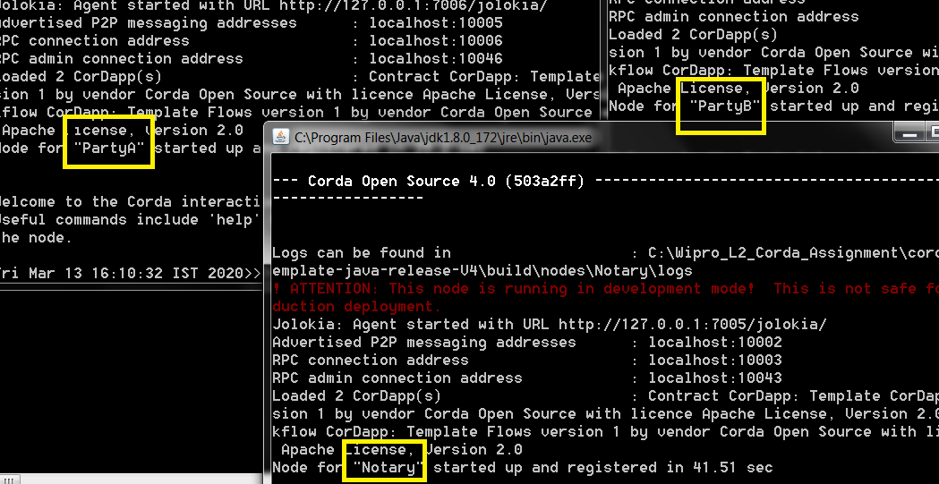

Test functionalities

- Run the below query on Party A and Party B to ensure there are no states present

run vaultQuery contractStateType: com.template.states.ProductState

Party A

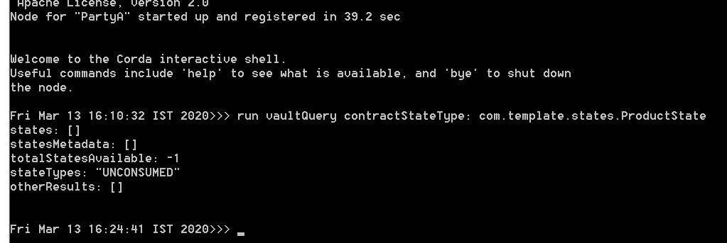

Party B

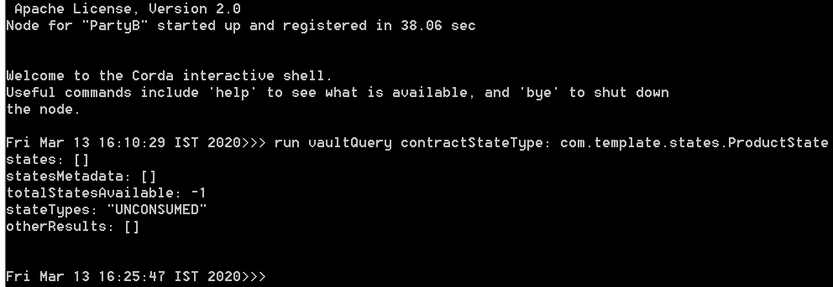

- From Party A, run the below 2 queries one after the other

start ProductCreateFlow otherParty: "O=PartyB,L=Seattle,C=US", productName: "Gadgets", productColor: "Red", status: "Pending"

start ProductCreateFlow otherParty: "O=PartyB,L=Seattle,C=US", productName: "Gadgets", productColor: "Green", status: "Pending"

Party A

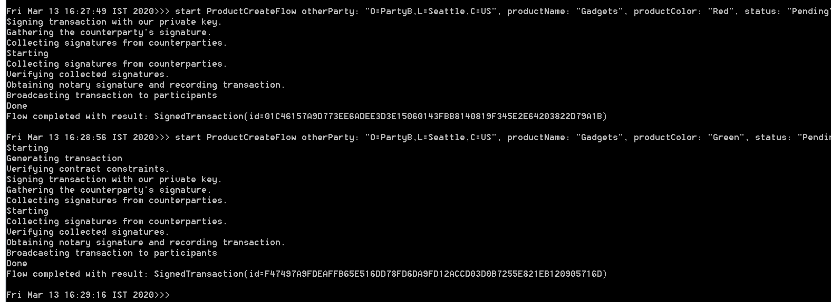

- On both Party A and Party B, run below query to validate 2 Product States created with color as Green and Red with status as Pending

run vaultQuery contractStateType: com.template.states.ProductState

Party A
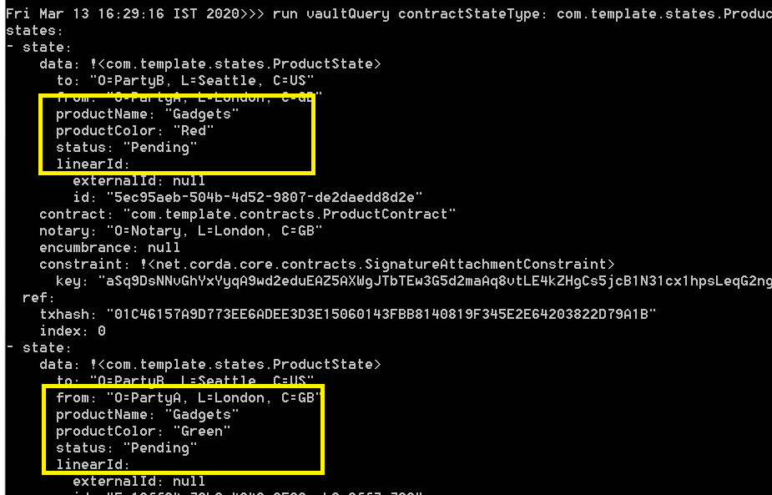

Party B

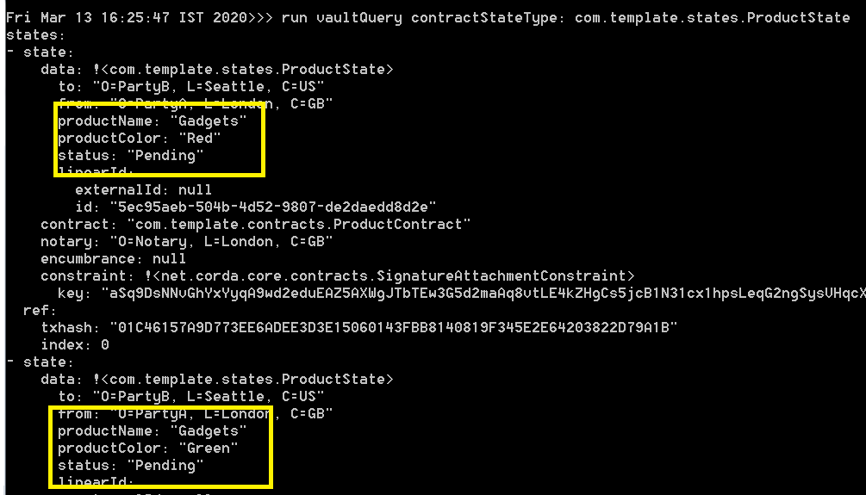

- From Party B, run the below queries one after another for updating the 2 product states created

start ProductUpdateFlow from: "O=PartyB,L=Seattle,C=US", otherParty: "O=PartyA,L=London,C=GB", status: "Received", color: "Green"
start ProductUpdateFlow from: "O=PartyB,L=Seattle,C=US", otherParty: "O=PartyA,L=London,C=GB", status: "Received", color: "Red"

Party B

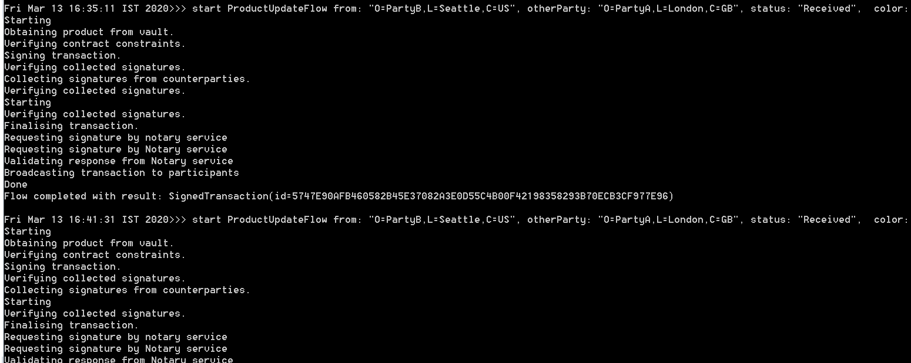

- Validate that 2 product status have been updated to Received by running below queries on Party A and Party B

run vaultQuery contractStateType: com.template.states.ProductState

Party A

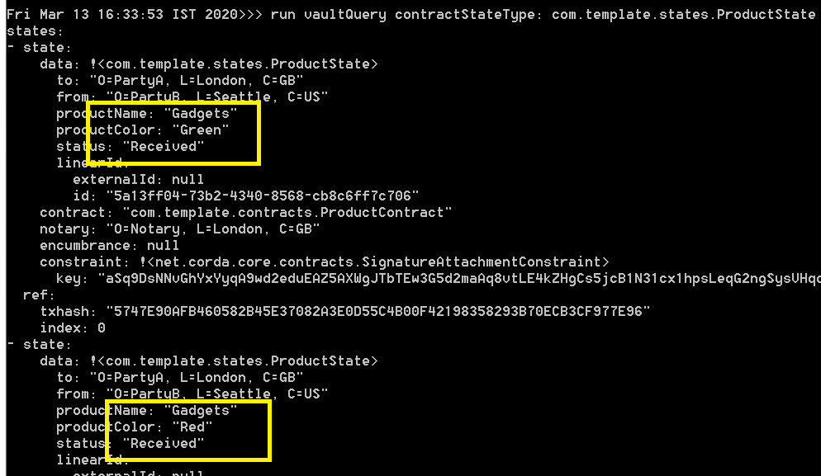

Party B

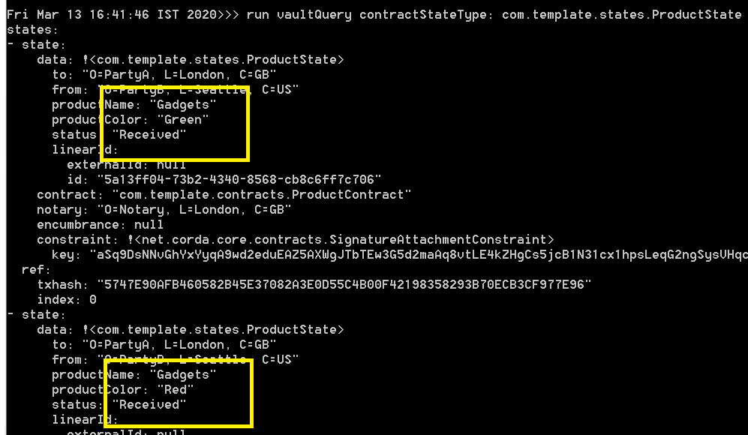

Test case summary table

Flow | Status | Color | Expected result | Actual result | Result | Remarks
Product Create | Received | Red | Error | Error | Success | Test failed as expected due to wrong status
Product Create | Pending1 | Red | Error | Error | Success | Test failed as expected due to wrong status
Product Create | Complete | Green | Error | Error | Success | Test failed as expected due to wrong status
Product Create | Unknown | Green | Error | Error | Success | Test failed as expected due to wrong status
Product Create | Pending | Black | Error | Error | Success | Test failed as expected due to wrong color
Product Create | Pending | Blue | Error | Error | Success | Test failed as expected due to wrong color
Product Create | Pending | Red | Product created with status Pending and Color Red | Product created with status Pending and Color Red | Success | Test succeeded due to correct color and status
Product Create | Pending | Green | Product created with status Pending and Color Green | Product created with status Pending and Color Green | Success | Test succeeded due to correct color and status

Test case summary for Product Update flow

Flow | Status | color | Expected result | Actual result | Result | Remarks
Product Update | Received | Black | Error | Error | Success | Test failed as expected due to color
Product Update | Pending1 | Red | Error | Error | Success | Test failed as expected due to wrong id & status
Product Update | Complete | Green | Error | Error | Success | Test failed as expected due to status
Product Update | Unknown | Red | Error | Error | Success | Test failed as expected due to status
Product Update | Pending | Black | Error | Error | Success | Test failed as expected due to wrong color & status
Product Update | Pending | Blue | Error | Error | Success | Test failed as expected due to wrong color & status
Product Update | Received | Green | Product status of Green product updated to Received from Pending | Product status of Green product updated to Received from Pending | Success | Test is successful due to correct status and color
Product Update | Received | Red | Product status of Red product updated to Received from Pending | Product status of Red product updated to Received from Pending | Success | Test is successful due to correct status and color

