# Out Screenshots for reference:

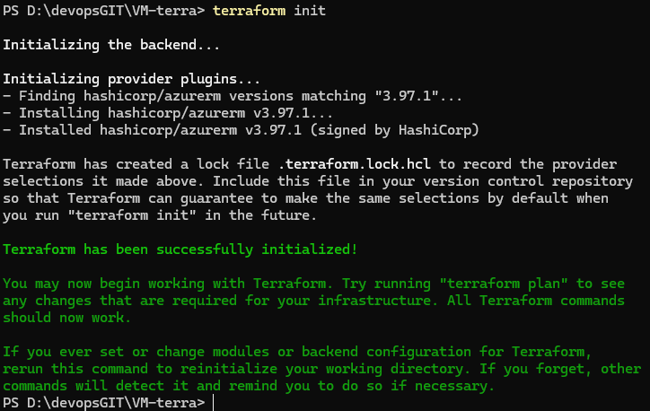

Figure PS D:\devopsGIT\VM-terra> terraform init

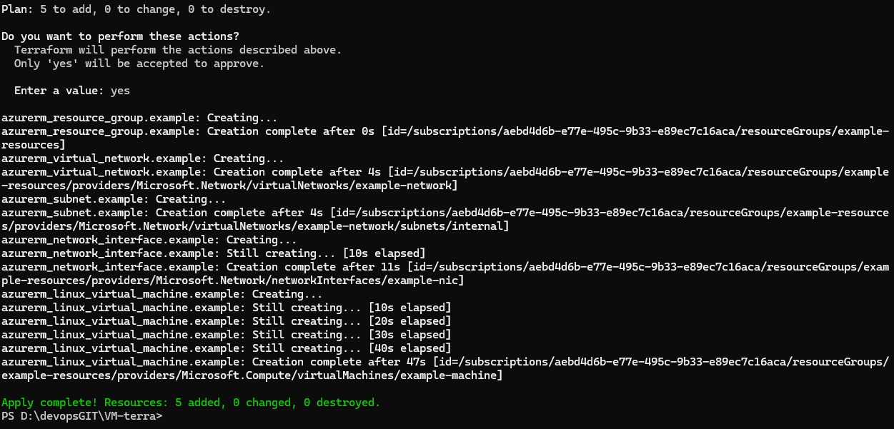

Figure PS D:\devopsGIT\VM-terra> Terraform apply

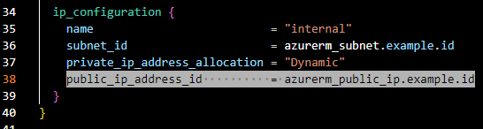

Figure Then adding the variable public key

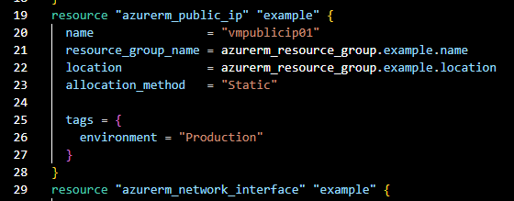



Figure azureuser@DemoLinux:~/dockerfile$ sudo docker ps

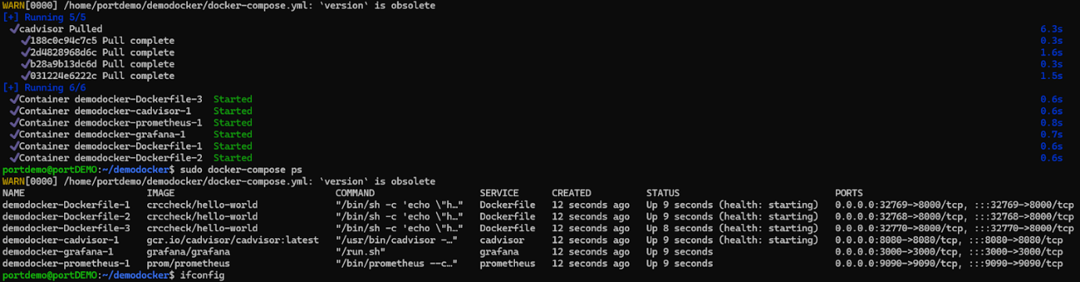

Figure portdemo@portDEMO:~/demodocker$ sudo docker-compose ps

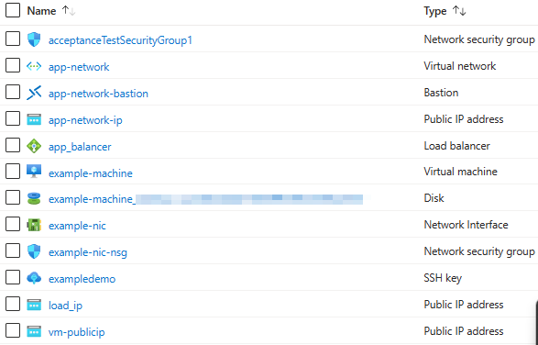

Figure Azure Dashboard

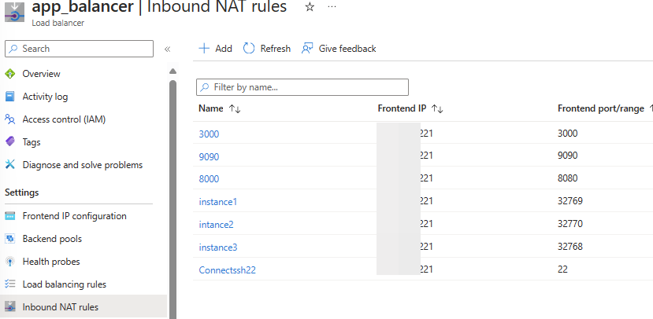

Figure Inbound NAT Rules

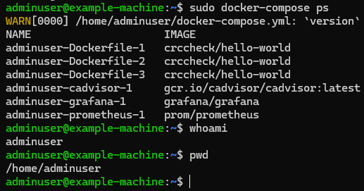

Figure using frontend IP address and port mapping connecting to the VM.

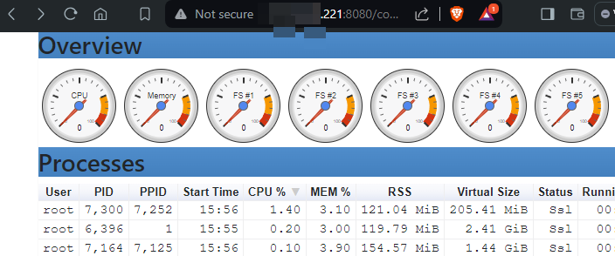

Figure cAdvisor : Demo Docker-cadvisor-1

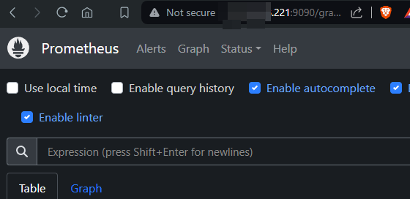

Figure Demo Docker-prometheus-1 : http://132.18.679.965:9090

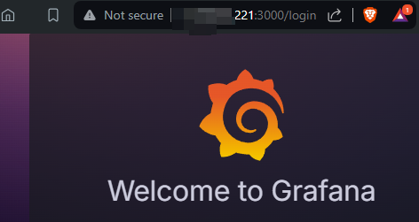

Figure Demo Docker-grafana-1 : http://132.18.679.965:3000/login

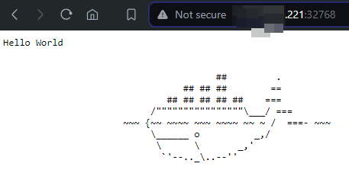

Figure Docker instance 1 demo docker-Dockerfile-1 : http://132.18.679.965:32768/

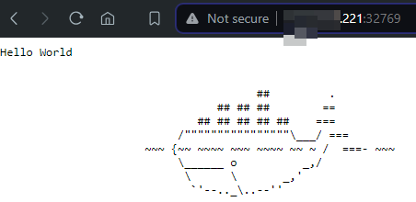

Figure Docker instance 2 demo docker-Dockerfile-2 : http://132.18.679.965:32769/

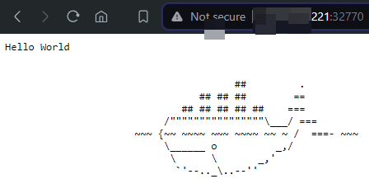

Figure Docker instance 3 demo docker-Dockerfile-3 : http://132.18.679.965:32770/

Appendix Version 1

Demo Docker-cadvisor-1 : http://132.18.679.965:8080/containers/

