三方调用（阿里云为例）
- 注册开发者账号
- 选取对应的服务
- 官方api手册—>下载sdk
- 按照api调用编写
- 进入短信服务
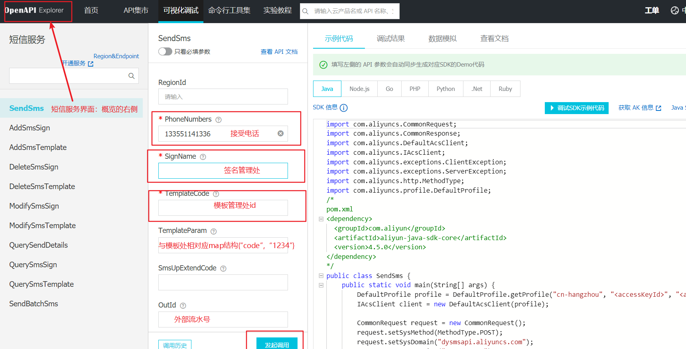

在maven导入sdk-core和短信包，如下
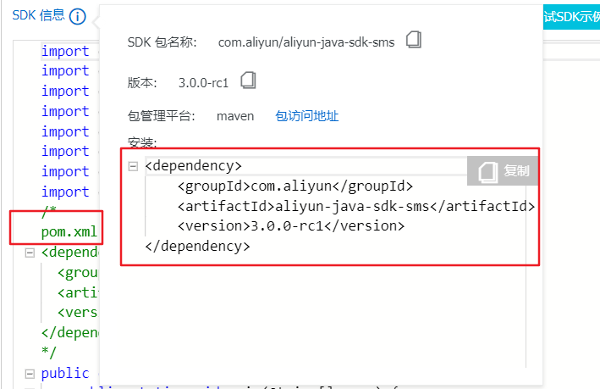
导入依赖信息
<dependencies>
<dependency>
<groupId>com.aliyun</groupId>
<artifactId>aliyun-java-sdk-core</artifactId>
<version>4.5.0</version>
</dependency>

<dependency>
<groupId>com.aliyun</groupId>
<artifactId>aliyun-java-sdk-sms</artifactId>
<version>3.0.0-rc1</version>
</dependency>
</dependencies>

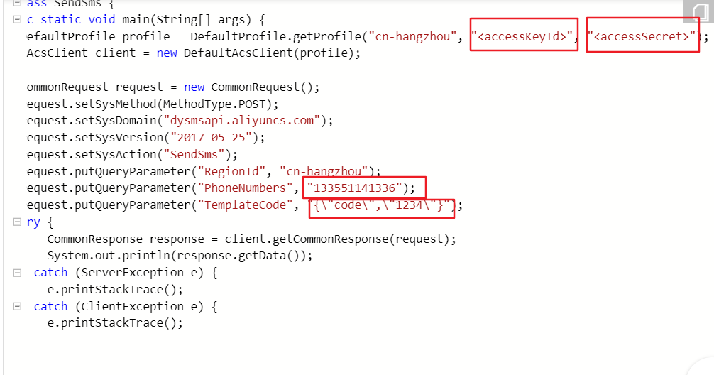

package cn.tools;

import com.aliyuncs.CommonRequest;
import com.aliyuncs.CommonResponse;
import com.aliyuncs.DefaultAcsClient;
import com.aliyuncs.IAcsClient;
import com.aliyuncs.exceptions.ClientException;
import com.aliyuncs.exceptions.ServerException;
import com.aliyuncs.http.MethodType;
import com.aliyuncs.profile.DefaultProfile;

public class AliyunSms {

public static void main(String[] args) {
DefaultProfile profile = DefaultProfile.getProfile("cn-hangzhou", "LTAI4G4bHZebvHPMwjzm4vQx",
"iWFFITyiP7MK4zwzM3TvykFbP8hUo5");
IAcsClient client = new DefaultAcsClient(profile);

CommonRequest request = new CommonRequest();
request.setSysMethod(MethodType.POST);
request.setSysDomain("dysmsapi.aliyuncs.com");
request.setSysVersion("2017-05-25");
request.setSysAction("SendSms");
request.putQueryParameter("RegionId", "cn-hangzhou");
request.putQueryParameter("PhoneNumbers", "18180419459");
request.putQueryParameter("SignName", "爱生活爱自己");
request.putQueryParameter("TemplateCode", "SMS_190273598");
request.putQueryParameter("TemplateParam", "{\"code\":\"1234\"}");
try {
CommonResponse response = client.getCommonResponse(request);
System.out.println(response.getData());
} catch (ServerException e) {
e.printStackTrace();
} catch (ClientException e) {
e.printStackTrace();
}
}
}

