

CS614 Generative AI with Large Language Models
Final Assignment Report
"How Much Do Advanced RAG Strategies Improve Answer Quality? A Comparative Study on Singapore Court Judgments"

Contents
Introduction 2
Dataset 3
Methodology 4
Architecture Diagram 4
Chunking Strategies 5
RAG Pipelines 6
Baseline 6
Naive RAG with section-based chunking 6
Naive RAG with recursive paragraph-based chunking 6
Advanced dense retrieval with Cohere reranking using section-based chunking 7
Advanced hybrid retrieval with Cohere reranking using section-based chunking 7
Advanced hybrid retrieval with Cohere reranking using recursive paragraph-based chunking 7
Experimental Setup 8
Evaluation and Results 8
Conclusion 9
Future Work 10

Introduction
Legal professionals regularly need to extract specific information from court judgments, such as the charges faced by an accused person, the court's reasoning on a legal issue, or the sentence imposed. Doing this manually across lengthy judgments is time-consuming. A question-answering system that can retrieve and synthesise answers from legal documents would reduce the time spent on document review. Large language models can generate fluent answers to questions, but they are limited by their training data. When asked about recent court judgments that were not part of their training corpus, they produce confident but incorrect answers. Retrieval-Augmented Generation addresses this by retrieving relevant passages from an external document collection and providing them as context to the LLM before generating an answer. However, the effectiveness of a RAG system depends on several design choices. This project investigates three questions.
First, does adding a cross-encoder reranking step improve answer quality?
Second, does combining dense semantic search with keyword-based BM25 search produce better results than dense search alone?
Third, does the granularity of the chunking strategy affect the quality of the generated answers?
Six RAG pipelines were built and evaluated on a corpus of seven Singapore court judgments spanning six legal domains. The corpus totals 230 pages and approximately 65,000 words. A ground-truth evaluation dataset of 140 question-answer pairs was created and manually verified against the source judgments.

Dataset
The corpus consists of seven Singapore court judgments totalling 230 pages. The judgments were sourced from publicly available decisions on the Singapore Courts website and merged into a single PDF for processing. The seven cases span six distinct areas of law. Two cases concern drug trafficking under the Misuse of Drugs Act, one concerns voluntarily causing grievous hurt under the Penal Code, and the remaining four are civil matters covering personal injury limitation, motor vehicle insurance, division of matrimonial assets, and landlord and tenant disputes. The cases originate from three different court levels: the General Division of the High Court, the Appellate Division of the High Court, and the Magistrate's Court. The shortest judgment is 15 pages and the longest is 54 pages, providing a range of document sizes for the chunking strategies to handle.
A ground-truth evaluation dataset of 140 question-answer pairs was created, with 20 questions per case. The questions were generated using a large language model and then manually verified against the source judgment to ensure factual accuracy. The questions cover a range of legal information types including charges, findings of fact, legal reasoning, procedural history, and outcomes.

Methodology

Architecture Diagram
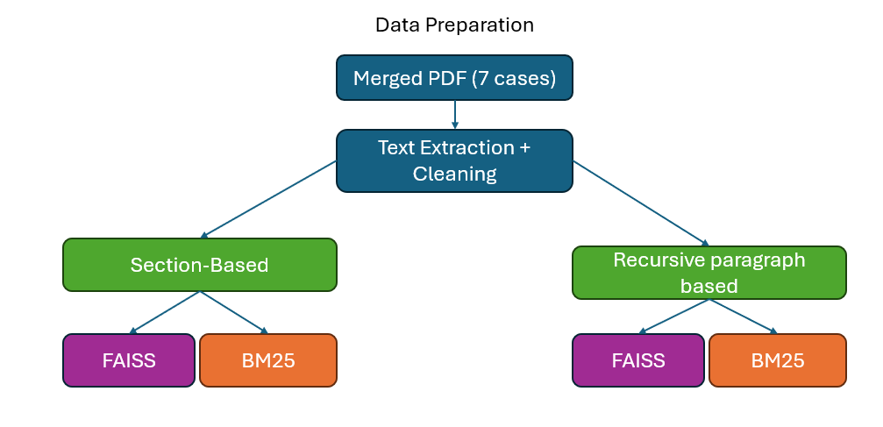
Figure 1: Data preparation pipeline
Based on Figure 1, the merged PDF containing all seven judgments is first processed using PyMuPDF to extract raw text page by page. The extracted text is then cleaned to remove PDF noise such as version lines, repeated page headers, table of contents entries, and editorial notices, while preserving paragraph numbers and section headings needed for chunking. The cleaned text is split using two strategies: section-based chunking, which produces 139 chunks with a mean of 464 words, and recursive paragraph-based chunking, which produces 516 chunks with a mean of 118 words. Each chunk is tagged with its source case citation using a position-based boundary map across all seven cases. A FAISS dense index and a BM25 sparse index are then built for each chunking strategy, giving four indexes in total.
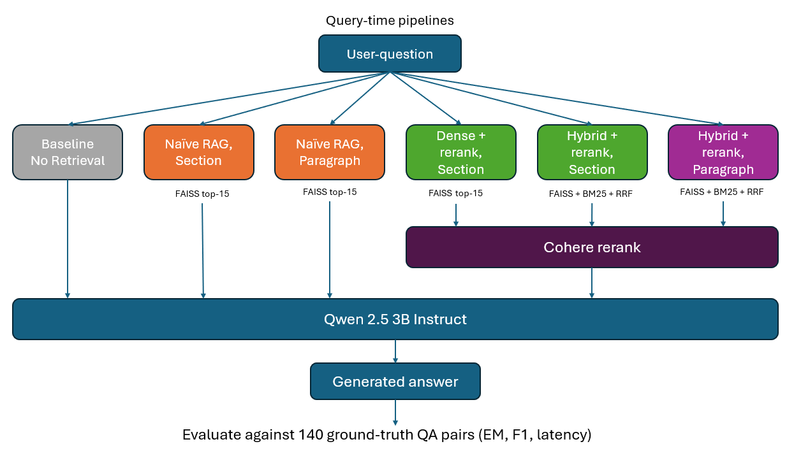
Figure 2:Query-time pipeline architecture
As seen in Figure 2, at query time, the user's question is routed through six pipelines. The baseline sends the question directly to the LLM with no retrieval. The two naive RAG pipelines retrieve the top 15 chunks from the FAISS dense index only, one using section-based chunks and the other using paragraph-based chunks and pass them directly to the LLM without reranking. The advanced dense retrieval pipeline retrieves the top 15 chunks from the FAISS section-based index and passes them to Cohere, which selects the top 5 most relevant chunks for the LLM. The two advanced hybrid retrieval pipelines query both the FAISS and BM25 indexes simultaneously, each returning 15 candidates, then merge the results using reciprocal rank fusion before passing them to the Cohere reranker. One uses section-based chunks and the other uses paragraph-based chunks. All six pipelines share the same LLM, Qwen 2.5 3B Instruct with greedy decoding, and the same prompt template. Generated answers are evaluated against 140 ground-truth QA pairs using exact match, F1 score, and latency.

Chunking Strategies
Two chunking strategies were implemented to test whether chunk granularity affects retrieval and answer quality for legal text. Both strategies operate on the same cleaned corpus and produce chunks tagged with their source case citation and metadata.
The first strategy, section-based chunking, splits the text at legal section headings that are already present in the judgments, such as Introduction, Background, Facts, Analysis and Decision, and Conclusion. The heading patterns were derived from the actual tables of contents of all seven cases in the merged PDF, covering both uppercase headings and title-case sub-headings specific to individual cases. Sections exceeding 800 words were split further by sentence with 80-word overlap to prevent any single chunk from dominating the LLM context window. This strategy produced 139 chunks with a mean of 464 words, representing broad topic-level segments of each judgment.
The second strategy, recursive paragraph-based chunking, splits the text at numbered paragraph boundaries. Singapore court judgments number every paragraph sequentially, and each paragraph typically contains one discrete legal point, finding of fact, or step in the court's reasoning. The function detects standalone paragraph numbers on their own line, followed by text beginning with an uppercase letter, then splits at each boundary. Paragraphs exceeding 400 words were split further by sentence with 50-word overlap. This strategy produced 516 chunks with a mean of 118 words, representing fine-grained individual legal points.
To illustrate the difference, consider paragraph 80 of SGHC 24, where the court finds that the appellant was aware of the victim's age, the victim's heavy build, and that the staircase was made of hard concrete. Under section-based chunking, this paragraph is combined with paragraphs 77 through 82 into a single chunk covering the court's finding on the appellant's state of mind, totalling over 1,000 words. Under recursive paragraph-based chunking, paragraph 80 becomes its own chunk of approximately 200 words, containing only the court's specific finding on the appellant's knowledge. When a question asks how the court established that the appellant knew his actions were likely to cause grievous hurt, the paragraph-based strategy retrieves this focused passage directly, while the section-based strategy retrieves the entire section, which includes surrounding material that may dilute the answer.
A key implementation challenge was correctly tagging each chunk to its source case. An earlier approach that searched for the most recent citation in the text preceding each chunk incorrectly assigned chunks to cases cited as legal authority within the body of a judgment. For example, a chunk in SGHC 24 was tagged as SGHC 149 because that case was referenced in the court's reasoning. This was resolved by building a case boundary map using hard-coded markers unique to each judgment's title page, then determining each chunk's source case based on its character position relative to these boundaries.
The rationale for comparing these two strategies is that they represent meaningfully different approaches to the same structured legal text. Section-based chunking preserves the court's organisational logic, keeping an entire legal argument together. Paragraph-based chunking preserves the court's reasoning at the level of individual points, allowing the retriever to pull exactly the relevant finding without surrounding noise. The evaluation tests which granularity produces better answers when paired with the same retrieval and reranking configuration.

RAG Pipelines
Six pipelines were implemented across the project, each designed to isolate the effect of a specific technique on answer quality. The pipelines build incrementally, starting from no retrieval and progressively adding retrieval, reranking, hybrid search, and a different chunking strategy.

Baseline
The baseline pipeline sends the user's question directly to the LLM with no retrieved context. The prompt instructs the model to answer in one to three sentences and to state that it does not have enough information if it cannot answer. This pipeline exists to establish the performance floor and to demonstrate that the LLM cannot answer questions about Singapore court judgments from 2026, which post-date its training data.

Naive RAG with section-based chunking
The first naive pipeline, naive dense retrieval using section-based chunking, uses a simple dense retrieval approach without reranking or hybrid search. The merged legal judgments are first split into chunks based on structural section headings such as Facts, Issues, Analysis, and Decision. Each chunk is embedded using the all-MiniLM-L6-v2 sentence transformer and stored in a FAISS index. When a question is asked, it is embedded using the same model and compared against the FAISS index to retrieve the top 15 most similar chunks by cosine similarity. The top 5 of these are concatenated and passed directly to the LLM as context. This pipeline serves as the basic RAG baseline for the section-based chunking strategy and allows us to evaluate how well dense retrieval alone performs without any reranking or hybrid enhancement.

Naive RAG with recursive paragraph-based chunking
The second naive pipeline, naive dense retrieval using recursive paragraph-based chunking, follows the same dense retrieval process but uses a different chunking strategy. Instead of splitting the judgments by section headings, the text is split into paragraph-level blocks, and any paragraph that is too long is further divided into smaller sentence-based chunks with overlap. These paragraph-based chunks are embedded using all-MiniLM-L6-v2 and indexed in a separate FAISS index. At query time, the question embedding is compared against this index to retrieve the top 15 most similar chunks. The top 5 are then passed directly to the LLM as context without reranking. This pipeline tests whether a more fine-grained chunking strategy improves answer quality under the same naive dense retrieval setup.

Advanced dense retrieval with Cohere reranking using section-based chunking
The first advanced pipeline, advanced dense retrieval with Cohere reranking using section-based chunking, adds cross-encoder reranking on top of dense retrieval. The question is embedded using all-MiniLM-L6-v2 and compared against the FAISS index to retrieve the 15 most similar chunks by cosine similarity. These 15 candidates are then passed to Cohere's rerank model, which jointly encodes the question and each candidate to produce a more accurate relevance score. The top 5 chunks after reranking are concatenated and passed to the LLM as context. This pipeline uses section-based chunking and tests whether reranking improves answer quality over naive RAG, which retrieves the same way but skips the reranking step.

Advanced hybrid retrieval with Cohere reranking using section-based chunking
The second advanced pipeline, advanced hybrid retrieval with Cohere reranking using section-based chunking, replaces dense-only retrieval with hybrid retrieval. The question is sent to both the FAISS index and the BM25 index simultaneously, each returning 15 candidates. BM25 matches on exact keywords, which is valuable for legal text containing specific case citations such as "SGHC 24," statutory section numbers such as "s 325," and dollar amounts such as "$100,000" that dense embeddings may miss. The two result sets are merged using reciprocal rank fusion with k=60, which produces a single ranked list by combining the rankings from both retrieval methods. The top 20 candidates from the fused list are passed to the Cohere reranker, which selects the top 5 for the LLM. This pipeline uses the same section-based chunking as the previous advanced pipeline and tests whether adding BM25 to the retrieval stage improves answer quality.

Advanced hybrid retrieval with Cohere reranking using recursive paragraph-based chunking
The third advanced pipeline, advanced hybrid retrieval with Cohere reranking using recursive paragraph-based chunking, is identical to the previous pipeline in retrieval method, fusion, and reranking. The only difference is the chunking strategy. It retrieves from a separate FAISS index and BM25 index built over the paragraph-based chunks instead of the section-based chunks. This pipeline tests whether the granularity of the chunks, rather than the retrieval method, is the more important factor in answer quality.
All advanced pipelines share the same prompt template, which instructs the LLM to answer in one to three sentences using only the provided context and to respond with "Not found in retrieved context" if there is truly nothing relevant. The prompt wording was deliberately softened from an earlier version that said, "not clearly found" to "truly nothing relevant," which reduced the number of false refusals where the answer was partially present across multiple chunks. All pipelines also share the same LLM, Qwen 2.5 3B Instruct, with greedy decoding and a maximum of 200 generated tokens to ensure deterministic and comparable outputs.

Experimental Setup
All experiments were conducted on our university server with an NVIDIA RTX 3090 GPU. A global random seed of 42 was set across Python, NumPy, and PyTorch to ensure reproducibility. The language model used for answer generation was Qwen 2.5 3B Instruct, loaded in float16 precision with greedy decoding and a maximum of 200 generated tokens. The embedding model for dense retrieval was all-MiniLM-L6-v2, with normalised embeddings stored in a FAISS IndexFlatIP index. Sparse retrieval used BM25Okapi with whitespace tokenisation. Reranking was performed using Cohere's rerank-english-v3.0 model. Retrieval parameters were held constant across all advanced pipelines: 15 candidates retrieved from each index, the top 20 from the fused list passed to the reranker, and the top 5 after reranking passed to the LLM. An initial configuration of top-k=20 and top-n=7 was tested but produced lower F1 scores across all pipelines, as the additional chunks introduced irrelevant content that confused the LLM. The final parameters of top-k=15 and top-n=5 were selected based on this comparison. The evaluation dataset consisted of 140 question-answer pairs, 20 per case across all seven judgments, generated using an LLM and manually verified against the source judgments. Evaluation metrics included exact match, token-level F1 score, and total latency per question.

Evaluation and Results
The performance of all pipelines is evaluated using Exact Match (EM), F1 score, average latency, and the number of “Not found” responses. This comparison highlights the trade-offs between retrieval quality and efficiency across naive and advanced RAG approaches under different chunking strategies.
Pipeline | EM | F1 | Latency | Not found
Baseline | 0.0% | 13.7% | 2.73s | 0/140
Naive Dense Retrieval (Section-Based Chunking) | 2.1% | 15.3% | 5.13s | 69/140
Naive Dense Retrieval (Paragraph-Based Chunking) | 2.9% | 15.7% | 3.77s | 84/140
Advanced Dense Retrieval + Cohere Reranking (Section-Based Chunking) | 3.6% | 17.2% | 7.06s | 51/140
Advanced Hybrid Retrieval + Cohere Reranking (Section-Based Chunking) | 3.6% | 17.0% | 7.08s | 43/140
Advanced Hybrid Retrieval + Cohere Reranking (Paragraph-Based Chunking) | 2.1% | 19.7% | 6.83s | 67/140

The results show a clear progression: each additional technique improved F1 score, with chunking strategy producing the largest single gain (+2.7%). The best pipeline, advanced hybrid retrieval with Cohere reranking and recursive paragraph-based chunking, achieved an F1 of 19.7% with an average latency of 6.83 seconds.

Conclusion
This project set out to answer three questions about advanced RAG strategies for legal question answering. The results provide clear answers to each.
Retrieval is essential for domain-specific legal questions. The baseline achieved an F1 of 13.7% with zero "not found" responses, meaning it answered every question but almost always incorrectly. Adding naive dense retrieval with section-based chunking increased F1 to 15.3%, a gain of +1.6%. However, 69 of 140 questions received "not found" responses, indicating that while retrieval improved accuracy on questions it did answer, it also introduced cases where the LLM could not find the answer in the retrieved chunks. The qualitative single-question test illustrates this clearly: the baseline hallucinated "theft" when asked about the charge in SGHC 24, while the naive section-based pipeline correctly identified "voluntarily causing grievous hurt under Section 325 of the Penal Code."
Reranking improves answer quality. Adding Cohere reranking to dense retrieval increased F1 from 15.3% to 17.2%, a gain of +2.0%. The number of "not found" responses also dropped from 69 to 51, meaning the reranker selected more relevant chunks, giving the LLM better context to answer from. In the single-question test, however, the dense + rerank pipeline produced a wrong answer about drug trafficking because chunks from the wrong case (SGHC 38) were retrieved and the reranker did not filter them out.
Hybrid search provides marginal improvement when using section-based chunks. Adding BM25 to create hybrid retrieval produced an F1 of 17.0%, essentially flat compared to dense + rerank at 17.2%. However, the number of "not found" responses dropped further from 51 to 43, suggesting that hybrid retrieval was better at finding relevant chunks, but the LLM did not translate this into higher F1 scores when using section-based chunks. In the single-question test, hybrid retrieval corrected the cross-case contamination problem: it correctly answered with "voluntarily causing grievous hurt" because BM25 matched the exact string "SGHC 24" in the question and boosted chunks from the correct case.
Chunking strategy is the most impactful variable. Switching from section-based to recursive paragraph-based chunking on the same hybrid + rerank pipeline increased F1 from 17.0% to 19.7%, a gain of +2.7%. This was the largest single improvement across all comparisons. Paragraph-based chunking also produced the fastest latency among advanced pipelines at 6.83 seconds, compared to 7.08 seconds for section-based. The generation time was lower (3.85 seconds vs 5.24 seconds) because smaller, more focused chunks led the LLM to produce shorter and more precise answers. In the single-question test, the paragraph-based pipeline produced a concise, correct answer in two sentences, while the section-based pipeline produced the correct answer but continued generating unnecessary detail about the trial length and appeal outcome.
The best-performing pipeline, advanced hybrid retrieval with Cohere reranking and recursive paragraph-based chunking, achieved its highest F1 on SGHC 24 at 24.9% and its lowest on SGMC 11 at 9.7%. SGMC 11 was the weakest case across all six pipelines, with the baseline itself scoring only 8.0% F1 on that case. This case is the shortest in the corpus at 15 pages and concerns landlord and tenant law, a domain structurally different from the criminal and civil cases that make up the rest of the corpus.
A consistent pattern across all pipelines is that higher F1 scores came with more "not found" responses. The baseline, which hallucinated every answer, had zero "not found" responses but the lowest F1. The best pipeline had 67 "not found" responses but the highest F1. This suggests that when the system correctly identifies that its retrieved context is insufficient, it refuses to answer rather than generating an incorrect response, which is a desirable behaviour for a legal question-answering system where accuracy matters more than coverage.

Future Work
Several directions could improve the system. First, contextual RAG, where an LLM-generated summary is prepended to each chunk before embedding, could improve retrieval by giving the embedding model more context about what each chunk contains. Second, testing with a larger LLM such as Qwen 2.5 7B or 14B may reduce the high "not found" rate, as a more capable model may be better at extracting answers from partially relevant context. Third, the poor performance on SGMC 11 suggests that shorter judgments with fewer paragraph boundaries may need a different chunking approach, such as a hybrid strategy that falls back to fixed-length chunking when paragraph boundaries are sparse. Finally, adding RAGAS metrics such as context precision, context recall, and faithfulness would provide a more detailed picture of where the retrieval and generation stages each fail.

