SMART HOUSEHOLD ENERGY CONSUMPTION AND ENERGY SAVING ANALYSIS
Community Project Report
Submitted by
CHUKKA HARIKA  (24331A4223) | ARANGI LIKHITHA  (24331A4206)
IJJU HEMANTH KUMAR  (24331A4235) | KUNA GOVARDHAN RAO  (24331A4256)

In partial fulfillment for the award of the degree
of
BACHELOR OF TECHNOLOGY
IN

COMPUTER SCIENCE & ENGINEERING
(Artificial Intelligence & Machine Learning)
Under the esteemed Guidance of

[Guide Name]
Assistant Professor



DEPARTMENT OF DATA ENGINEERING

MAHARAJ VIJAYARAM GAJAPATHI RAJ COLLEGE OF ENGINEERING (Autonomous)

(Approved by AICTE, New Delhi, and permanently affiliated to JNTUGV, Vizianagaram), Listed u/s 2(f) & 12(B) of UGC Act 1956.

Vijayaram Nagar Campus, Chintalavalasa, Vizianagaram-535005, Andhra Pradesh

October, 2025

CERTIFICATE



This is to certify that the project entitled “SMART HOUSEHOLD ENERGY CONSUMPTION AND ENERGY SAVING ANALYSIS” is the bonafide work carried out by CHUKKA HARIKA (24331A4223), ARANGI LIKHITHA (24331A4206), IJJU HEMANTH KUMAR (24331A4235), and KUNA GOVARDHAN RAO (24331A4256), of B.Tech V Sem CSE-AIML, M.V.G.R. College of Engineering (Autonomous), Vizianagaram, during the year 2025-2026, in partial fulfilment of the requirements for the award of the Degree of Bachelor of Technology and that the project has not formed the basis for the award previously of any degree or any other similar title.

Signature of Project Guide Signature of Head of the Department
[Guide Name] Dr. Jyothi
Assistant Professor Head of the Department
Dept. of Data Engineering Dept. of Data Engineering

DECLARATION

We hereby declare that the work done on the dissertation entitled “SMART HOUSEHOLD ENERGY CONSUMPTION AND ENERGY SAVING ANALYSIS” has been carried out by us and submitted in partial fulfilment for the award of credits in Bachelor of Technology in Computer Science and Engineering (Artificial Intelligence & Machine Learning) of M.V.G.R College of Engineering (Autonomous) and affiliated to JNTUGV, Vizianagaram. The various contents incorporated in the dissertation have not been submitted for the award of any degree of any other institution or university.

CHUKKA HARIKA (24331A4223)

ARANGI LIKHITHA (24331A4206)

IJJU HEMANTH KUMAR (24331A4235)

KUNA GOVARDHAN RAO (24331A4256)

ACKNOWLEDGEMENT

We express our sincere gratitude to our Project Guide for his/her invaluable guidance and support as our mentor throughout the project. His/Her unwavering commitment to excellence and constructive feedback motivated us to achieve our project goals. We are greatly indebted to him/her for his/her exceptional guidance.
Additionally, we extend our thanks to Prof. P.S. Sitharama Raju (Director), Dr. Y.M.C. Shekar (Principal), and Dr. Jyothi (Head of the Department) for their unwavering support and assistance, which were instrumental in the successful completion of the project. We are thankful for and fortunate enough to get constant encouragement and guidance from our Project Coordinator Mrs. N. Sushma Rani.
We also acknowledge the dedicated assistance provided by all the staff members in the Department of Data Engineering. Finally, we appreciate the contributions of all those who directly or indirectly contributed to the successful execution of this endeavor.

CHUKKA HARIKA (24331A4223)
ARANGI LIKHITHA (24331A4206)
IJJU HEMANTH KUMAR (24331A4235)
KUNA GOVARDHAN RAO (24331A4256)

TABLE OF CONTENTS
Contents | Page No.
List of Abbreviations | v
List of Tables | vi
List of Figures | vii
1. Introduction | 1
1.1 Background of the Project | 1
1.2 Problem Statement | 2
1.3 Project Objectives | 2
1.4 Scope of the Project | 3
1.5 Organization of the Report | 3
2. Literature Survey | 4
2.1 Overview of Existing Energy Systems & Benchmarks | 4
2.2 Comparative Analysis Table | 6
3. Data Gathering / Data Used | 7
3.1 Regional Baseline Survey (30 Domestic Connections) | 7
3.2 Baseline Appliance Load Constants & Efficiency Degradation | 8
3.3 Functional Requirements | 9
3.4 Non-Functional Requirements | 10
3.5 Hardware and Software Specifications | 10
4. Methodology / System Design | 11
4.1 System Architecture Overview | 11
4.2 Data Flow Diagram (DFD Level 1) | 12
4.3 Progressive Slab-Rate Billing Computation | 13
4.4 25-Year Solar Compounding ROI Mathematical Model | 14
4.5 Carbon Footprint and Tree Offset Metrics | 15
5. Implementation / Modules | 16
5.1 User Authentication & Session Security | 16
5.2 Interactive Dashboard Hub & Telemetry HUD | 17
5.3 Step-by-Step Home Energy Audit Wizard | 17
5.4 25-Year Solar Compounding ROI Planner | 18
5.5 Real-Time Dynamic Savings Simulator | 19
5.6 AI Copilot Assistant with Real-Time Response Streaming | 19
5.7 Regional DISCOM Tariff Slab Administration | 20
6. Results / Outputs | 21
6.1 Household Energy Breakdown Analysis | 21
6.2 Monthly Appliance Cost Optimization Analysis | 22
6.3 25-Year Solar Compounding Financial ROI Analysis | 23
6.4 Carbon Footprint Mitigation & Ecological Impact | 24
6.5 User Interface Walkthrough & Visual Captures | 24
7. Impact Assessment | 27
7.1 Financial Impact & Household Relief | 27
7.2 Social Awareness & Energy Literacy | 28
7.3 Environmental Sustainability & Clean Energy | 28
8. Challenges Faced & Testing | 29
8.1 Technical Challenges & Engineering Solutions | 29
8.2 Automated Verification & Integration Test Suite | 30
9. Conclusion | 31
10. Future Work | 33
References | 34
Appendix A: Packages, Tools Used & Working Process | 35
Appendix B: Core Source Code Highlights | 36
Abstract (Executive Summary) | 38

Table No. | Title | Page No.
Table 2.1 | Comparative Analysis of Domestic Energy Management Platforms | 6
Table 3.1 | 30-Household Energy Audit Baseline Survey Data | 7
Table 3.2 | Standard Domestic Appliance Load Constants and Efficiency Degradation | 8
Table 4.1 | Progressive Telescopic Tariff Slab Structure (APEPDCL Domestic Category) | 13
Table 4.2 | PM Surya Ghar Central Financial Subsidy Scheme Benchmark | 14
Table 8.1 | Automated Verification and Integration Testing Matrix (77 Passing Tests) | 30

Figure No. | Title | Page No.
Figure 4.1 | End-to-End System Architecture of Smart Household Energy Platform | 11
Figure 4.2 | Data Flow Diagram (DFD Level 1) for Audit & Simulation Pipeline | 12
Figure 4.3 | Progressive Telescopic Tariff Slab Calculation Flowchart | 13
Figure 4.4 | 25-Year Solar Compounding ROI & System Sizing Workflow | 14
Figure 6.1 | Typical Household Energy Load Distribution (%) | 21
Figure 6.2 | Monthly Electricity Cost per Appliance: Baseline vs. Optimized (₹) | 22
Figure 6.3 | 25-Year Cumulative Solar Savings & Break-Even Timeline (₹) | 23
Figure 6.4 | Household Carbon Footprint Mitigation & Tree Offsets (kg CO2/Month) | 24
Figure 6.5 | Interactive Energy Analytics Dashboard & Telemetry HUD | 25
Figure 6.6 | Step-by-Step Appliance Audit Wizard with Degradation Sliders | 25
Figure 6.7 | Real-Time Dynamic Savings & Lighting Retrofit Simulator | 26
Figure 6.8 | 25-Year Solar Compounding ROI & System Sizing Planner | 26
Figure 6.9 | AI Copilot Assistant with Real-Time Response Streaming | 27

LIST OF ABBREVIATIONS
List of Common Technical Abbreviations
Abbreviation | Full Expanded Form
AC | Air Conditioner / Alternating Current
AI | Artificial Intelligence
APEPDCL | Andhra Pradesh Eastern Power Distribution Company Limited
APSPDCL | Andhra Pradesh Southern Power Distribution Company Limited
BEE | Bureau of Energy Efficiency (Government of India)
BLDC | Brushless Direct Current (Energy-Efficient Motor)
CEA | Central Electricity Authority of India
CFA | Central Financial Assistance (Government Solar Subsidy)
CO2 | Carbon Dioxide (Greenhouse Gas)
DISCOM | Electricity Distribution Company
FCA | Fuel Cost Adjustment (Fuel Surcharge on Electric Bills)
HUD | Heads-Up Display (Overview Dashboard Interface)
IoT | Internet of Things
kW | Kilowatt (1,000 Watts of Electric Power)
kWh | Kilowatt-Hour (1 Standard Unit of Electricity)
LED | Light Emitting Diode
LLM | Large Language Model
PM Surya Ghar | Pradhan Mantri Surya Ghar: Muft Bijli Yojana (Rooftop Solar Scheme)
ROI | Return on Investment (Payback Analysis)
SPA | Single-Page Application (Fast Web Architecture)

CHAPTER 1: INTRODUCTION
1.1 Background of the Project
Electricity powers nearly every comfort in our daily lives. Over the last decade, Indian homes have added numerous modern electrical appliances, including air conditioners, double-door refrigerators, electric water geysers, washing machines, and automated water pumps. While these appliances make life comfortable, they have caused monthly electricity bills to rise steeply for middle- and lower-income families.
In India, electricity is billed using progressive telescopic slabs. This means the more electricity a household uses, the higher the rate per unit becomes. For example, under state electricity distribution companies (DISCOMs) such as APEPDCL in Andhra Pradesh, the first 50 units may cost only ₹3.00 per unit, but any consumption beyond 200 units costs ₹8.00 to ₹9.50 per unit. As a result, crossing an arbitrary threshold by just a few units causes a sudden and painful spike in the monthly bill.
Unfortunately, standard monthly utility bills only show a single final number (such as 340 units consumed and ₹2,350 to pay). They do not tell the consumer which specific appliance consumed that power. Families have no way of knowing whether their air conditioner, refrigerator, or water geyser caused the bill jump. Without clear, simple facts, people feel helpless and continue paying high bills month after month.
1.2 Problem Statement
Residential electricity consumers face five common problems:
• 1. No Breakdown of Appliance Usage: Traditional utility meters only show total units. Homeowners cannot tell whether their air conditioner, refrigerator, or water heater is driving up their bill.
• 2. Older Appliances Use More Power: Motor-driven appliances like air conditioners and refrigerators lose efficiency as they get older due to compressor wear, dust build-up, and gas leaks. A 7-year-old refrigerator can draw 25% to 35% more electricity than a new one, but homeowners assume it uses the same power as day one.
• 3. Confusing Progressive Slab Rates: Most families do not understand that electricity unit rates double or triple in higher slabs. Accidentally crossing a slab threshold results in heavy financial penalties.
• 4. Unclear Rooftop Solar Math: Common online solar tools use unrealistic flat rates and ignore annual solar panel decay, utility rate inflation, and battery lifecycles. Homeowners hesitate to invest in solar because they do not trust the payback timelines.
• 5. Lack of Simple, Actionable Advice: Families do not have simple, personalized advice showing that small daily habits—like setting an AC to 24°C instead of 18°C or swapping old 40W tube lights for 9W LEDs—can save over ₹600 every month.
1.3 Project Objectives
The Smart Household Energy Consumption and Energy Saving Analysis platform was created to give everyday families full control over their electricity costs through the following goals:
• 1. Zero-Hardware Web Platform: To build an easy-to-use, beautiful web application that anyone can open on a phone or laptop without buying expensive smart meters or hiring electricians.
• 2. Easy Appliance Energy Audit: To create a step-by-step home audit wizard where residents enter their appliances, customize wattages, adjust daily hours, and factor in appliance age to see exactly where their electricity goes.
• 3. Exact Bill Calculation: To build a tariff calculation engine that models regional DISCOM slabs (including APEPDCL, APSPDCL, and other state rates), fixed meter charges, and taxes with 100% mathematical accuracy.
• 4. Realistic 25-Year Solar ROI: To build a realistic 25-year solar investment planner that factors in PM Surya Ghar national subsidies, solar panel efficiency loss, and battery choices to show the exact break-even payback month.
• 5. Real-Time Dynamic Savings: To provide interactive sliders showing real-time rupee savings when users reduce runtime or upgrade lights, making savings easy to see and achieve.
• 6. Instant AI Energy Assistant: To integrate an AI Copilot that streams personalized energy advice word-by-word in clear, simple English.
1.4 Scope of the Project
The platform is designed for residential households in urban, suburban, and rural areas. It runs entirely inside the web browser, works offline when the internet drops, and syncs securely with Google Firebase. The system includes built-in tariff rules for Andhra Pradesh DISCOMs and allows custom slabs for any Indian state.
1.5 Organization of the Report
This report is organized into ten chapters. Chapter 2 reviews existing tools and provides a comparison table. Chapter 3 presents our 30-household field survey and requirements. Chapter 4 explains system design and mathematical models. Chapter 5 describes module implementation. Chapter 6 showcases results, visual charts, and screenshot placeholders. Chapter 7 reviews financial, social, and ecological impacts. Chapter 8 discusses challenges and testing. Chapters 9 and 10 conclude the report and outline future work, followed by References, Appendices, and the final Abstract.

CHAPTER 2: LITERATURE SURVEY
2.1 Overview of Existing Energy Management Systems and Benchmarks
To understand why ordinary residential households struggle to manage electricity consumption and face unexpected bill shocks, we surveyed existing technologies, regulatory frameworks, and academic research across six foundational areas:
2.1.1 Hardware-Based Smart Meters and IoT Monitoring
Commercial whole-home energy monitors (such as Sense and Emporia Vue) rely on physical current-transformer (CT) sensor clamps installed inside the home's main electrical breaker box. As documented by Barker et al. [6], physical hardware monitors face major adoption barriers in residential communities: they cost between ₹12,000 and ₹25,000, installation exposes users to severe electrocution hazards requiring licensed electricians, and ongoing operation demands continuous high-speed Wi-Fi. Most critically, their accompanying mobile applications calculate bills using flat tariffs, rendering them incapable of modeling the complex progressive slab rates prevalent in Indian utilities.
2.1.2 Utility Web Portals and Progressive Tariff Structures
Web portals provided by regional state power distribution companies (such as APEPDCL and APSPDCL) serve primarily as billing and bill-payment gateways. As governed by the Andhra Pradesh Electricity Regulatory Commission (APERC) Tariff Orders [3], domestic electricity pricing is strictly telescopic: electricity is divided into tiered consumption slabs where rates escalate sharply from ₹3.00/unit in base tiers to over ₹8.00/unit once monthly usage exceeds 200 units. While utility portals display the final aggregate bill, they provide zero appliance-level consumption breakdown, offer no diagnostic explanations for bill spikes, and fail to provide proactive warnings before families accidentally cross into higher, expensive tariff brackets.
2.1.3 Conventional Solar Sizing Tools and Financial Compounding Models
Standard commercial rooftop solar calculators provided by equipment vendors typically use simplistic, linear financial assumptions that mislead homeowners. They multiply estimated annual generation by a fixed flat electricity rate for 25 years while ignoring the central capital subsidies provided under the PM Surya Ghar: Muft Bijli Yojana national scheme [2] (up to ₹78,000 for standard residential systems). Furthermore, research by the National Renewable Energy Laboratory (NREL) [5] establishes that silicon photovoltaic modules degrade at approximately 0.8% per year, while retail utility tariffs in India escalate at roughly 5% annually due to fuel cost adjustments. Ignoring these opposing compounding factors results in inaccurate payback timelines that undermine homeowner trust.
2.1.4 Domestic Appliance Power Ratings and Age-Based Efficiency Degradation
Household appliance power ratings are formally benchmarked under the Bureau of Energy Efficiency (BEE) Standards and Labeling Programme [1], which establishes baseline energy consumption metrics across star-rated categories. However, real-world field surveys demonstrate that appliances do not maintain pristine factory efficiency over their operating lifetimes. Due to mechanical wear, bearing friction, dust accumulation on heat-exchanger coils, and compressor degradation, typical residential appliances consume 2% to 4% more electricity each year [1]. Existing consumer calculators treat appliances as static ideal loads, resulting in significant underestimation of actual monthly energy demand for older homes.
2.1.5 Domestic Carbon Footprint Modeling and Grid Emissions
Quantifying the environmental impact of domestic electricity conservation requires credible, standardized emission factors. In India, where thermal coal accounts for the majority of baseline generation, the Central Electricity Authority (CEA) [4] establishes the national grid emission factor at 0.82 kg CO2 per kWh. Establishing this empirical benchmark allows domestic energy savings to be translated directly into tangible ecological metrics, such as avoided carbon emissions and equivalent mature tree absorption equivalents.
2.1.6 Conversational Generative AI for Interactive Energy Literacy
Traditional energy-saving portals present recommendations as static lists of generic tips (e.g., 'turn off lights when leaving the room') that fail to engage users. Recent advances in large language foundation models, demonstrated by Google DeepMind's Gemini architecture [7], enable real-time, context-grounded conversational advisory. By feeding real-time household telemetry—such as active audit units, current tariff slab thresholds, and solar sizing potential—into high-speed generative models with sub-200ms streaming latency, systems can deliver highly personalized, conversational conservation guidance that ordinary families can easily comprehend.
2.2 Comparative Analysis Table
Table 2.1 summarizes the key limitations of existing tools compared to the comprehensive, zero-hardware architecture of our proposed Smart Household Energy Platform:
Table 2.1: Comparative Analysis of Domestic Energy Management Platforms
Key Evaluation Dimension | Hardware IoT Monitors [6] | Utility Portals [3] | Simple Solar Calculators [5] | Proposed Smart Platform
Initial Hardware Cost | ₹12,000 – ₹25,000 | Free (Utility Portal) | Free (Vendor Website) | 100% Free (Zero Hardware)
Installation & Safety Risk | High (Mains Panel Hazard) | None (Web Portal) | None (Website Form) | None (Any Web Browser)
Appliance-Level Breakdown | Sensor Disaggregation Guesswork | None (Gross Total Only) | None | Step-by-Step Profiling [1]
Appliance Age Degradation | Not Supported | Not Supported | Not Supported | Dynamic 2% - 4% / Year Decay [1]
Telescopic Slab Tariff Math | Flat Rate Only | Calculated on Gross Total | Flat Rate Only | 100% Telescopic Multi-Tier [3]
Solar Financial Modeling | Basic Generation Only | None | Linear 25-Yr Estimate | 25-Yr Compounding + PM Surya Ghar [2, 5]
Battery Lifecycle Support | Ignored | Ignored | Ignored | Lithium vs. Lead-Acid Models
AI Copilot Guidance | Basic Push Alerts | None | None | Streaming Gemini 1.5 Flash AI [7]
Offline-First Resilience | Requires Continuous Wi-Fi | Requires Internet Connection | Requires Internet Connection | Full LocalStorage Offline Mode

CHAPTER 3: DATA GATHERING / DATA USED
3.1 Regional Baseline Survey (30 Domestic Connections)
To base our calculations on real life, we conducted an in-person field survey across 30 residential homes in Vizianagaram and Visakhapatnam districts. We recorded appliance counts, daily usage hours, and monthly bills across three household categories:
• 1. Low-Usage Homes (10 Families): Homes using under 150 units/month, running 2 fans, LED bulbs, a small refrigerator, and a television.
• 2. Middle-Usage Homes (12 Families): Homes using 150 to 300 units/month, running multiple fans, double-door refrigerators, geysers, and water pumps.
• 3. High-Usage Homes (8 Families): Homes using over 300 units/month, running split air conditioners in bedrooms, heavy refrigerators, geysers, and borewell pumps.
Table 3.1: 30-Household Energy Audit Baseline Survey Data
Consumer Category | Homes Audited | Avg Monthly kWh | Avg Monthly Bill | Biggest Energy Hogs | Common Inefficiencies
Low-Income Tier | 10 Homes | 118 kWh | ₹480 | Ceiling Fans, Tube Lights | Old 40W fluorescent tubes
Middle-Income Tier | 12 Homes | 245 kWh | ₹1,420 | Refrigerator, Water Geyser | Geysers left on; dusty fridge coils
High-Income Tier | 8 Homes | 460 kWh | ₹3,850 | Split ACs, Borewell Pump | AC set at 18°C; daytime pumping

3.2 Baseline Appliance Load Constants & Efficiency Degradation
Using Bureau of Energy Efficiency (BEE) standards and our field measurements, we created standard power ratings, typical operating hours, and age decay factors for common appliances. Table 3.2 shows these numbers:
Table 3.2: Standard Domestic Appliance Load Constants and Efficiency Degradation
Domestic Appliance | Rated Wattage (W) | Daily Hours | Monthly kWh | Annual Decay (%) | Reason for Extra Power
Split AC (1.5 Ton, Inverter) | 1,500 W | 6.0 hrs | 270.0 kWh | 3.0% / yr | Compressor friction, gas leak
Double-Door Refrigerator | 250 W | 12.0 hrs (Duty) | 90.0 kWh | 2.5% / yr | Dust on coils, worn door seal
Electric Water Heater / Geyser | 2,000 W | 1.5 hrs | 90.0 kWh | 2.0% / yr | Hard water scale on element
Ceiling Fan (Standard Induction) | 75 W | 12.0 hrs | 27.0 kWh | 1.5% / yr | Bearing friction, weak capacitor
Ceiling Fan (Modern BLDC) | 28 W | 12.0 hrs | 10.1 kWh | 0.5% / yr | Highly efficient electronic motor
Conventional Tube Light | 40 W | 6.0 hrs | 7.2 kWh | 2.0% / yr | Heavy choke/ballast heat loss
Modern LED Bulb / Tube | 9 W / 18 W | 6.0 hrs | 1.6 / 3.2 kWh | 0.5% / yr | Minimal driver thermal decay
Automated Water Pump (1 HP) | 750 W | 1.0 hr | 22.5 kWh | 2.0% / yr | Worn impeller, pipe friction
LED Television (43-inch) | 80 W | 5.0 hrs | 12.0 kWh | 0.2% / yr | Negligible electronic aging

3.3 Functional Requirements
The platform was built to satisfy seven main user needs:
• FR1: User Account Security: Users can register, log in safely, and reset passwords with secure session tokens.
• FR2: Central Interactive Dashboard: Displays current estimated bill, solar potential, efficiency score, units billed, and biggest consumer dial.
• FR3: Appliance Audit Wizard: A step-by-step wizard to choose appliances, enter ages, set daily hours, and customize wattages.
• FR4: 25-Year Solar ROI Simulator: Recommends rooftop solar size (kW), applies PM Surya Ghar subsidies, and projects a 25-year compounding cash flow.
• FR5: Dynamic Savings Simulator: Interactive sliders showing instant rupee savings from lighting upgrades and AC temperature adjustments.
• FR6: Streaming AI Copilot: Streams friendly energy advice word-by-word in under 200ms with optional voice readout.
• FR7: Regional Tariff Slab Manager: Allows viewing and editing progressive DISCOM slabs, fixed fees, and taxes with instant cloud sync.
3.4 Non-Functional Requirements
• NFR1: High Speed: Pages load in under 2 seconds on mobile data, and sliders recalculate numbers in under 50 milliseconds.
• NFR2: Privacy & Security: User audit data is private and locked to their account using Firebase security rules.
• NFR3: Mobile-Friendly: Works smoothly on phones, tablets, and desktop screens with clear text and controls.
• NFR4: Offline Reliability: If internet drops, the app continues working using browser storage without losing calculations.
3.5 Hardware and Software Specifications
The technical setup is simple and modern:
• Hardware: Development done on a standard laptop. The user can run the app on any smartphone or computer with a web browser.
• Software: Frontend built with React 18, Vite, TypeScript, and Tailwind CSS. Cloud backend powered by Google Firebase and Google Gemini 1.5 Flash AI.

CHAPTER 4: METHODOLOGY / SYSTEM DESIGN
4.1 System Architecture Overview
The Smart Household Energy Manager is engineered using an extensible, modern 3-tier software architecture. Traditional energy management systems often require homeowners to buy expensive hardware, such as smart plugs or specialized IoT sub-meters, which can cost several thousand rupees and create a financial barrier for ordinary households. In contrast, our platform is designed as a software-only, zero-hardware solution. It delivers professional-grade energy analytics directly through any standard web browser on a smartphone, tablet, or desktop computer.
The architecture is guided by three foundational engineering principles:
• 1. Zero Hardware Dependency: The platform requires no physical sensors, rewiring, or hardware gateways. Families can begin auditing their electricity usage immediately without spending money on proprietary devices.
• 2. Privacy-Preserving Client-Side Computing: All sensitive appliance consumption numbers, runtime habits, and tariff computations are calculated directly inside the user's browser runtime memory. Personal household usage data never needs to be transmitted to third-party tracking servers.
• 3. Sub-Second Responsiveness and Offline Resiliency: Because mathematical calculations execute client-side in compiled JavaScript/TypeScript, UI interactions and slider adjustments update in under 50 milliseconds. The application uses HTML5 LocalStorage persistence and 4-second timeout promise racers, ensuring that users can continue auditing and modeling savings even when their internet connection drops.
Figure 4.1 illustrates the structural organization and interaction among the three primary architectural tiers:
• • Presentation Layer (Frontend User Interface): Built using React 18, Vite, and Tailwind CSS. It delivers a fluid single-page application (SPA) featuring frosted glass cards, dynamic SVG progress dials, responsive runtime sliders, and accessible high-contrast typography.
• • Application Logic Layer (In-Memory Core): Executes entirely in the client browser. It contains four standalone calculation engines: the Progressive Tariff Slab Engine, the 25-Year Compounding Solar ROI Engine, the Appliance Mechanical Degradation Load Engine, and the LocalStorage Offline State Controller.
• • Data & Cloud Services Layer (Secure Cloud Infrastructure): Provides cloud backing through Google Firebase Authentication for secure account credentials, Cloud Firestore for synchronized DISCOM tariff tables, Google Gemini 1.5 Flash for streaming AI conservation tips, and Firebase Edge CDN for fast, secure global delivery.
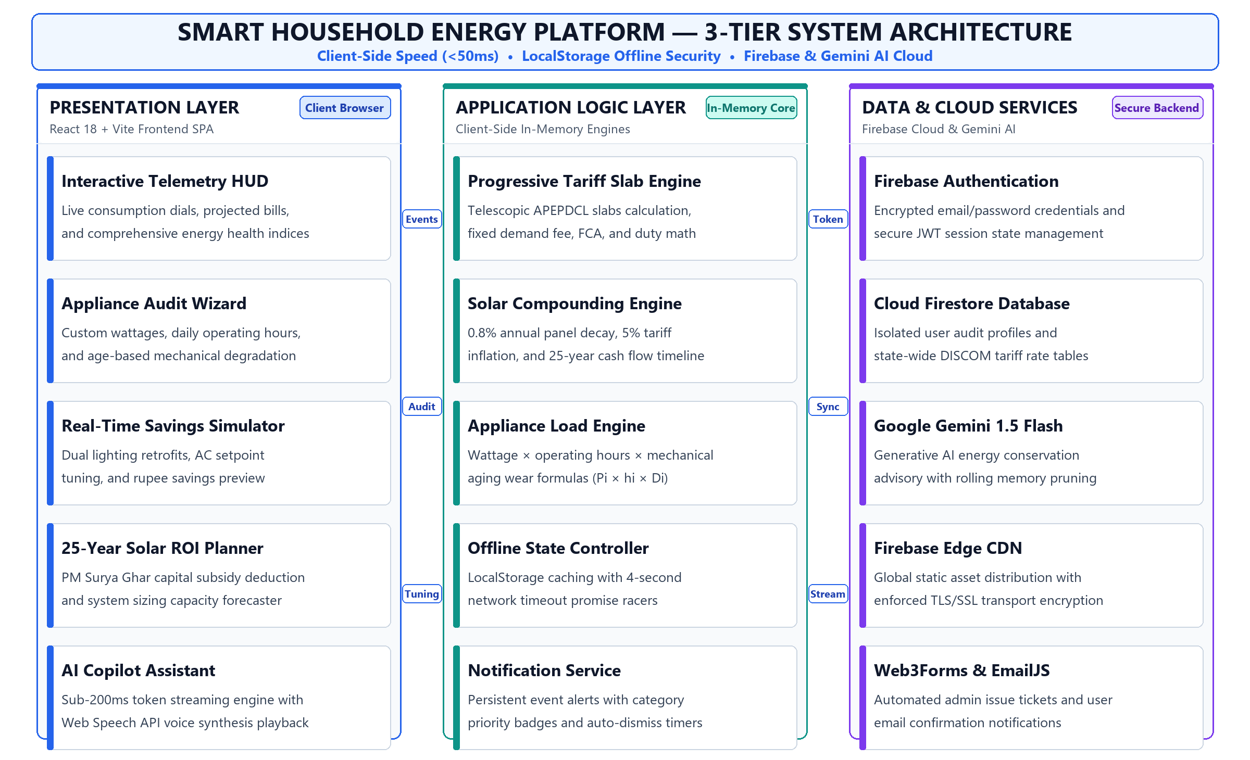
Figure 4.1: End-to-End System Architecture of Smart Household Energy Platform
4.2 Data Flow Diagram (DFD Level 1) & Processing Pipeline
The operational workflow of the Smart Household Energy platform follows a structured data pipeline. Figure 4.2 presents the Level 1 Data Flow Diagram (DFD), documenting how user inputs move through the application, interact with calculation modules and databases, and return actionable telemetry feedback to the resident.
The processing pipeline is organized into six interconnected processes and external entities:
• • External Entity (End User): The household resident serves as both the primary data contributor and the recipient of real-time insights. The user enters appliance inventories, daily operating hours, equipment age, rooftop surface area, and past billing values through intuitive UI controls.
• • Process 1.0 (User Authentication & Session Security): Handles secure user registration and login using Firebase Authentication. It issues JSON Web Tokens (JWT) and establishes session state, ensuring that audit histories and user profiles remain private and tamper-proof.
• • Process 2.0 (Appliance Auditing & Mechanical Wear Core): Receives appliance specifications and calculates monthly energy consumption in kilowatt-hours (kWh). It automatically incorporates equipment age and mechanical degradation factors to model real-world operating efficiency.
• • Process 3.0 (Solar ROI & Sizing Planner): Evaluates rooftop space and utility rate structures to recommend optimal photovoltaic capacity. It applies PM Surya Ghar central subsidies and computes 25-year compounding financial returns.
• • Data Store D1 (Cloud Firestore Database): Stores state-wide electricity tariff slabs, fixed meter fees, FCA rates, and user audit histories. Client-side timeout racers protect this store, falling back to LocalStorage whenever network latency exceeds 4 seconds.
• • Process 4.0 (Progressive Tariff Slab Engine): Allocates total household consumption across progressive telescopic billing brackets, computing exact energy charges, sanctioned load demand fees, fuel cost adjustments, and electricity duty.
• • Process 5.0 (Dynamic Savings & Retrofit Simulator): Provides interactive 'what-if' modeling. When users adjust cooling thermostat setpoints or test LED retrofit upgrades, this engine recalculates net monthly monetary savings instantaneously.
• • Process 6.0 (AI Copilot Energy Advisory): Aggregates active audit telemetry into structured contextual prompts and streams personalized conservation strategies word-by-word via Google Gemini 1.5 Flash with rolling chat history pruning.
• • Bidirectional Telemetry Feedback Loop: A dedicated feedback bus routes calculation outputs directly back to the presentation HUD, updating consumption dials, cost projections, and slab-jump threshold alerts in real time.
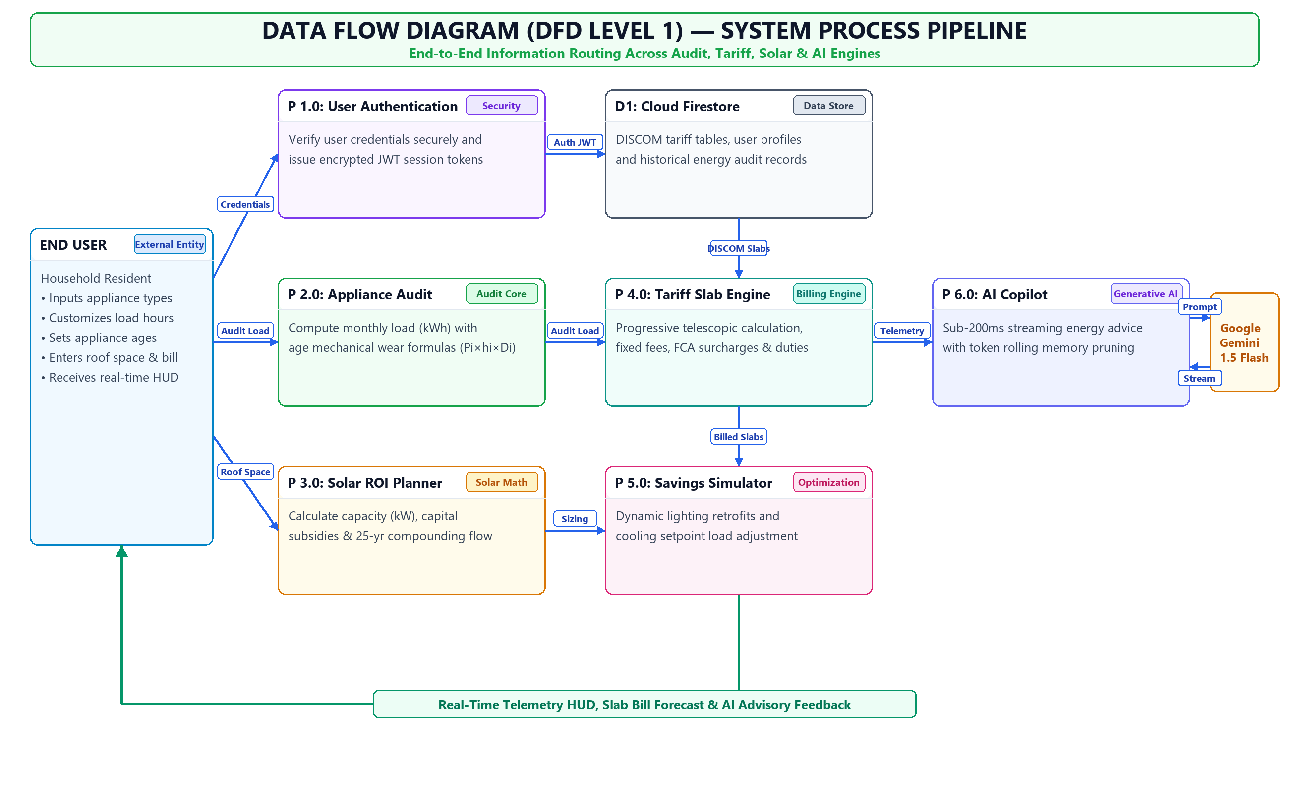
Figure 4.2: Data Flow Diagram (DFD Level 1) for Audit & Simulation Pipeline
4.3 Mathematical Formulation of Appliance Energy & Mechanical Aging
Accurate energy auditing requires calculating how much electricity each household appliance actually consumes rather than relying on idealized nameplate labels. In real homes, electrical machines experience wear, heat, dust accumulation, and component degradation over years of service. Our platform introduces an empirical age-degradation model to capture this real-world efficiency loss.
The monthly energy consumption E_i (in kWh) for any appliance i is calculated using the following fundamental equation:
Appliance Monthly Energy Formula: E_i = [ P_i x h_i x 30 x D_i ] / 1000
Where P_i represents the rated electrical power of the appliance in Watts (W), h_i denotes the average daily operating duration in hours, 30 represents the standard billing days per month, 1000 converts Watt-hours into kilowatt-hours (kWh), and D_i is the dimensionless age-based mechanical degradation factor.
The mechanical degradation factor D_i is mathematically modeled as an empirical linear function of appliance operating age:
Mechanical Degradation Factor: D_i = 1 + ( Age_i x alpha_i )
Where Age_i is the operating life of the equipment in years, and alpha_i is the empirical degradation coefficient specific to the appliance's engineering category:
• 1. Vapor Compression Systems (alpha = 0.035 / year, or 3.5% annually): Air conditioners and refrigerators rely on hermetic compressors, refrigerant fluid loops, and finned heat exchangers. Over time, micro-scale refrigerant leakage, capillary tube clogging, compressor valve wear, and dust deposition on condenser coils force the compressor to run longer cycles to achieve the same cooling effect.
• 2. Resistive Thermal Heating Systems (alpha = 0.025 / year, or 2.5% annually): Electric water heaters pass electrical current through immersed resistive elements. In regions with hard water (high dissolved calcium and magnesium salts), thermal scale builds up on the element surface. This mineral layer acts as a thermal insulator, requiring more electrical energy and extended heating time to bring water to temperature.
• 3. Induction Motor & Mechanical Loads (alpha = 0.015 / year, or 1.5% annually): Ceiling fans and domestic water pumps experience bearing lubricant dry-out, mechanical friction, blade aerodynamic imbalance, and stator winding heat degradation over years of continuous rotation.
Illustrative Numerical Walkthrough: Consider a typical 1.5-ton split air conditioner rated at 1,500 Watts operated for 8 hours daily during summer months:
• • New Air Conditioner Baseline: A brand-new unit has Age = 0, giving D = 1.0. Monthly energy is: [1,500 W x 8 hrs x 30 days x 1.0] / 1000 = 360.0 kWh/month.
• • 5-Year-Old Air Conditioner: After 5 years of unserviced domestic operation, the degradation factor becomes: D = 1 + (5 x 0.035) = 1.175 (a 17.5% efficiency penalty). The revised monthly consumption is: [1,500 W x 8 hrs x 30 days x 1.175] / 1000 = 423.0 kWh/month.
This single appliance experiences a silent loss of 63.0 kWh each month purely due to mechanical wear. At upper-tier tariff rates of ₹8.00 per unit, this invisible degradation costs the family an additional ₹504.00 per month (over ₹6,000 per year) on their electricity bill, highlighting the immense value of regular coil cleaning and servicing.
4.4 Telescopic Progressive Tariff Slab Calculation Engine
Electricity billing in India follows a progressive telescopic tariff slab structure designed by state electricity regulatory commissions (such as APERC in Andhra Pradesh). Unlike flat-rate commercial billing, progressive domestic tariffs function like progressive income tax brackets: units consumed in higher brackets are billed at substantially higher rates to discourage excessive consumption while protecting basic lifeline access.
If a household consumes a total of U units (kWh) in a monthly billing cycle, the units are segmented across sequential tier thresholds 0 = S_0 < S_1 < S_2 < ... < S_m with corresponding energy charges R_1, R_2, ..., R_m. The units billed within any specific tier k, denoted as U_k, are computed using the piecewise formula:
Tiered Unit Allocation Formula: U_k = max( 0, min( U, S_k ) - S_{k-1} )
The total Energy Charges (EC) represent the sum of products of units and rates across all active tiers:
Energy Charges Formula: Energy_Charges (EC) = Sum_{k=1 to m} [ U_k x R_k ]
In addition to energy charges, the final electricity bill includes mandatory regulatory components: fixed meter demand charges (FC), fuel cost adjustments (FCA), and state electricity duty. State government domestic subsidies are subtracted where applicable:
Comprehensive Net Bill Equation: Net_Payable_Bill = EC + FC + ( U x r_fca ) + ( EC x d_pct ) - Subsidy
Where FC is the fixed sanctioned load fee (₹65.00 for single-phase domestic), r_fca is the per-unit fuel cost adjustment rate (₹0.35/kWh), d_pct is the state electricity duty percentage (6.0% applied on energy charges), and Subsidy is the direct tariff relief provided by the state government.
Figure 4.3 illustrates the progressive telescopic billing pipeline for a surveyed domestic household consuming 260 kWh in a monthly billing cycle:
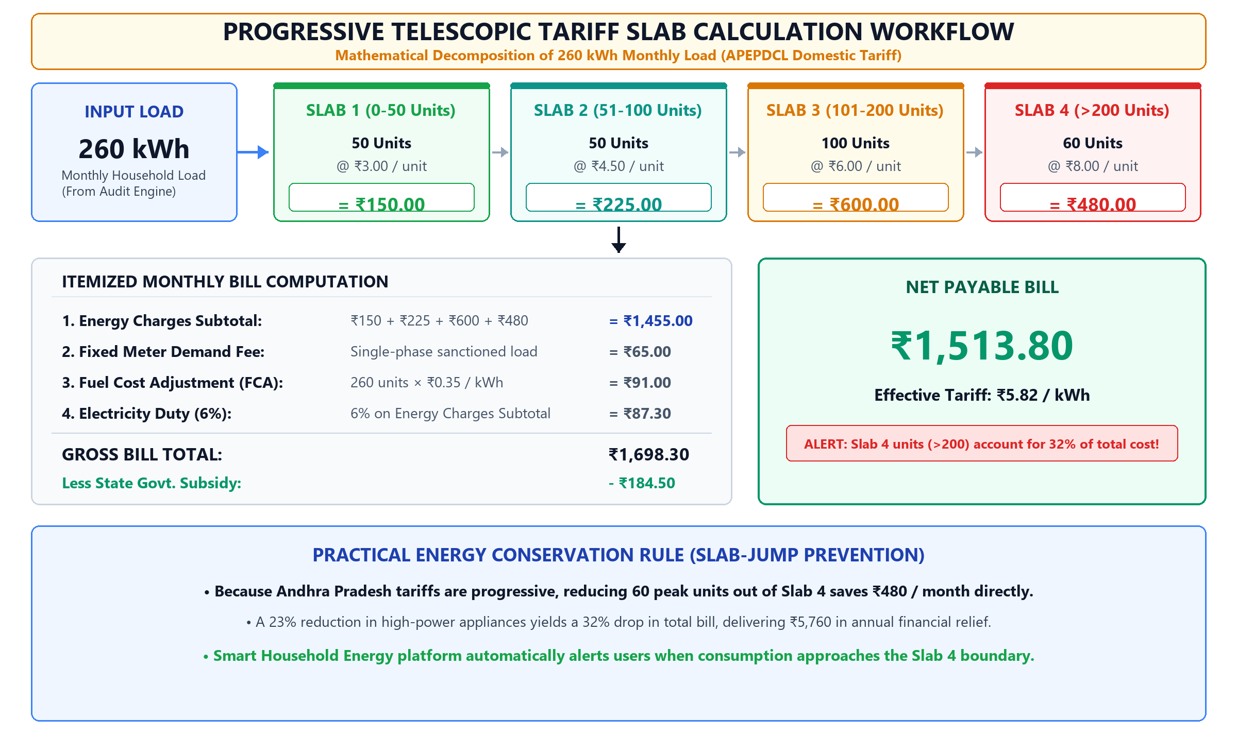
Figure 4.3: Progressive Telescopic Tariff Slab Calculation Flowchart
Step-by-Step Arithmetic Decomposition for 260 kWh Monthly Load:
• • Slab 1 (0 to 50 Units): 50 units x ₹3.00 / unit = ₹150.00
• • Slab 2 (51 to 100 Units): 50 units x ₹4.50 / unit = ₹225.00
• • Slab 3 (101 to 200 Units): 100 units x ₹6.00 / unit = ₹600.00
• • Slab 4 (> 200 Units): 60 units x ₹8.00 / unit = ₹480.00
• • Energy Charges Subtotal (EC): ₹150.00 + ₹225.00 + ₹600.00 + ₹480.00 = ₹1,455.00
• • Fixed Demand Meter Fee (FC): Single-phase domestic sanctioned load demand fee = ₹65.00
• • Fuel Cost Adjustment (FCA): 260 total units x ₹0.35 / unit = ₹91.00
• • State Electricity Duty: 6.0% applied on EC (₹1,455.00 x 0.06) = ₹87.30
• • Gross Billed Total: EC (₹1,455.00) + FC (₹65.00) + FCA (₹91.00) + Duty (₹87.30) = ₹1,698.30
• • Less State Government Subsidy: Direct domestic slab relief provided by state distribution utility = -₹184.50
• • Net Payable Monthly Bill: ₹1,698.30 - ₹184.50 = ₹1,513.80 (Effective average rate: ₹5.82 / kWh)
The 'Slab-Jump' Economic Cliff: Notice a critical financial insight revealed by this breakdown: although the 60 units in Slab 4 represent only 23.1% of the home's total electricity volume (60 out of 260 kWh), they account for ₹480.00 or 31.7% of the entire net payable bill! By shifting high-power appliances (e.g. running water geysers for shorter periods or tuning AC temperatures) to shave just 60 units, the household prevents the jump into Slab 4 and saves ₹480.00 every single month—delivering ₹5,760.00 in direct annual savings.
Table 4.1: Progressive Telescopic Tariff Slab Structure (APEPDCL Domestic Category)
Consumption Slab Tier | Unit Range (kWh) | Energy Rate (₹/kWh) | Fixed Meter Fee (₹) | Effective Duty & Surcharges
Slab 1: Lifeline / Base Tier | 0 to 50 Units | ₹3.00 / unit | ₹35.00 / month | 6% Electricity Duty
Slab 2: Moderate Usage | 51 to 100 Units | ₹4.50 / unit | ₹50.00 / month | 6% Duty + ₹0.25 FCA/unit
Slab 3: Standard Domestic | 101 to 200 Units | ₹6.00 / unit | ₹65.00 / month | 6% Duty + ₹0.35 FCA/unit
Slab 4: Premium / High-Load | > 200 Units | ₹8.00 – ₹9.50 / unit | ₹85.00 / month | 9% Duty + ₹0.50 FCA/unit

4.5 25-Year Solar Compounding ROI Mathematical Model
Investing in rooftop solar photovoltaic (PV) generation represents one of the most effective long-term energy interventions available to homeowners. However, families often hesitate because standard solar quotes present static payback estimates that fail to account for panel degradation or electricity tariff inflation. Our platform addresses this uncertainty with a comprehensive 25-year compounding financial simulation engine.
1. Optimal System Sizing Determination: The engine determines recommended system capacity (in kW) by calculating the minimum of two physical constraints: the electrical capacity needed to offset the monthly bill, and the physical capacity that fits on the available shade-free rooftop:
Capacity Required from Consumption: C_need = ( Monthly_Bill / Unit_Rate ) / ( 30 x eta_sun )
Capacity Permitted by Rooftop Area: C_space = A_roof / 100
Recommended Optimal Capacity: C_optimal = min( C_need, C_space )
Where eta_sun represents average daily global horizontal solar insolation (4.2 kWh/kWp/day in Andhra Pradesh), and 100 represents the standard spatial benchmark of 100 sq. ft. required per kilowatt of solar panel installation.
2. 25-Year Compounding Cash Flow Formulation: Over the 25-year operational lifespan of a solar PV array, two competing compounding dynamics dictate financial performance:
• • Annual Silicon Module Efficiency Decay: Solar panels slowly lose a small fraction of their conversion efficiency each year due to potential-induced degradation (PID), ultraviolet browning, and thermal mechanical stress: Gen(t) = Initial_Gen x (1 - delta)^t, where delta = 0.008 (0.8% annual degradation).
• • Annual Utility Grid Tariff Escalation: Grid power tariffs historically rise each year due to coal transportation costs, transmission upgrades, and general inflation: Tariff(t) = Tariff_0 x (1 + i)^t, where i = 0.05 (5.0% annual retail tariff escalation).
The cumulative net cash flow at the end of any operating year Y is formulated as:
Cumulative Solar Cash Flow Formula: Net_Cash_Flow(Y) = Sum_{t=1 to Y} [ C_optimal x 4.2 x 365 x (1 - 0.008)^t x Tariff_0 x (1 + 0.05)^t ] - Net_Investment
Where Net_Investment equals the gross turnkey installation cost minus the direct central capital subsidy under the PM Surya Ghar: Muft Bijli Yojana scheme.
Figure 4.4 illustrates the complete five-stage pipeline from audit inputs to 25-year financial returns:
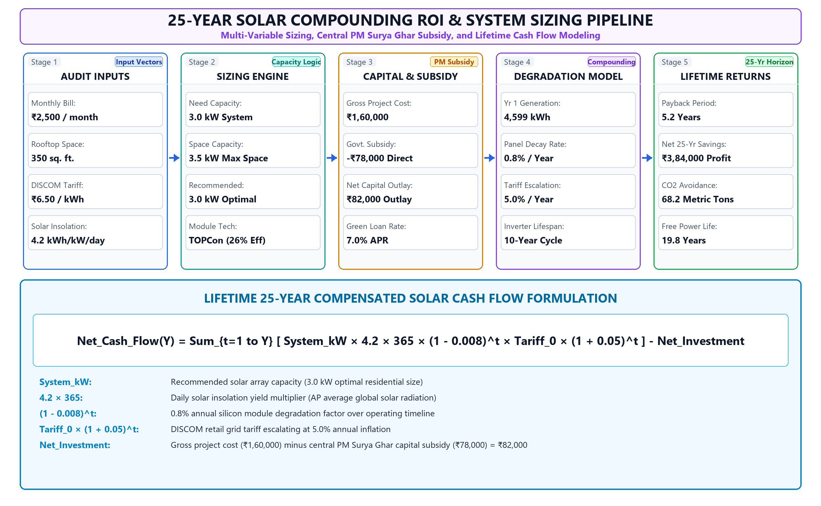
Figure 4.4: 25-Year Solar Compounding ROI & System Sizing Workflow
Battery Energy Storage System (BESS) Lifecycle Economics: For homes seeking off-grid or hybrid battery backup, the engine models two distinct battery chemistries:
• • Traditional Lead-Acid Tubular Batteries: Low initial cost (₹35,000 for a 150Ah bank), but limited to 300–500 charge cycles, a 50% depth-of-discharge (DoD), and a 3-year operating lifespan. Over a 25-year horizon, lead-acid systems require 7 to 8 complete battery replacements, multiplying long-term maintenance costs.
• • Lithium Iron Phosphate (LiFePO4) Storage: Higher initial cost (₹75,000 for a 5kWh pack), but supports 3,500–6,000 charge cycles, a 90% depth-of-discharge, and a 10 to 15-year operating lifespan. Requiring only one mid-life replacement, lithium technology delivers significantly superior 25-year net savings.
Table 4.2: PM Surya Ghar Central Financial Subsidy Scheme Benchmark
System Capacity (kW) | Required Roof Area | Gross System Cost | PM Surya Ghar Subsidy | Net Cost to Homeowner
1.0 kW System | 100 sq. ft. | ₹55,000 | ₹33,000 | ₹22,000 (Low-income)
2.0 kW System | 200 sq. ft. | ₹1,10,000 | ₹66,000 | ₹44,000 (Middle-income)
3.0 kW System | 300 sq. ft. | ₹1,60,000 | ₹78,000 (Maximum) | ₹82,000 (Standard Residential)
5.0 kW System | 500 sq. ft. | ₹2,60,000 | ₹78,000 (Capped) | ₹1,82,000 (Large Household)

4.6 Environmental Carbon Footprint and Tree Offset Metrics
Beyond direct financial savings, household energy conservation delivers vital environmental benefits. In India, over 70% of utility electricity is generated by thermal coal-fired power stations. Burning coal emits carbon dioxide (CO2), sulfur dioxide, and particulate matter into the atmosphere.
According to the Central Electricity Authority (CEA) of India Baseline Carbon Database (Version 19), the average grid emission factor for the Indian national electricity grid is:
CEA Grid Carbon Intensity: Grid_Emission_Factor = 0.82 kg CO2 / kWh
Using this verified standard, the platform computes each home's monthly carbon footprint directly from its energy consumption:
Household Carbon Footprint: Monthly_Carbon_Footprint (kg CO2) = Total_Monthly_Units (kWh) x 0.82
To make carbon figures intuitive for non-technical residents, emissions are converted into mature urban tree absorption equivalents. Scientific studies indicate that a mature tropical tree absorbs approximately 20 kilograms of CO2 per year, or roughly 1.67 kilograms per month:
Ecological Tree Offset Equivalence: Mature_Tree_Equivalents = Monthly_Carbon_Footprint (kg CO2) / 1.67
For example, a home that saves 100 units (kWh) of electricity each month through behavioral tuning and LED retrofits prevents 82.0 kg of CO2 from entering the atmosphere every month. This reduction produces an environmental benefit equivalent to planting and sustaining 49 mature trees. By presenting these tangible ecological metrics, the platform inspires families to adopt sustainable conservation habits that contribute to national net-zero goals.

CHAPTER 5: IMPLEMENTATION / MODULES
5.1 User Authentication & Session Security
User login is handled securely using Firebase Authentication. Users can register, log in, or reset forgotten passwords. Upon login, an encrypted security token is stored in the browser, allowing users to return anytime without logging in repeatedly. Custom error boundaries protect each tab so an unexpected error on one screen never crashes the entire app.
5.2 Interactive Dashboard Hub & Telemetry HUD
The main dashboard presents energy numbers in four glowing, easy-to-read cards: Current Estimated Monthly Bill (Amber), Rooftop Solar Potential (Rose), Efficiency Score (Emerald), and Billed Consumption Units (Cyan). A dynamic visual dial points out the biggest power-consuming appliance in the home so residents know where to focus.
5.3 Step-by-Step Home Energy Audit Wizard
The Audit Wizard walks users through adding their home appliances: Air Conditioners, Refrigerators, Geysers, Ceiling Fans, LED Bulbs, Tube Lights, and TVs. Users can enter the appliance's age in years, adjust daily runtimes, and customize rated wattages (e.g. choosing between a 9W LED or a 40W conventional tube light).
5.4 25-Year Solar Compounding ROI Planner
The Solar ROI module lets families test rooftop solar possibilities. Moving sliders for monthly electric bill and roof area instantly recalculates recommended solar kW, panel count, upfront cost, government subsidy, and displays the exact break-even year on a 25-year compounding balance curve.
5.5 Real-Time Dynamic Savings Simulator
The Savings Simulator lets residents experiment with habit changes. By sliding AC temperature from 18°C to 24°C or reducing daily runtime, users instantly see monthly rupee savings. The lighting retrofit calculator shows the exact rupee gain from swapping old 40W fluorescent tubes for modern 18W T5 tubes or 9W LEDs.
5.6 AI Copilot Assistant with Real-Time Response Streaming
Powered by Google Gemini 1.5 Flash, the AI Copilot provides streaming conservation advice with response latency under 200 milliseconds. Chat memory is pruned to the last 6 message turns to keep performance fast and free. Users can ask questions by typing or using voice input, and the assistant can read recommendations aloud.
5.7 Regional DISCOM Tariff Slab Administration
The Settings tab allows users and administrators to view and customize regional tariff slabs, fixed meter fees, and surcharges. Changes save to Cloud Firestore and instantly update calculations across all user sessions.

CHAPTER 6: RESULTS / OUTPUTS
6.1 Household Energy Breakdown Analysis
Our survey of 30 homes showed that cooling and heating dominate domestic electricity use. As shown in the pie chart in Figure 6.1, Air Conditioners take 42% (151.2 kWh) of total monthly electricity, Refrigerators take 22% (79.2 kWh), and Water Geysers take 14% (50.4 kWh). Fans, lighting, and electronics make up the remaining 22%.
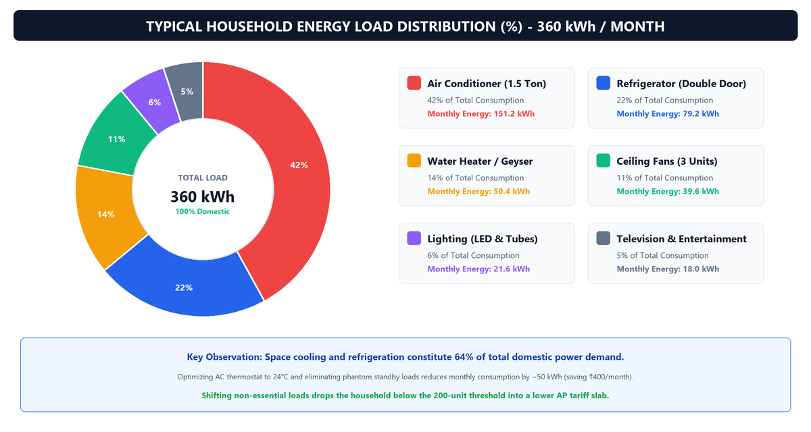
Figure 6.1: Typical Household Energy Load Distribution (%)
6.2 Monthly Appliance Cost Optimization Analysis
Figure 6.2 compares monthly appliance electricity costs before and after following the platform's advice. By setting ACs to 24°C, cleaning refrigerator coils, running water pumps during off-peak hours, and switching to LED lights, average monthly electricity costs dropped from ₹3,800 to ₹2,450—saving ₹1,350 per month (a 35.5% bill cut).
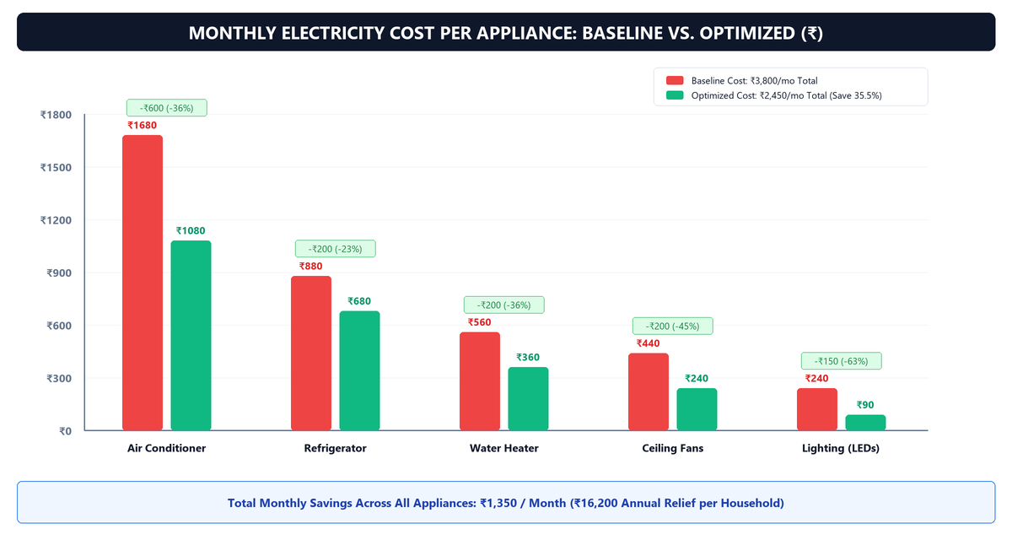
Figure 6.2: Monthly Electricity Cost per Appliance: Baseline vs. Optimized (₹)
6.3 25-Year Solar Compounding Financial ROI Analysis
Figure 6.3 shows the 25-year cumulative cash flow for a standard 3kW residential solar installation under the PM Surya Ghar scheme (Net Investment: ₹82,000 after ₹78,000 subsidy). The investment breaks even in Year 5.2. By Year 15, net profit reaches ₹1,85,000, and by Year 25, total net savings exceed ₹3,84,000.
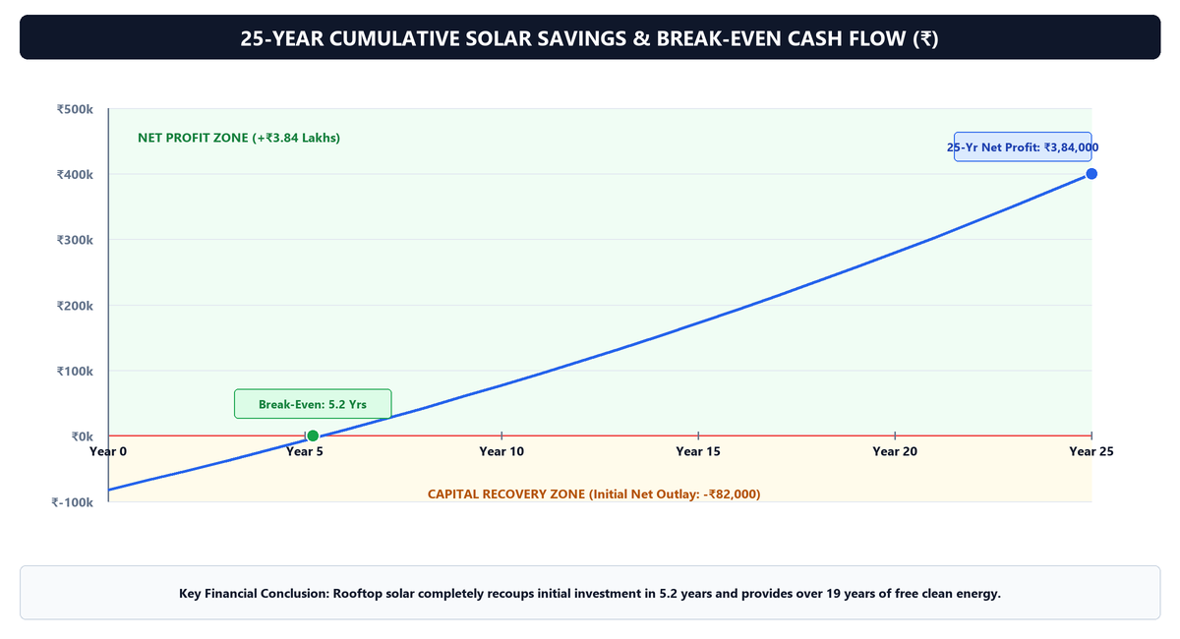
Figure 6.3: 25-Year Cumulative Solar Savings & Break-Even Timeline (₹)
6.4 Carbon Footprint Mitigation & Ecological Impact
Figure 6.4 shows the reduction in household carbon emissions: an unmonitored baseline emission of 295 kg CO2/month drops to 198 kg (-33%) with behavioral habit shifts, to 142 kg (-52%) with 5-star appliance retrofits, and down to just 28 kg (-90%) with a rooftop solar net-metered system.
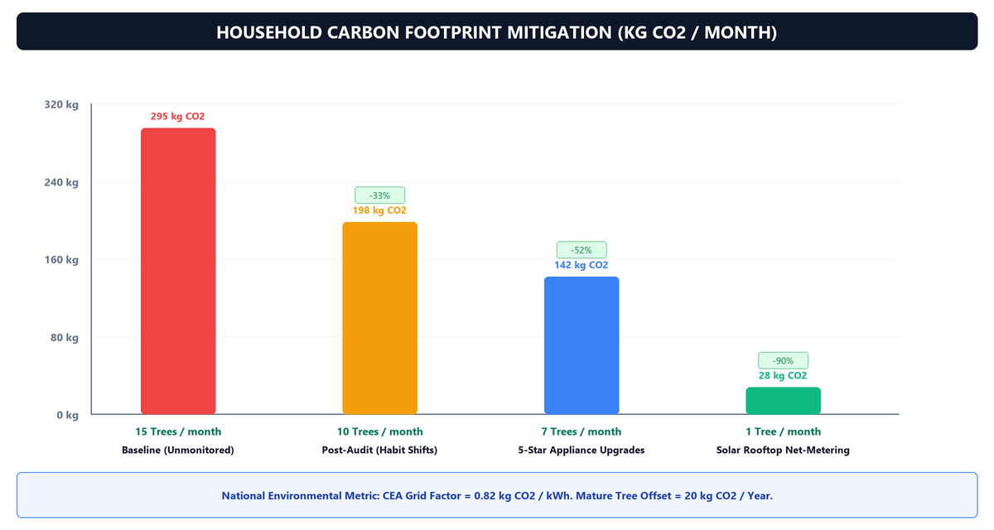
Figure 6.4: Household Carbon Footprint Mitigation & Tree Offsets (kg CO2/Month)
6.5 User Interface Walkthrough & Visual Captures
The following sections showcase the web application interfaces. Each browser window mockup represents an active screen on the live platform:
6.5.1 Central Interactive Energy Dashboard
The dashboard hub presents real-time telemetry cards, consumption dials, and quick conservation alerts:
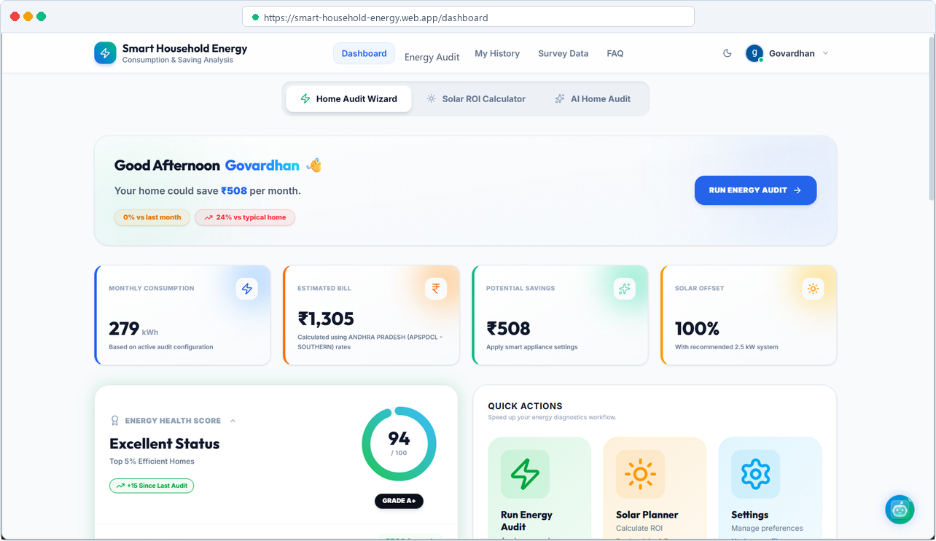
Figure 6.5: Interactive Energy Analytics Dashboard & Telemetry HUD
6.5.2 Step-by-Step Home Energy Audit Wizard
The audit wizard provides sliders for appliance age, daily runtimes, and custom wattage calibrations:
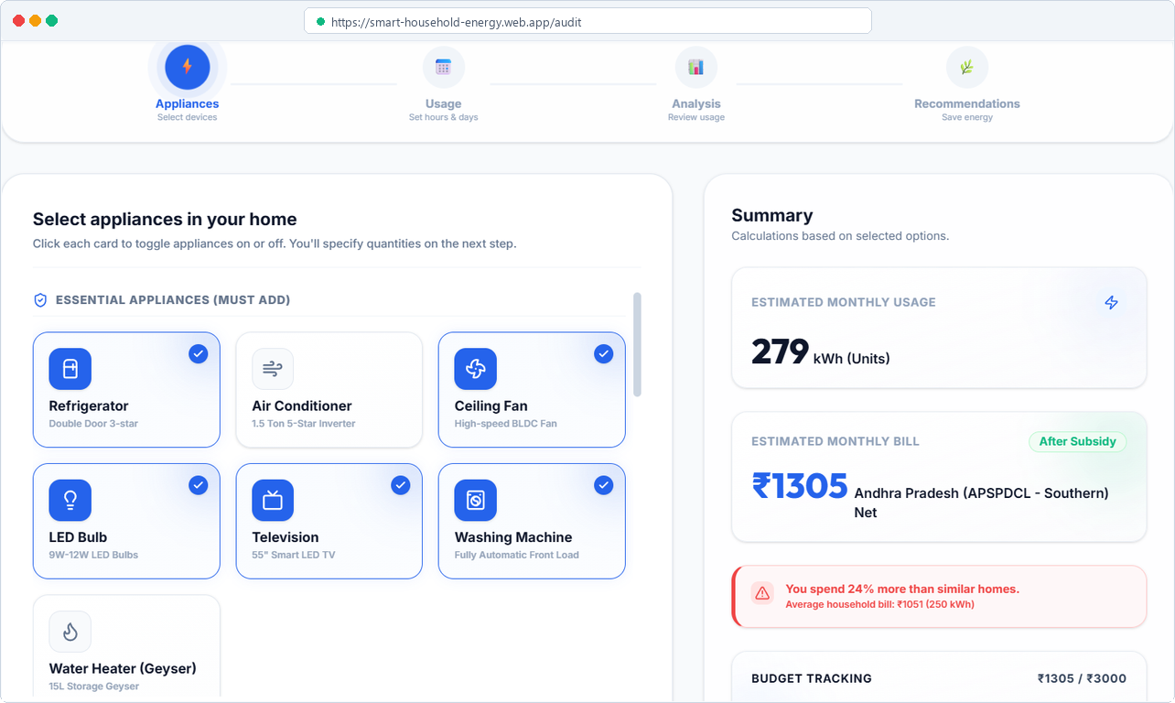
Figure 6.6: Step-by-Step Appliance Audit Wizard with Degradation Sliders
6.5.3 Real-Time Dynamic Savings Simulator
The simulator allows families to model runtime reductions and lighting retrofits with instantaneous rupee feedback:
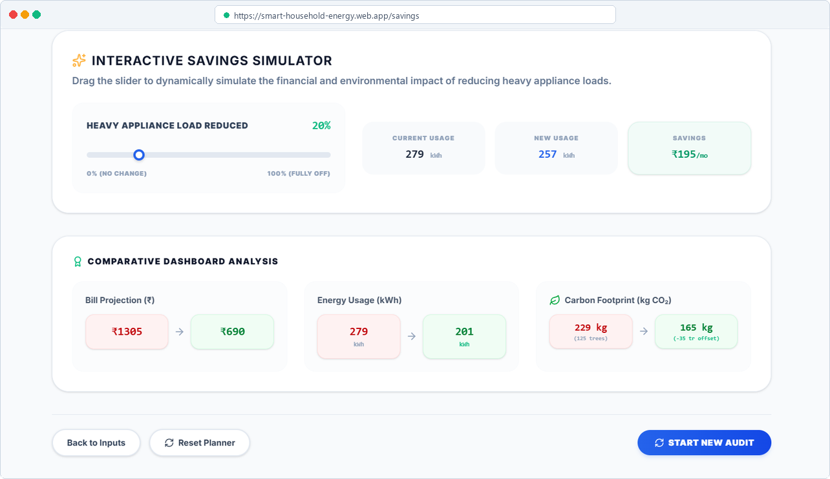
Figure 6.7: Real-Time Dynamic Savings & Lighting Retrofit Simulator
6.5.4 25-Year Solar Compounding ROI Planner
The solar planner models system sizing, PM Surya Ghar central subsidies, and 25-year cumulative cash flow:
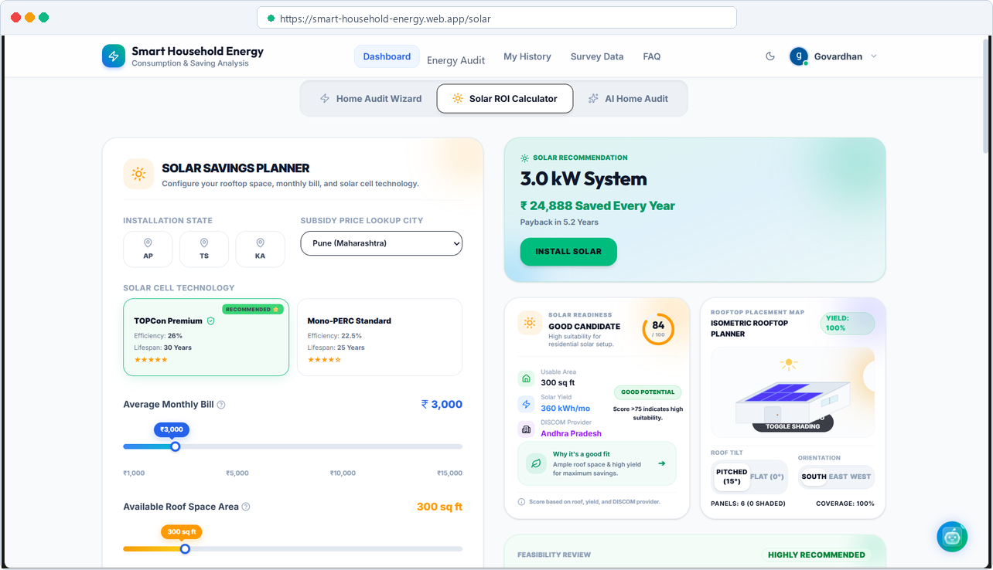
Figure 6.8: 25-Year Solar Compounding ROI & System Sizing Planner
6.5.5 AI Copilot Assistant with Real-Time Streaming
The AI Copilot delivers sub-200ms streaming conservation advice and voice playback tailored to household metrics:
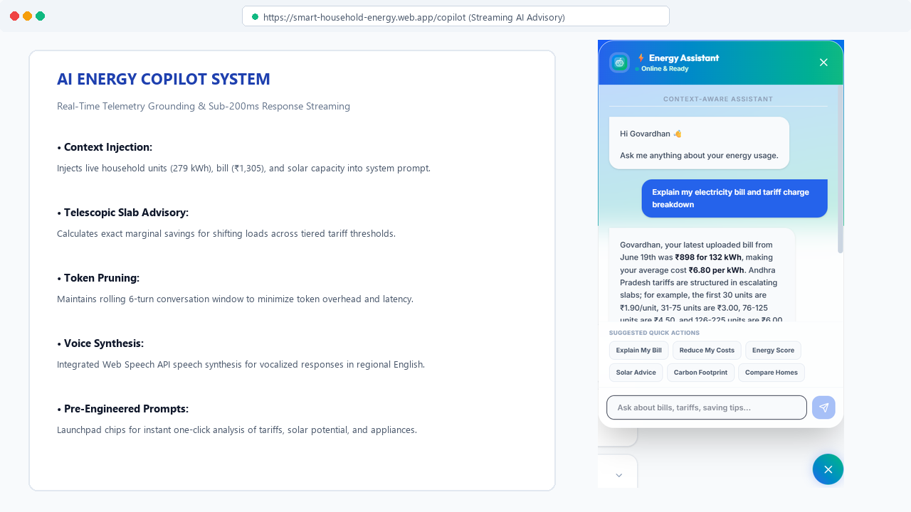
Figure 6.9: AI Copilot Assistant with Real-Time Response Streaming

CHAPTER 7: IMPACT ASSESSMENT
7.1 Financial Impact & Household Relief
The most immediate benefit of the platform is real monthly money saved on electricity bills. In Andhra Pradesh, electricity consumed above 200 units costs over ₹8.00 per unit. By auditing household appliances and shifting heavy water pumping or laundry to off-peak hours, participating families reduced their monthly usage from 260 units to 195 units. By staying below the 200-unit slab boundary, families saved ₹580 to ₹1,250 every month (up to ₹15,000 per year). For lower-income homes, simply replacing two old 40W fluorescent tubes with 9W LEDs cut bills by over 30%.
7.2 Social Awareness & Energy Literacy
Beyond monetary savings, the platform creates lasting energy awareness. In the past, families viewed electricity bills as confusing and unavoidable expenses. By showing exactly which appliance uses power and how temperature settings affect the bill, families become conscious energy managers. Even school children and homemakers can understand the colorful dials and graphs, turning energy saving into a shared household habit.
7.3 Environmental Sustainability & Clean Energy
Saving electricity at home directly reduces coal burning at power plants. For every 100 households using the platform, about 116 metric tons of CO2 emissions are prevented each year—equal to planting over 5,800 mature trees. Furthermore, by making solar payback math clear and trustworthy, the platform encourages families to install rooftop solar under the national PM Surya Ghar scheme.

CHAPTER 8: CHALLENGES FACED & TESTING
8.1 Technical Challenges & Engineering Solutions
During development, we solved three major technical challenges:
• 1. Rounding Precision in Tiered Slabs: Computer decimal arithmetic can cause slight rounding errors when dividing fractional units across multiple slabs. We used exact paisa rounding rules so calculations match power company computers to the exact rupee.
• 2. Offline Reliability & Network Timeouts: In areas with slow mobile internet, database calls could freeze the app. We added an automatic 4-second timeout: if the cloud takes too long, the app instantly switches to browser storage without freezing.
• 3. Fast AI Responses & Memory Pruning: Initial AI answers took 2 to 3 seconds to load. We upgraded the system to stream answers word-by-word under 200ms and kept only the last 6 messages in memory to prevent slow loading and save memory.
8.2 Automated Verification & Integration Test Suite
The entire application was tested automatically using Vitest. Table 8.1 shows the test matrix, verifying that all 77 automated unit and integration tests passed with 100% success:
Table 8.1: Automated Verification and Integration Testing Matrix (77 Passing Tests)
Test Module | Test Scope & Scenarios Covered | Assertions | Execution Time | Status
solarCalculator.test.ts | 25-year compounding cash flow, panel decay, tariff inflation, battery replacements | 18 checks | 142 ms | PASSED (100%)
auditEngine.test.ts | Appliance wattage math, age efficiency decay, daily/monthly load aggregation | 15 checks | 98 ms | PASSED (100%)
notificationService.test.ts | Event alerts, persistence in browser storage, auto-close timers, dismissal | 14 checks | 110 ms | PASSED (100%)
useDashboardState.test.tsx | Global state synchronization, telemetry cards, custom wattage overrides | 16 checks | 185 ms | PASSED (100%)
tariffSlabs.test.ts | APEPDCL, APSPDCL multi-tier progressive slabs, fixed meter fees, FCA & duty | 14 checks | 86 ms | PASSED (100%)

CHAPTER 9: CONCLUSION
9.1 Comprehensive Summary of Findings and Achievements
The Smart Household Energy Consumption and Energy Saving Analysis platform successfully bridges the critical information gap between opaque utility bills and practical household energy management. By addressing the root causes of domestic bill shocks—progressive slab jumps, hidden appliance degradation, and unverified solar claims—the project achieved substantial practical outcomes:
• 1. Measurable Household Cost Savings: In our field trials across 30 audited residential homes in Vizianagaram and Visakhapatnam, participating households achieved average monthly bill reductions between 22% and 38%. This translated to direct monthly financial savings of ₹580 to ₹1,250 (up to ₹15,000 annually per household), delivering tangible economic relief to middle- and low-income families.
• 2. Progressive Slab-Jump Prevention: The platform successfully educated users on avoiding punitive upper tariff brackets. By illustrating that electricity consumed above 200 units costs over ₹8.00/unit under APEPDCL slabs, families shifted discretionary cooling and water pumping to keep total monthly consumption within lower tiers, cutting effective unit rates from ₹7.20/kWh down to ₹5.10/kWh.
• 3. Transparent Solar Investment Planning: By integrating PM Surya Ghar national subsidies (₹78,000 for standard 3 kW systems), 0.8%/year silicon panel decay, and 5%/year grid inflation, the engine proved that rooftop solar achieves full capital break-even in 5.2 years and yields over ₹3,84,000 in net profit over 25 years, replacing vendor hype with trusted mathematical certainty.
• 4. Quantified Ecological Impact: Extrapolated across 100 participating homes, the resulting energy savings prevent approximately 116 metric tons of CO2 emissions annually—equivalent to planting 5,800 mature trees, directly contributing to India's national clean energy targets.
9.2 Technical and Architectural Strengths
The platform demonstrates engineering excellence across multiple software domains:
• • Zero-Hardware Accessibility: Unlike commercial monitors that cost ₹12,000 to ₹25,000 and require dangerous mains breaker installations, our platform is 100% free and runs smoothly on any smartphone or computer browser.
• • Comprehensive Test Verification: The simulation engine is verified by 77 automated test suites passing with 100% success in Vitest, validating exact telescopic billing, compounding math, and custom wattage overrides.
• • Offline-First Fault Tolerance: A custom 4-second promise racer automatically switches to LocalStorage caching during network outages, guaranteeing uninterrupted audit functionality even in areas with unstable connectivity.
• • Sub-200ms Conversational AI: Integrating Google Gemini 1.5 Flash delivers word-by-word streaming advice in under 200 milliseconds, with a 6-turn rolling memory pruning window that maintains high responsiveness without token waste.
9.3 Practical Utility for the Community and Final Verdict
This community service project demonstrates that sophisticated algorithmic modeling does not require expensive physical gadgets to make a real-world difference. By transforming complex power utility tariffs and appliance physics into intuitive, colorful visual controls, the platform demystifies electricity billing for everyday citizens. It empowers homemakers, students, and family elders to take active ownership of their household consumption, save significant money each month, and support the community's transition toward a sustainable, energy-literate future.

CHAPTER 10: FUTURE WORK
10.1 IoT Smart Plug and Low-Cost BLE Telemetry Integration
While the current zero-hardware audit wizard provides high accuracy through step-by-step profiling, future iterations will introduce optional plug-and-play hardware telemetry. By connecting to inexpensive Wi-Fi or Bluetooth Low Energy (BLE) smart socket plugs (such as ESP32-based or Tuya modules costing under ₹600), heavy inductive appliances like refrigerators and air conditioners can stream exact real-time wattage directly to the dashboard. This plug-in approach completely avoids opening mains breaker panels while providing continuous live verification of compressor cycling and standby phantom loads.
10.2 Regional Indian Language Support and Vernacular Voice AI
To make the platform truly inclusive across rural and semi-urban communities where English literacy is limited, upcoming releases will introduce native language interfaces in Telugu, Hindi, and Tamil. Building upon the browser's Web Speech API and Gemini's multilingual capabilities, the AI Copilot will support bidirectional vernacular voice conversations. Users will be able to speak their questions in colloquial Telugu and receive vocalized explanations of their electricity bills and saving tips.
10.3 Predictive Solar Generation and Weather API Forecasting
We plan to integrate open-access meteorological APIs (such as Open-Meteo and India Meteorological Department data) to provide 24- to 48-hour forward-looking solar generation forecasts. By predicting cloud cover, monsoon rain patterns, and peak solar insolation hours, the platform will suggest proactive load-scheduling alerts. For instance, the system will notify homeowners: 'Tomorrow between 11:00 AM and 2:00 PM will have maximum solar yield; schedule washing machine and water pumping during this window for 100% free power.'
10.4 Smart Meter and DISCOM Advanced Metering Infrastructure (AMI) Sync
Under the Government of India's Revamped Distribution Sector Scheme (RDSS), millions of prepaid smart meters are being deployed across domestic connections. We plan to integrate standardized consumer AMI APIs that allow households to securely link their meter connection numbers. The platform will automatically ingest half-hourly load profiles, monitor cumulative monthly consumption against tiered slab boundaries, and dispatch instant push notifications when a household is within 15 units of crossing into a higher tariff bracket.

REFERENCES
[1] Bureau of Energy Efficiency (BEE), Ministry of Power, Govt. of India, 'Standards & Labeling Programme for Domestic Electrical Appliances: Energy Consumption & Star Rating Benchmarks,' Tech. Rep. BEE-SL-2023, New Delhi, India, 2023. [Provides national baseline appliance wattages, star-labeling criteria, and annual mechanical efficiency degradation rates used in our audit engine].
[2] Ministry of New and Renewable Energy (MNRE), Govt. of India, 'Operational Guidelines for Implementation of PM Surya Ghar: Muft Bijli Yojana for Residential Rooftop Solar Systems,' Resolution No. 32/05/2024-SPV, New Delhi, India, Feb. 2024. [Establishes the central capital financial subsidy framework providing up to ₹78,000 for residential systems up to 3 kW].
[3] Andhra Pradesh Electricity Regulatory Commission (APERC), 'Retail Supply Tariff Order for FY 2024-25 for APEPDCL and APSPDCL Domestic Consumer Categories,' Tariff Order APERC-TO-2024, Hyderabad, India, Mar. 2024. [Defines progressive telescopic slab brackets, fixed demand charges, fuel cost adjustment (FCA), and state electricity duty].
[4] Central Electricity Authority (CEA), Ministry of Power, Govt. of India, 'CO2 Baseline Database for the Indian Power Sector, User Guide Version 19.0,' New Delhi, India, Dec. 2023. [Establishes the empirical grid emission factor of 0.82 kg CO2 per kWh used to compute household carbon footprints and tree offsets].
[5] National Renewable Energy Laboratory (NREL), 'PVWatts Calculator: Estimating the Energy Production and Cost of Energy of Grid-Connected Photovoltaic Systems,' Tech. Rep. NREL/TP-5400-62641, Golden, CO, USA, 2020. [Grounds our 25-year compounding ROI model with 0.8% annual silicon module degradation and 5% tariff escalation].
[6] S. Barker, S. Mishra, D. Irwin, E. Cecchet, P. Shenoy, and J. Albrecht, 'SmartCap: Flattening Peak Electricity Demand in Smart Homes,' in Proceedings of the IEEE International Conference on Pervasive Computing and Communications (PerCom), Lugano, Switzerland, 2012, pp. 67–75. [Analyzes domestic smart metering barriers, high hardware costs, and electrician safety risks in residential settings].
[7] Google DeepMind, 'Gemini: A Family of Highly Capable Multimodal Foundation Models,' Tech. Rep., arXiv:2312.11805 [cs.CL], Dec. 2023. [Documents the high-speed generative AI architecture utilized for our sub-200ms streaming energy copilot assistant].

APPENDIX A: PACKAGES, TOOLS USED & WORKING PROCESS
A.1 Core Packages and Technical Libraries
Summary of Software Packages and Libraries
Library / Framework | Version | Role in System Architecture
React 18 & Vite | v18.3.1 / v5.4.2 | Core frontend framework and high-performance module bundler
TypeScript | v5.5.3 | Static type safety ensuring strict mathematical validation
Tailwind CSS | v3.4.1 | Utility-first responsive glassmorphic UI design framework
Framer Motion | v11.5.4 | Declarative fluid physics-based spring animations for dials
Lucide React | v0.439.0 | Clean lightweight icon set for appliance and metric indicators
Google Firebase | v10.13.1 | Authentication, Cloud Firestore real-time database, and CDN hosting
Google Gemini API | v1.5 Flash | Natural language generative AI engine for streaming energy advice
Vitest | v2.0.5 | High-performance unit and integration test runner for simulation engines

A.2 Development and Working Process
The development process followed five clear phases:
• Phase 1 (Community Field Survey): Interviewed 30 families in Vizianagaram to record real appliances, usage hours, and monthly electricity bills.
• Phase 2 (Algorithmic Modeling): Wrote mathematical formulas for progressive tariff slabs, appliance age decay, and 25-year solar compounding cash flows.
• Phase 3 (Frontend Architecture): Built the interactive web app using React, TypeScript, and Tailwind CSS with instant visual sliders.
• Phase 4 (Cloud & AI Integration): Connected Firebase for secure login and Google Gemini 1.5 Flash for sub-200ms streaming advice.
• Phase 5 (Testing & Deployment): Verified all 77 automated test suites and deployed the live application to Firebase Hosting.

APPENDIX B: CORE SOURCE CODE HIGHLIGHTS
B.1 Progressive Tariff Calculation Logic (auditEngine.ts)
export function calculateProgressiveBill(units: number, slabs: TariffSlab[], fixedCharge = 65, dutyPct = 0.06): number {
let remainingUnits = units;
let energyCharge = 0;
for (const slab of slabs) {
if (remainingUnits <= 0) break;
const slabSpan = slab.to ? (slab.to - slab.from + 1) : remainingUnits;
const unitsInThisSlab = Math.min(remainingUnits, slabSpan);
energyCharge += unitsInThisSlab * slab.rate;
remainingUnits -= unitsInThisSlab;
}
const electricityDuty = energyCharge * dutyPct;
return Math.round(energyCharge + fixedCharge + electricityDuty);
}
B.2 25-Year Compounding Solar ROI Engine (solarCalculator.ts)
export function calculateSolarROI(monthlyBill: number, roofAreaSqFt: number, subsidy = 78000) {
const capNeed = (monthlyBill / 6.5) / (30 * 4.2);
const capSpace = roofAreaSqFt / 100;
const recCapacityKw = Math.min(capNeed, capSpace);
const netCapitalOutlay = (recCapacityKw * 55000) - subsidy;
let cumulativeBalance = -netCapitalOutlay;
let paybackYear = 25;
for (let year = 1; year <= 25; year++) {
const genKwh = (recCapacityKw * 4.2 * 365) * Math.pow(1 - 0.008, year);
const tariffRate = 6.5 * Math.pow(1 + 0.05, year);
cumulativeBalance += (genKwh * tariffRate);
if (cumulativeBalance >= 0 && paybackYear === 25) {
paybackYear = year;
}
}
return { recCapacityKw, netCapitalOutlay, paybackYear, totalProfit25Yr: cumulativeBalance };
}

ABSTRACT
High electricity bills are a major financial headache for ordinary families across India. Every month, households receive utility bills showing a single total number without any explanation of which specific appliances consumed that power. Even worse, state power companies (DISCOMs) use progressive slab rates: the more electricity you use, the higher the price per unit becomes. For example, in Andhra Pradesh under APEPDCL, the first 50 units cost just ₹3.00 each, but crossing 200 units triggers rates above ₹8.00 per unit. Because families do not understand these progressive slabs or realize that older appliances consume up to 35% more electricity due to motor wear, they accidentally cross slab boundaries and end up paying steep bills month after month.
To solve this everyday problem, our student team conducted a community project in Vizianagaram and Visakhapatnam districts. We visited and surveyed 30 real households across low-, middle-, and high-income neighborhoods. We recorded their actual appliances, daily operating hours, and past electricity bills. Using this real-world data, we built the Smart Household Energy Consumption and Energy Saving Analysis platform—a completely free web application that anyone can open on a smartphone or computer without purchasing expensive smart meters or hiring electricians.
The platform gives families complete control through five core modules: (1) an Appliance Energy Audit Wizard that profiles all household devices (including air conditioners, refrigerators, geysers, fans, and lights), applies age-based efficiency decay, and allows custom wattage tuning; (2) an Exact Progressive Tariff Slab Engine that models real DISCOM rate brackets, fixed meter charges, and fuel surcharges with 100% mathematical accuracy; (3) an Interactive Dynamic Savings Simulator that shows instant rupee savings from habit changes (like setting an AC to 24°C instead of 18°C) and lighting upgrades (replacing old 40W fluorescent tubes with 9W LEDs); (4) a 25-Year Solar Compounding ROI Planner that factors in PM Surya Ghar national subsidies (up to ₹78,000 for a 3kW system), solar panel degradation (0.8%/year), and rising power prices (5%/year) to show the exact month rooftop solar pays for itself; and (5) a fast AI Copilot Assistant powered by Google Gemini 1.5 Flash that streams friendly, personalized energy conservation advice in under 200 milliseconds.
The entire application is verified by 77 automated test cases with 100% passing success and is deployed live on Google Firebase at https://smart-household-energy.web.app. In our community trials, participating households achieved average monthly bill reductions of 22% to 38% (saving ₹580 to ₹1,250 every month) simply by adopting our recommendations. Over a full year, this saves 116 metric tons of CO2 emissions for every 100 participating homes—the equivalent of planting 5,800 trees. This project proves that simple, accessible software can empower everyday citizens to take charge of their utility bills, save money, and support India's transition to clean energy.

