What are Access Teams?

If you have never used access teams, never heard of them here is a quick description

Access teams and access team templates are new functionality added in CRM 2013, where you can share permissions to records to users/teams on an individual record basis.  You create a sub grid on an entity, which allows you to add users to the sub grid and shares the record with them.

Access Teams and Access team templates are a method to share permissions and records, which is easier to manage, quicker to add/remove users/teams because Access team templates will applying a standard set of privileges (read, write, delete, append, append to) rather than having to set this up for each individual user/team.

Use access teams and owner teams to collaborate and share information

With *owner* teams or *access* teams, you can easily share business objects and collaborate with the users across business units in Microsoft Dynamics CRM. A team belongs to one business unit, but it can include users from other business units. A user can be associated with more than one team.

An owner team owns records and has security roles assigned to the team. The team’s privileges are defined by these security roles. In addition to privileges provided by the team, team members have the privileges defined by their individual security roles and by the roles from other teams in which they are members. A team has full access rights on the records that the team owns.

An access team doesn’t own records and doesn’t have security roles assigned to the team. The team members have privileges defined by their individual security roles and by roles from the teams in which they are members. The records are shared with an access team and the team is granted access rights on the records, such as Read, Write or Append.

The team functionality is supported by the **Team** entity and the **Team Template** entity. The **Team** entity is used to create owner teams and user-created access teams. For auto-created access teams, the **Team** entity and the **Team Template** entity are used.

**Owner team or access team?**

Choosing the type of the team may depend on the goals, nature of the project, and even the size of your organization. There are a few guidelines that you can use when choosing the team type.

[**When to use owner teams**](javascript:void(0))

* Owning records by entities other than users is required by your company’s business policies.
* The number of teams is known at the design time of your Microsoft Dynamics CRM system.
* Daily reporting on progress by owning teams is required.

[**When to use access teams**](javascript:void(0))

* The teams are dynamically formed and dissolved. This typically happens if the clear criteria for defining the teams, such as established territory, product, or volume aren’t provided.
* The number of teams isn’t known at the design time of your Microsoft Dynamics CRM system.
* The team members require different access rights on the records. You can share a record with several access teams, each team providing different access rights on the record. For example, one team is granted the Read access right on the account and another team, the Read, Write and Share access rights on the same account.
* A unique set of users requires access to a single record without having an ownership of the record.

Example:

Perfect example of use:

Buckingham Palace is a VIP record where nobody except a System Admin will have access to this record or may have a maximum of read access.

We want to quickly allow a particular user write access to the record or append access and then remove them again without messing with teams and roles. We have a sub grid based on a template which determines the privileges and can quickly add the user here and then remove them.

Access team grid is near the bottom right – If I add User A to this grid they will be able to write on this record then I could remove that user again.

Configure Access Teams in Dynamics CRM

In Dynamics CRM there is a cool new feature that allows us to assign records to multiple users through the use of Access Teams. An Access Team is basically a sub-grid of users that have access to a particular record. This means on an Opportunity for example, where multiple sales people may be involved we can add additional users into the access team to allow them access to the record.

First I’ll walk through how to set up access teams, then I’ll explain a bit more about it.

1. Enable the entity for auto-created access teams

To get started you need enable the entity for auto-created access teams. To do this, open the customization area and navigate to your entity. In my example I will use Account. Under the ‘Options for entity’ there is a new option called ‘Access Teams’. Toggle this on, and then save and publish the entity.

Note: Once this is enabled it cannot be disabled after saving.

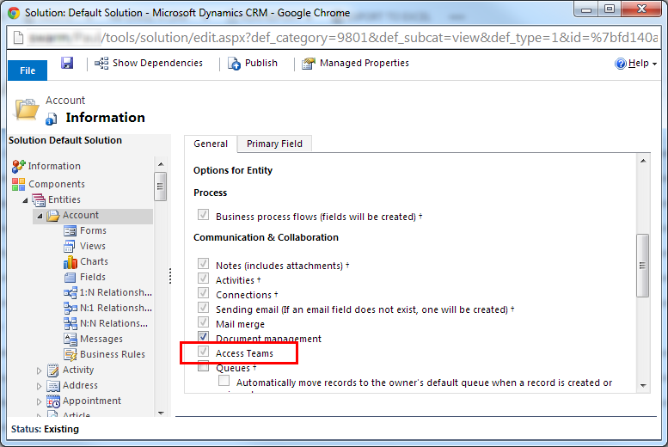

2. Create Access Team Template

Next you need to set up the team templates, which define what levels of access the users will have to the record. Access Team Templates are created and managed from Settings -> Administration -> Access Team Templates. By default there is already a template for Opportunity, as opportunity has access teams enabled already for use with the ‘Sales Team’.

When you create a new Team Template, you can specify the Entity to use, which will only display entities that are enabled for ‘Access Teams’. We then select the Access Rights we want to grant our users. Remember that all security is additive, so if the users are given Organization Write access in their security roles, but we don’t give them Write access here, they will still have write access on the records.

We can also define multiple Access Team Templates for a single entity, however at the time of writing this blog post, using more than one template on the same entity still has some bugs. Supposedly this will allow us to configure multiple sub-grids on our form to define different levels of access for different groups of users.

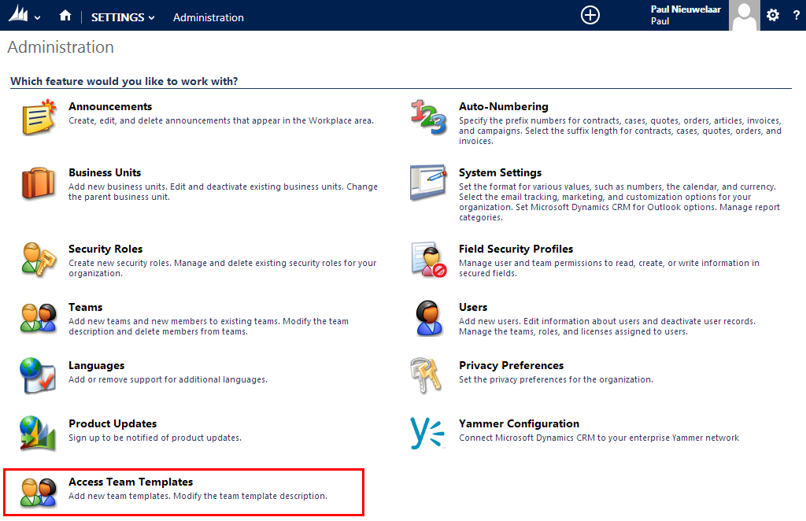

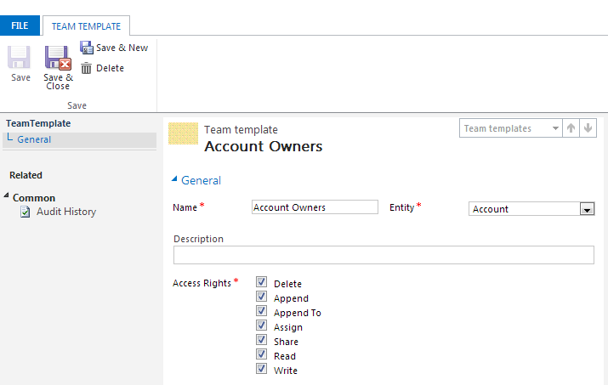

3. Add Users sub-grid to entity form

The last step is to add a sub-grid to the form so you can associate users into the access team. This step has a bit of a trick to it, which wasn’t obvious at first. When configuring the sub-grid; you need to select ‘All Record Types’ instead of related only. You can then select the ‘Users’ entity. Finally the tricky part is that you need to select the ‘Associated Record Team Members’ view, which will then display a ‘Team Template’ field which allows you to select the team template to use for this sub-grid.

Note: changing an existing sub-grid will not work, so you’ll need to add a new sub-grid.

**How to create an Access team**

**Enable an entity**

1. Make sure you have the System Administrator security role or equivalent permissions in Dynamics CRM
2. Go to **Settings** > **Customizations**
3. In the **Customization** window, choose **Customize the System**
4. In the navigation pane, expand **Entities**, and then choose the entity you want to use in the team template
5. On the **Entity Definition** form, in the **Communication & Collaboration** section, select **Access Teams**
6. On the **Actions** toolbar, choose **Save**

**Create a team template**

1. Go to **Settings** > **Security** and choose **Access Team Templates**
2. On the **Actions** toolbar, choose **New**, complete the required fields, and then **Save**

**Add a team template to the entity form**

1. Make sure you have the System Administrator security role or equivalent permissions in Dynamics CRM
2. Go to **Settings** > **Customizations**
3. In the **Customization** window, choose **Customize the System**
4. In the navigation pane, expand **Entities**, expand the entity you want to use in the team template, and then choose **Forms**
5. In **System Forms**, select **Active Forms** > **Main** form
6. On the **Main** form, open the **Insert** tab
7. On the ribbon, choose **Sub-Grid** (**Set Properties** dialog box appears)
8. In **Set Properties**, complete the required fields, and then select **Display label on the Form**
9. In the **Records** drop-down list, select **All Record Types**
10. In the **Entity** drop-down list, select **Users**
11. In the **Default View** drop-down list, select **Associated Record Team Members**
12. In the **Team Template** drop-down list, select the desired template and choose **Set t**he team template you selected now appears on the **Main** form.
13. On the **Actions** toolbar, click or tap **Save**, and then choose **Publish**

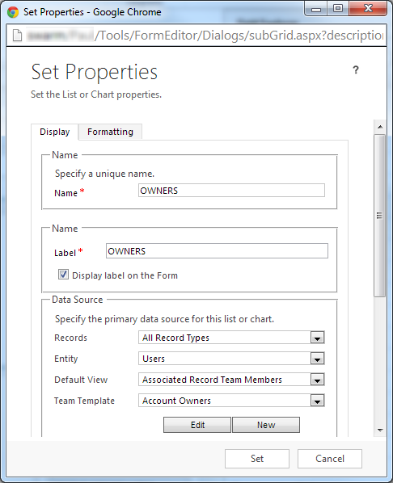

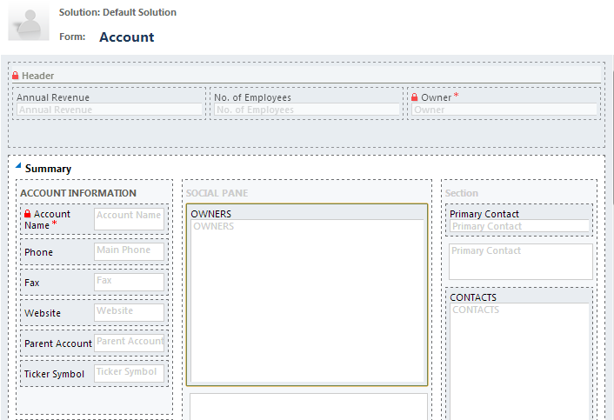

Once you’ve added your sub-grid you can save and publish the form and then try it out. You can see below I’ve added the ‘Owners’ sub-grid to the account form, and associated a couple of users using the ‘+’.

Note: The actual ‘Owner’ of the record will not change when using Access Teams.

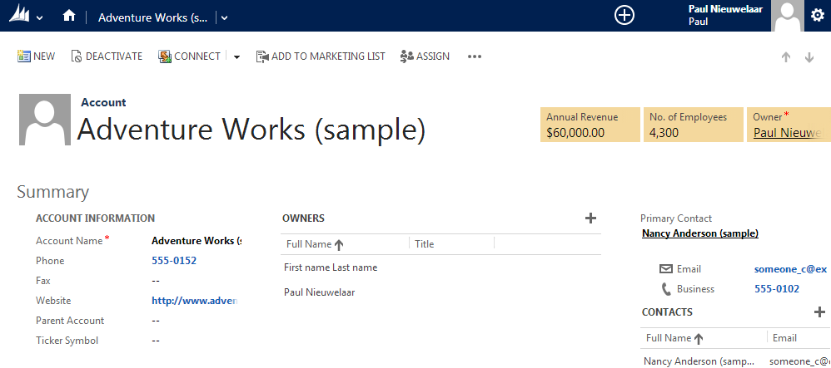

So how does it actually work? Where are these users stored? How are they given access?

If we do an advanced find on ‘Teams’ we can see there’s a new filter added, which excludes teams of type ‘Access’ by default. If we simply remove this filter, we can now see a team with a GUID name. Upon opening this team, we can see the users we associated are added as members. On closer inspection, the Team Name (the GUID) is actually the ID of our account record. From here we can also modify the team members, which will directly update the sub-grid on our account form.

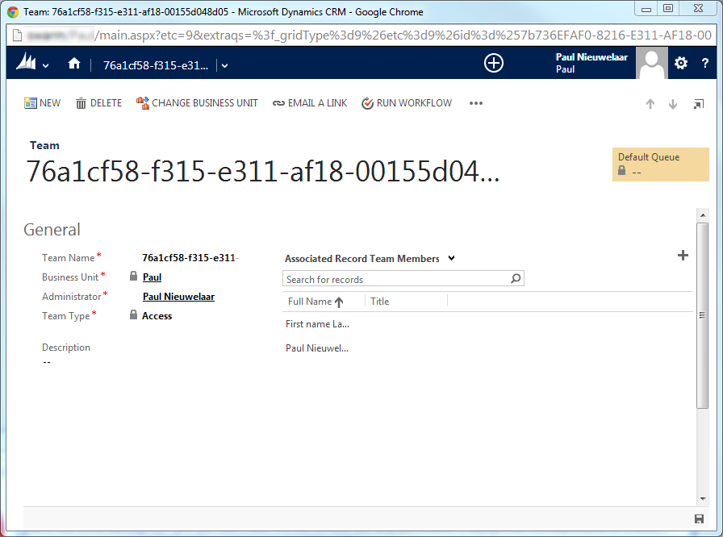

As for ‘how’ the team gains access to the record, it doesn’t seem to be ‘shared’, so this is still unclear.

Important things to note

- If you delete the physical team record, the account in my case will be reset as if there were no users associated in the sub-grid. As soon as you add a user back into the sub-grid, a new team record will be created. Note that the physical team is not deleted if you only remove the users from the sub-grid.

- Modifying the Team Template access rights will not affect existing teams. Only new records/access teams will inherit the updated permissions.

- Records will not display in ‘My’ views, as these views are filtered by ‘Owner = Current User’ so users granted access via Access Teams will have to view ‘All’ records to see them.

- To delete a Team Template, any sub-grids that reference the team template must first be removed.

 Overall I think this feature will be really useful when configuring security models, as it gives us another depth of team access which wasn’t quite there in CRM 2011 using just teams.