**Entitlements follows a similar concept but in comparison to Contracts** this offers several features which were lacking in the earlier entity.

These improvements combine to enforce greater control over the type and amount of support that each customer is entitled to receive.

**This can be stated in terms of the number of CRM cases or available hours.**

As we featured in an [earlier post](http://www.preact.co.uk/blog/top-12-service-team-updates-in-the-dynamics-crm-spring14-wave/) CRM entitlements can also be used with another recent addition, Service Level Agreements.

To access entitlements CRM administrators can browse to: Settings -> Service Management -> Entitlement

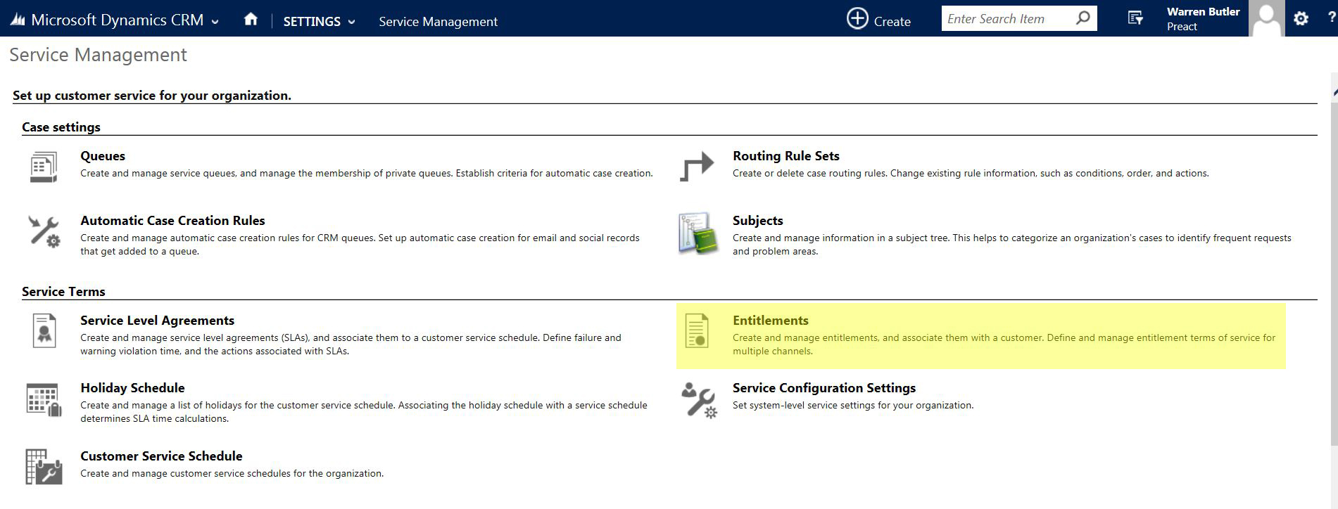  
  
Each entitlement is based on the number of hours or number of cases.

The choice will depend on the product or service that the customer has purchased:

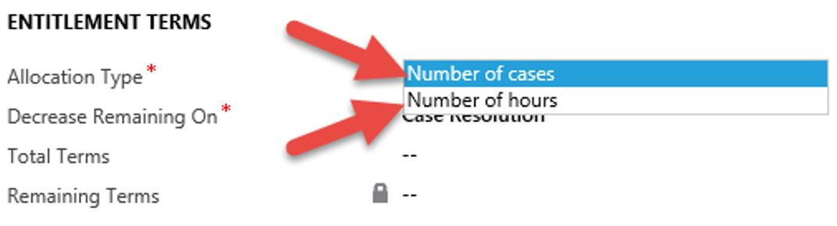  
  
Each Entitlement record includes 4 key fields:

**1. Allocation Type**

Defining if the entitlement is based on the number of cases or hours consumed by the customer.

**2. Decrease Remaining On**

• *Case Resolution:* The total number of Entitlement terms is decreased when a case is **closed**  
• *Case Creation:* Or, the number of Entitlement terms is decreased when a case is **created**

**3. Total Terms**

This represents total terms which have been purchased by any customer.

For example, if 15 is entered in this field it will reflect either 15 cases or 15 hours depending on the allocation type selected.

**4. Remaining Terms**

This is a running total that is automatically calculated by Dynamics CRM which shows the remaining resource available for the customer.

**Working with CRM Entitlements**

You can define the above terms for each entitlement channel.

The default channels are Phone, Email, Web, Facebook, and Twitter. You can add or edit this channel from the Case Origin Global option set.

This means CRM will now support advanced entitlement agreements whereby support can be metered and capped by specific channels.

To demonstrate this we’ll create a new Entitlement on an account named Fourth Coffee.

We’ll define a Start and End date that will apply for this customer contract. In the below example we've applied a restriction to enforce these entitlement terms.

In the form below we’ve also defined the Entitlement Terms and Entitlement Channel.

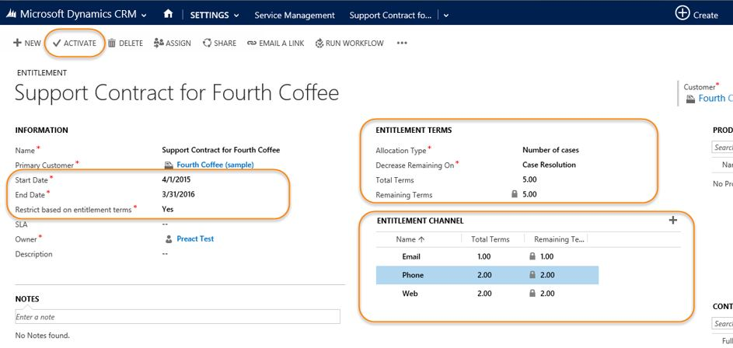

The date range will validate the Entitlement for the defined customer which would prevent any case being created outside these dates.

In this example the allocation type is set to track the number of cases.

The total terms is entered as 5 which means this customer is entitled to get help with up to 5 support cases.

The same figure appears in the 'Remaining Terms' calculation field which confirms that no cases have been resolved for this client since the agreement commenced.

For this example we’ve detailed a series of entitlement channels which limit the number of cases this customer can log during the agreement period by origin.

In this scenario they can log 2 cases by web, 1 by email and log 2 cases by phone during this timeframe.

Once complete the entitlement must be activated.

To demonstrate we’ll create a new case for this account.

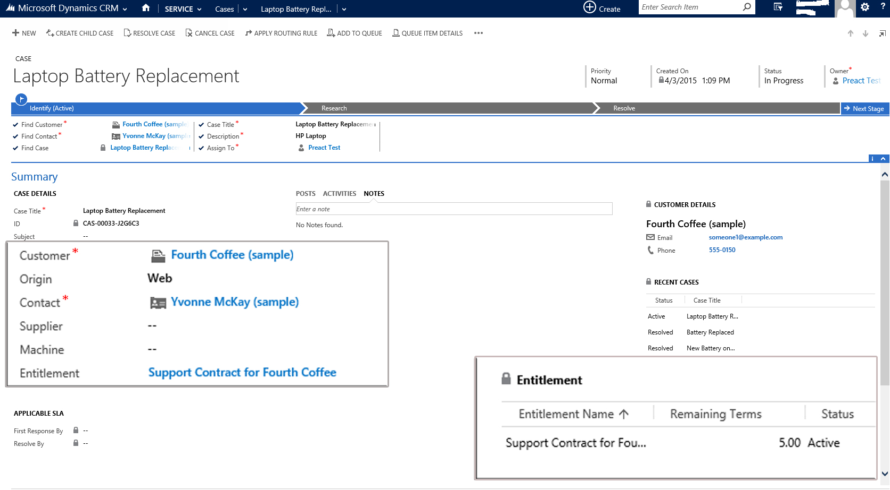

In the example above the new case that references this account entitlement originates from a web request.

The case form has automatically shown an available entitlement rule we’ve defined for this customer in an entitlements grid on the case form.

To fully enforce entitlements this field can be set as mandatory to ensure an entitlement record is set for every case.

[The CRM Online Spring 15 Update](http://www.preact.co.uk/blog/whats-new-in-the-dynamics-crm-online-2015-update-1-spring-15-release) includes a new feature to set a default entitlement for each customer which removes the need for users to manually associate available entitlements when a new case is created.

Once this case is closed we can review the Entitlement Terms.

As shown below the remaining terms have been reduced by 1 and because this case originated from a web request the remaining terms for this channel are also reduced.  
  
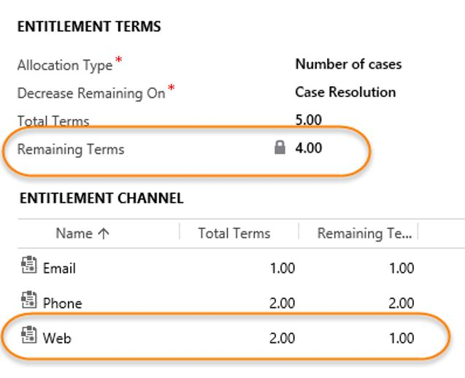

The reduced terms are also reflect on the entitlement grid when a new case is created for this account, or when the earlier case record is opened (see below):  
  
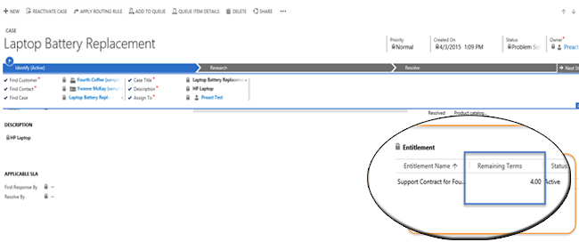

If we go ahead and create another case for the same customer with Origin = Phone and resolve this it reduces the remaining terms and also reduce the same in ‘Phone’ channel.  
  
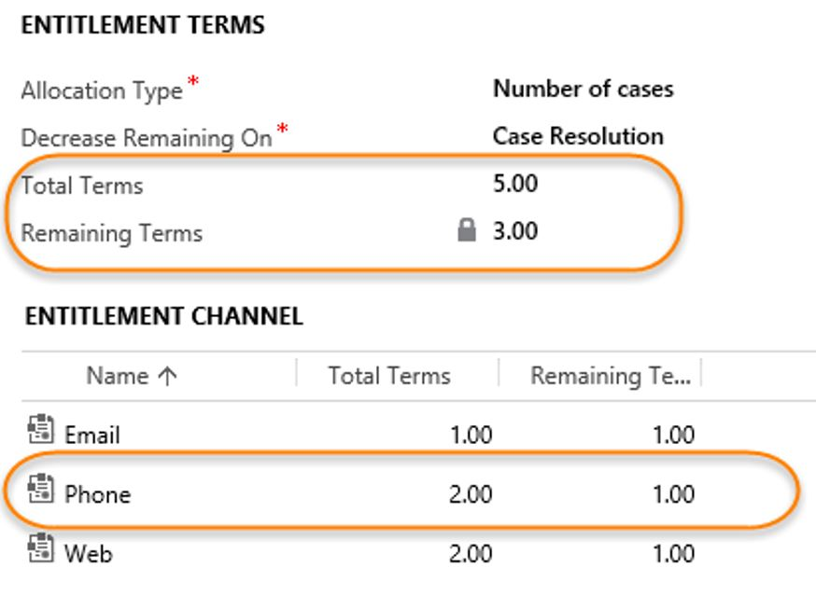

In this example we’ve defined ‘Decrease Remaining On’ as Case Resolution. Using the option of 'Decrease on Case Creation' the remaining terms would be reduced immediately when the case is first saved.

In instances where Allocation Type is set to Number of Hours this will reduce the hours based on the billable time which you have specified while closing the case.