SERVICELEVEL AGREEMENTS

**Define service level agreements (SLAs)**

Define the level of service or support that your organization agrees to offer to a customer by using service level agreements (SLAs) in Microsoft Dynamics CRM. Include detailed items to define metrics or key performance indicators (KPIs) to attain the service level.

KPIs help you get a timely warning on your team's issues while providing support.

You can associate an SLA with an entitlement so that when an entitlement is added to a case, the associated SLA is also applied.

**Allow Pause and Resume**. Select **Do Not Allow**. Because standard SLAs do not support pausing and resuming of SLAs, you can set this field to **Allow** only when you're creating an enhanced SLA.

**Simple SLA’s**

SLA’s have a type, either ‘Simple’ or ‘Enhanced’. Simple SLA’s are the original SLA’s which have had the ability to have the Timer functionality added to the Case form from CRM 2015 SP1. These are what can be referred to as ‘Standard’ SLA Types. When you open a new SLA Item, you’ll see the field ‘Related Case Field’ and as Out of the Box form layout goes, these fields are found on the form in a few places which I’ve screenshot below.

**Related Case Field**: First Response By; Follow up By, Last On Hold Time (need to add this on, not in form by default); Resolve By

The important thing to remember here is you have to add the Timer on the form manually, you also cannot pause the Timer functionality when a case is On Hold & you cannot add Success action to your SLA Items. (You can only add Failure action)

[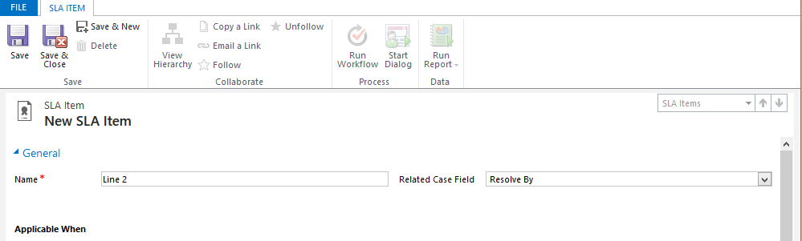](http://crm.fueledbysleep.com/wp-content/uploads/2015/02/standardline.png)

*‘Related Case Field’ on the Simple SLA Item form*

[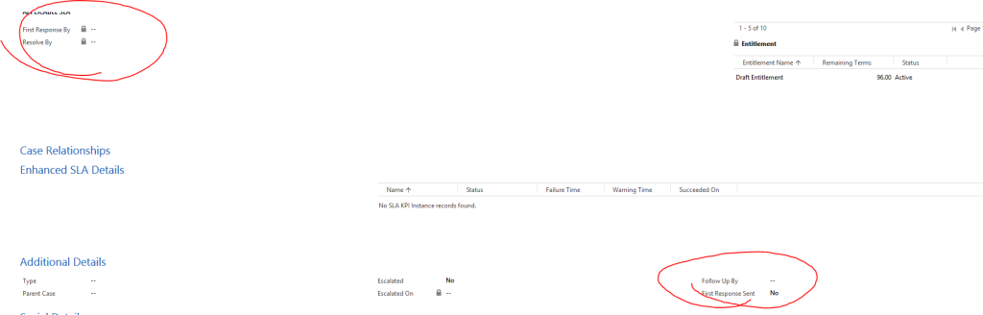](http://crm.fueledbysleep.com/wp-content/uploads/2015/02/case.png)

*Three of the fields related to the dropdown list in ‘Related Case Field’ on the SLA Item*

[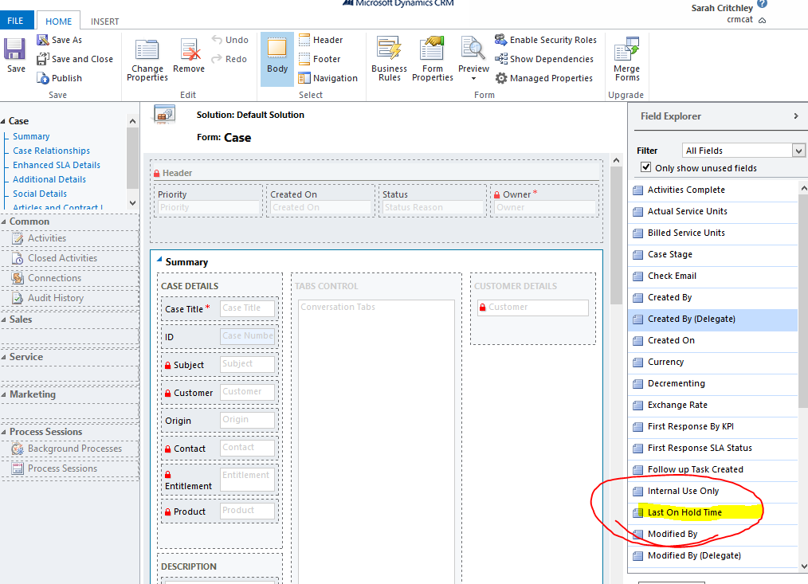](http://crm.fueledbysleep.com/wp-content/uploads/2015/02/case2.png)

*The fourth related Case field which is not on the form as default*

**Enhanced SLA’s**

If you select the option of ‘Enhanced’ in the SLA Type field when creating a SLA record, you can then check the option to ‘Allow Pause and Resume’ which will pause the time calculation of the SLA and not include it in it’s total rollup when a Case is ‘On Hold’.

When you open a new SLA Item record, you will see that things look a *little* bit different. You now have the field **‘SLA KPI’** and as standard only two options. This is no longer looking at those fields I have highlighted above, this is looking no longer at fields but an actual **entity** –  the **SLA KPI Entity** and the lookup fields in the Case form (That are not actually on the case form – (This is how new ones can be added, this will be covered in another post)).

These are now looking at the built in sub grid nearer the bottom of the Case entity – whilst confusing at first, this allows you to create multiple lines and keep track of them all at once. It embeds the Timer functionality on your form as well by default, and also you can set Success actions for Enhanced SLA’s. (Same as Failure actions but depend on your Success Criteria). If you then put a Case on Hold, it pauses the SLA. Resuming the Case then updates the related SLA KPI record.

If you create a Case that has an Entitlement, with an SLA (or just an SLA) which tracks a number of SLA KPI’s, e.g. the 2 default ones, upon creation it creates 2 SLA KPI type records and related them to your Case record.

[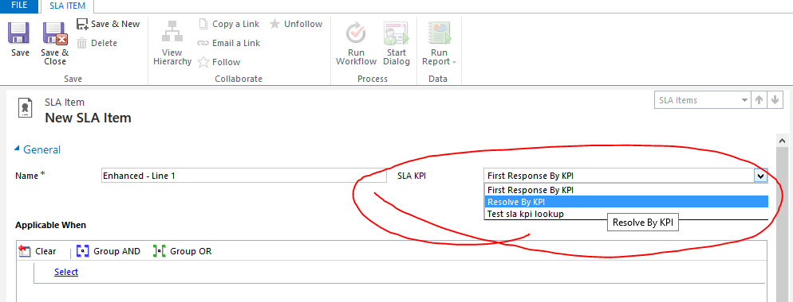](http://crm.fueledbysleep.com/wp-content/uploads/2015/02/enhancedline.png)

*The ‘SLA KPI’ field on the Enhanced SLA Item form*

[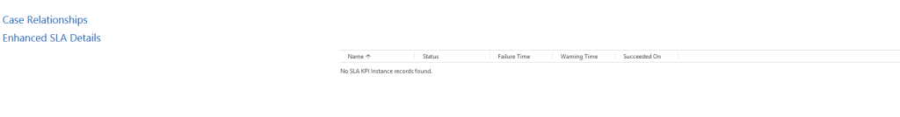](http://crm.fueledbysleep.com/wp-content/uploads/2015/02/SLAKPIsection.png)

*An empty Enhanced SLA Sub grid*

[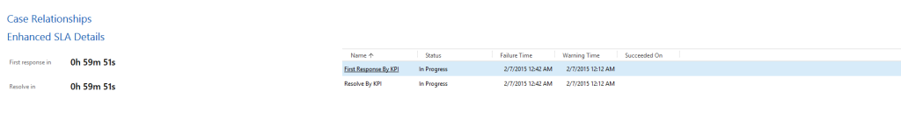](http://crm.fueledbysleep.com/wp-content/uploads/2015/02/SLAKPIsectioncompleted.png)

*An Enhanced SLA Sub grid with active SLA KPI records related to it*

I hope that helps demystify the difference between the two and what further enhancements 2015 brings to the picture, any questions feel free to post in the comments. More information on how to configure enhanced SLA’s will be coming soon.

<http://crmmongrel.blogspot.in/2014/06/dynamics-crm-2013-service-level.html>

<http://prettydarngood.com/2014/09/slas-entitlement-customer-service-microsoft-dynamics-crm-2013/>