Experiment 10.1: Spectral Subtraction for Speech/Signal Noise Reduction

Aim
To corrupt a two-tone test signal with additive noise and enhance it using the spectral subtraction technique, comparing the clean, noisy and enhanced signals in the time, spectrogram and frequency domains.

MATLAB Code
clc; clear; close all;
Fs=8000; t=0:1/Fs:3;
x=sin(2*pi*200*t)+0.5*sin(2*pi*400*t); % Clean signal
xn=x+0.3*randn(size(x)); % Noisy signal
Y=fft(xn);
N=fft(0.3*randn(size(x)));
xe=real(ifft(max(abs(Y)-abs(N),0).*exp(1j*angle(Y))));
% Signals
figure;
subplot(311),plot(t,x),title('Clean Speech')
subplot(312),plot(t,xn),title('Noisy Speech')
subplot(313),plot(t,xe),title('Enhanced Speech')
% Spectrograms
figure;
subplot(311),spectrogram(x),title('Clean Spectrogram')
subplot(312),spectrogram(xn),title('Noisy Spectrogram')
subplot(313),spectrogram(xe),title('Enhanced Spectrogram')
% Magnitude Spectra
figure;
subplot(311),plot(abs(fft(x))),title('Clean Spectrum')
subplot(312),plot(abs(fft(xn))),title('Noisy Spectrum')
subplot(313),plot(abs(fft(xe))),title('Enhanced Spectrum')

Output / Screenshots
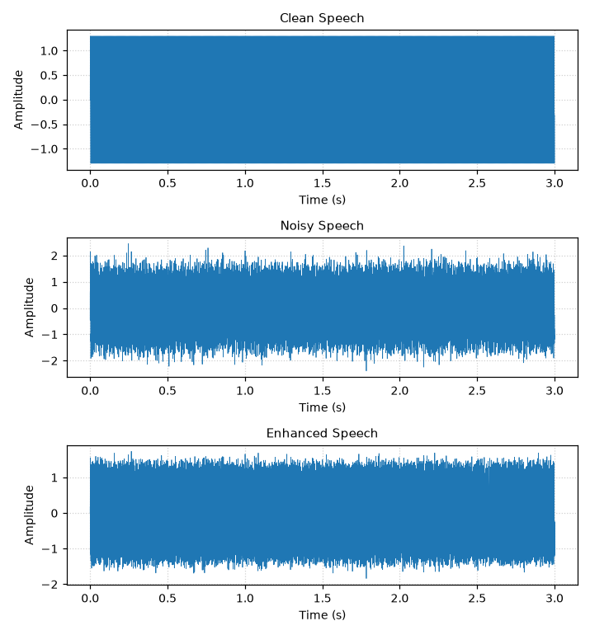
Fig. 10.1(a): Clean, noisy and enhanced time-domain waveforms
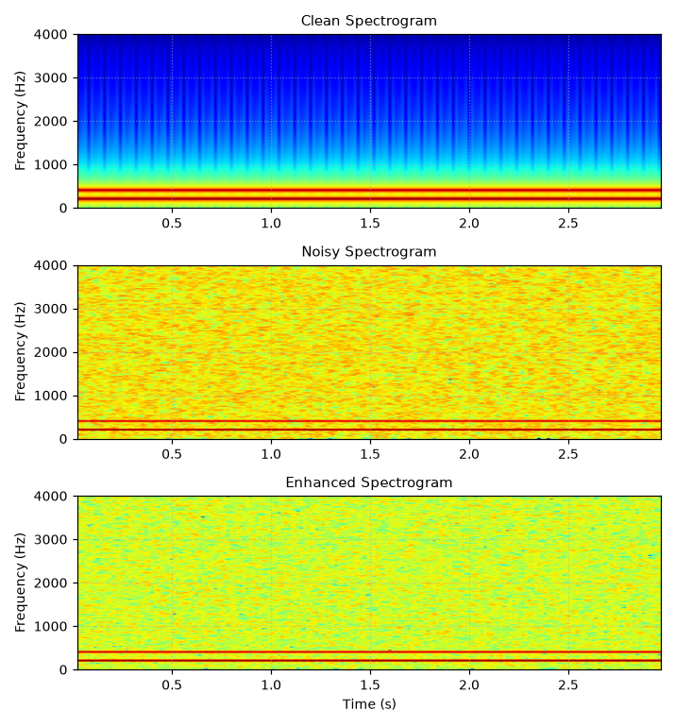
Fig. 10.1(b): Spectrograms — clean, noisy and enhanced
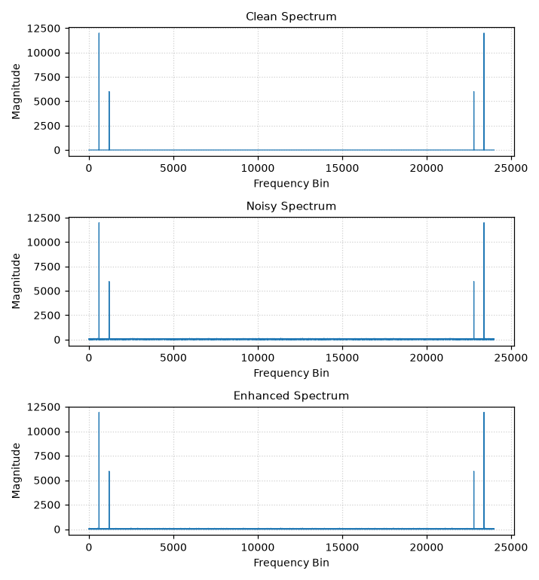
Fig. 10.1(c): Magnitude spectra — clean, noisy and enhanced

Result
Spectral subtraction visibly reduces the broadband noise floor in both the spectrogram and the magnitude spectrum of the enhanced signal while preserving the two dominant tonal components at 200 Hz and 400 Hz, though some residual noise ('musical noise') remains — a well-known limitation of basic spectral subtraction.

