Experiment 1.1: Low-Pass Butterworth Filter Design (Minimum Order & Cutoff Estimation)

Aim
To design a digital low-pass Butterworth filter for given passband/stopband specifications, determine the minimum filter order and cutoff frequency using MATLAB, and analyse its magnitude, phase, impulse, step and pole-zero responses.

MATLAB Code
clc; clear
Fs=10000; Fp=1000; Fst=1500;
[N,Wn]=buttord(Fp/(Fs/2),Fst/(Fs/2),1,60);
[b,a]=butter(N,Wn);
freqz(b,a) % Magnitude & Phase
figure
[h,n]=impz(b,a,50);
stem(n,h), grid on
title('Impulse Response')
figure
stepz(b,a)
figure
zplane(b,a)
fprintf('Minimum Filter Order (N) = %d\n',N);
fprintf('Cutoff Frequency (Wn) = %.4f\n',Wn);

Output / Screenshots
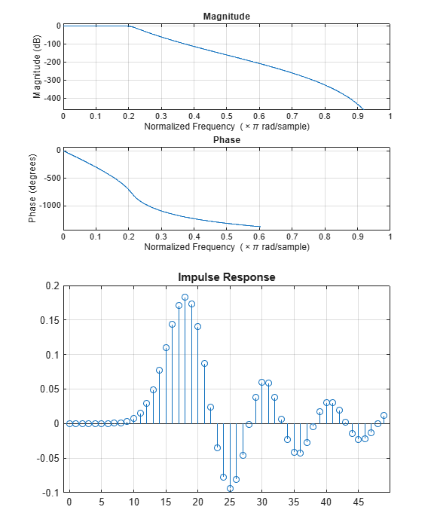
Fig. 1.1(a): Magnitude & Phase response, and Impulse response
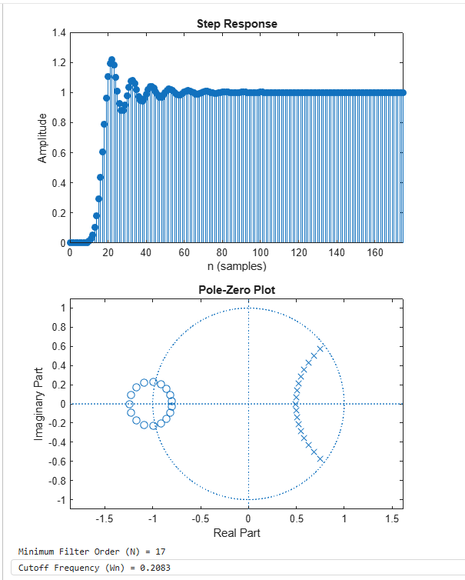
Fig. 1.1(b): Step response, Pole-Zero plot, and computed filter order (N = 17) & cutoff frequency (Wn = 0.2083)

Result
The minimum Butterworth filter order required to meet the given specifications was found to be N = 17, with a normalized cutoff frequency Wn = 0.2083. All poles lie within the unit circle, confirming the filter is stable.

