Experiment 1.2: High-Pass Butterworth Filter Design

Aim
To design a digital high-pass Butterworth filter meeting given passband/stopband specifications and to study its frequency, step, group-delay and pole-zero characteristics.

MATLAB Code
clc; clear
Fs=10000; Fp=3000; Fst=2000;
[N,Wn]=buttord(Fp/(Fs/2),Fst/(Fs/2),1,60);
[b,a]=butter(N,Wn,'high');
freqz(b,a)
figure
[h,n]=impz(b,a,50);
stem(n,h), grid on
title('Impulse Response')
figure
stepz(b,a)
title('Step Response')
figure
grpdelay(b,a)
title('Group Delay')
figure
zplane(b,a)
title('Pole-Zero Plot')
fprintf('Minimum Filter Order (N) = %d\n',N);
fprintf('Cutoff Frequency (Wn) = %.4f\n',Wn);

Output / Screenshots
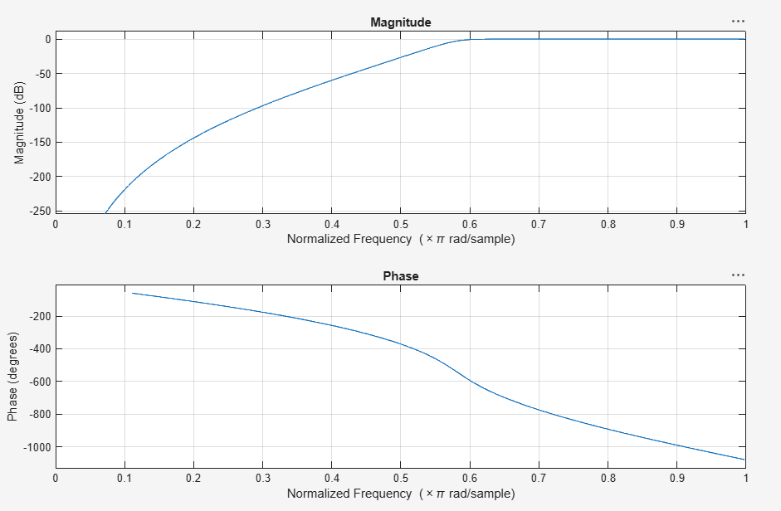
Fig. 1.2(a): Magnitude & Phase response
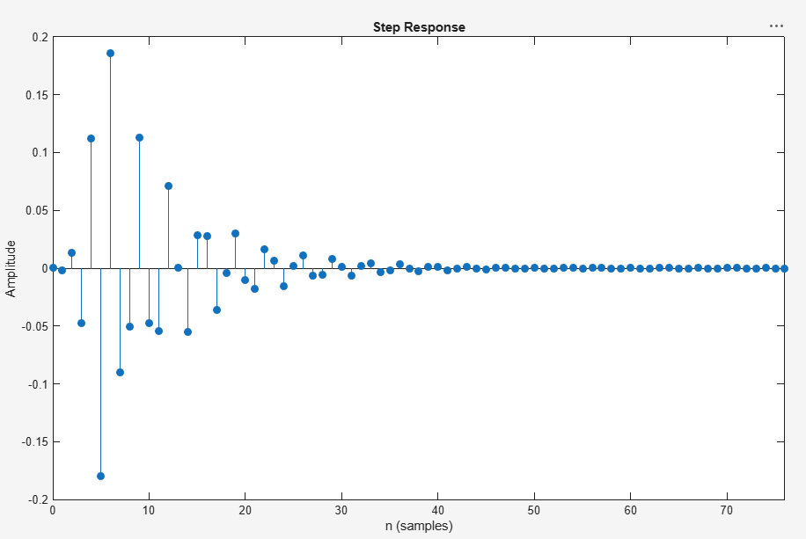
Fig. 1.2(b): Step response
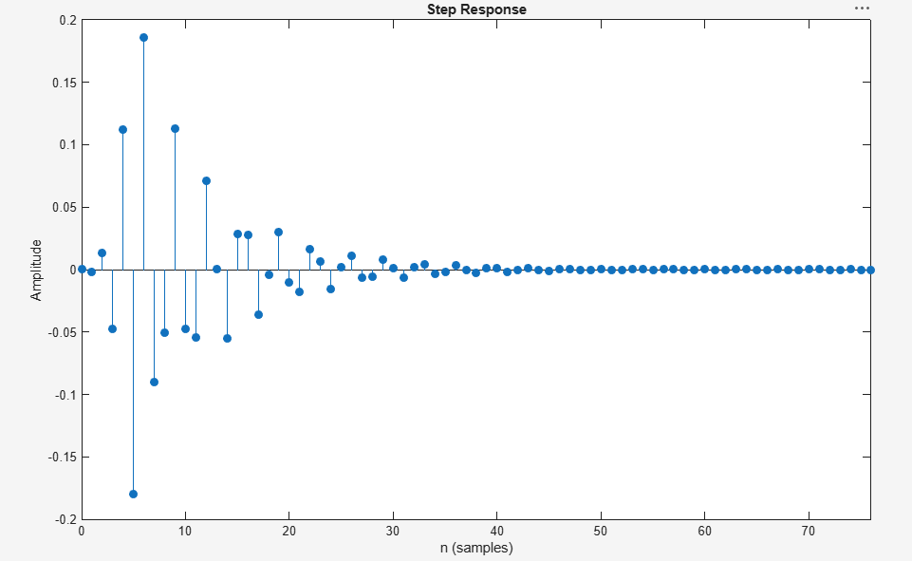
Fig. 1.2(c): Step response (zoomed)
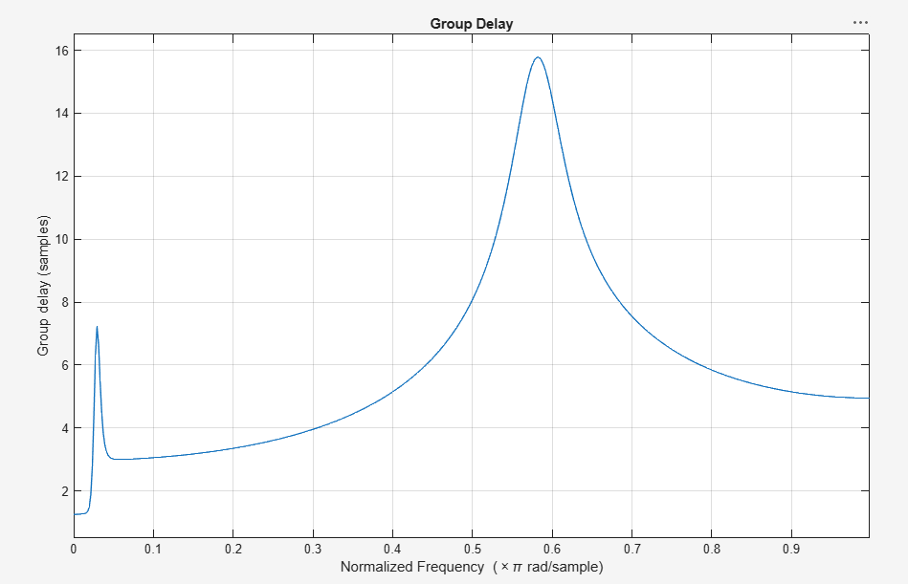
Fig. 1.2(d): Group delay
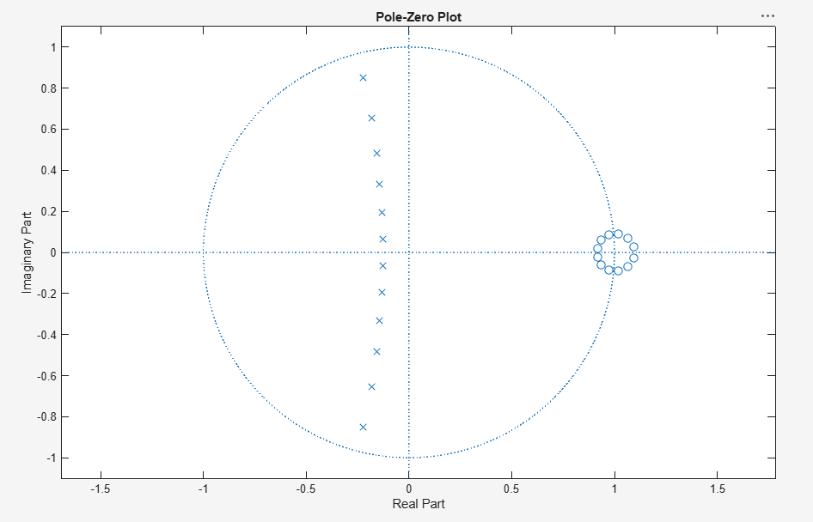
Fig. 1.2(e): Pole-Zero plot

Result
The designed high-pass Butterworth filter meets the specified passband and stopband attenuation requirements, with all poles located inside the unit circle indicating a stable system.

