Experiment 2.1: Low-Pass Chebyshev Type-I Filter Design & Stability Check

Aim
To design a low-pass Chebyshev Type-I filter for the given specifications, verify system stability from the pole locations, and study its frequency, impulse, group-delay and pole-zero responses.

MATLAB Code
clc; clear;
Wp=0.4; Ws=0.55; Rp=1; As=40;
[N,Wn]=cheb1ord(Wp,Ws,Rp,As);
[b,a]=cheby1(N,Rp,Wn);
fprintf('Filter Order = %d\n',N);
fprintf('Cutoff Frequency = %.2f * pi rad/sample\n',Wn);
if all(abs(roots(a))<1)
disp('System is STABLE');
else
disp('System is UNSTABLE');
end
figure; freqz(b,a);
figure; impz(b,a);
figure; grpdelay(b,a);
figure; zplane(b,a);

Output / Screenshots
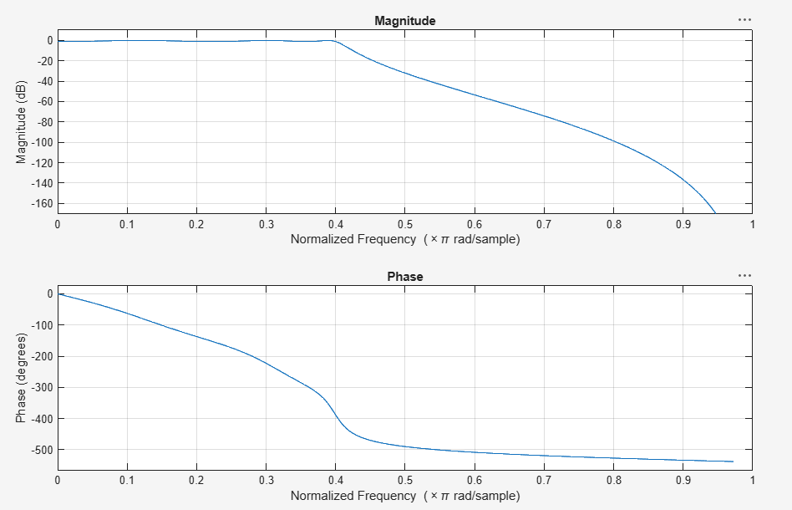
Fig. 2.1(a): Magnitude & Phase response
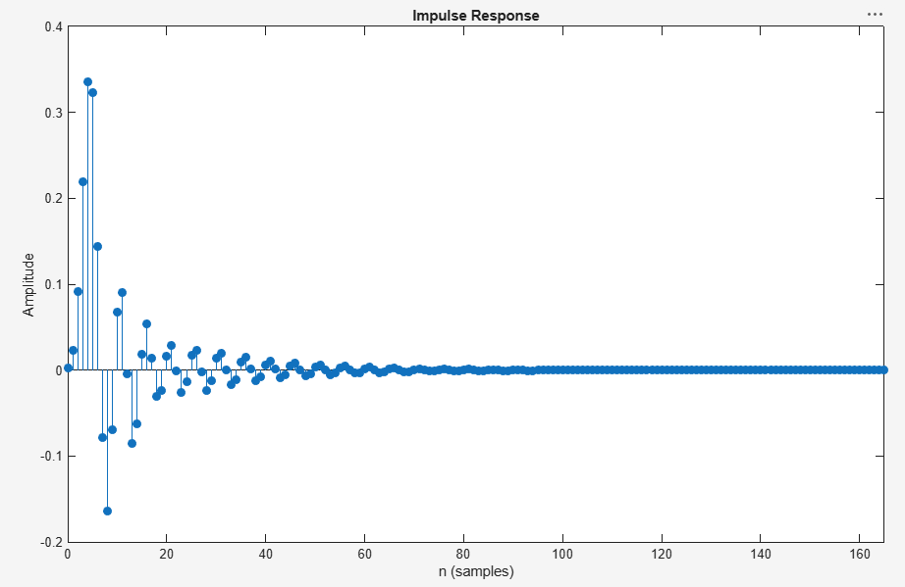
Fig. 2.1(b): Impulse response
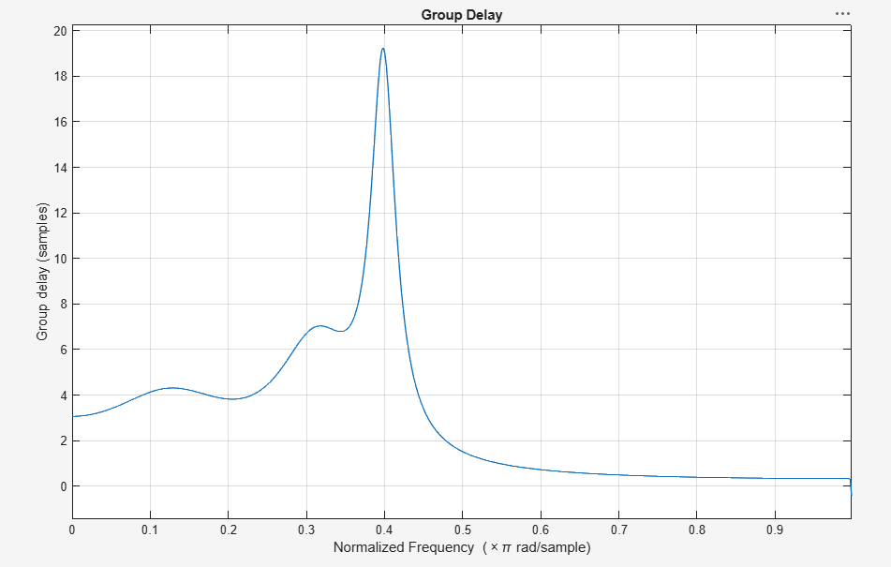
Fig. 2.1(c): Group delay
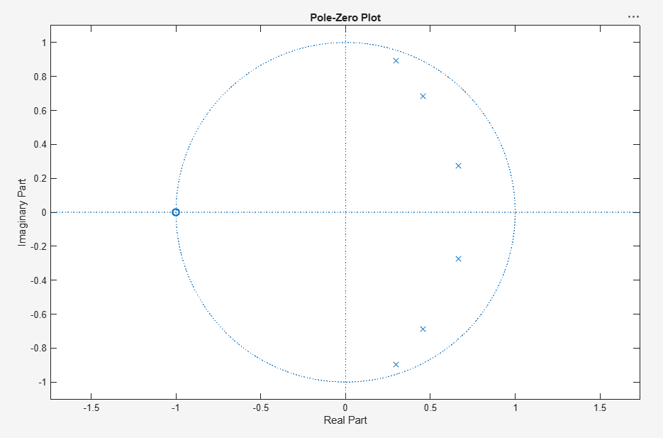
Fig. 2.1(d): Pole-Zero plot

Result
All the poles of the designed Chebyshev Type-I filter lie strictly inside the unit circle, so the system is confirmed to be STABLE. The passband shows the characteristic equiripple behaviour of Chebyshev filters.

