Experiment 2.2: High-Pass Chebyshev Type-I Filter Design

Aim
To design a high-pass Chebyshev Type-I filter for given specifications and examine its frequency, impulse, group-delay and pole-zero responses.

MATLAB Code
clc; clear; close all;
Rp = 1; Rs = 40; Wp = 0.5; Ws = 0.35;
[n,Wn] = cheb1ord(Wp,Ws,Rp,Rs);
[b,a] = cheby1(n,Rp,Wn,'high');
figure; freqz(b,a); title('Frequency Response');
figure; impz(b,a); title('Impulse Response');
figure; grpdelay(b,a); title('Group Delay');
figure; zplane(b,a); title('Pole-Zero Plot');
fprintf('Filter Order = %d\n',n);
fprintf('Cutoff Frequency = %.4f\n',Wn);

Output / Screenshots
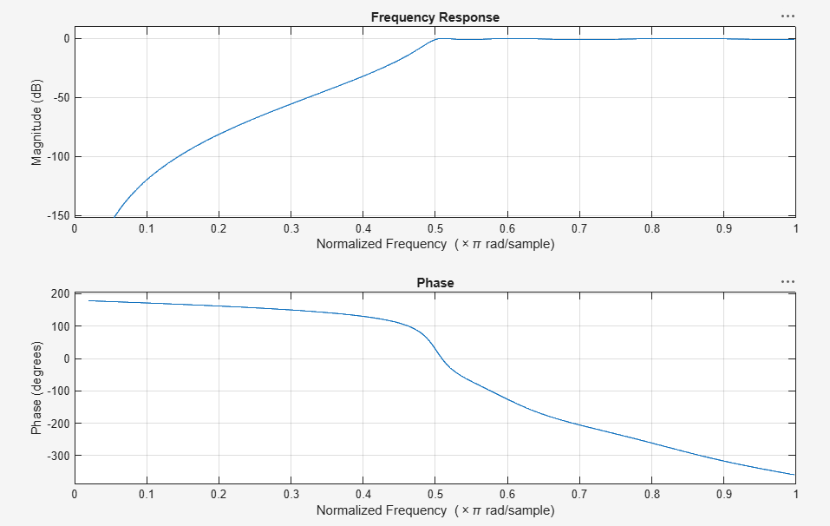
Fig. 2.2(a): Frequency response
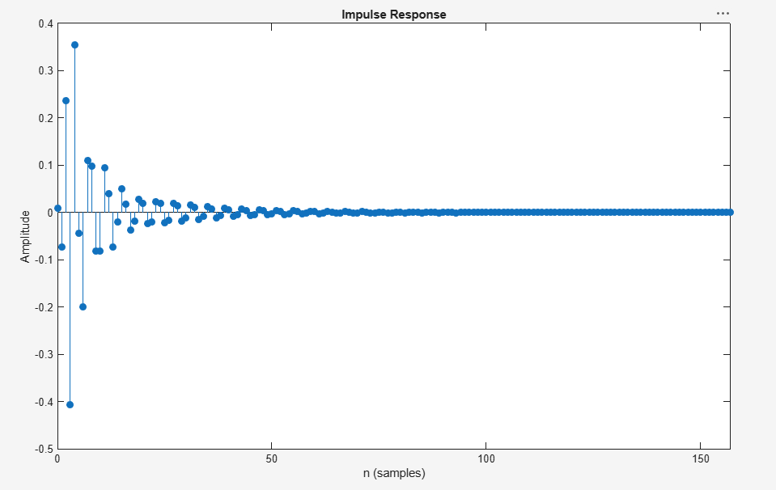
Fig. 2.2(b): Impulse response
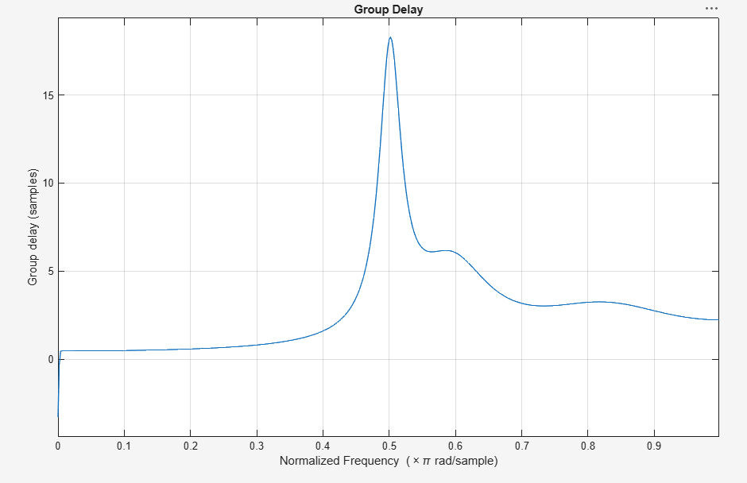
Fig. 2.2(c): Group delay
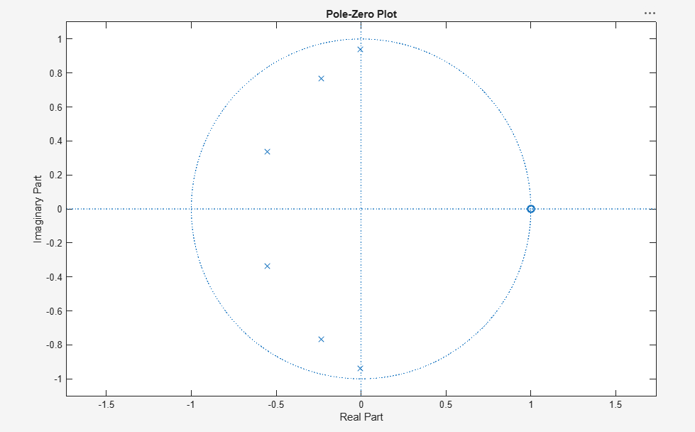
Fig. 2.2(d): Pole-Zero plot

Result
The high-pass Chebyshev Type-I filter attenuates frequencies below the cutoff sharply while showing equiripple behaviour in the passband, with all poles inside the unit circle confirming stability.

