Experiment 3: Band-Pass Filter: Butterworth vs Chebyshev Type-I Comparison

Aim
To design band-pass Butterworth and Chebyshev Type-I filters for identical specifications and compare their order, frequency response, group delay, pole locations and impulse response.

MATLAB Code
clc; clear; close all;
Fs=2000; Rp=1; Rs=40;
Wp=[300 600]/(Fs/2);
Ws=[200 700]/(Fs/2);
[n1,W1]=buttord(Wp,Ws,Rp,Rs);
[b1,a1]=butter(n1,W1,'bandpass');
[n2,W2]=cheb1ord(Wp,Ws,Rp,Rs);
[b2,a2]=cheby1(n2,Rp,W2,'bandpass');
figure; freqz(b1,a1); title('Butterworth Filter');
figure; freqz(b2,a2); title('Chebyshev Type-I Filter');
figure; grpdelay(b1,a1); hold on; grpdelay(b2,a2); legend('Butterworth','Chebyshev-I');
figure;
subplot(121),zplane(b1,a1),title('Butterworth')
subplot(122),zplane(b2,a2),title('Chebyshev-I')
figure;
subplot(211),impz(b1,a1),title('Butterworth Impulse')
subplot(212),impz(b2,a2),title('Chebyshev Impulse')
figure;
subplot(121),stem(abs(roots(a1)),'filled'),title('Butterworth Pole Magnitude')
subplot(122),stem(abs(roots(a2)),'filled'),title('Chebyshev Pole Magnitude')
disp(['Butterworth Order = ',num2str(n1)])
disp(['Chebyshev Order = ',num2str(n2)])

Output / Screenshots
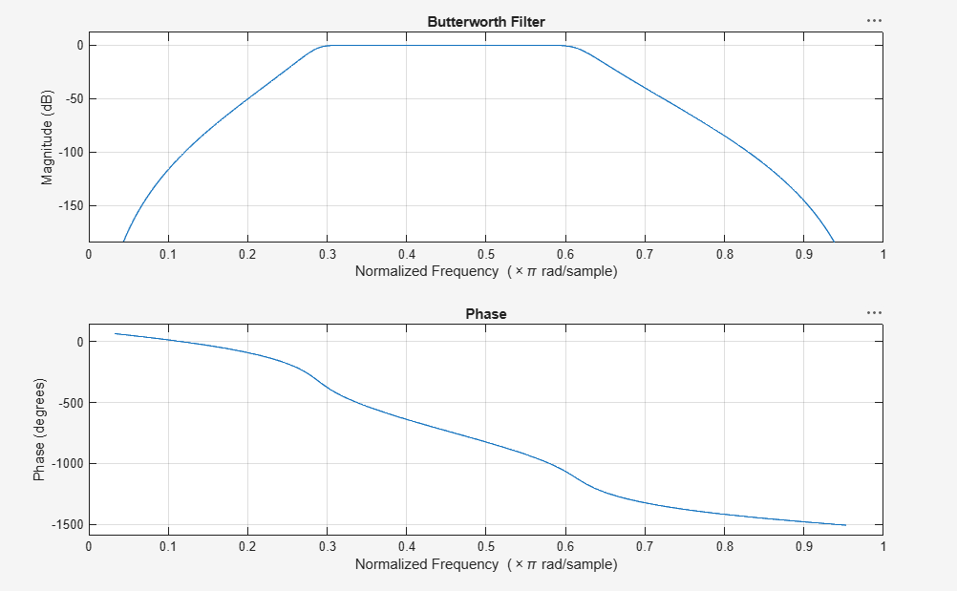
Fig. 3(a): Butterworth band-pass frequency response
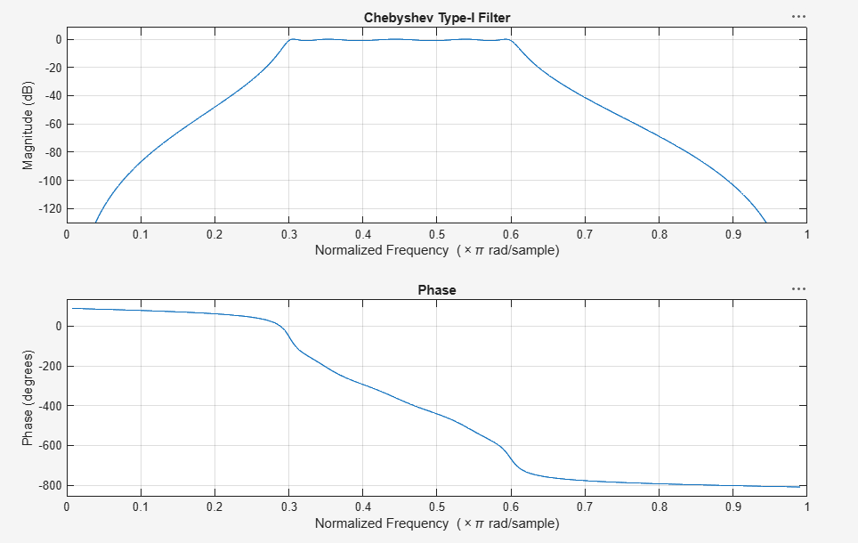
Fig. 3(b): Chebyshev Type-I band-pass frequency response
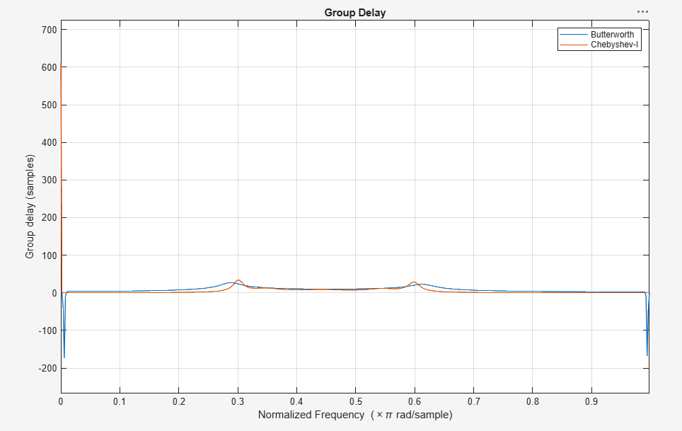
Fig. 3(c): Group delay comparison
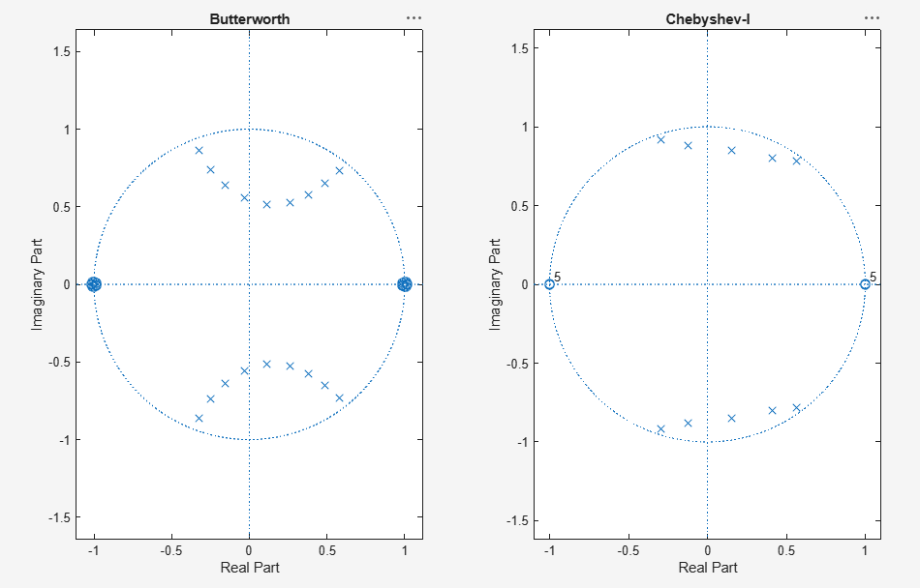
Fig. 3(d): Pole-Zero plots — Butterworth vs Chebyshev-I
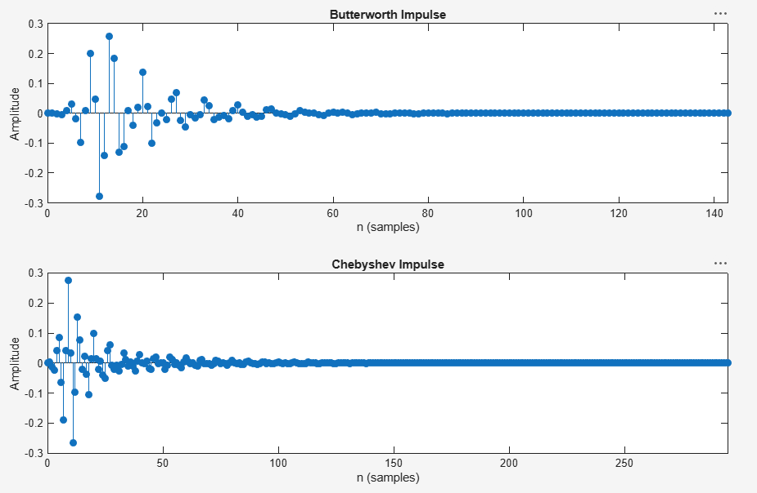
Fig. 3(e): Impulse responses — Butterworth vs Chebyshev-I
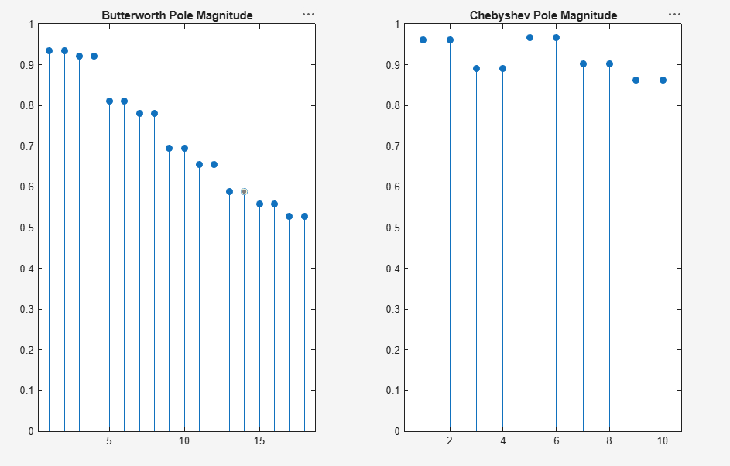
Fig. 3(f): Pole magnitude comparison

Result
For identical band-pass specifications, the Butterworth filter required a higher order than the Chebyshev Type-I filter. The Chebyshev design achieves a sharper roll-off with fewer poles at the cost of passband ripple, while the Butterworth response is maximally flat in the passband.

