Experiment 4.1: FIR Low-Pass Filter Using Rectangular Window

Aim
To design an FIR low-pass filter using the window method with a Rectangular window and study its frequency response characteristics.

MATLAB Code
clc; clear; close all;
%% --- Input Parameters ---
fp = 1000; % Passband cutoff (Hz)
fs = 4000; % Sampling frequency (Hz)
N = 50; % Filter order
wc = fp/(fs/2); % Normalized cutoff frequency
%% --- FIR Low Pass using Rectangular Window ---
b_rect = fir1(N, wc, 'low', rectwin(N+1));
disp('--- Rectangular Window Coefficients ---');
disp(b_rect');
%% --- Plot Frequency Response ---
figure;
freqz(b_rect,1);
title('Low-pass FIR using Rectangular Window');

Output / Screenshots
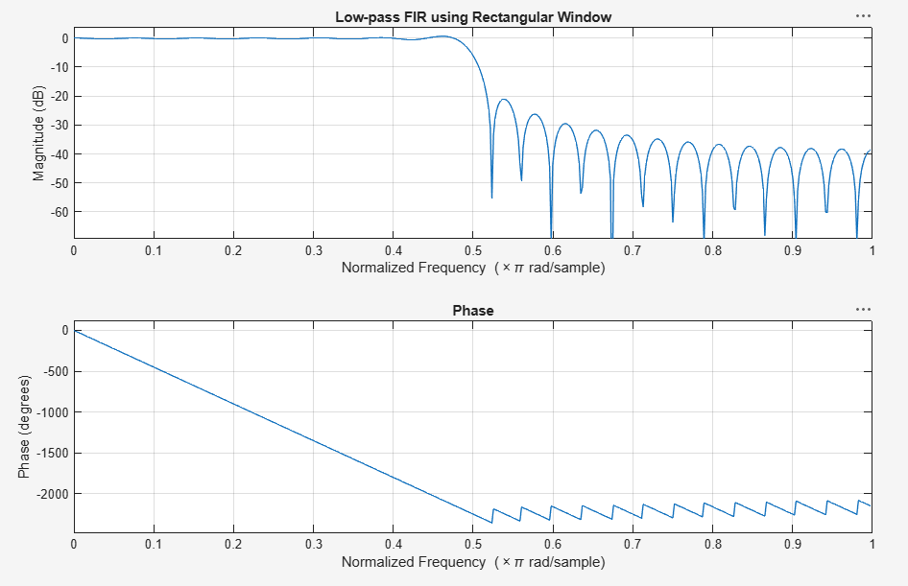
Fig. 4.1: Magnitude & Phase response of low-pass FIR filter (Rectangular window)

Result
The Rectangular-window FIR low-pass filter shows a narrow transition band but relatively high sidelobe levels (~-20 dB), causing noticeable ripples in the stopband — a known trade-off of the rectangular window.

