Experiment 4.2: FIR Low-Pass Filter Using Hamming Window

Aim
To design an FIR low-pass filter using the Hamming window and observe its improved stopband attenuation compared to the rectangular window.

MATLAB Code
clc; clear; close all;
%% --- Input Parameters ---
fp = 1000; fs = 4000; N = 50;
wc = fp/(fs/2);
%% --- FIR Low Pass using Hamming Window ---
b_hamm = fir1(N, wc, 'low', hamming(N+1));
disp('--- Hamming Window Coefficients ---');
disp(b_hamm');
figure;
freqz(b_hamm,1);
title('Low-pass FIR using Hamming Window');

Output / Screenshots
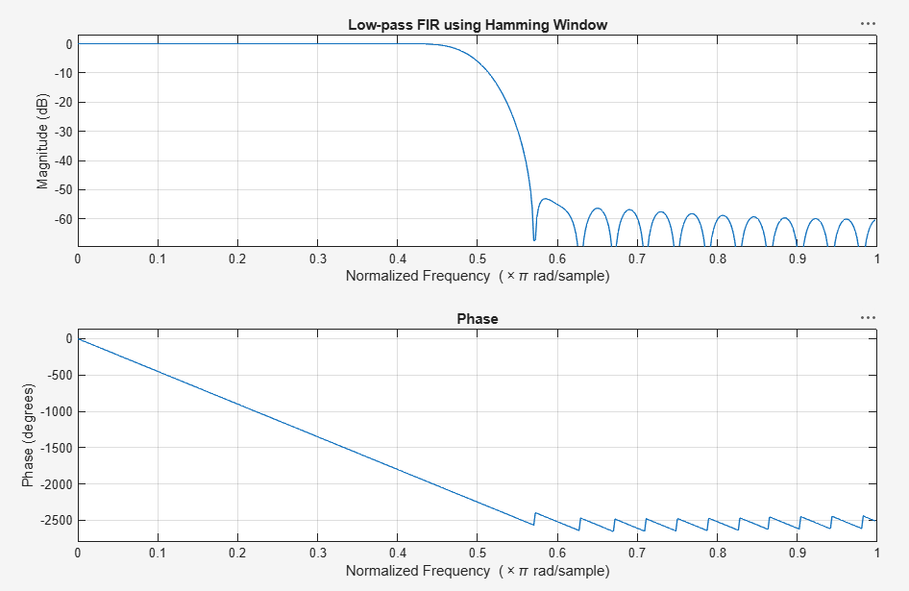
Fig. 4.2: Magnitude & Phase response of low-pass FIR filter (Hamming window)

Result
The Hamming-window design shows a wider transition band than the rectangular window but a much lower and flatter stopband ripple (~-60 dB), giving superior stopband attenuation.

