Experiment 4.3: FIR Low-Pass Filter Using Hanning Window

Aim
To design an FIR low-pass filter using the Hanning window and compare its spectral characteristics with other window functions.

MATLAB Code
clc; clear; close all;
%% --- Input Parameters ---
fp = 1000; fs = 4000; N = 50;
wc = fp/(fs/2);
%% --- FIR Low Pass using Hanning Window ---
b_hann = fir1(N, wc, 'low', hanning(N+1));
disp('--- Hanning Window Coefficients ---');
disp(b_hann');
figure;
freqz(b_hann,1);
title('Low-pass FIR using Hanning Window');

Output / Screenshots
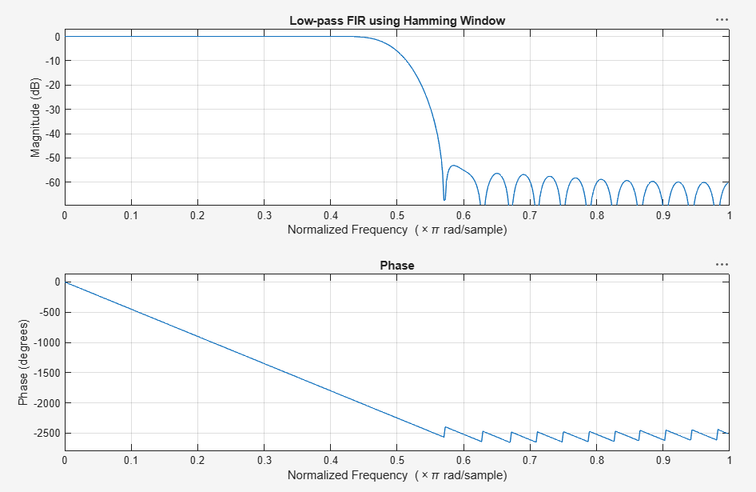
Fig. 4.3(a): Magnitude & Phase response of low-pass FIR filter (Hanning window)
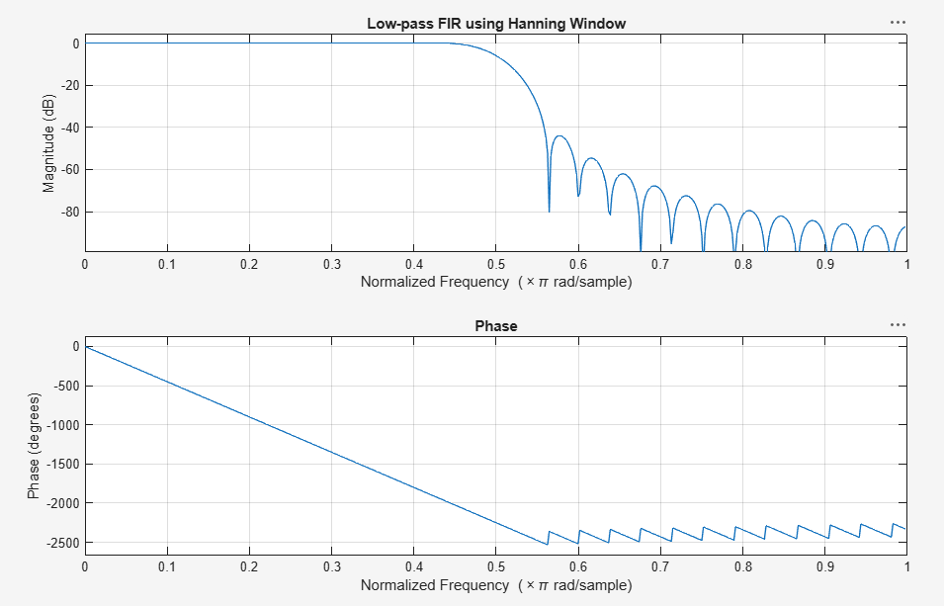
Fig. 4.3(b): Magnitude & Phase response (extended view)

Result
The Hanning window yields the lowest sidelobe levels (~-80 dB or better) among the three windows tested, at the cost of the widest main-lobe/transition band, confirming the classic ripple-vs-transition-width trade-off.

