Experiment 5.1: FIR High-Pass Filter Using Rectangular Window

Aim
To design an FIR high-pass filter using the Rectangular window method.

MATLAB Code
clc; clear; close all;
%% --- Input Parameters ---
fp = 1000; % High-pass cutoff frequency (Hz)
fs = 8000; % Sampling frequency (Hz)
N = 50; % Filter order
wc = fp/(fs/2);
%% --- FIR High Pass using Rectangular Window ---
b_rect = fir1(N, wc, 'high', rectwin(N+1));
disp('--- High-Pass Coefficients (Rectangular Window) ---');
disp(b_rect');
figure;
freqz(b_rect,1);
title('High-pass FIR using Rectangular Window');

Output / Screenshots
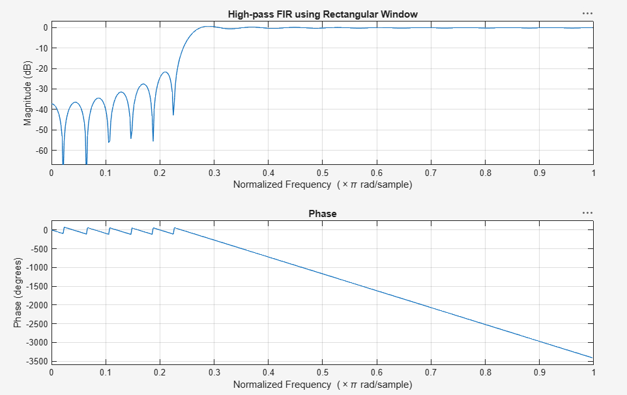
Fig. 5.1: Magnitude & Phase response of high-pass FIR filter (Rectangular window)

Result
The rectangular-window high-pass filter shows a sharp transition but visible passband/stopband ripple due to Gibbs phenomenon.

