Experiment 5.2: FIR High-Pass Filter Using Hamming Window

Aim
To design an FIR high-pass filter using the Hamming window and study the improvement in stopband attenuation.

MATLAB Code
clc; clear; close all;
%% --- Input Parameters ---
fp = 1000; fs = 8000; N = 50;
wc = fp/(fs/2);
%% --- FIR High Pass using Hamming Window ---
b_hamm = fir1(N, wc, 'high', hamming(N+1));
disp('--- High-Pass Coefficients (Hamming Window) ---');
disp(b_hamm');
figure;
freqz(b_hamm,1);
title('High-pass FIR using Hamming Window');

Output / Screenshots
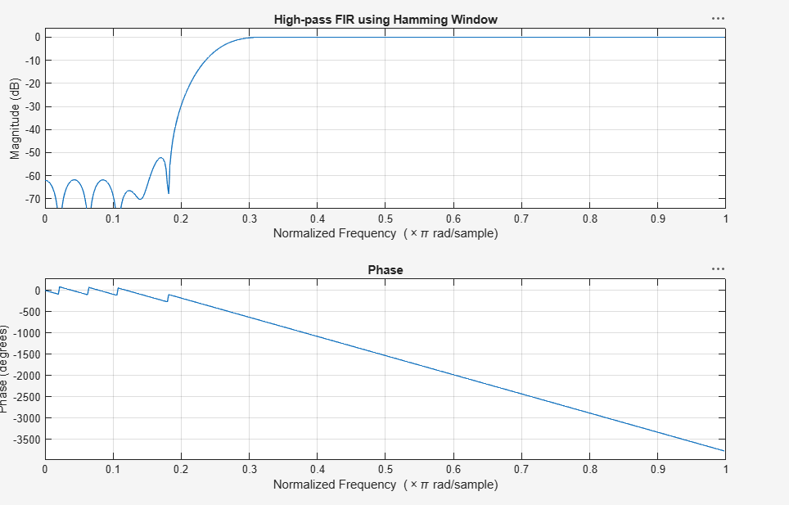
Fig. 5.2: Magnitude & Phase response of high-pass FIR filter (Hamming window)

Result
The Hamming window gives a noticeably cleaner stopband than the rectangular window with reduced ripple amplitude, at the cost of a slightly wider transition band.

