Experiment 5.3: FIR High-Pass Filter Using Hanning Window

Aim
To design an FIR high-pass filter using the Hanning window and compare its performance with the rectangular and Hamming designs.

MATLAB Code
clc; clear; close all;
%% --- Input Parameters ---
fp = 1000; fs = 8000; N = 50;
wc = fp/(fs/2);
%% --- FIR High Pass using Hanning Window ---
b_hann = fir1(N, wc, 'high', hanning(N+1));
disp('--- High-Pass Coefficients (Hanning Window) ---');
disp(b_hann');
figure;
freqz(b_hann,1);
title('High-pass FIR using Hanning Window');

Output / Screenshots
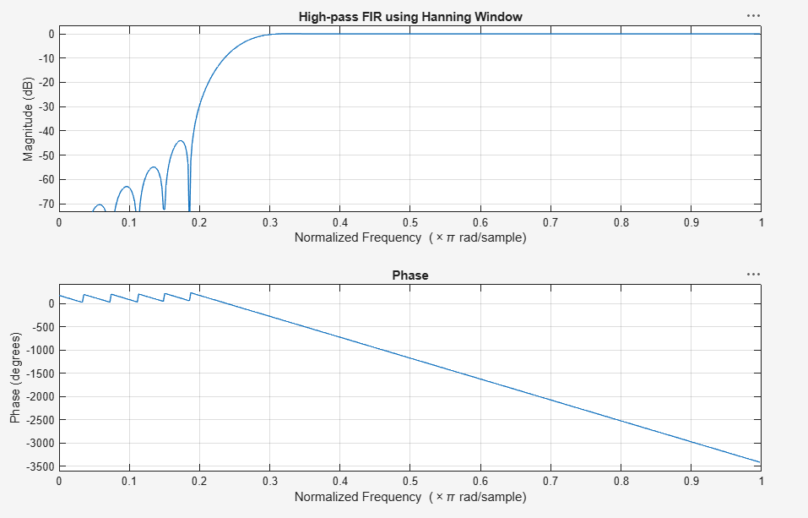
Fig. 5.3: Magnitude & Phase response of high-pass FIR filter (Hanning window)

Result
The Hanning window produces the deepest stopband attenuation of the three windows for the high-pass design, again with the widest transition region.

