Experiment 6.1: Uniform Quantization & Quantization Error Analysis

Aim
To quantize a sinusoidal signal at different numbers of quantization levels (8, 16, 32), and to analyse how the quantization error and mean-squared error (MSE) vary with the number of levels.

MATLAB Code
clc; clear; close all;
%% Signal
fs = 1000; f = 50;
t = 0:1/fs:0.1;
x = sin(2*pi*f*t);
%% Quantization Levels
L = [8 16 32];
colors = {'r','g','m'};
figure;
for i = 1:length(L)
% Quantization
xq{i} = round((x+1)*(L(i)-1)/2)*(2/(L(i)-1)) - 1;
% Error & MSE
e{i} = x - xq{i};
mse(i) = mean(e{i}.^2);
% Plot Quantized Signals
subplot(4,1,i+1);
stairs(t,xq{i},colors{i},'LineWidth',1.2);
title(['Quantized Signal (' num2str(L(i)) ' Levels)']);
grid on;
end
% Original Signal
subplot(4,1,1);
plot(t,x,'LineWidth',1.5);
title('Original Signal'); grid on;
% Display MSE
fprintf('MSE for 8 Levels = %f\n', mse(1));
fprintf('MSE for 16 Levels = %f\n', mse(2));
fprintf('MSE for 32 Levels = %f\n', mse(3));
%% Error Plots
figure;
for i = 1:3
subplot(3,1,i);
plot(t,e{i});
title(['Error (' num2str(L(i)) ' Levels)']);
grid on;
end

Output / Screenshots
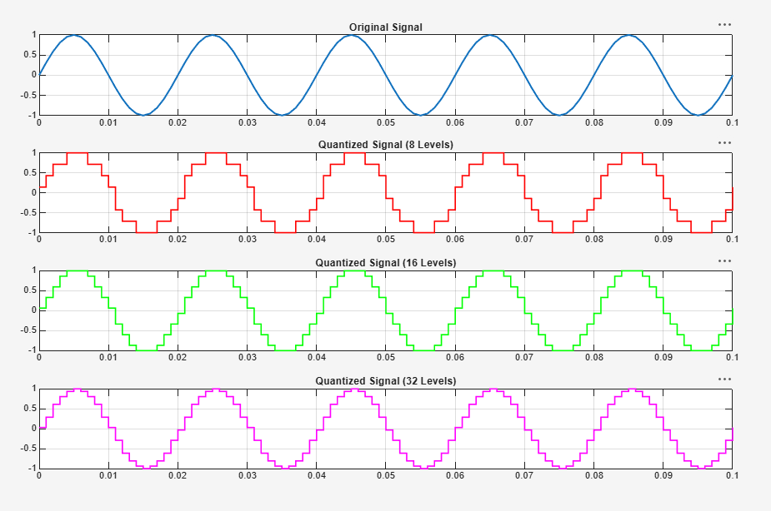
Fig. 6.1(a): Original signal and quantized signals at 8, 16 and 32 levels
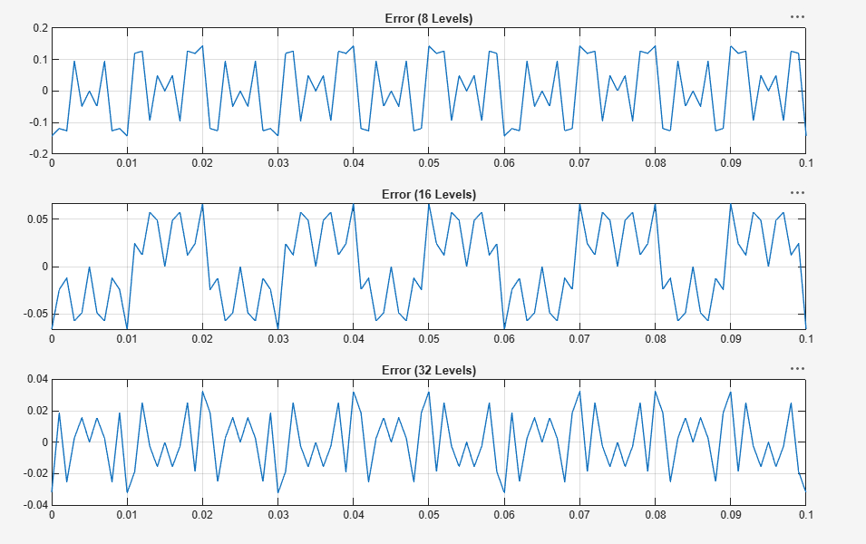
Fig. 6.1(b): Quantization error for 8, 16 and 32 levels

Result
As the number of quantization levels increases from 8 to 32, the step size of the quantizer reduces, and the quantization error and MSE decrease correspondingly, confirming that a finer quantizer yields better signal fidelity.

