Experiment 6.2: Finite Word-Length Effects: Truncation vs Rounding (MSE Comparison)

Aim
To study the effect of finite word-length representation on a sinusoidal signal by comparing truncation and rounding quantization methods, and to compute their respective mean-squared errors.

MATLAB Code
clc; clear; close all
n=0:79;
x=sin(2*pi*n/40);
q=8;
xt=floor(x*q)/q;
xr=round(x*q)/q;
et=x-xt;
er=x-xr;
% Fig 1
figure
plot(n,x,'b',n,xr,'r','LineWidth',1.5)
grid on
title('Original vs Quantized')
legend('Original','Quantized')
% Fig 2
figure
plot(n,x,'b',n,xt,'r',n,xr,'g','LineWidth',1.5)
grid on
title('Truncation vs Rounding')
legend('Original','Truncated','Rounded')
% Fig 3
figure
stem(n,et,'r')
hold on
stem(n,er,'g')
grid on
title('Quantization Error')
legend('Truncation','Rounding')
% Fig 4
figure
bar([mean(et.^2) mean(er.^2)])
set(gca,'XTickLabel',{'Truncation','Rounding'})
grid on
title('MSE Comparison')
ylabel('MSE')

Output / Screenshots
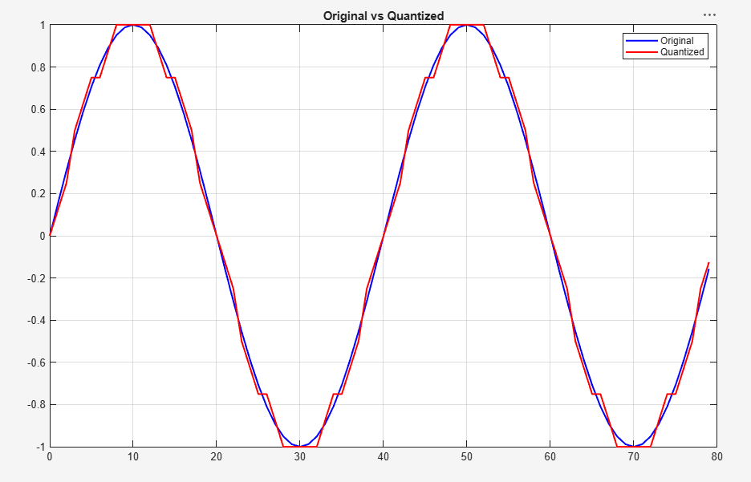
Fig. 6.2(a): Original vs quantized (rounded) signal
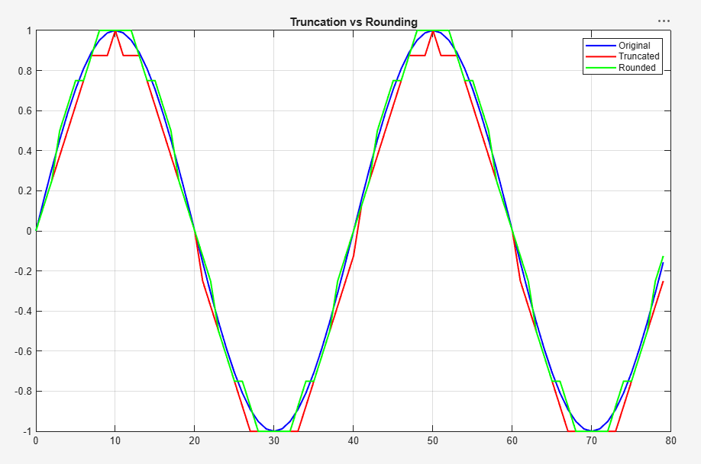
Fig. 6.2(b): Truncation vs Rounding compared to the original signal
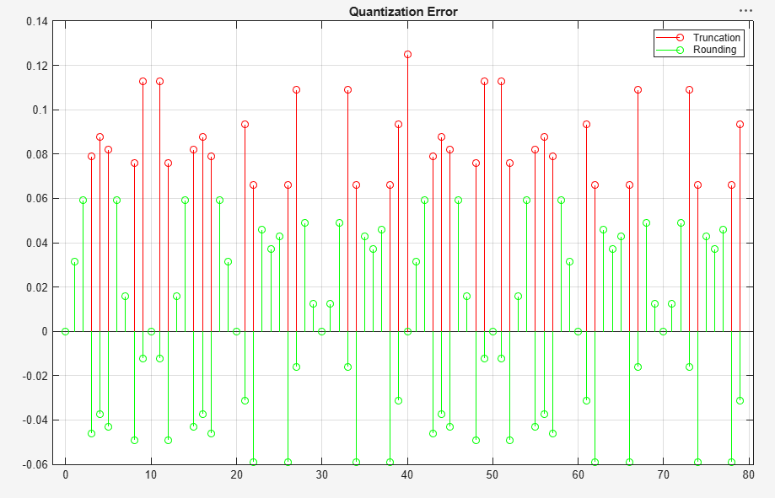
Fig. 6.2(c): Quantization error — truncation vs rounding
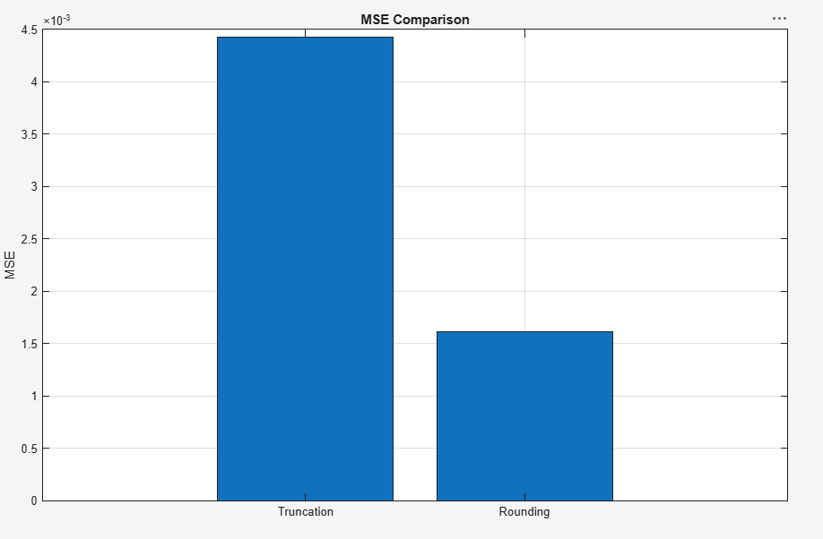
Fig. 6.2(d): MSE comparison bar chart

Result
The MSE for truncation (≈4.4×10⁻³) is noticeably higher than the MSE for rounding (≈1.6×10⁻³), showing that rounding introduces a smaller, zero-mean quantization error and is therefore the preferred quantization strategy.

