Experiment 7.1: PSD Estimation of Noisy Sinusoids Using the Periodogram Method

Aim
To generate a signal composed of two sinusoids corrupted by additive noise, and to estimate its power spectral density (PSD) using the periodogram method, comparing it with the FFT magnitude spectrum.

MATLAB Code
clc; clear; close all
fs=1000; t=(0:999)/fs;
s=sin(2*pi*100*t)+0.5*sin(2*pi*200*t);
n=0.3*randn(size(t));
x=s+n;
figure, plot(x), grid on
title('Signal with Noise')
figure, periodogram(x,[],[],fs)
title('PSD using Periodogram')
figure
X=abs(fft(x));
f=(0:length(X)-1)*fs/length(X);
plot(f(1:500),X(1:500)), grid on
title('Magnitude Spectrum')
figure
bar([mean(s.^2) var(n)])
set(gca,'XTickLabel',{'Signal','Noise'})
title('Power Comparison')
grid on

Output / Screenshots
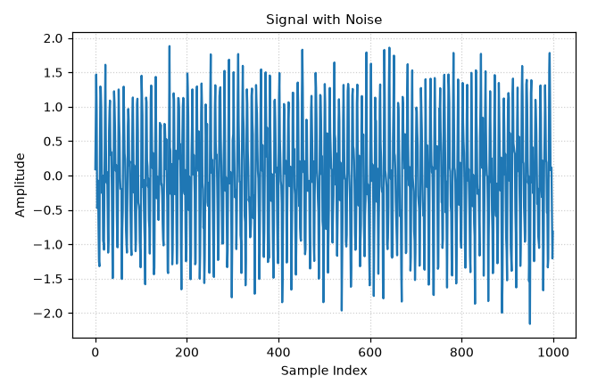
Fig. 7.1(a): Noisy time-domain signal
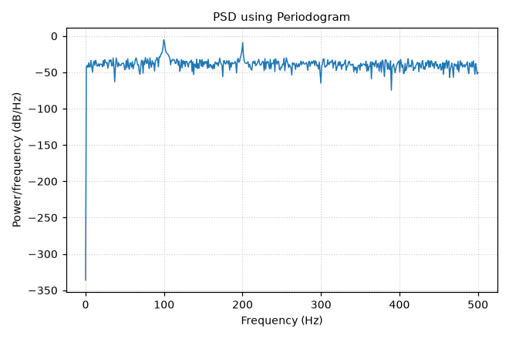
Fig. 7.1(b): PSD estimate using the periodogram method
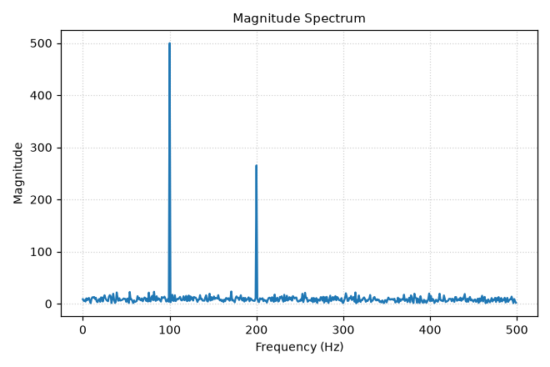
Fig. 7.1(c): FFT magnitude spectrum
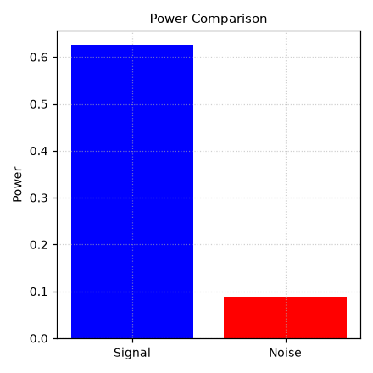
Fig. 7.1(d): Signal power vs noise power comparison

Result
The periodogram and FFT magnitude spectrum both clearly identify spectral peaks at 100 Hz and 200 Hz, matching the two sinusoidal components, while the signal power is shown to be significantly higher than the noise power.

