Experiment 8.1: Decimation & Interpolation in Multirate Signal Processing

Aim
To perform decimation (down-sampling by 2) and interpolation (up-sampling by 2) on a discrete sinusoidal sequence, and to observe the resulting changes in the sequence.

MATLAB Code
clc; clear; close all;
% Original Sequence
n = 0:40;
x = sin(0.3*pi*n);
% Decimation by 2
y = x(1:2:end);
nd = 0:length(y)-1;
% Interpolation by 2
v = zeros(1,2*length(x));
v(1:2:end) = x;
ni = 0:length(v)-1;
% Figure 1: Original Sequence
figure;
stem(n,x,'filled');
grid on;
title('Original Sequence x[n]');
xlabel('n'); ylabel('Amplitude');
% Figure 2: Decimated Sequence
figure;
stem(nd,y,'filled');
grid on;
title('Decimated Sequence by 2');
xlabel('n'); ylabel('Amplitude');
% Figure 3: Interpolated Sequence
figure;
stem(ni,v,'filled');
grid on;
title('Interpolated Sequence by 2');
xlabel('n'); ylabel('Amplitude');
% Figure 4: Comparison
figure;
stem(n,x,'b'); hold on;
stem(0:2:length(v)-2,v(1:2:end),'r');
legend('Original x[n]','Interpolated Samples');
grid on;
title('Comparison of Sequences');
xlabel('n'); ylabel('Amplitude');

Output / Screenshots
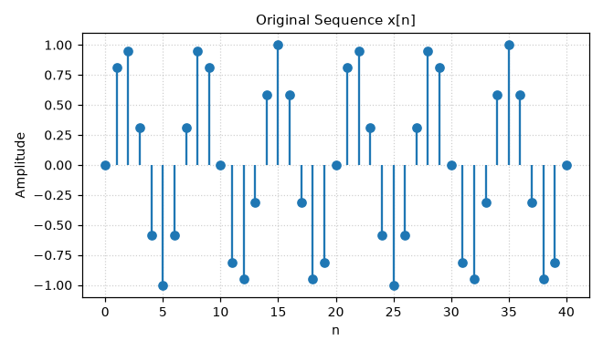
Fig. 8.1(a): Original sequence x[n]
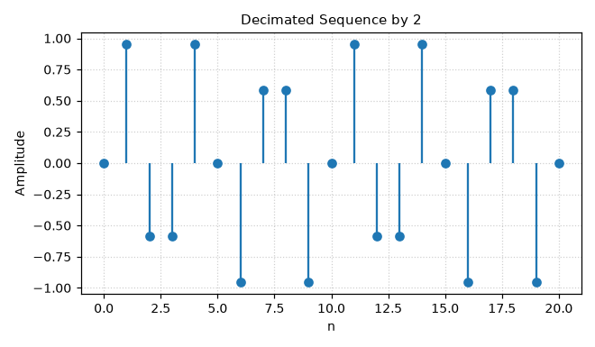
Fig. 8.1(b): Decimated sequence (down-sampled by 2)
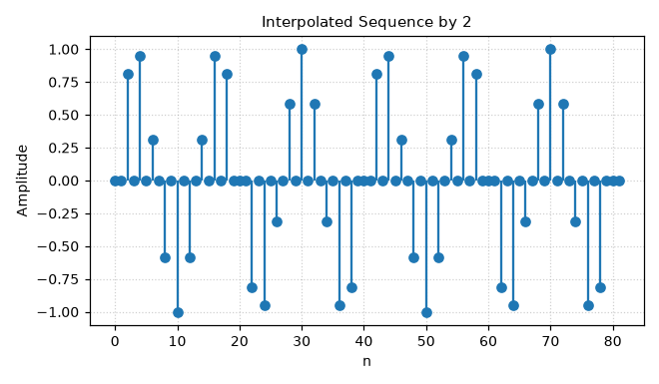
Fig. 8.1(c): Interpolated sequence (up-sampled by 2, zero-stuffed)
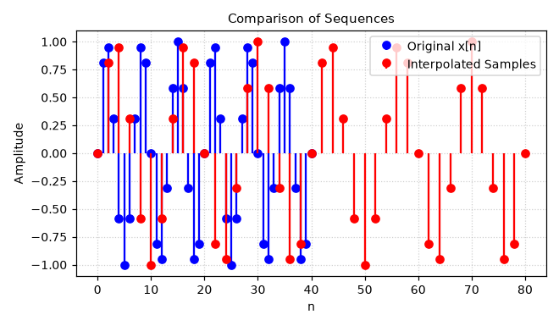
Fig. 8.1(d): Comparison of original and interpolated sample positions

Result
Decimation by 2 reduces the sequence length by half while retaining every second sample, whereas zero-stuffing interpolation by 2 doubles the length by inserting zeros between samples — as expected prior to low-pass (anti-imaging) filtering.

