Experiment 9.1: LMS & NLMS Algorithms for Adaptive Echo Cancellation

Aim
To simulate an acoustic echo path and cancel the resulting echo using the LMS and Normalized-LMS (NLMS) adaptive filtering algorithms, and to compare their convergence behaviour via the mean-squared error.

MATLAB Code
clc; clear; close all
N = 1000; % Number of samples
x = randn(1,N); % Input (far-end) signal
h_echo = [0.8 0.5 0.3]; % Echo path impulse response
d = filter(h_echo,1,x); % Echo signal (received)
noise = 0.001*randn(1,N); % Background noise
desired = d + noise; % Desired signal at near-end
%% LMS Algorithm
L = length(h_echo);
mu = 0.02;
w = zeros(1,L);
y = zeros(1,N);
e1 = zeros(1,N);
for i = L:N
xin = fliplr(x(i-L+1:i));
y(i) = w*xin';
e1(i) = desired(i) - y(i);
w = w + 2*mu*e1(i)*xin;
end
%% NLMS Algorithm
L = length(h_echo);
mu2 = 0.5;
w = zeros(1,L);
y = zeros(1,N);
e2 = zeros(1,N);
for i = L:N
xin = fliplr(x(i-L+1:i));
y(i) = w*xin';
e2(i) = desired(i) - y(i);
w = w + (mu2/(xin*xin'+eps))*e2(i)*xin;
end
%% Plots
figure
plot(x); hold on; plot(d); grid on
legend('Input','Echo'); title('Input and Echo Signal')
figure
plot(e1); grid on; title('LMS Output')
figure
plot(e2); grid on; title('NLMS Output')
figure
semilogy(e1.^2,'r'); hold on; semilogy(e2.^2,'b')
grid on; legend('LMS','NLMS'); title('MSE Comparison')

Output / Screenshots
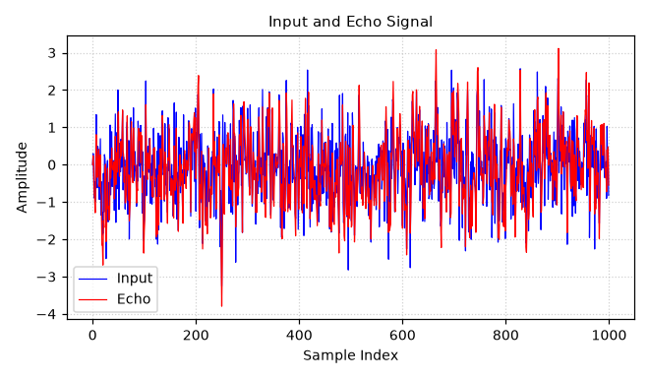
Fig. 9.1(a): Far-end input signal and the resulting echo
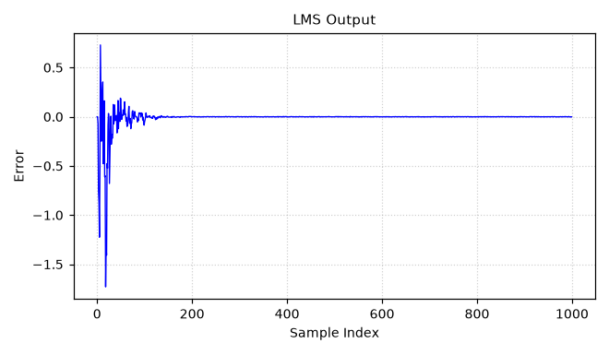
Fig. 9.1(b): LMS error (residual echo) signal
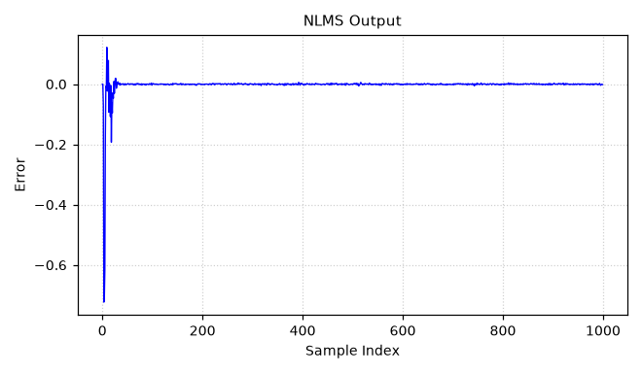
Fig. 9.1(c): NLMS error (residual echo) signal
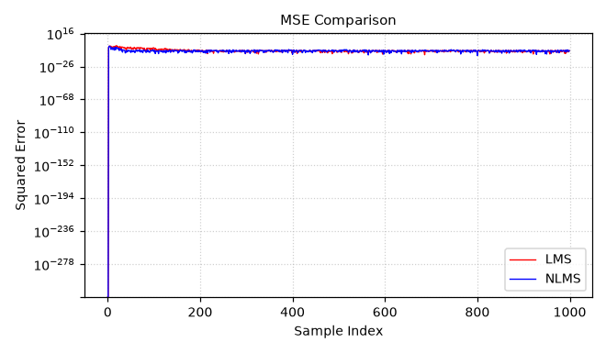
Fig. 9.1(d): Squared-error (MSE) comparison — LMS vs NLMS

Result
Both LMS and NLMS successfully converge and cancel the simulated echo, driving the error toward the noise floor. NLMS converges within a few samples and settles with a smaller steady-state error than the standard LMS algorithm because its step size is normalized by the input signal power.

